Community Assessment Project
Oakland, Illinois
RN404 Community Health Nursing
Tenika McMillan, RN, Alicia Northen, RN, Sheila Roth, RN, and Lori Turner, RN
Lakeview College of Nursing

Community Assessment Project
I. Introduction
Oakland, Illinois is a community located in South East Illinois. Community, as defined by Webster (2005) is, “the whole body of the people living in a city, district, country, etc., (p. 44).” The map below shows the surrounding towns located near Oakland. As one can see, these towns are small which make them similar to Oakland. Within these small towns, it is difficult to find healthcare. People must travel a fair distance to receive any form of medical treatment. Mattoon, for example, is the closest area to Oakland that provides healthcare.
Oakland is located 33.9 miles South East of Champaign, Il, 100.3 miles west of Indianapolis, IN, and 152.1 miles South of Chicago. (Oakland, Illinois, 2011)
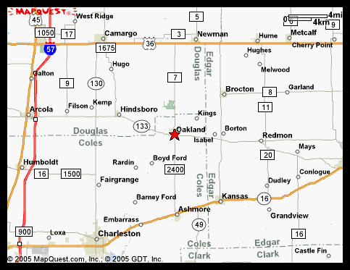 http:www.mapquest.com/oaklandIL

http://maps.msn.com/
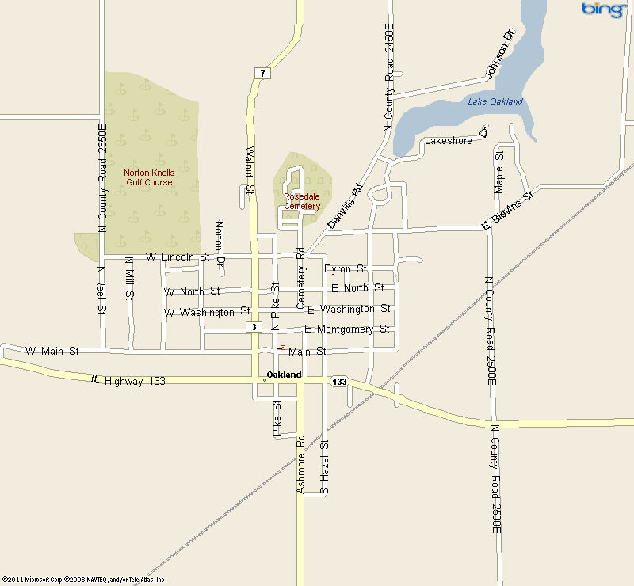
The map above provides a more detailed look at the town of Oakland. One can more clearly see the boundaries, streets, golf course, lake, railroad, and major highways that define the perimeters of Oakland.

II. Assessment
This windshield survey was conducted multiple times during different times of the day. While assessing the homes in this town, it was noted that most of the homes were approximately the same age with similar styles. Most styles were Ranch with occasional Cape Cod or Bungalow styles. All homes appeared to be older but well kept. It was noted; the homes on the south side of route 133 were more run down and had more mobile homes with less upkeep. This area appeared to be where the lower socioeconomical class lived. Most homes had moderately sized yards and were not spaced in close proximity to one another. In general, the neighborhoods were status quo. There were no new developments occurring and few abandoned homes.
The center of the town has a square that has an open grassy area. The square is where some local businesses are located. During business hours, many people are seen frequenting the established businesses; however, during the evening hours, no one was noted to be around the square.
The north side of the square has the Christian Church while one block north of this church is the Methodist Church. Two Baptist Churches are located outside of town. One church is located south west of town; while the other church is located north of town.
East of the town square, there is an insurance company, a furniture store, a beauty and barber shop, and a bank. There is also a small restaurant, a farm implement store, an antique store, the food pantry, a used clothing store, and another restaurant. If one were to travel a few blocks further east; one would find a modern funeral home, a lumber yard and a crop production business.
South of the town square, the community has been complimented by a building that has been rebuilt which is used for social activities and gatherings. This building is called the “Columbia Building” and can be rented for social gatherings. One will also find a newspaper building, the “Noodle Company,” a bank, a variety store which sells paint, T-shirts, sweat shirts (that can have the school mascot applied), flowers, movie rentals, jewelry, and other knick knacks. There are empty buildings along this side of the square as well. Just south of route 133 is the fire house, the ambulance garage, a car wash, laundry mat, and a vehicle body shop.
There are two gas stations located on the south east side of town. One gas station is Casey’s General Store that sells food and a few grocery items. The other gas station provides mechanical repairs for automobiles. The town appears to be thriving.
Moving one block west of the town square, one will find a library; a senior citizen building (which provides meals to senior citizens through a program called “Meals on Wheels”), and a grocery store. Just south of the library, there is an independent living facility called the “The Oaks Manor.” It is a small apartment-like complex that houses 13 small apartments for seniors.
The North West side of town includes a swimming pool and a golf course. The school is located on the north east side of town and north of the school is the town park. The town also has a small lake just north of the park. No one was observed visiting the park or lake.
The north side of town is separated from the south side of town by Route 133. Route 133 runs east and west. A county road, the locals refer to as the, “Oakland/Ashmore Road,” along with Walnut Street separates the east side of town from the west side of town. Walnut Street, just west of the square, runs north of Route 133 while Oakland/Ashmore Road runs south of Route 133. Route 133, Oakland/Ashmore Road, and Walnut Street were found to be in good shape.
There is no public transportation available in this community. Transportation was observed through the use of privately owned vehicles. The forms of transportation consist of driving a car alone, worked at home, walking, and carpooling. (City-data, 2010)
The town does not have health care or dental care available and the nearest hospital is east of Oakland approximately 18 miles. The community, as a whole, must drive a significant distance to receive healthcare. The elderly are forced to depend on others to be transported to appointments and run errands.
The community consists of pre-dominantly white people; however, there is one Hispanic child, two Asian children and one African American child noted. The parents / guardians of these children are noted as being white.
When this RN performed the windshield survey, each time it was noted that there was very little activity observed throughout the community. On occasion, older adults were observed walking early in the morning before work; however, no children were observed playing ball, bike riding or any other physical activities. Because there was minimal physical activity noted throughout the town, the risk for obesity became an immediate concern.
This RN had the opportunity to interview several people in the community. Many people voiced the concern of increased childhood obesity as well as the adults due to limited activities in the community. An interview with the school nurse, Vivian Hudson, revealed a shared concern on this topic. This RN was encouraged by Vivian who is taking a pro-active approach in the community to help address this risk. Vivian is working to provide opportunities for people within the community to become more active. Some activities she has organized include: the community 5k race and 1k walk, providing open gym for physical activities, and encouraging Walk Night.” She has also been instrumental in changing meals and snacks the school offers, i.e., placing a salad bar in the cafeteria for lunches.
Descriptive Data / Demographics
This group has agreed to focus its attention on the risk of obesity in Oakland, Illinois. According to the CDC (2010),
Overweight and obesity are both labels for ranges of weight that are greater than what is generally considered healthy for a given height. The terms also identify ranges of weight that have been shown to increase the likelihood of certain diseases and other health problems. (Obesity, 2010)
A major health issue revealed during the windshield survey became boldly apparent when the lack of physical activity was observed in Oakland. Obesity alone is a strain on an individual’s health; however, it is only the beginning of the domino effect to greater health issues. This group of RN’s has determined that in order to prevent further health issues developing; obesity must be addressed.
Obesity is calculated differently for adults and children. Adults with a body mass index (BMI) (calculating the relation between height and weight) calculating between 25 and 29.9 are considered to be overweight; however, a BMI that has been calculated at 30 or greater for an adult is considered to be obese. Children on the other hand according to the CDC (2010), “Overweight is defined as a BMI at or above the 85th percentile and lower than the 95th percentile. Obesity is defined as a BMI at or above the 95th percentile for children the same age and sex (Centers for Disease Control and Prevention, 2010).”
Table 1. Prevalence of obesity among U.S. children and adolescents aged 2-19, for selected years 1963-1965 through 2007-2008. NHANES (National Health and Nutrition Examination Survey)
Age  (in years) | NHANES  1963-1965  1966-1970 | NHANES  1971-1974 | NHANES  1976-1980 | NHANES  1988-1994 | NHANES  1999-2000 | NHANES  2001-2002 | NHANES  2003-2004 | NHANES  2005-2006 | NHANES  2007-2008
Total | (3) | 5.0 | 5.5 | 10.0 | 13.9 | 15.4 | 17.1 | 15.5 | 16.9
2-5 | (3) | 5.0 | 5.0 | 7.2 | 10.3 | 10.6 | 13.9 | 11.0 | 10.4
6-11 | 4.2 | 4.0 | 4.0 | 11.3 | 15.1 | 16.3 | 18.8 | 15.1 | 19.6
12-19 | 4.6 | 6.1 | 6.1 | 10.5 | 14.8 | 16.7 | 17.4 | 17.8 | 18.1

http://www.cdc.gov/nchs/data/hestat/obesity_child_07_08/obesity_child_07_08.htm#table1.
In Oakland, Illinois in the year 2010 the adult obesity rate reached 27.2% of the city’s entire population. The statistics of childhood obesity found only addressed “Low-income preschool obesity rate” in Coles County. That rate was 13.6%. One can only guess and imagine that the number of children today experiencing obesity in that area of the state are increasing. Simple everyday exercise such as walking to school is observed less and less for kids attending school. Oakland schools are no different. (City-data, 2010)
In 1986 Illinois had an obesity rate of <10%. By 1994 the obesity rate had increased to between 15% and 19%. In 1999 Illinois’ obesity rate had increased to 20%-24% and unfortunately, in 2008 Illinois’ obesity rate reached an all time high of 25% to 29%. As of 2009 Illinois had maintained this very high percentage rate of obesity. At this time, this group of RN’s have been unable to find the obesity rate for Illinois in 2011. It is fair to surmise, based on the previous data and continued lack of exercise, the trend will continue negatively upward. (Centers for Disease Control and Prevention, 2010)
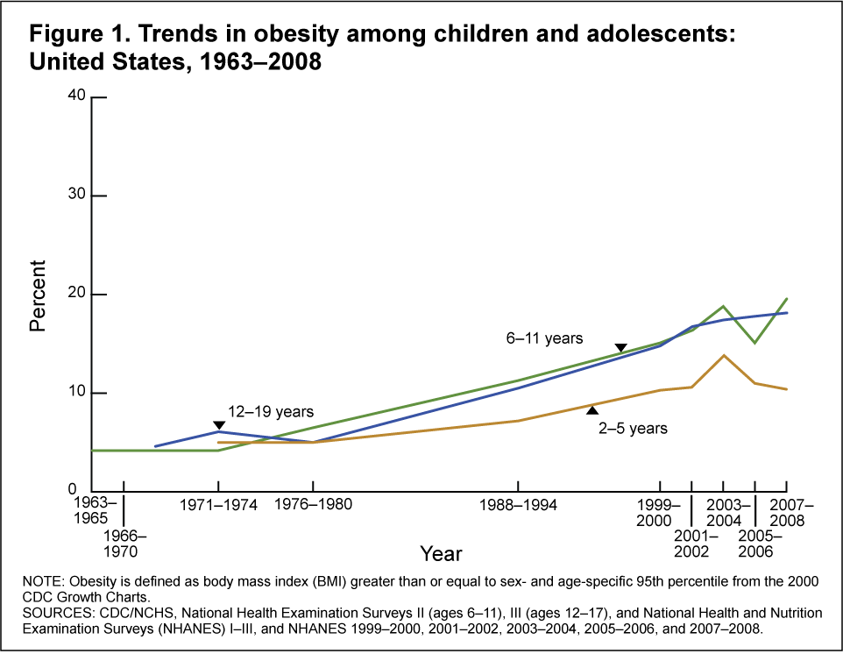
http://www.cdc.gov/nchs/data/hestat/obesity_child_07_08/obesity_child_07_08.htm#tabl0e1.
The charts above give two different perspectives regarding the rate at which obesity has been climbing over the years. The charts above describe only children and most understand it affects adults too; however, if the issue of obesity is addressed at the younger ages; there may be an improvement as people age.
As of 2009 the Oakland township had a population of 933. There were 454 males and 479 females. The median age of Oakland’s residents in 2009 was 40.5 years which was comparable to Illinois’ median age of 34.7 years. (City-data, 2010)
Median household income was estimated at $39,498 for Oakland residents while the median household income for residents of the state of Illinois was $53,966. The most common jobs held by men in 2009 were farmers and farm managers at 4%, assemblers and fabricators at 5%, metal workers and plastic workers at 5%, construction trades workers except carpenters, electricians, painters, plumbers, and construction laborers at 5%, carpenters at 7%, driver/sales workers and truck drivers were at 8% and other occupations including supervisors ranked at 8%
Jobs for women included secretaries and administrative assistants at 8%, other production occupations including supervisors at 8%, preschool, kindergarten, elementary and middle school teachers were at 6%, cooks and food preparation workers at 6%, other office and administrative support workers including supervisors at 5%, assemblers and fabricators at 5%, and retail sales workers except cashiers at 4%. (City-data, 2010)
The predominant and almost only race noted in Oakland is white. 99.2% of Oakland’s residents are white while only a mere 0.8% of the population is Asian. In 2009, a whopping 1.5% of residents were foreign born. (City-data.com)
Education for the residents of Oakland range from high school to a graduate or professional degree. 82.7% of Oakland residents have a high school diploma or higher. 15.3% of the residents have achieved a Bachelor’s degree or higher and 3.8% have a graduate or professional degree. 2.7% of the population is unemployed; however, those who are working have a mean travel time to work at 24.4 minutes. (City-data, 2010)
Marital status varies throughout Oakland. Oakland’s residents who are 15 years of age and older fall into five different categories. Those who have never been married in 2009 consisted of 16.8% of Oakland’s population. Those married in 2009 comprised of 60.1%, separated individuals counted for about 0.9%, widows and widowers consisted of 10.0% and those who were divorced ranked as 12.3%. (City-data, 2010)
38.64% of Oakland’s population is associated with a religious congregation. Oakland’s Lutheran’s consist of 10% of the population, 13% are United Methodist, 10% are Southern Baptist, 15% are Christian Churches and Churches of Christ, and 16% are Catholic. (City-data, 2010)

III. Analysis of Data
Through the use of the windshield survey, statistics found through the Centers for Disease Control and Prevention, NHANSE, and interviews performed with several of Oakland’s residents, this group of RN’s have found significant data that supports the need for obesity education and intervention.
After investigating the different theorist models suggested, this group of RN’s agreed upon the use of Betty Neuman’s System Model. Ms. Neuman, according to Wikipedia (2010) believes,
The purpose of the nurse is to retain the system’s stability through three levels of prevention.
1. Primary prevention to protect the normal line and strengthen the flexible line of defense.
2. Secondary prevention to strengthen internal lines of resistance, reducing the reaction, and increasing resistance factors.
3. Tertiary prevention to readapt and stabilize and protect reconstitution or return to wellness following treatment. (Neuman Systems Model, 2010)
Positive healthcare results begin with prevention techniques. Of course, this group of RN’s recognize the fact that not all diseases and illnesses are preventable. Heredity plays a significant role in the disease process for many people. It is, however, plausible to consider prevention as the first step in caring for a potential disease process.

 | PROBLEM LIST
Problem Correlates of Factors | Relationships | Supportive Data
High risk for diabetes | Patients with diagnosis | Interviews
High risk for obesity | Patients with diagnosis | Interviews
Lack of local medical care | No physician or healthcare offices in the town of Oakland | Windshield interviews
Lack of pharmacy & medical supply | No pharmacy located in town of Oakland | Windshield interviews
Lack of dental care | No dental office in town of Oakland | Windshield interviews
Lack of transportation | No agencies offering transportation to town | Interviews
Lack of health education | No agencies providing healthcare education in town | Interviews
Lack of exercise options | No gym or structured exercise programs in town | Windshield/interviews
Low socioeconomic status | No money to pay for exercise options | 49.7% poverty status in 1999
Low level of education | Limited comprehension and motivation | 14% non-graduates from H.S.

Strengths / Resources
- School Nurse-provides school kids with education, evaluations, treatments, and organizes a 5k run annually
- Churches-5-helps members, provides some local services
- Food Pantry-sponsored by church
- Grocery Store- in town, over the counter meds
- Independent Living Facility-Oaks Manor
- Senior Center-sponsors home delivered meals
- Schools-k-12-large track
- Swimming Pool
- Golf Course
- Newspaper
- State Park-fishing, hiking, boating within 5 miles of town
- Post office
- Retail-Furniture, Noodle, Used clothing
- Insurance office
- Restaurants-2
- Library-could be a place for educational meetings
- Funeral Home
- Historical Marker-Rutherford Home
- VFW Legion
- Farm Implement Store
- Grain Elevator
- Chemical Plant
- Gas Station
- Police Dept
- Lions Club
- Masons of Illinois
- Ladies VFW Auxiliary

IV. Nursing Care
A. Nursing Diagnosis:
Knowledge deficit related to obesity in Oakland, Illinois related to lack of equipment and information from interviews as evidenced by overweight community observed.
B & C: Plan & Interventions
Community Assessment Interventions
Completion date | Intervention | Person Responsible | Level of intervention | Evaluation-Effective, Efficient, Adequate, Appropriate
5/15/2011 | Develop parish nurse program | Public health nurse | Primary, Community | Was parish nurse hired and trained?
5/15/2011 | Contact all churches for support-schedule meeting | Public health nurse | Primary, Secondary, Individual, Family | Did all churches respond, attend a meeting?
5/31/2011 | Provide education to community on obesity-office, home visits | School Nurse, Parish Nurse, Public health nurse | Primary, Community | Is the parish nurse or lay teachers holding classes, attendance?
6/15/2011 | Schedule Lay teacher training- 3 lay teachers | School Nurse, Parish Nurse, Public health nurse | Primary, Community | Is the parish nurse training 3 teachers?
5/31/2011 | Newspaper articles-once a week for 6 weeks | Parish Nurse | Primary, Community | Did the parish nurse develop article and submit?
5/31/2011 | Hold classes at library regarding obesity- 2 classes per week | Parish Nurse, Lay Teachers | Primary, Community | Did the parish nurse develop article and submit?
5/31/2011 | Mail brochures to all residents | Parish Nurse, Lay Teachers | Primary, Community | Did residents receive brochures, understand, and call to schedule class?
6/30/2011 | Develop classes through churches-nutrition, exercise, healthy lifestyle | Parish Nurse | Primary, Community | Is the parish nurse fulfilling the duties-lay teachers and classes?
6/30/2011 | Provide nursing care to community | Parish Nurse | Primary, Secondary, Individual, Family | Is the nurse scheduling office and home visits-documenting?
7/15/2011 | Increase exercise to 30 minutes / day | Parish Nurse, Lay Teachers | Primary, Secondary, Individual, Family | How many residents are attending exercise/walking on their own?
7/15/2011 | Develop Structured exercise programs-4 new programs | Parish Nurse, Lay Teachers | Primary, Secondary, Individual, Family | How many programs developed with teachers, participants?
7/15/2011 | Organize water aerobics at pool-once weekly | Parish Nurse, Lay Teachers | Primary, Secondary, Individual, Family | How many residents are attending aerobics/swimming on his or her own?
7/15/2011 | Walking groups at school track and state park, 5K | Parish Nurse, Lay Teachers, School Nurse | Primary, Secondary, Individual, Family | How many residents are attending groups or walking, or 5K?

Long Term Goals
- Improve knowledge deficit related to obesity involving 50% of residents of Oakland residents with obesity. (Demographic profiles, 2000)
- Increase awareness of risk factors of obesity within Oakland.
- Increase options for physical activity in Oakland by 50%.

Short Term Goals
- In six weeks, a part time paid registered nurse position will be approved and hired.
- In eight weeks, an educational program will be implemented for healthy lifestyle changes related to obesity.
- In eight weeks, the parish nurse will have office hours and home visits scheduled.
- In ten weeks, a training program will be developed to train community members to lead exercise classes.
- In twelve weeks, a structured physical activity program will be implemented in town.
V. Personal Summary
A. Sheila Roth
This group project was an enjoyable one. Each group member worked very hard to provide accurate and thorough information for this project. At no time did anyone of this RN’s group members perform only what was asked of her. Each person continued to volunteer to help with any portion of the project despite the individual assigned portions. This was truly a cohesive group fueled by determination and a drive to work together as a team.
The learning process for this team consisted of bringing different pieces of information together to create a complete picture. The components of this project were divided into sections that each individual felt comfortable investigating. This RN was to research the various theorists and write about the theorist the group agreed upon. It was also this RN’s responsibility to pull all of the information together and place it into a format that flowed smoothly. This RN’s final responsibility was to create a power point presentation to present to the class. The information and pictures were provided by this RN’s peers. The learning process for this RN developed through the compilation of the information that was researched and provided. This RN also participated in researching the community and the known statistics and demographics presented.
The most important part of this project was not only learning about the community of Oakland but also observing the often overlooked medical needs of the community. It became very apparent how quickly one enters a community without really assessing the intricate pieces that make it a true community. The lack of resources available to Oakland grew larger the more the town was investigated by this group. It has provided this RN a whole new perspective on taking the time to really look into the communities in which people live and exist. This information is instrumental in handling an individual’s care.
From this point forward, this RN will work to develop a more conscious effort to learn about any future patient’s community when caring for him or her as an individual. Advocating for individuals will take on a whole meaning. No longer will the individual in front of this RN be looked at as just a person with symptoms; but rather a person who is a part of a community that may or may not have resources available. The community in which that individual lives must be considered when educating and developing a plan of care.
Personal objectives for this RN included: learning about the community, its resources, lack of resources; and discovering what it meant to be a part of a community. Personally speaking, it was also important to pay attention to all aspects of a community in an effort to learn how to identify community health necessities.
Class objectives were met by investigating each piece of the provided outline in order to gain a full understanding of Oakland and its residents. Each portion of the outline was divided among the various group members and then brought together. Each individual member of the group was held accountable for developing her portion of information that met the standards and expectations of the rest of the group. If one did not feel a piece of information was developed well enough, she was asked to refine that portion. Each member did so willingly and happily. In working together this way, the agreed upon objectives were met and completed. The information in the outline provided has been investigated and understood to the best of this RN’s ability.

References
Aubert, R. E., Kapuaolaokalaniakea, S., Mikami, S. (2010). Ke ano ola: Molokai's community- based healthy lifestyle modification program. American Journal of Public Health, 100(5), 779-783.
Community (defined). 2005. Webster’s Concise: English dictionary. (pp. 44). New Lanark, ML: Geddes & Grossest
CDC / National Center for Health Statistics (2010). NCHS health e-stat: Prevalence of obesity among children and adolescents United States, trends 1963-1965 through 2007-2008. Retrieved March 17, 2011, from http://www.cdc.gov/nchs/data/hestat/obesity_child_07_08.htm#tabl0e1
Centers for Disease Control and Prevention (2010). Overweight and obesity. Retrieved March 17, 2011, from http://www.cdc.gov/obesity/defining.html
Centers For Disease Control And Prevention (2010). U.S. obesity trends: Trends by state 1985-2009. Retrieved March 17, 2011, from http://www.cdc.gov
MSN (2011). MSN: Maps and directions. Retrieved March 15, 2011, from http://maps.msn.com.
Neuman Systems Model. (2010, November 22). In Wikipedia, the free encyclopedia. Retrieved March 17, 2011, http://en.wikipedia.org/wiki/Neuman_Sytems_Model
Oakland, Illinois (2011, March 16). City-data. Retrieved March 16, 2011, from http://www.city-data.com/city/Oakland-Illinois.html.

