Danville is located in East Central Illinois and is a city in Vermilion County, Illinois, United States. As of the 2010 census, the city had a total population of 32,467. It is the county seat of Vermilion County. Danville is the 14th-most populous city in Illinois, outside of the Chicago Metropolitan Area. Danville is located approximately 120 miles south of Chicago, 35 miles east of Champaign-Urbana, and 90 miles west of Indianapolis, Indiana. Illinois Route 1, U.S. Route 136, and U.S. Route 150 intersect in Danville; Interstate 74 passes through the south end of town. Lake Vermilion is located on the northwest side of town. According to the United States Census Bureau, the city has a total area of 17.1 square miles (44.3 km²), of which, 17.0 square miles (44.0 km²) of it is land and 0.1 square miles (0.3 km²) of it (0.58%) is water (Wikipedia,2011).
There is one hospital in the community and it is Provena United Samaritans Hospital at 812 N. Logan Danville Illinois. When a person needs to get medical attention they should always know where the hospital is, being that everyone should now where it is they are always aware of the community surrounding the establishment. A quick windshield survey would show the following routes into the hospital.
From the North you will pass mainly residential areas followed by a city park Lincoln Park a city park with large oak trees and a very active Lincoln Park Historic District community group. The hospital is also located across the street from Lakeview College of Nursing.
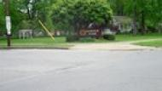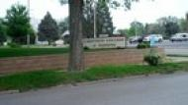
From the South you pass through residential areas. Most of the houses look run down but you can tell these house once were large grand houses in the community.
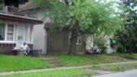

From the East you will pass by the local High school. Danville high school was established in 1870. Today it is staffed by a faculty and support staff of 200, approximately 1600 students is served in grades 9-12.
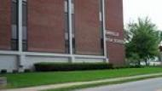
From the West coming into town you will come in over an overpass that looks over another city park Ellsworth park. This area is also home to many houses and is often referred to as the “Heights” because the houses seem to sit up on hills.
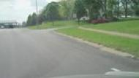

Reference
Wikipedia (2011). City of Danville Illinois. Retrieved fromhttp://en.wikipedia.org/wiki/Danville,_Illinois on May 8 ,2011 .

