CAROTID ARTERY DISEASE
http://www.parknicollet.com/Heart/PDFs/CarotidArteryDisease.pdf
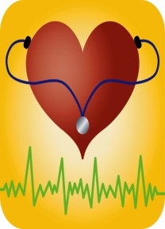
No Smoking: Nicotine causes your blood vessels to narrow, decreases the amount of oxygen in your blood and can cause the blood to clot more easily. Avoid all forms of tobacco, including cigarettes, pipes, cigars and chewing tobacco. Even one or two cigarettes a day is harmful.

Maintain a healthy weight: Being overweight contributes to other risk factors for stroke such as high blood pressure, heart disease and diabetes. Losing as little as 10 pounds may lower your blood pressure and improve your cholesterol levels.
Lower your cholesterol and saturated fat intake. This can reduce the plaques in your arteries. Cholesterol is
found in animal products that contain fat, such as egg yolks, meats and dairy products. Saturated fats are found in
most animal fats and some plant oils (coconut oil, palm oil and cocoa butter).
Control high blood pressure. This is one of the most important things you can do to reduce your stroke risk. Have your blood pressure checked regularly as recommended by your doctor. Follow your doctor’s recommendations for lifestyle changes and take any medications prescribed for you.

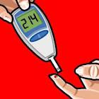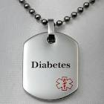
Control diabetes: Control of blood sugar levels can delay complications that increase the risk of stroke.
Be physically active: Being physically active reduces your risk of stroke in many ways. You don’t need to exercise vigorously, just do it regularly. Try walking for 30 minutes, most days of the week.

