Calista Roy Adaptation Theory of Nursing:
The Roy adaptation model is used as a framework for nursing for theory, practice and research.
The major concepts of Roy’s theory included person, environment, health and nursing as the art and science of adaptation.
The adaptation model aims to direct nursing practice, research and education. (bc.edu)
Concepts (bc.edu)
Person had four adaptive modes
Physiological and physical
*Includes five needs: oxygen, nutrition, elimination, activity and rest, and protection.
Self- concept and Group identity
*Includes spiritual integrity so that an individual will feel a sense of purpose and meaning in the universe.
Role function (bc.edu)
*Social integrity, knowing ones place in regards to others, role development and accepting the roles one already has.
Interdependence (bc.edu)
*The need to love and feel loved, the need to be valued and respected through effective communication and relationships.
Environment (bc.edu)
*All conditions, influences and circumstances that affect the behavior and development of an individual.
There are three different types of stimuli, focal, contextual and residual. (Current nursing.com)
Focal- internal or external stimuli that directly affect the environment.
Contextual- all stimuli that contribute to the effect of the focal stimuli.
Residual- all stimuli whose effect to the environment is unclear.
*The most significant stimuli consists of adaptation with family, culture and development.
Health (bc.edu)
*a state of becoming whole and integrated based on the individual, and environment.
Nursing (bc.edu)
*expands adaptive ability and enhances the person and environment transformation.
*nursing goals are meant to promote adaptation of individuals using the four adaptive modes.

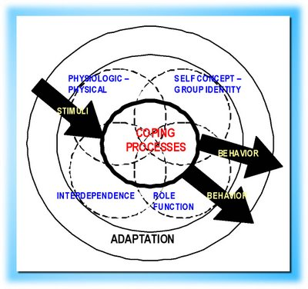
http://nursingtheories.blogspot.com/2008/07/sister-callista-roy-adaptation-theory.html

References
http://www.bc.edu/schools/son/faculty/featured/theorist/Roy_Adaptation_Model.html
http://currentnursing.com/nursing_theory/Roy_adaptation_model.html
http://nursingtheories.blogspot.com/2008/07/sister-callista-roy-adaptation-theory.html (image)

