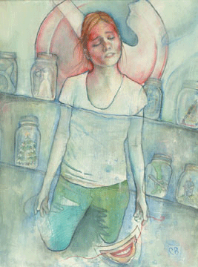

www.headache-adviser.com/migraine-art.html

Sheila Roth
Lakeview College of Nursing
Art of Nursing Module 2 (Self Reflection)

This drawing depicts “the art of nursing for me” in the most significant way. It is full of details that jump off of the page. The details… that is what the art of nursing is. It is not the medical tasks a nurse performs; it’s what he or she is doing despite the medical tasks, which make up the art of nursing. I chose this picture because I believe it depicts the details we as nurses must pay attention to and incorporate into the care of our patients.
The woman in this picture, if you look closely, has jars all around her. Each jar contains what could be interpreted as pieces of her future. The jars are unopened which symbolizes her future being put on hold while she faces her illness. Behind her, you can see what appears to be a plate with a “piece” missing. The “missing piece” contains a silhouette of a person. This, to me, symbolizes a space in her life in which she wasn’t there due to illness. The silhouette symbolizes that she is still there in the background.
She holds in her left hand a mask that shows a smile. Often we will put on a smile for others in an effort to “mask” what we are truly feeling. What she is feeling appears to be pain, suffering, and total surrender. She has taken off her mask to allow herself to face the illness in as real a form as possible. Surrender is demonstrated through the removal of the mask, falling to her knees, and having her arms and hands open. She appears to accept her illness. It also looks as if she may be kneeling in water. The water represents the illness consuming her and yet she is allowing it to just be. She is alone which may allow her more opportunity for her to deal with her illness without pretending. One might even surmise, she is a private person and being alone allows her to remove the mask of “happiness” allowing her to face her illness more openly. This is a picture of strength, acceptance, and surrender.
This picture reminds me; even though a person may demonstrate a smile, it may not be what they are really feeling. It tells me to look past the smile to develop a better understanding of that person as a unique individual. Look for their story in the details of what they may say verbally or non-verbally. Connect with each person on a personal level using the details of their life as a focal point for them instead of their illness. A nurse who shifts the patient care from the illness to the individual’s story demonstrates “the art of nursing.”

