Angina
What is angina?
Angina is chest pain or a discomfort that occurs if your heart doesn’t get enough oxygenated blood. Angina could feel like a squeezing or pressure in your chest. It can even be felt in your shoulders, neck, and arm.
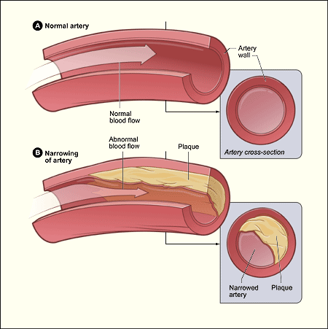
Types of angina
Stable Angina- Stable angina is the most common type of angina. Stable angina has a pattern. It occurs at the same rate, and the severity is the same. This isn’t a heart attack but signals a heart attack could happen.
-usually occurs for a short time (five minutes)
- Usually occurs doing physical activity when the heart has to work harder
- Pain is usually relieved by medicine
Unstable Angina- doesn’t have a particular pattern and you can’t predict when it will happen. Sometimes the pain will be more severe than other times. Unstable angina signals that you may have a heart attack soon, so you should receive emergency care if this occurs.
- Usually occurs during rest
- Can last up to 30 minutes
- Comes as a surprise
- Usually isn’t relieved by medicine

Prevention

Don’t smoke
Eat healthy
Learn how to cope with stress
Be active!
Keep weight under control
Medicines
Nitrates are the most common medicine to treat angina. Nitrates widen and relax blood vessels which allows more heart flow to the blood.
- Nitroglycerin is the most common medication. It dissolves under the tongue or in the cheeks and helps relieve angina episodes.
Statins- help reduce cholesterol and helps reduce the chance of heart attack.

References
“Other Names for Angina- NHLBI, NIH” ( Jun 2011).National heart, lung,and
Blood institution.

