

Accessing and Completing the
Non-Associate Orientation WBT
09-07-2011

St. Vincent Indianapolis Hospital Campus
86th Street Building, Peyton Manning Children’s Hospital,
Stress Center, Women’s Hospital
Home Care, Hospice, Physician Clinics

Instructions for Accessing the Non-Associate Orientation WBT

HR.1.20, EP 12 of the Joint Commission standard states that our facility is required to review the qualifications, performance and competence of each non-employed individual including those brought into the hospital by a licensed independent practitioner to provide care, treatment, or services at the same frequency as individuals employed by the hospital.

The new Non-Associate Orientation web-based training (WBT) is available online! Non-associates can now access all WBTs just like regular associates, internally via the Intranet and also from home through the web portal. The Non-Associate Orientation WBT is found in SEED, located on the St.Vincent homepage under Associate Information.

This web-based training (WBT) has been designed for the non-associate performing services at St.Vincent to use as a general orientation to St.Vincent. All non-associates must complete this WBT.

Following are step-by-step instructions for the non-associate on how to access and complete the WBT.

New User Registration
New users need to complete the “registration” process to set their passwords and gain access to the hospital network. The system called Password Self-Service allows users to reset their passwords, manage “challenge response questions” and complete the registration for new users.

The registration process provides an easy and secure way for new users to gain access to the hospital network. It combines the username and non-associate ID, provided by Education & Development, with two pieces of information that the user should know, last four numbers of his/her Social Security Number or Student ID and his/her birth month and date.

During the registration process new users are required to read and accept St. Vincent’s Acceptable Use Policy, complete “challenge response questions” and set their password.

The “challenge response questions” that users select are used by the “Self-Service Password Reset” process and when calling the HelpDesk as a means of identity verification.

Self-Service Password Reset provides network users throughout St.Vincent Health with a fast and easy means to change a forgotten password thus ensuring a more secure network.

The Registration Process will work as follows:

1. As you begin, be sure your pop-up blocker is off. At your Internet Web Browser type portal.stvincent.org.
- Click on Self-Service Password Reset Website.
  - Enter username & click Get Questions.
  - Enter requested information & click Submit. (Note: Non-Associate ID is first provided to Education & Development upon ID creation.)
  - Accept the Acceptable Use Policy. (Note: If “Refuse” Policy is selected, the process will loop back to the beginning.)
  - Enter password and click Set Password.
  - At Self-Service Challenge Questions select four different questions from the drop down list and enter the answers in the space at the right of each question. (Note: The answers to these questions are maintained in an encrypted database that not even an Information Services Administrator can view)
  - At HelpDesk Challenge Questions select three (3) different questions from the drop down list and enter the answers in the space at the right of each question. (Note: The answers to these questions are only viewable by HelpDesk individuals.)
  - Click Save Responses. User is successfully registered.
  - Logout and then login again to synchronize your password.

The following pages show more detailed instructions.

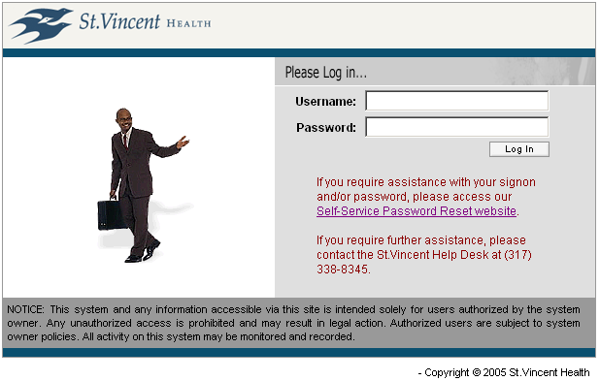
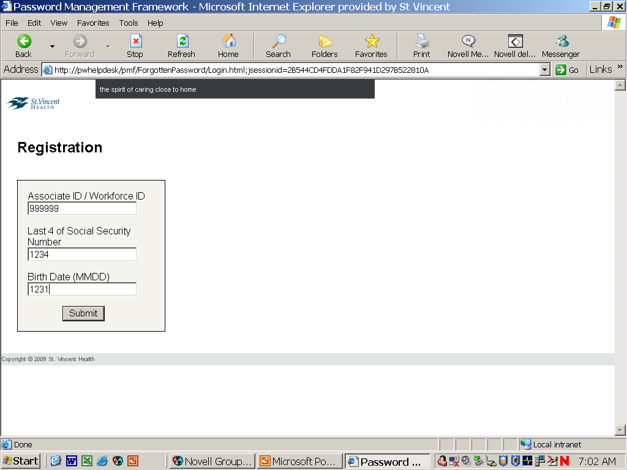
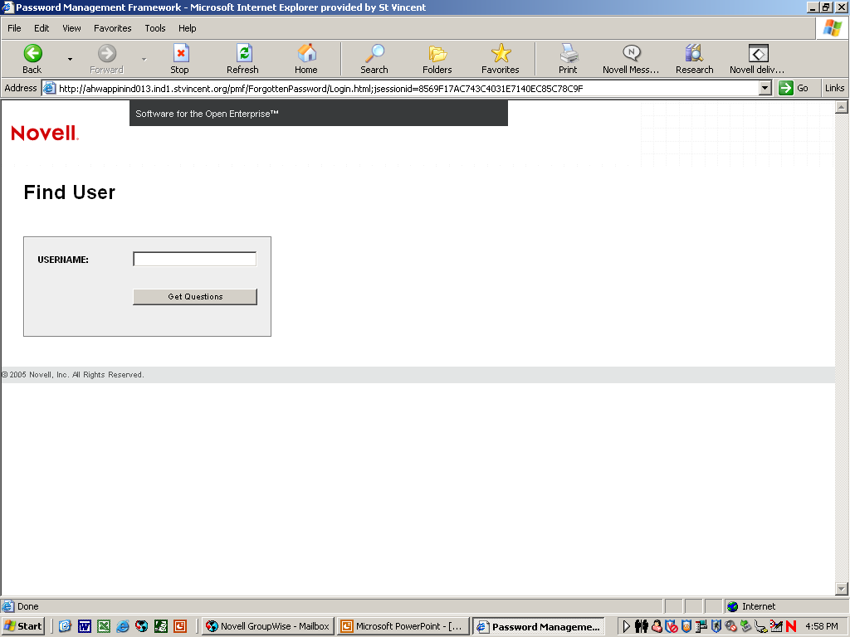
Enter Username & Click “Get Questions”
Enter requested information & click “Submit

- As you begin, be sure your pop-up blocker is off. Follow directions explicitly. Do not try to be intuitive in your navigation. From your Internet Web Brower type portal.stvincent.org in the Address field.

- Click on Self-Service Password Reset website.

- Click on Forgot Password/New User Registration.

- Enter Username, e.g., ABSmith, & click Get Questions.
(Note: Username and Non-Associate number are provided by Education & Development and forwarded to Instructor.)

- Enter requested information.
  - Associate ID: e.g., N012345
  - Last 4 digits of SS or last 4 digits of school ID
  - Birth date: e.g., for May 5 enter 0505

- Click Submit.

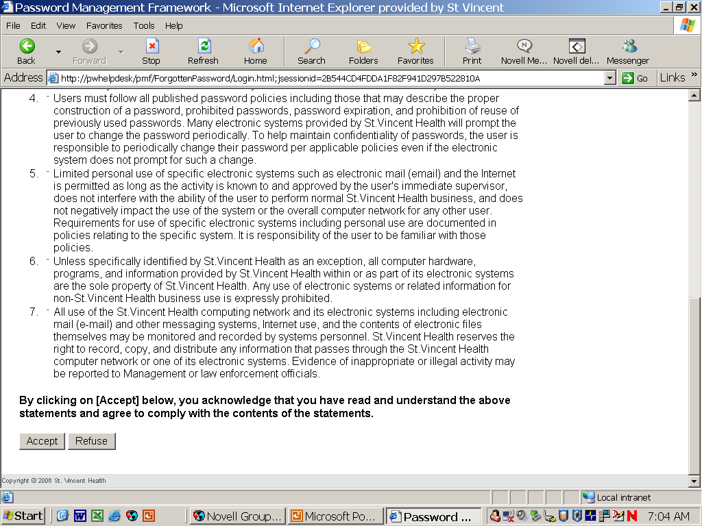
“Accept” Policy

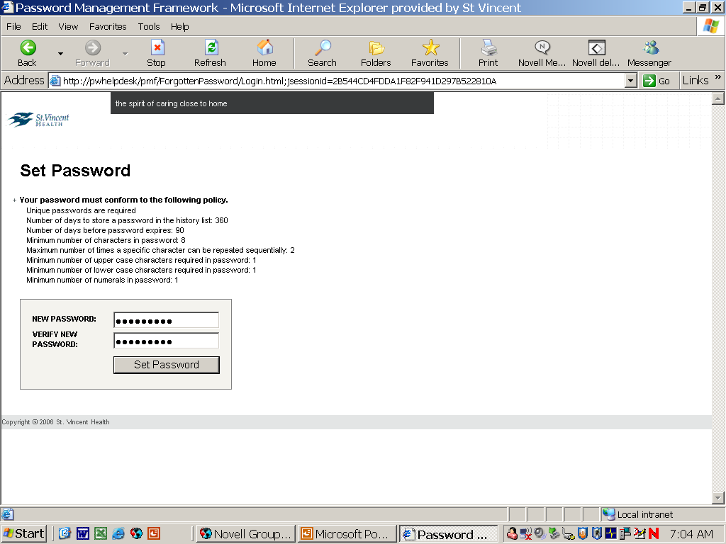
Password Policy
Enter Password & Click “Set Password”

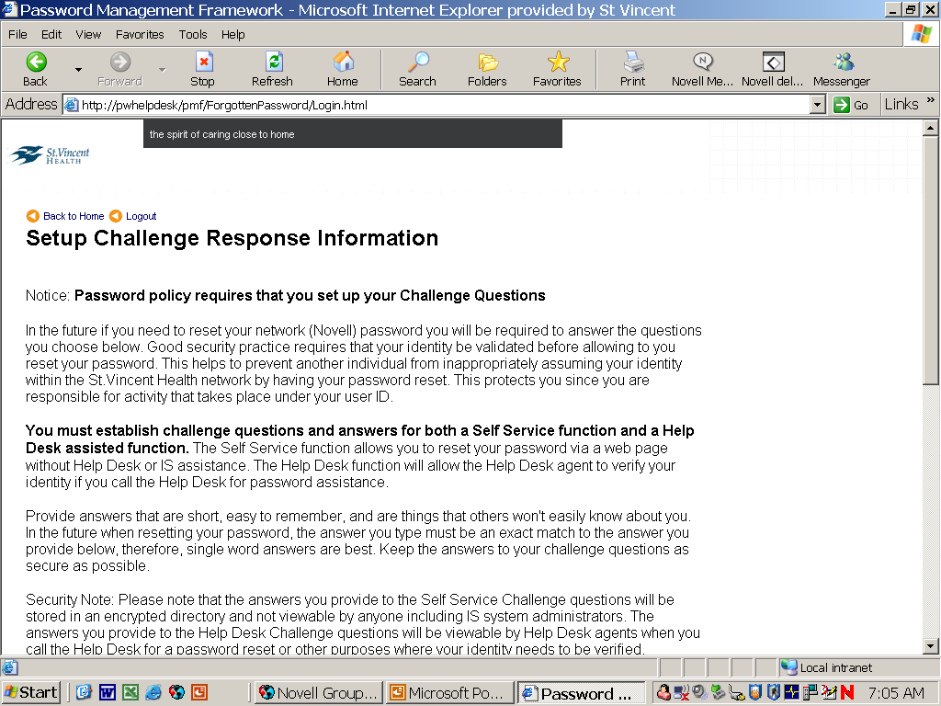

- Accept the Acceptable Use Policy. (Note: If Refuse policy is selected, the process will loop back to the beginning.)

- Enter Password and click Set Password.
(Note: the Password Policy that governs what a password must contain is shown above.)

- Read about setting challenge response questions.

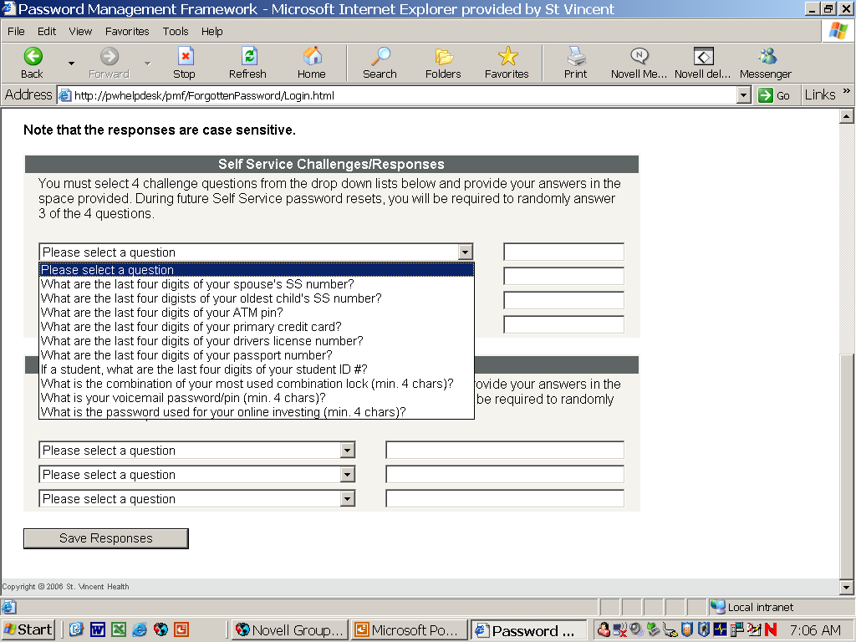
Self-Service Challenge Questions.

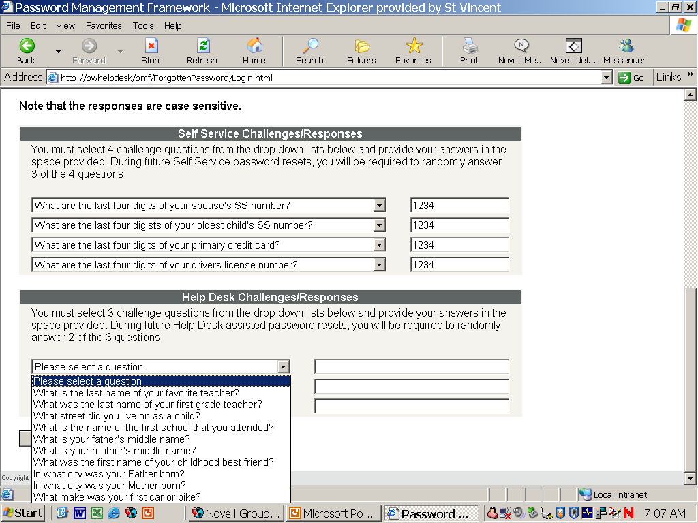
Help Desk Challenge Questions

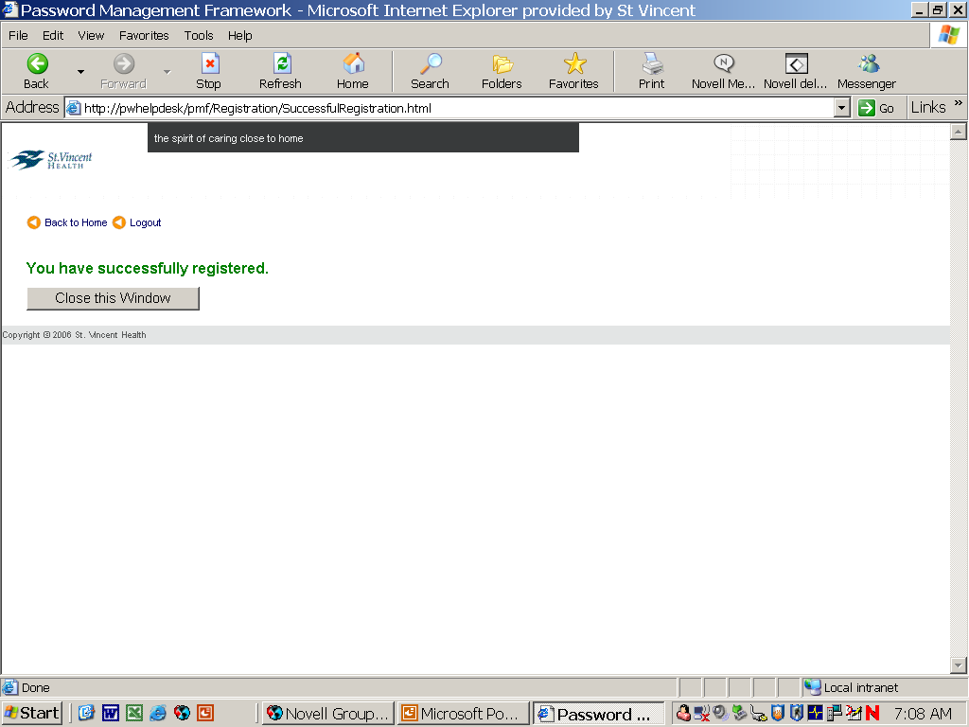

- Self-Service Challenge Questions Select four different questions from the drop down list and enter the answers in the space at the right of each question. (Note: The answers to these questions are maintained in an encrypted database that not even an Information Services Administrator can view.)

- Help Desk Challenge Questions
Select three (3) different questions from the drop down list and enter the answers in the space at the right of each question. (Note: The answers to these questions are only viewable by Help Desk individuals.) Click Save Responses. User is successfully registered.

- Logout then shut down computer.

- Restart computer and login to synchronize your password.
Accessing Your Web-Based Orientation
Non-associates are required to complete the online Non-Associate Orientation WBT on the St.Vincent Intranet.

We hope after completing this web-based training, you will be better acquainted with St.Vincent.

First, let’s go through the process of accessing the WBT internally from within St.Vincent via St.Vincent-owned computers.

We will then explain how to access the WBT from computers outside St.Vincent.

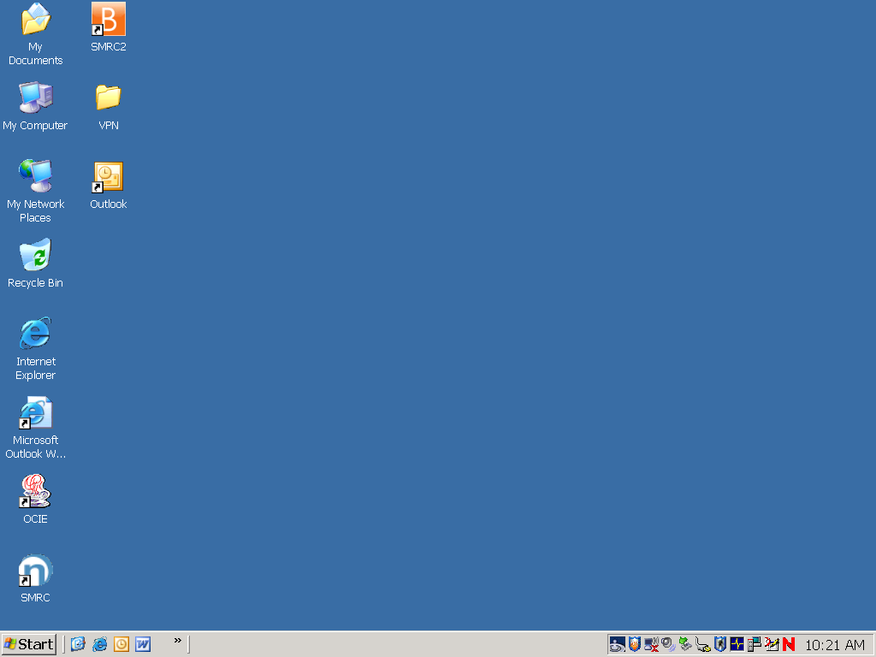

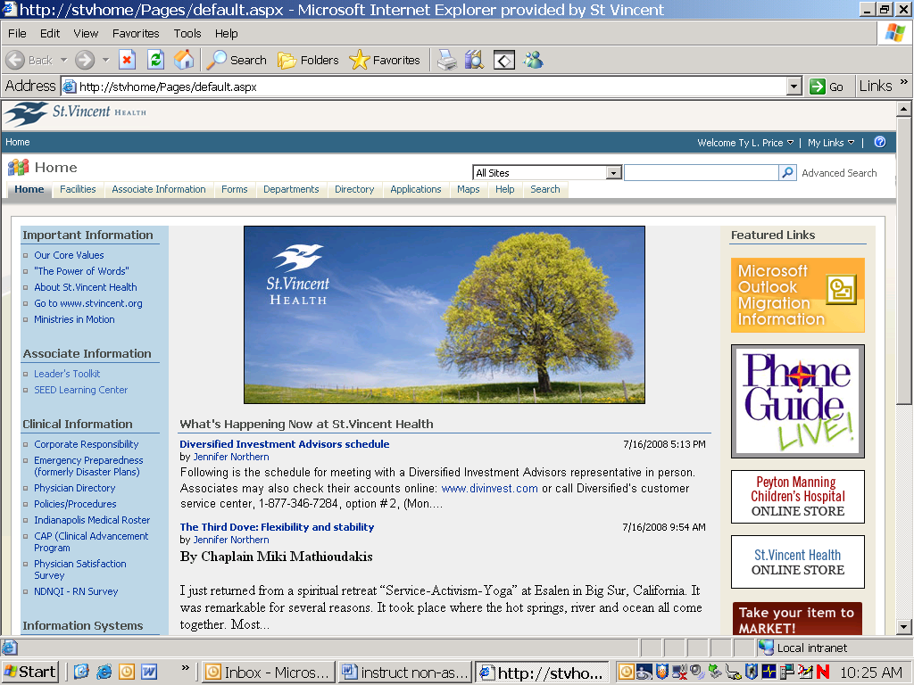

- Opening the web browser
Double click the Internet Explorer icon.

- Opening SEED
Click on the SEED Learning Center link.

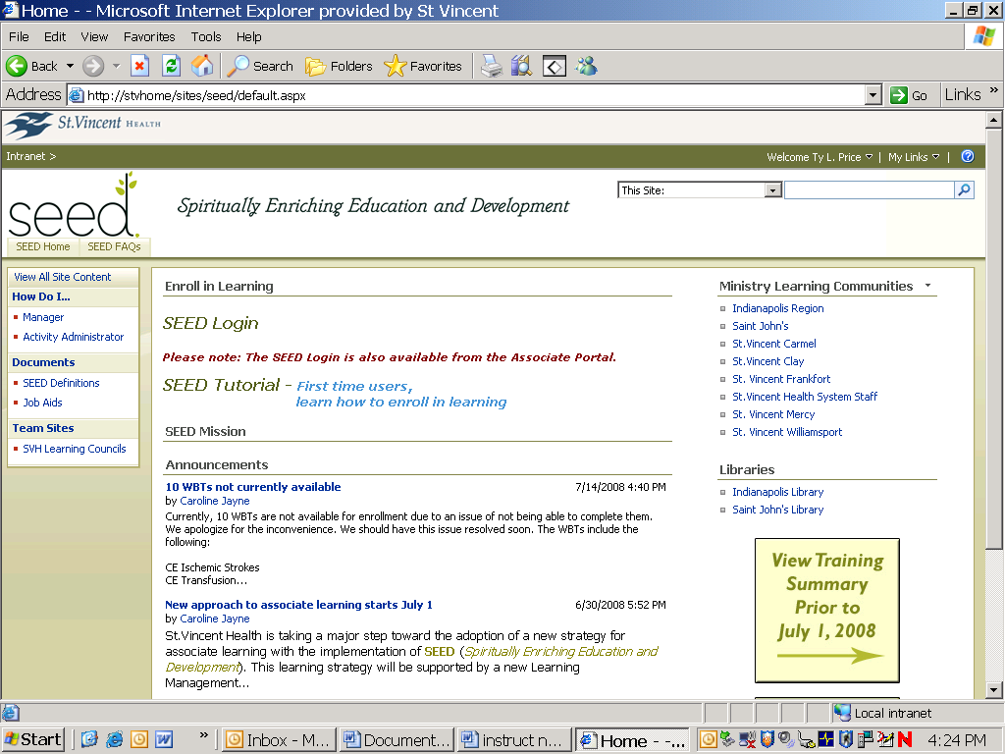

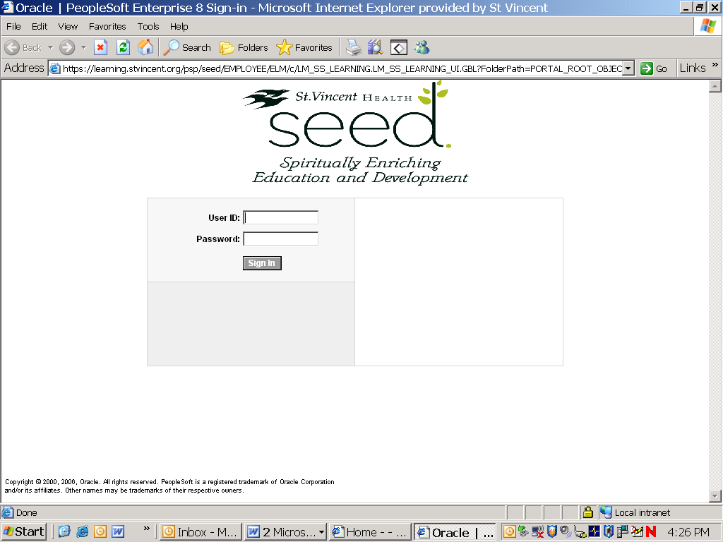

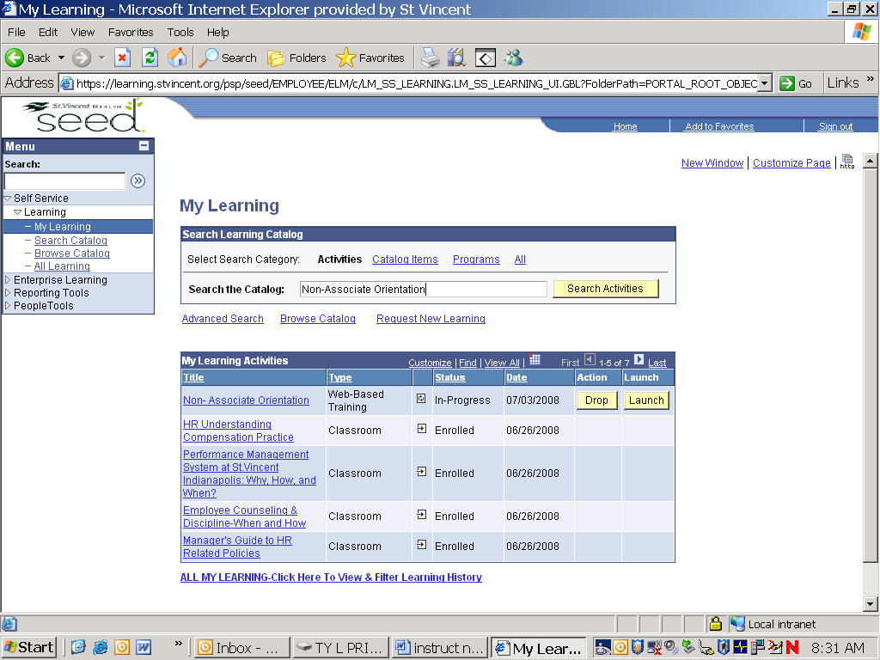

- Opening the SEED Login page
Click on the SEED Login link.

- Opening your My Learning page
Enter your network User ID and Password.
Click the Sign In button to continue.

If you have a problem and need help, please call the HR Service Center during regular business hours at 317-338-8640 or the IS HelpDesk at 317-338-8345.

- Opening the Search Catalog page
In the Search the Catalog textbox, type Non-Associate Orientation.
Click the Search Activities button on the right to view the activity.

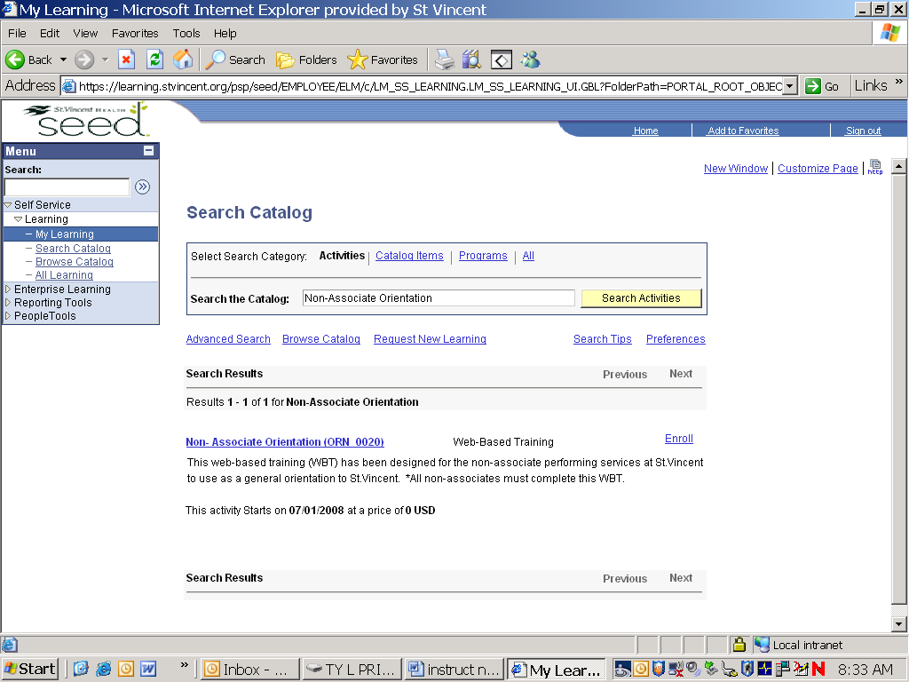

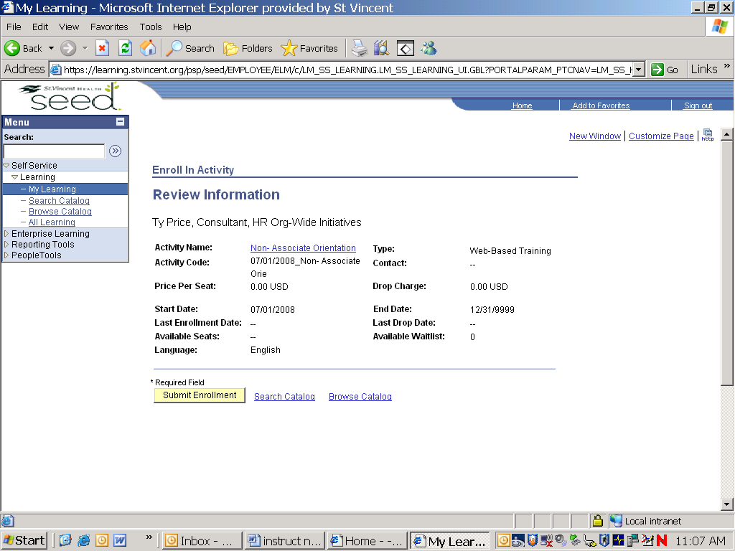

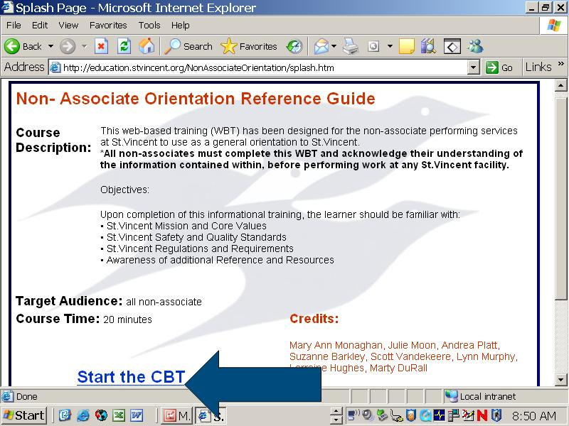

- Opening the Enroll in Activity page
Click the Enroll link.

- Opening the Web-Based Orientation
Click the Submit Enrollment button.

- Opening the Orientation WBT
Click the Start the WBT link to begin.

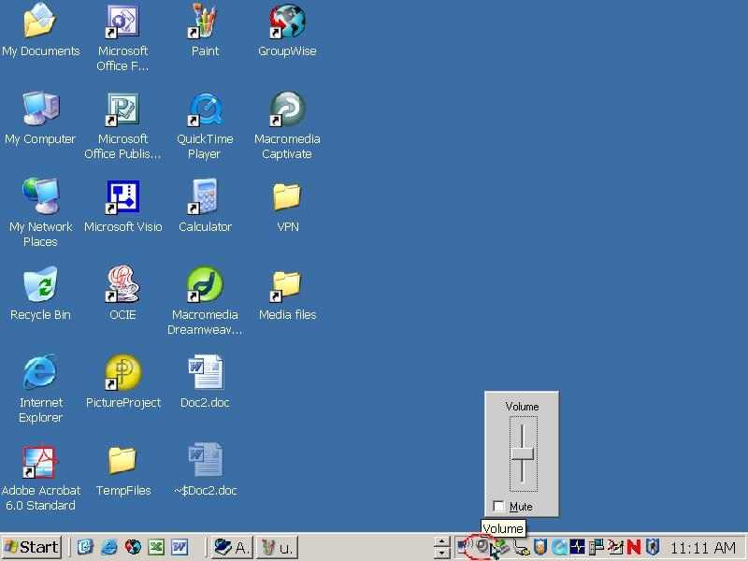

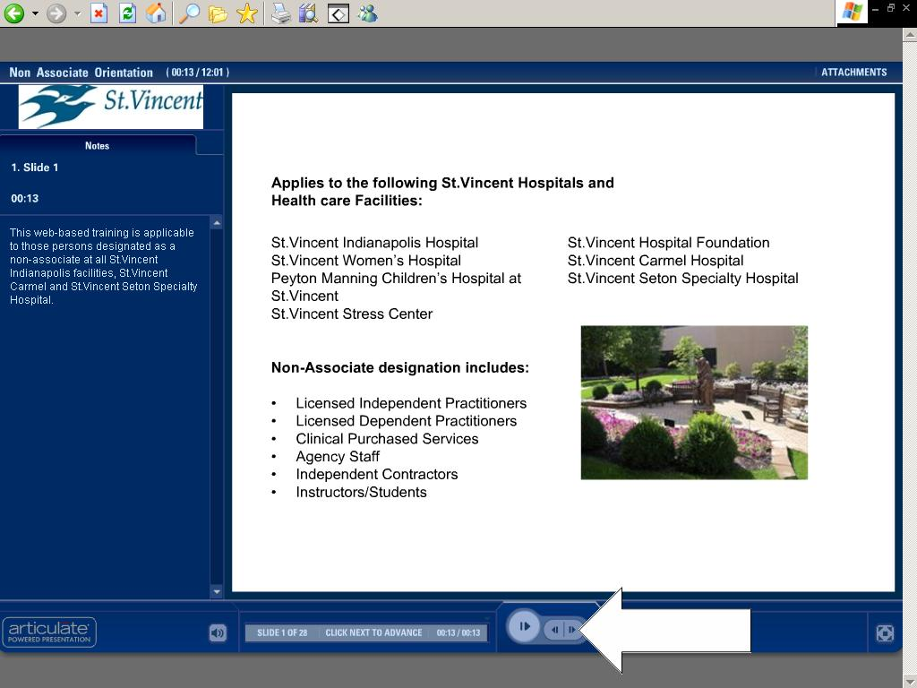

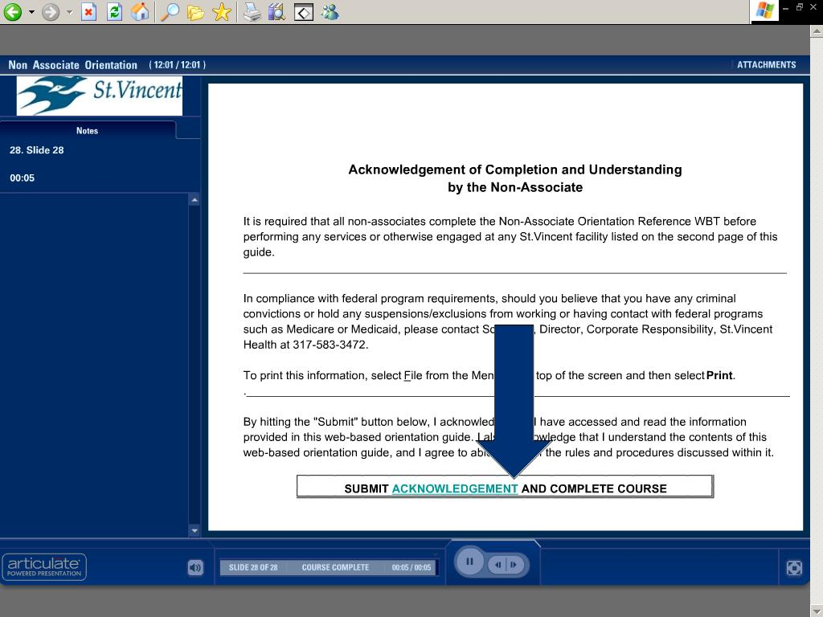

- Selecting Sound or No Sound
This is an interactive WBT that has audio narration included. If you do not hear any sound, make sure to check your sound settings to ensure that Mute is not selected. If you prefer to read only without sound, simply select the Mute check box.

- Completing the Orientation WBT
To advance to each slide through the WBT to the end, you will need to manually click the forward navigation button.

11. Once you get to the last slide, click the Submit Acknowledgement button to complete the Orientation WBT.

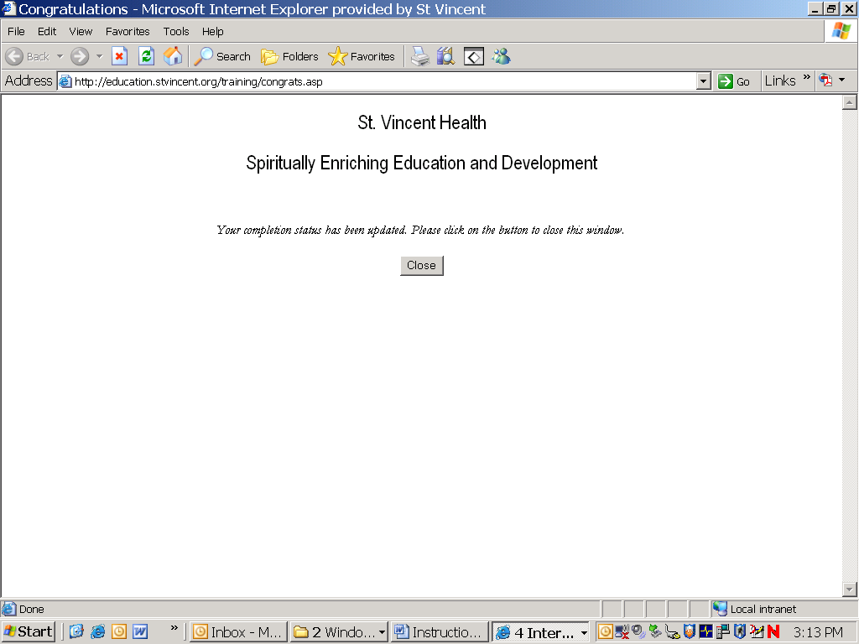

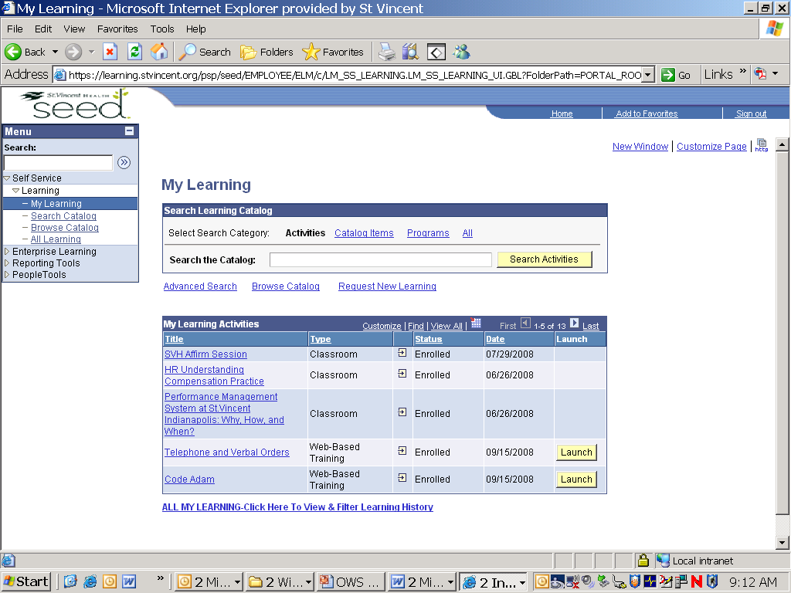

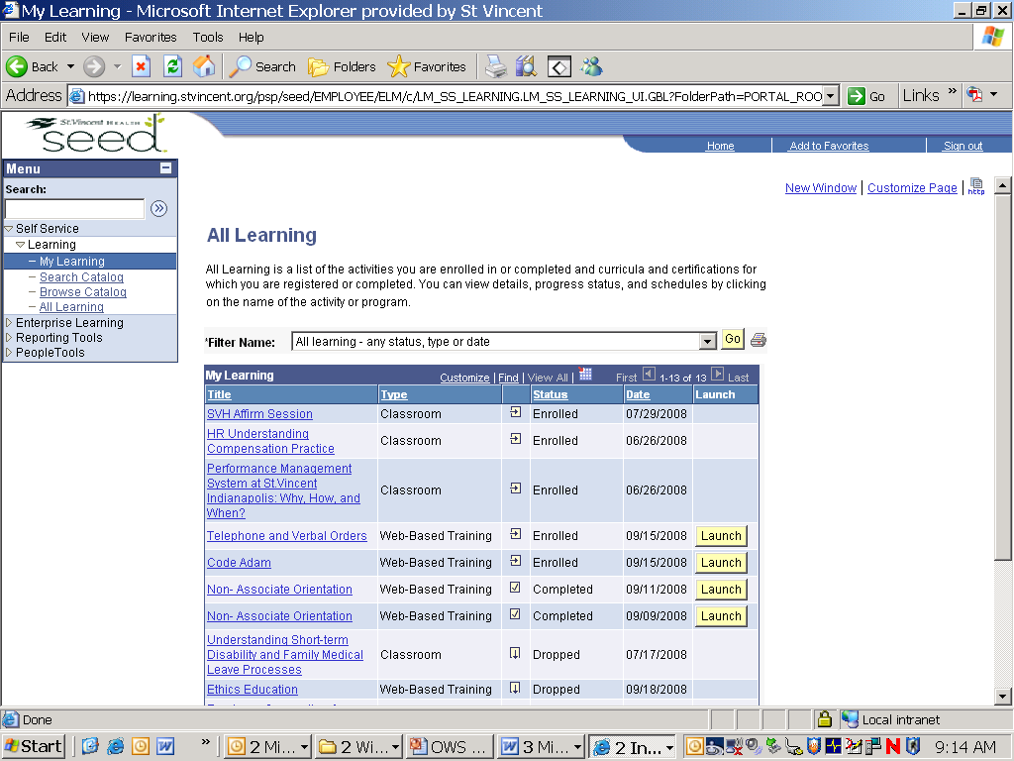

WBT completion will be tracked automatically in SEED. Once you see this page of completion, you are finished with the WBT. Congratulations!

However, don’t stop here. Continue as directed below.

- Printing a List of Completion (if required)
Click on the All My Learning link.

- Click on the printer icon. Printing will not begin when you click this icon. Clicking the icon only takes you to the next screen.

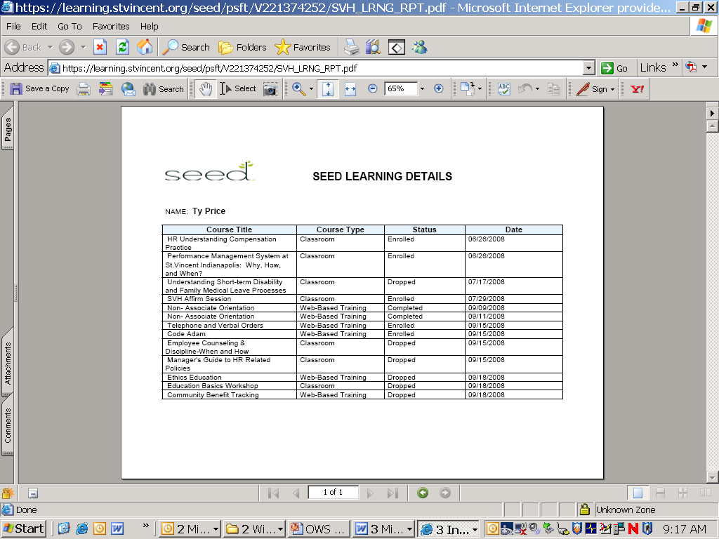
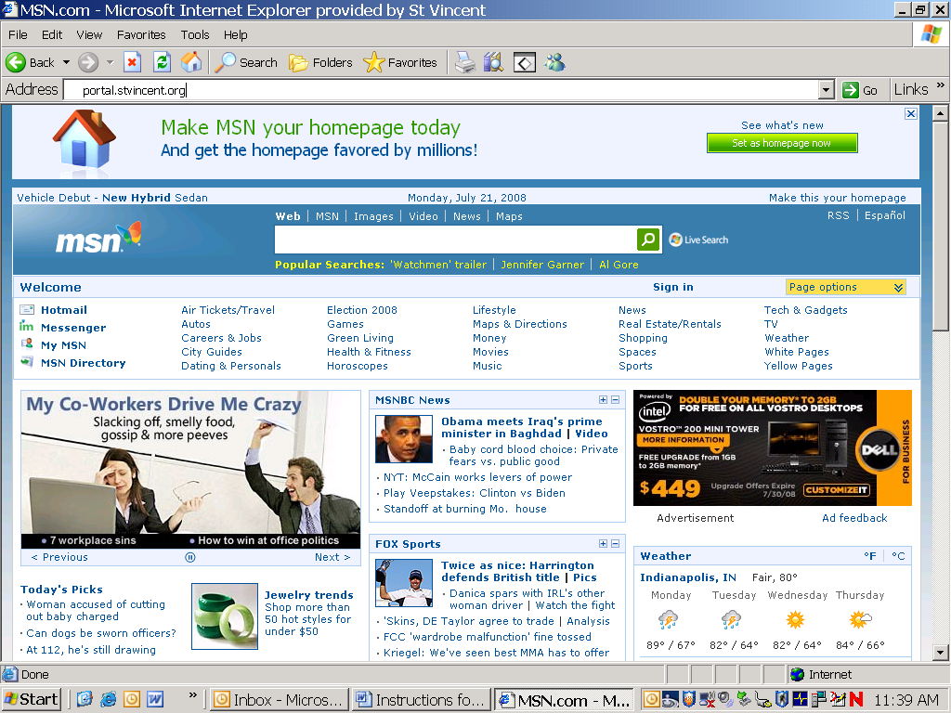
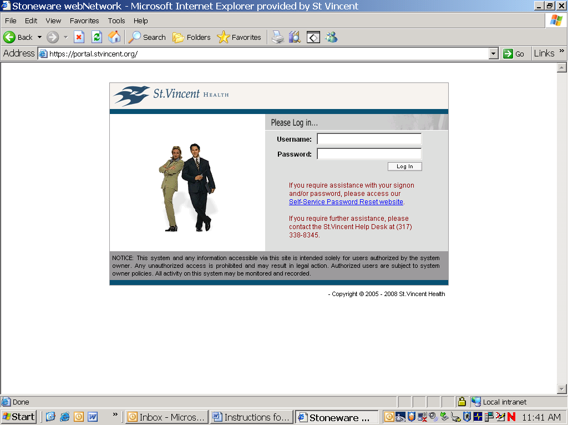

- Click on the printer icon again. Give printed copy to your Instructor who will submit to Education & Development.
Please note that this is the only acceptable page to meet the requirement for documentation of completion of the WBT.

Accessing the WBT from Home or Anywhere
- To access the Non-Associate Orientation WBT from home, open your personal web browser
In the Address text box type this Internet address: http://portal.stvincent.org/
Then click on the Go button or press Enter.

- Log In as normal using your network User ID and Password.

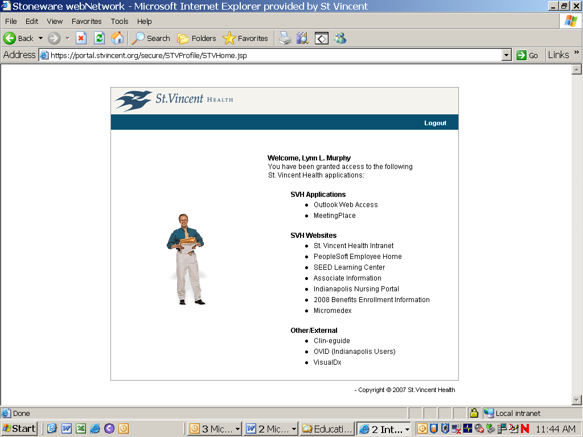

- Access SEED
Click on the SEED Learning Center link and follow the directions listed in directions printed above (page 36).

Again, if you have a problem and need help, please call the HR Service Center during regular business hours (317-338-8640) or the HelpDesk (317-338-8345).

