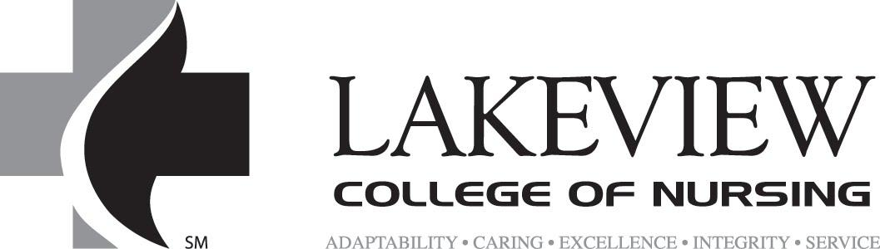

903 North Logan Avenue ∙ Danville, IL 61832 ∙ 217-709-0929∙ Fax 217-442-2279

Lakeview Seniors Volunteer within Community

FOR IMMEDIATE RELEASE

October 13, 2019

Contacts:
Kory Kowalski Melissa McDaniel, Executive Director
217-663-5098 217-348-7066
kkowalski@lakeviewcol.edu colescountyhabitat@consolidated.net

A group of students from Lakeview College of Nursing will participate in volunteering at Coles County Habitat for Humanity Restore in Charleston, Illinois during the fall semester 2019.

Students: Jason Tegeler, Laura Pfeiffer, Kory Kowalski, Morgan Kelley, Rachel West, and Kelsey Reardon chose to volunteer at the local Habitat for Humanity Restore location for their senior legacy project.

Students felt passionate about this location due to the mission of providing homes for those in need within the Coles County area. “We wanted to provide service locally to positively impact the area our school and hospitals are located in. In doing this, we were able to help this organization sell items to raise money to fund the building of homes for local families in need,” states senior, Kory Kowalski. Students volunteered on multiple occasions within the Charleston Restore location throughout the fall semester.

Lakeview College of Nursing has provided excellence in nursing education since 1894. Lakeview currently offers a Bachelor of Science in nursing program in Danville as well as Charleston, Illinois.

For more information about this event please contact Lakeview College of Nursing at 217-345-3575.
