N432 Focus Sheet #2 2020
Ricci, Kyle, & Carman Ch 13, 14, 21; ATI Ch 11, 12, 13, 14, 15,16 and online Fetal Monitoring program

- Fill in the following table with associated s/s of each
 | TRUE LABOR | FALSE LABOR
Uterine Contractions  (Braxton Hicks) | Regular, close together, and usually lasting for 30 -60 seconds and 4-6 minutes apart. | Irregular, not occurring close together
Cervical Dilation & Effacement | Cervix becomes effaced and dilates progressively | The cervix is usually uneffaced and closed
Bloody show | Ruptured cervical capillaries release a small amount of blood that mixes with mucus plug that is expelled due to the cervical softening. | No bloody show
Fetus: Engagement | There is no significant change in fetal movement | Fetal movement may intensify for a short period or it may remain the same.

- How does lightening relate to labor?
  - It is a premonitory sign of labor

- Describe the Bishop score and the indications for doing it.
  - Scores maternal readiness
  - 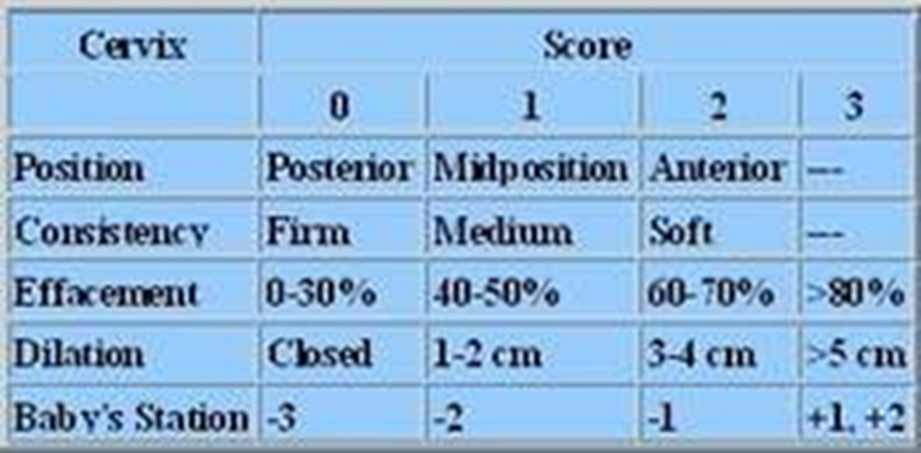

- What are Leopold’s maneuvers (make sure to understand all 4 maneuvers) and what 4 questions does each maneuver answer?
  - #1identify fetal part Presentation
  - #2: locate & palpate fetal back-validates presenting part
  - #3: what part is presenting over true pelvis descent into pelvis
  - #4: outline fetal head to palpate cephalic prominence- fetal attitude
    - # of fetuses
    - Presenting part, lie, and attitude
    - Location of fetal back to assess for heart tones
    - Degree of descent

- List the “preprocedures” done on admission to labor and delivery.
  - Assessing FHR
  - Cervical dilation/effacement
  - Determining whether membranes have ruptured or are intact
  - Maternal health history and cultural assessment
  - Physical examination
  - Labs

- State the 5 “P’s” of the labor progress and what each P is composed of.

  - Passageway (Birth canal)
  - Passenger (Fetus & placenta)
  - Powers (contractions)
  - Position (Maternal)
  - Psychological response

- Define fetal lie and fetal attitude.
  - Fetus aptitudes is the position of the fetus if their joints are flexed or extended
  - Fetus lie spine to spine position of baby and mother

- What role do the fetal skull suture lines and fontanelles play in identifying fetal position?
  - Palpation of the sutures and fontanelles reveals the position of the fetal head and the degree of rotation that has occurred

- Define the various fetal presentations (RKC p 462-464 & ATI p 74).
  - 

- What do each of the 3 letters associated with fetal positioning stand for?
  - The first letter defines whether the presenting part is tilted toward the left (L) or right (R) side of the maternal pelvis
  - The second letter represent the particular presenting part of the fetus
    - O is for occiput
    - S for sacrum
    - M for mentum
    - A for acromion process
    - D for dorsal
  - The third letter defines the location of the presenting part in relation to the anterior (A) portion of the maternal pelvis or the posterior (P) portion. If the presenting part is directed to the side, the fetal presentation is designated as transverse (T)

- Fetal station is assessed in relation to what?
  - Relationship of the presenting part to the level of the maternal pelvic ischial spines

- Outline the rationale for and the pros and cons of external cephalic version.
  - Rotation of fetus for patients who have breech or transvers presentation after 36 weeks
  - Cons: placental abruption, umbilical cord compression, and emergent c/s
  - Works in 50% of cases

- Describe methods of cervical ripening and the indications for their use?
  - Complementary and alternative methods
    - Herbal or oils
    - Sexual intercourse
    - Breast stimulation
  - Mechanical
    - Hygroscopic and osmotic dilators
    - Foley catheter
  - Surgical
    - Amnihook
    - Finger insertion and to detach membranes
  - Pharmacological
    - Prostagladnis

- Use this chart to summarize the Stages & phases of labor. Write it so that it makes sense to you.
Stage of Labor | What is happening during this Stage/Phase? | Expected effacement & dilation of cervix | Expected Frequency of Contractions | Expected duration of contractions | Anticipated Nursing assessments & interventions
First Stage  1. Latent  2. Active  3. Transition | Cervical dilation from 0-10 cm | 1. 0-3 cm dilation, 0-40% effacement  2. 4-7 cm dilation, 40-80% effacement  3. 8-10 cm dilation, 80-100% effacement | 1. every 5-10 min  2. every 2-5 minutes  3. Every 1-2 min | 1. 30-45 sec  2.45- 60 sec  3. 60-90 sec | 1. Pain management  Leopold maneuver  Vaginal exams  FHR  Bladder palpation  medication
Second Stage | From complete dilation to birth of the newborn, may last 3 hours | 10 cm dilation and 100% effacement | Contractions occur every 2-3 min | last for 60-90 sec | Encourage bearing down  If received an epidural, monitor for fall  Allow for individual to perform own pushing behaviors  Vitals  FHR
Third Stage | Separation and delivery of the placenta; usually takes 5-10 minutes | n/a | 2-30 minutes | Until expulsion of placenta | Monitor blood loss  Vitals  Apgars  Clinical Findings of placenta seperation
Fourth Stage | 1-4 hours after birth, time of maternal physiologic adjustment | n/a | n/a | n/a | Assess fundus, should be firm and contracted  Monitor for hemorrhage, bladder distention and venous thrombosis  Vital signs  Pain management  Urine output

- How can we confirm rupture of membranes?
  - A sample of fluid is taken from the vagina via a Nitrazine yellow dye swab to determine the fluid’s pH. A blue strip = memrbanes have rupture

What is our priority nursing intervention after confirmation of rupture of membranes?
A priority is assessing the fetal heart rate to identify a deceleration.

What information do we want to gather from the mother about rupture of membranes if we did not witness it?
If engagement has not occurred since the release of fluid

- Describe when an induction might be warranted and the difference between induction and augmentation
  - Is used to accelerate the progress
  - Augmentation is stimulation of contractions once labor has started
  - Induction is the initiation of UC to stimulate labor before spontaneous onset

- Describe what an amniotomy is, the indications for it to be done, and the considerations.
  - Artificial rupture of the membranes using an amnihook
  - Induce postterm labor
  - There is a risk for cord prolapse and infection

- Medications: What is each medication used for? What does it do? Nursing indications/interventions?
Oxytocin | Acts on uterine myofibrils to contract and initiate labor  Assess baseline vital signs and FHR  Maintain I&O  Monitor for adverse effects like hyperstimulation of uterus, impaired uterine blood flow, rapid labor leading, water intoxication
Misoprostol | Ripens cervix to induce labor  Ensure informed consent  Monitor for possible adverse effects like nausea and vomiting, diarrhea, uterine hyperstimulation, and category 2 FHR patterns
Penicillin G | Narrow spectrum antibiotic to reduce the risk of newborn GBS infection.  Close monitoring of sever allergic reactions
Methylergonovine | Stimulates the uterus to prevent and treat postpartum hemorrhage due to atony or subinvolution.  Assess baseline bleeding, uterine tone and vital signs  Report complaints of chest pain quickly and monitor for adverse effects
Betamethasone | Promotes fetal lung maturity by stimulating surfactant production; prevents/reduces risk of respiratory distress syndrome and intraventricular hemorrhage in the preterm neonate less than 34 week gestation  Monitor for maternal infection or pulmonary edema  Assess maternal lung sounds and for signs of infection
Terbutaline Sulfate | Used to delay preterm labor, slow contractions of the uterus  Monitor for serious risks for caregiver and baby
Methotrexate | Management of unruptured tubal pregnancy  Monitor for adverse effects  Educate risks, benefits, adverse effects, and possible failure which would resul in tubal rupture
Indomethacin | Inhibits prostaglandins, which stimulate contractions; inhibits uterine activity to arrest preterm labor  Assess vital signs, uterine activity and FHR  Don’t give with hx of peptic ulcer disease  Monitor for adverse effects maternal and fetal
Magnesium Sulfate | Relaxes uterine muscles to stop irritability ad contractions to arrest uterine contracts for preterm labor  Asses vital signs and DTR; report for hypotension of decreased DTR  Perform continuous electronic fetal monitoring  Monitor for side effects  Have calcium gluconate readily available at the bedside to reverse magnesium toxicity
Nalbuphine hydrochloride (Nubain) | Used for extreme pain  Monitor for serious adverse effects like respiratory depression
Calcium Gluconate | Used for mild preclampsia and if magnesium levels become toxic  Montior for sumptoms of hypoxemia, impending seizure activity or increased intracranial pressure
Naloxone (Narcan) | Antagonizes action of narcotic agents  Monitor respiratory

- List procedures done during labor (“intra partum”).
  - Fetal heart monitoring
  - Vacuum assisted deliveries
  - Use of forceps
  - C/section

- Define each of the 6 cardinal movements of labor (Mechanisms of labor).
  - 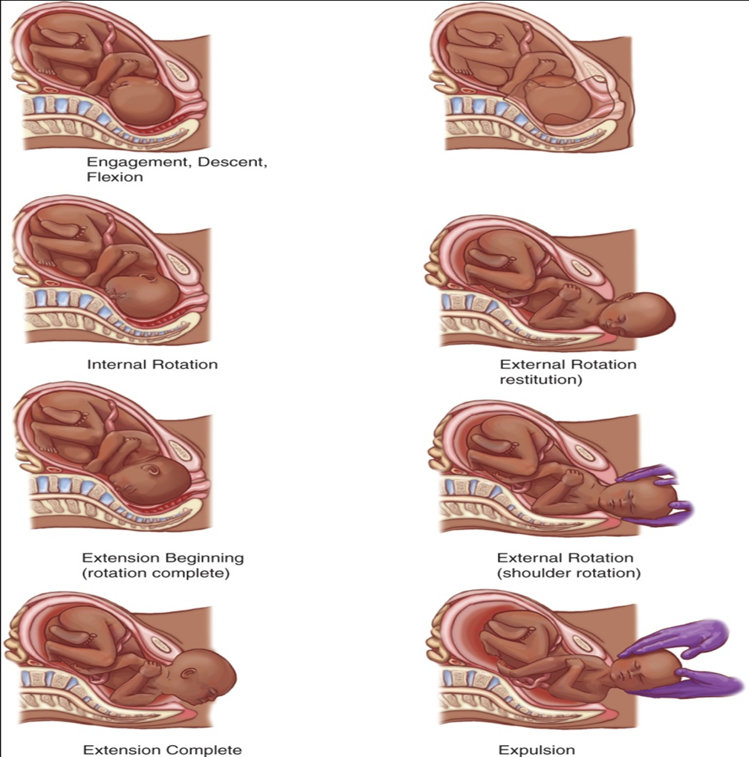

- Describe the benefits for a woman to change position while in labor. Include what suggestions the nurse can give the laboring woman about position changes?
  - Helps with pain management
  - Gravity helps bring the baby down
  - Movement moves the bones of the pevis helping the baby find the best fit

- What are the 4 techniques used to assess ongoing data during labor and birth?
  - Vital signs
  - Vaginal examination
  - Electrical monitoring of contractions
  - Leopolds maneuvers

- What is a vaginal exam (SVE-sterile vaginal exam)? How often should it be done according to WHO (World Health Organization)?
  - Who recommens digital vaginal examination at intervals of 4 hours for routine assessment and inde

- Why is important to assess frequency, duration and intensity of contractions?
  - Coordination of all three promotes birth of the fetus and expulsion of the fetal membranes and placenta from the uterus
- What 2 ways can you assess uterine contractions?
  - Palpitation
  - Electrical monitoring

- To palpate uterine contraction intensity, a mild contraction feels like your Nose, a moderate contraction feels like your Chin, and strong contraction feels like your Forehead.

- List the sources of pain during labor.
  - Fetal Decent and explusion
  - Contractions
  - Dilation, effacement, stretching

- List how pain assessment is done during labor.
  - Verbal
  - Questionnaire
  - Numerical

- What should the nurse consider prior to administration of opiod pain medication during labor?
  - They are associated with newborn respiratory depression, decreased alertness, inhibited sucking, and a delay in effective feeding

- Describe the gate-control theory of pain control. Give examples.
  - Gate control theory of pain is when local physical stimulation can interfere with pain stimuli by closing a hypothetical gate in the spinal cord, thus blocking pain signals from reaching the brain.
    - Examples are hydrotherapy, ambulation and position change, acupuncture and acupressure, heat and cold compression, guided imagery, massage, and breathing techniques.

- List 3 non pharmacologic pain intervention methods.
  - guided imagery, massage, and breathing techniques.

- Describe how epidural analgesia is administered, what are the implications, and what is the difference between this and a spinal epidural?
  - Lidocaine and morphine injected into the lumbar epidural space for pain relief
  - Spinal epidural is injected directly into the spinal fluid while an epidural is into the epidural space

- What added considerations are there for the nurse caring for a woman who has undergone general anesthesia?
  - There is a rapid loss of consciousness,
    - client must be NPO,
    - change client position to prevent vena cava compression

COMPLETE Q34 & Q35 after you review R,K,C p 492-498 and ATI p86-89 for understanding of fetal monitoring and you complete the Online Fetal monitoring program

- Where in the contraction do the increment, acme and decrement happen?
  - Increment is the beginning and buildup of the contraction
  - Acme is the peak of the contraction
  - Decrement is the descent or relaxation of the uterus

- Briefly describe what Category I, Category II and Category III fetal heart rate tracings look like.
  - Category I
    - Predictive of normal fetal acid-base status and do not require intervention
    - Baseline rate 110-160 bpm
  - Category II
    - Not predictive of abnormal fetal acid-base status, but require evaluation and continued surveillance
    - Tachy or bradycardia present, no baseline variability, and prolonged deceleration >2 min but <10 bpm
  - Category III
    - Predictive of abnormal fetus acid-base status and require intervention
    - Bradycardia, recurrent late and variable decelration

- Why is support vital for laboring women? What is a doula? What is a CNM?
  - They offer a safe and satisfyinging birth and healthy coping
  - A doula is a woman servant or caregiver, but modernly they offer support before, during, and after childbirth
  - Certified nurse midwife

- What is “crowning”?
  - “Ring of fire”, baby’s head becomes visible in the birth canal after you’ve fully dilated. “the home stretch”

- List a summary of assessments during second , third and fourth stages of labor.
  - Second
    - Vitals
    - Uterine contraction
    - Fetal Heart Rate
  - Third
    - Vitals
    - Apgars
    - Placenta seperation
  - Fourth
    - Maternal VS
    - Fundus & Iochia
    - Urinary output
    - Baby-friendly activities

- What are the signs of placental separation and how long can it take for the placenta to be expelled?
  - Placental separation
    - The uterus rises upward
    - Umbilical cord lengthens
    - Suddent trickle of blood is released from the vaginal opening
    - Uterus changes its shape to globular
  - Can take about 2 -30 minutes to expell

- What is the difference between a laceration and an episiotomy?
  - Laceration is form on its own during vaginal birth
  - Episiotomy is an incision made into the perineum that largens the vaginal opening

- What are the normal blood loss amounts for a vaginal and a cesarean delivery?
  - Vaginal
    - 500 mL
  - Cesarean
    - 1000 mL

- List “post procedures” done during the fourth stage of labor.
  - Monitoring mother closely to prevent hemorrhage, bladder distention, and venous thrombosis
  - Vital signs
  - Amount and consistency of vaginal discharge
  - Uterine fundus

- What are important interventions for the newborn at birth? Why is skin to skin time with mom so important?
  - Facilitates positive effects on brain and attachment
  - Stronger uterine contraction
  - Thermoregulation

- What important assessments as the nurse are you continuing to make, in relation to mom, during the third stage of labor?
  - Monitoring placental separation and its membranes
  - Assessing for any perineal trauma or laceration

