http://www.tracheostomy.com/care/suction.htm
Suctioning a Tracheostomy
The upper airway warms, cleans and moistens the air we breath. The trach tube bypasses these mechanisms, so that the air via the tube is cooler, dryer and not as clean. In response to these changes, the body produces more mucus. The trach tube is suctioned to remove mucus from the tube and trachea to allow for easier breathing. Generally, the child should be suctioned every 4 to 6 hours and as needed. There may be large amounts of mucus with a new tracheostomy. This is a normal reaction to an irritant (the tube) in the airway. The heavy secretions should decrease in a few weeks. While a child is in the hospital, suctioning is done using sterile technique, however a clean technique is usually sufficient for most children at home. If your child has frequent respiratory infections, trach care and suctioning techniques may need to be addressed. Frequency of suctioning will vary from child to child and will increase with respiratory tract infections. Try to avoid suctioning too frequently. The more you suction, the more secretions can be produced.
Care Techniques
- Sterile Technique: sterile catheters and sterile gloves
- Modified Sterile Technique: sterile catheters and clean gloves
- Clean Technique: clean catheter and clean hands
The size of the suction catheter depends on the size of the tracheostomy tube. Size 6, 8 or 10 French are typical sizes for neonatal and pediatric trach tubes. The larger the number, the larger the diameter of the suction catheter. Use a catheter with an outer diameter that is about half the inner diameter of the artificial airway this will allow air to enter around it during suctioning. You can also compute the catheter size with this formula: Multiply the artificial airways diameter in millimeters by two. For example, 8 mm X 2 = 16, so a 16 French catheter. Also seeTracheostomy Sizing Chart for recommended catheter sizes for specific Bivona and Shiley pediatric tracheostomy tubes.
Older children may be taught to suction themselves.
Suction Depths
- Shallow Suctioning: Suction secretions at the opening of the trach tube that the child has coughed up.
- Pre-measured Suctioning: Suction the length of the trach tube. Suction depth varies depending on the size of the trach tube. The obturator can be used as a measuring guide.
- Deep Suctioning: Insert the catheter until resistance is felt. (Deep suctioning is usually not necessary. Be careful to avoid vigorous suctioning, as this may injure the lining of the airway).
Signs That a Child Needs Suctioning
- Rattling mucus sounds from the trach
- Fast breathing
- Bubbles of mucus in trach opening
- Dry raspy breathing or a whistling noise from trach
- Older children may vocalize or signal a need to be suctioned.
- Signs of respiratory distress under Tracheostomy Complications
Equipment
- Suction machine
- Suction connecting tubing
- Suction catheters
- Normal saline
- Sterile or clean cup
- 3cc saline ampules (“bullets”)
- Ambu bag
- Tissues
- Gloves (optional for home care, use powder-free gloves)
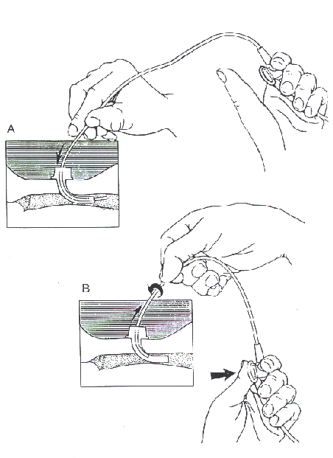
Illustration courtesy of the Department of Otolaryngology, Cincinnati Children's
Hospital Medical Center, Cincinnati, Ohio
Suctioning a Tracheostomy
Procedure
- Explain procedure in a way appropriate for child's age and understanding.
- Wash hands.
- Set up equipment and connect suction catheter to machine tubing.
- Pour normal saline into cup.
- Put on gloves (optional).
- Turn on suction machine (suction machine pressure for small children 50-100mm Hg, for older children/adults 100-120mm Hg)
- Place tip of catheter into saline cup to moisten and test to see that suction is working.
- Instill sterile normal saline with plastic squeeze ampule into the trach tube if needed for thick or dry secretions. Excessive use of saline is not recommended. Use saline only if the mucus is very thick, hard to cough up or difficult to suction. Saline may also be instilled via a syringe or eye dropper, which is less expensive than single dose units. Recommended amount per instillation is approximately 1cc.
- Gently insert catheter into the trach tube without applying suction. (Suction only length of trach tube - premeasured suctioning. Deeper insertion may be needed if the child has an ineffective cough.)
- Put thumb over opening in catheter to create suction and use a circular motion (twirl catheter between thumb and index finger) while withdrawing the catheter so that the mucus is removed well from all areas. Avoid suctioning longer than 10 seconds because of oxygen loss. Note: Some research has shown that by applying suction both going in and then out of the tube takes less time and therefore results there is less hypoxia. Also, there are now holes on all sides of the suction catheters, so twirling is not necessary.
- Draw saline from cup through catheter to clear catheter.
- For trach tubes with cuffs, it may be necessary to deflate the cuff periodically for suctioning to prevent pooling of secretions above trach cuff.
- Let child rest and breathe, then repeat suction if needed until clear (allow at least 30 seconds between suctioning).
- Oxygenate as ordered (extra oxygen may be given before and after suction to prevent hypoxia).
- Some children need extra breaths with an Ambu bag (approximately 3 - 5 breaths). Purposes of bagging: hyperoxygenation, hyperinflation, and hyperventilation of the lungs. However, this is usually not needed for stable children with no additional respiratory problems.

