Telemetry Monitoring Experience

Firelands Regional Medical Center School of Nursing

Nursing Care of Adults III Course

Information: Each student is required to complete 4 hours with the telemetry monitor; report to 4 Progressive Telemetry Monitoring Room on your scheduled day and time. A sign-up schedule is available on the first day of class to work around your clinical schedules. The experience is on Tuesday, Wednesday or Thursday. Scheduled times are 8 am to 12 noon, 12 noon to 4 pm, 4 pm to 8 pm or 8 pm to 12 midnight.

Telemetry Monitoring (4 hours): The focus of this experience is the importance of proper placement of electrodes, management of telemetry monitors, interpretation of ECG strips and prioritizing urgency and treatment options.

Collect 4 rhythm strips during your time and complete the form for each strip addressing measurements, rhythm interpretation, patient history, and rhythm evaluation (see attached form). Following the clinical experience, submit your assignment and signed verification of attendance to F. Brennan by 0800 on the Friday.

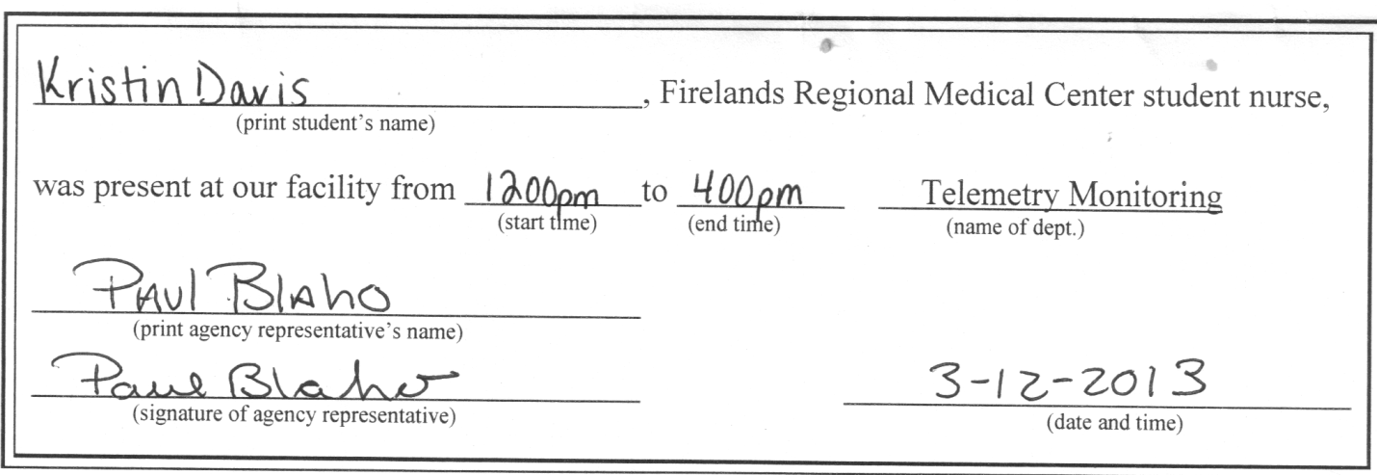

Telemetry Monitoring Experience

Firelands Regional Medical Center School of Nursing

Nursing Care of Adults III Course

Student Name: __Kristin Davis________________ Date: __3/12/13________

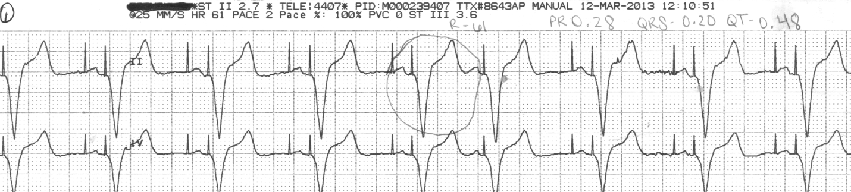

Rhythm Interpretation: Heart Rate: _____61 bpm__________________________

PR Interval ____0.24_________ QRS ______0.20____________ QT ______0.48__________

Rhythm Identification: _______duel paced_________________________________

____________________________________________________________________________

Patient History: Age ___90______ Admitting Diagnosis____subdural hematoma______

Rhythm Evaluation: (State possible contributing factors associated with this rhythm and list medications with dosages that may be used to treat this rhythm).

The pacemaker is placed to correct some type of dysrhythmia. There is not necessarily a need for medications to “treat” this rhythm. Some reasons for insertion of a pacemaker are heart blocks, a-fib with svr, cardiomyopathy, heart failure, SA node dysfunction, and tachydysrhythmias.

Telemetry Monitoring Experience

Firelands Regional Medical Center School of Nursing
Nursing Care of Adults III Course

Student Name: ___Kristin Davis_______ Date: ____3/12/13____

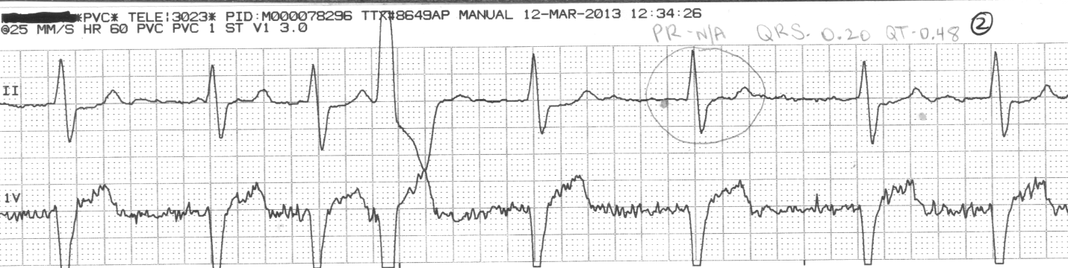

Rhythm Interpretation: Heart Rate: ________60 bpm_______________________

PR Interval _____N/A___________ QRS ____0.20______________ QT _______0.48_____

Rhythm Identification: _______A-fib________________________________________

Patient History: Age __73____ Admitting Diagnosis: __Respiratory distress ______

Rhythm Evaluation: (State possible contributing factors associated with this rhythm and list medications with dosages that may be used to treat this rhythm).
A-fib is the most common dysrhythmia. It often occurs in patients with underlying heart disease, rheumatic heart disease, cardiomyopathy, hypertensive heart disease, HF, and pericarditis. Common drug treatments for rate control include diltiazem (30-120 mg 3-4 times/day), metoprolol (25-100 mg/day), digoxin (0.125-0.5 mg/day), and dronedarone (400 mg twice daily). Drugs for conversion and maintenance include amiodarone (400 mg/day for maintenance) and ibutilide (1 mg IV infusion). Warfarin (2-4 mg/day and then adjusted by INR) or aspirin (50-325 mg/day) may be used long term for prevention of stroke.

Telemetry Monitoring Experience

Firelands Regional Medical Center School of Nursing

Nursing Care of Adults III Course

Student Name: ______Kristin Davis________ Date: ____3/12/13____________

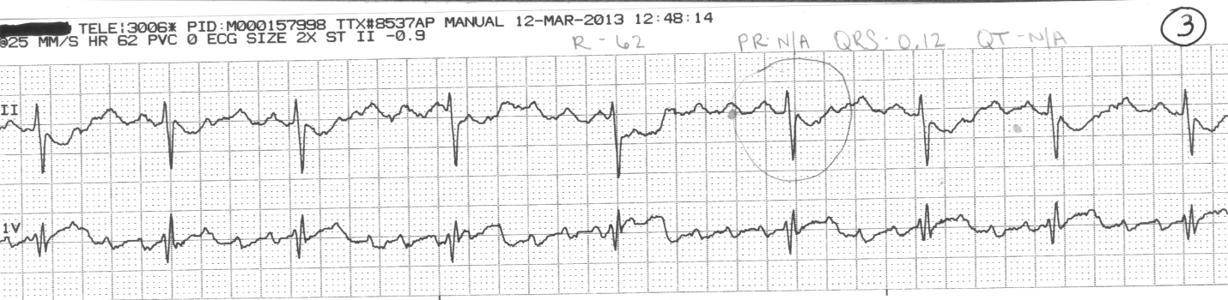

Rhythm Interpretation: Heart Rate: ___62 bpm____________________________

PR Interval _____0.24______________ QRS _____0.12__________ QT___N/A__________

Rhythm Identification:__ atrial flutter____________________________________________

____________________________________________________________________________

Patient History: Age ___84_____
Admitting Diagnosis _right lower lobe pneumonia, new onset atrial flutter_________________

Rhythm Evaluation: (State possible contributing factors associated with this rhythm and list medications with dosages that may be used to treat this rhythm).
Atrial flutter is associated with CAD, HTN, mitral valve disorders, pulmonary embolus, chronic lung disease, cor pulmonale, cardiomyopathy, hyperthyroidism, and drugs like digoxin, quinidine, and epinephrine. Drugs to control ventricular rate include diltiazem and metoprolol; drugs for conversion to or maintenance of sinus rhythm include amiodarone, and ibutilide. Dosages are the same as listed above for a-fib.
Telemetry Monitoring Experience

Firelands Regional Medical Center School of Nursing
Nursing Care of Adults III Course

Student Name: __Kristin Davis_________ Date: ____3/12/13____

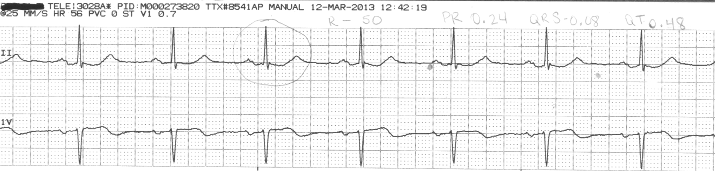

Rhythm Interpretation: Heart Rate: ____56 bpm_____________________

PR Interval _____0.28__________ QRS _____0.08_________ QT ___0.48______

Rhythm Identification: _____Sinus rhythm; 1° AV block______________________________

____________________________________________________________________________

Patient History: Age ____78_____ Admitting Diagnosis ___hypertensive urgency_________

Rhythm Evaluation: (State possible contributing factors associated with this rhythm and list medications with dosages that may be used to treat this rhythm).
This rhythm is associated with MI, CAD, rheumatic fever, hyperthyroidism, vagal stimulation, and drugs like digoxin, beta blockers, calcium channel blockers, and flecainide. There are no medications to treat this type of rhythm. They may evaluate medications the patient currently takes to see if they are contributing to the rhythm. The patient is also carefully monitored, because this rhythm could lead to more severe heart blocks that do require treatment.

