Pulmonary Artery/Central Venous Pressure Measurement

- PAP and CVP are measured with a Swan-Ganz catheter in acute cardiac, pulmonary, and intravascular problems. PA diastolic pressure and PAWP are sensitive indicators of cardiac function and fluid volume status
  - PAD and PAWP are increased in heart failure and fluid volume overload and decreased in fluid volume depletion
  - Fluid therapy based on PAP restores fluid balance without over- or under-correcting the problem
  - Monitoring PAP permits precise manipulation of preload, allowing CO to be maintained without increasing the patients’ risk for pulmonary edema
  - Technical aspects of monitoring affect the accuracy and reliability of the measurements

- The square waveform test verifies the accuracy of the system, and should be done at initial setup, at least once each shift, after opening the system (rezeroing, blood draw, or tubing change) and whenever the waveform appears to be distorted.
  - Potential problems are air bubbles in tubing, excessive tubing length, loose connections, and catheter patency
- Patient Position: should be in the supine position with the HOB elevated between 0°-60°.
- Referencing: positioning the transducer so that the zero reference point is at the level of the atria of the heart. The stopcock nearest the transducer is usually the zero reference for the transducer.
  - Phlebostatic axis is the external reference point on the patient that marks the level of the atria. (4th ICS at ½ the AP diameter of the chest)
  - Once the reference level is found, a mark should be placed on patients’ chest with permanent marker.
  - Place the zero reference stopcock on the transducer level with the phlebostatic axis and mount it on an IV pole (This should be done with a laser or carpenters level)
- Allow patient to stabilize for 5-15 minutes after a position change before taking measurements
- Measurements should be taken at end-expiration, when pleural pressure is minimal. (For vented pt, the point immediately before release of PEEP and initiation of inspiration)
- Pressures should be read from analog tracings or using the stop cursor method. Digital readouts should not be used because they reflect pressures throughout respiration.
- Use a simultaneous ECG tracing to assist with proper waveform identification
- PA catheters can be safely withdrawn and removed by competent registered nurses, as long as it is within the state’s scope of practice for RNs

Actions for Nursing Practice
- Follow the above recommendations
- Ensure the presence of a written policy that includes these standards
- If unit compliance is <90%
  - educate staff about inaccuracies that can occur with improper techniques; incorporate into orientation and annual competency program
  - develop communication strategies to alert/remind staff about these practices
  - create an audit tool for measuring compliance with practice standards

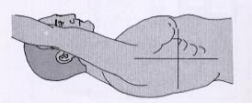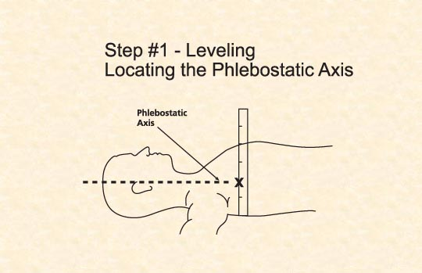
Phlebostatic Axis: 4th ICS at ½ the AP diameter of the chest

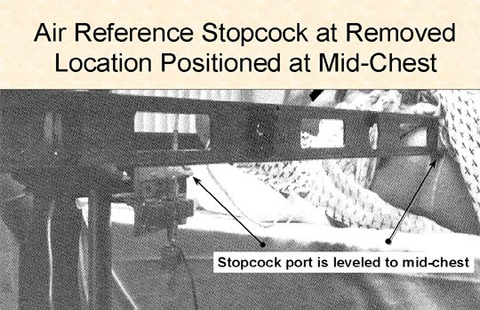

AUDIT OF
PULMONARY ARTERY/CENTRAL VENOUS PRESSURE
MEASUREMENT

Purpose: To evaluate proper reading of PAP/PAOP/CVP measurements
Instructions: Circle yes or no answers. Fill in the blank on question 2.

Date: _____________ Time: ___________ Room number: ________

Bedside Nurse: ___________________________ Auditing Nurse: __________________________

1. Was a square waveform test performed before each shift? Yes No

2. What was the position of the patient during the PAP/PAOP or CVP measurement? ____________

3. Is the phlebostatic axis marked on the patients? Yes No

4. Is there a tracing recorded of the PAP/PAOP/CVP for reading measurements at end-expiration?
Yes No

5. Was a simultaneous ECG tracing done for proper waveform identification? Yes No

