Anatomy, Physiology, and Terms
The Basics of Pregnancy
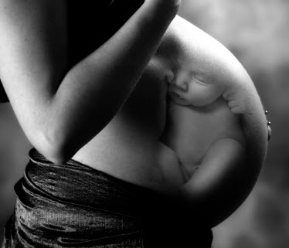
By: Lara Wilken, Demi Fox, Elizabeth Fannin,
& Kurtis Hupp

Uterus (Womb): Uterus is a hollow pear shaped muscle that is connected to both fallopian tubes. About 7-8 days after the mothers egg is fertilized by semen it travels to the uterus and attaches to the uterine wall. It is now that the placenta and fetal organs begin to form. The walls of the uterus are very thick with three layers of muscle tissue. Proceeding labor these muscles will contract simultaneously to produce the pressure needed to begin the labor process. At the base of the uterus is the cervix the path through the baby with pass during labor. The cervix is thick and contains a mucus plug during pregnancy to aide in the protection of the fetus. The uterus is able to grow and stretch with the child and will return to its original size within around 2 weeks and birth.
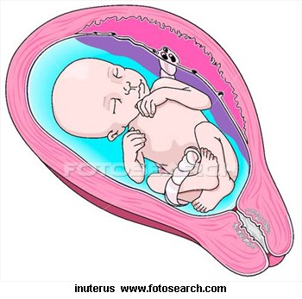

Effacement: Is the thinning out of the cervix during the first stage of labor. As the uterus contracts the area around the cervical canal is pulled back and up in preparation for the babies exit. The cervix will go from 1-2 cm thick to paper thin at the time of expulsion. This is measured in percentages. 0 means the cervix has not yet begun to thin. 100% means that it has now completely thinned out in preparation of the delivery. This is estimated by the nurses of doctor with an internal exam.
Dilation: Is the opening of the cervix. This is measured from 0(which means no dilation) to 10(which means full dilation). This will also be measured by attending nurses and/or doctors. Once a female has 100% effaced and is 10cm dilated the fetus now has the green light to begin the his/her journey.
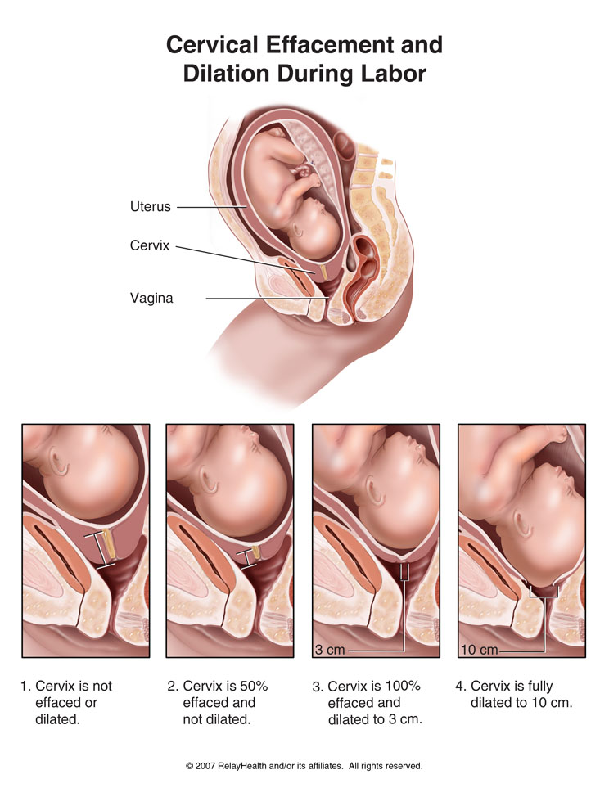
Placenta: The placenta is formed from the fertilized egg along with the organs of the fetus. It a selective barrier around the fetus which allows the growing fetus if receive oxygen and nutrients and excrete any waste products back to the mother (so yes our children start giving us back their junk before they are even born). The placenta does not allow for blood mixing between mother and child but since it does allow for entry of some substances a pregnant woman should consult with her doctor before taking any medication even over the counter medications. After the birth of the child the contractions will continue until the placenta is expelled from the mother.
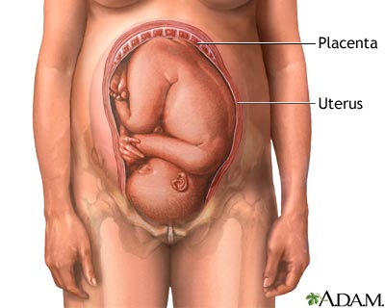

Umbilical Cord
- Connects placenta to baby
- Carries oxygen to the baby and takes waste back to the mother
- Cord is two feet long, cut and clamped at birth. The rest of the cord dries out and falls off after about two weeks.
- It is filled with Wharton’s jelly which prevents the cord from knotting in the uterus.

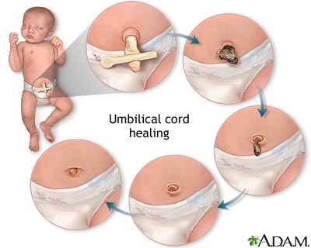

Mucous plug
- It fills thee cervix and helps protect from infection of the bacteria from the vagina.
- Before labor, cervical changes lead to the discharge of the mucous plug, which is a clump of mucous that is blood tinged or pinkish. This should not be a bright red color!

Amniotic sac and fluid
- The amniotic sac surrounds the baby and acts as a barrier against infection.
- The amniotic fluid is clear and watery. It maintains the temperature and works as a shock absorber for the baby.
- Typically, there is 1 quart of fluid at birth. The fluid is reproduced every three hours so there aren’t “dry births”.
- When the amniotic sac ruptures or tears, there may be a gush or a trickle of fluid. If you think your water broke, notify the physician immediately.
- When you call the physician, remember C.O.A.T. :
  - Color: Typically it should be a straw color. A green color may mean that the baby had a bowel movement, better known meconium, which may indicate the baby is distressed.
  - Odor: Typically, there should be no odor or have a slightly bleachy smell. A foul odor may mean there is an infection. To check that it was amniotic fluid and not urine, the physician or nurse may use the Nitrazine test.
  - Amount: Was there was a gush or trickle of fluid?
  - Time: It is important to know the time the fluid was noticed because after the water is broke, there is a 24 hour window for delivery to prevent infection.

Vagina
The vagina, aka the birth canal, extends from the cervix to the vulva. The cervix dilates, or opens, during labor to allow the baby to pass through this canal. The cervix requires the pressure caused by contractions to dilate, however the vagina is a very elastic structure and does not. Pregnancy and labor hormones help increase the elasticity of the vagina near the end of pregnancy and labor, for this reason near the end of your pregnancy you may also note an increase in vaginal secretions, this is completely normal.
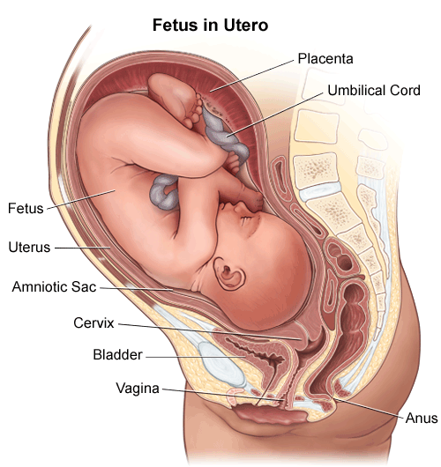

Pelvis
Your hips, sacrum, and coccyx are all connected with joints to make up your pelvis. Fibrocartilage and ligaments hold these bones together. During pregnancy hormones allow the pelvis to relax and stretch. This is the reason pregnant women may have hip pain, waddle, and should avoid vigorous exercise late in pregnancy. Early in pregnancy your doctor will probably have estimated the measurement of your hips to ensure they would accommodate the birth of a normal sized baby.
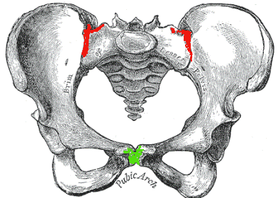

Presentation
Presentation categorizes the birth according to which part of the baby presents out of the birth canal first. Vertex, head first, is the most common presentation. Transverse lie is when the baby is lying with his spine horizontal in the womb. There are also several types of breech presentations. Frank breech is when the baby’s butt presents first with his feet up by his head. Complete breech is when the baby’s knees are bent and the feet and butt are present at the birth canal. Finally an incomplete breech is where the baby has one leg bent and one straight, this baby presents with one foot by his head and the other with his butt at the birth canal.
Position
The position of the baby is in reference to the way the baby is facing in relation to the moms back. The crown of the baby’s head is used as the reference point.

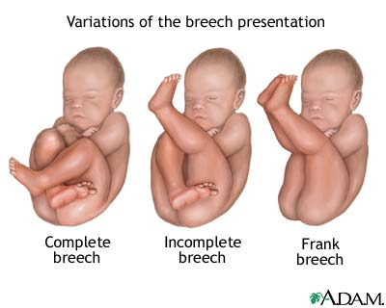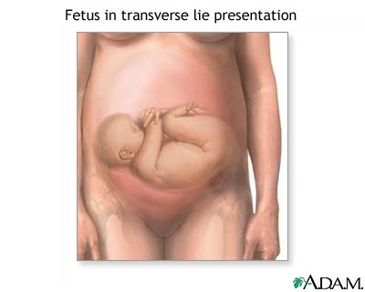

The Fetal Position:
Anterior: The baby is head down with the back portion of the head toward the mom’s front.
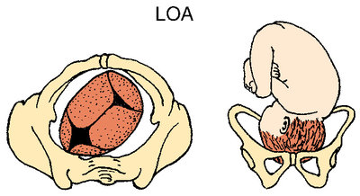
Posterior: The baby is head down with the back portion of the head toward the mom’s back.
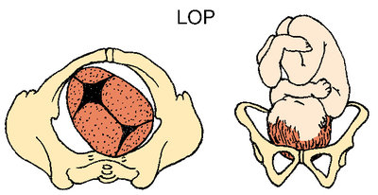

Labor:
Labor is the contracting and relaxing of the uterus that causes the shortening of the vaginal portion of the cervix, thinning of its walls along and widening of its opening leading to the baby’s delivery.

Contractions:
In the last trimester of pregnancy the uterus contracts, you may have felt a tightening of your uterus. These are Braxton Hicks contractions that are uncomfortable, but not painful. The purpose of these contractions is to soften the cervix to better prepare for the changes that will occur during labor.
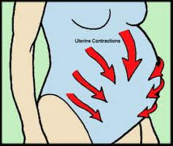
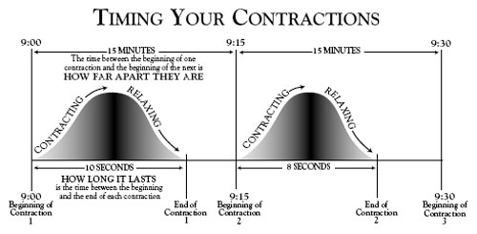

Signs of Labor:
There are multiple signs of labor…
- Loss of the mucous plug
- Rupture of the membrane
- Increased backache, lower abdominal cramps, and/or contractions
- Slight Bloody Show
- Spurt of Energy
- Diarrhea or nausea
When you think labor is happening continue with normal activities as long as possible while monitoring what is happening. Time your contractions, limit your intake to easily digested foods and liquids, rest if it is late, contact your doctor, and or local hospital.
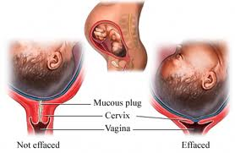
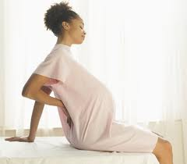

References:

http://t2.gstatic.com/images?q=tbn:ANd9GcSA4oczU-xOvVit-wsU1bTVDa8UgQ4hZZif3dxT5i-wGr-foLC6quLTQHW6
http://0.tqn.com/d/pregnancy/1/5/8/e/3/Fotosearch_COG12045.jpg
http://0.tqn.com/d/pregnancy/1/5/4/e/3/lopFotosearch_COG12046.jpg
http://t0.gstatic.com/images?q=tbn:ANd9GcSZhtDjYVNwmtSgXUznG2xncA1fwuYud-Y93KYbhM3XDQohTYoZ
http://www.empowher.com/files/ebsco/images/si55551477_96472_1.jpeg
http://healthpages.org/wp-content/uploads/2010/06/timing-contractions.jpg
http://t2.gstatic.com/images?q=tbn:ANd9GcSGWSNa3YXCopJkZcUC1_sMjd8cYmiT5nobaOFdkeTD4Ybq9ku _
http://t1.gstatic.com/images?q=tbn:ANd9GcRt7rxO0ZXzIxYqN89ImrTdnaEd7RAuq5e3fwsJyDz88t7KhyGI

