Triangular bandage on foot for sprained ankle
To apply a triangular bandage to the foot--
a. Place the foot in the middle of the triangular bandage with the heel well forward of the base (Figure 3-42 A). Ensure that the toes are separated with absorbent material to prevent chafing and irritation of the skin.
b. Place the apex over the top of the foot and tuck any excess material into the pleats on each side of the foot (Figure 3-42 B).
c. Cross the ends on top of the foot, take them around the ankle, and tie them at the front of the ankle (Figure 3-42 C, D, and E).
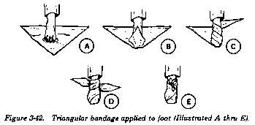 (Wilderness Survival, 2003)

Applying a Bandage to the Head

- Apply a Triangular Bandage to the Head. To apply a triangular bandage to the head--
- Turn the base (longest side) of the bandage up and center its base on center of the forehead, letting the point (apex) fall on the back of the neck (Figure 3-10 A).
- Take the ends behind the head and cross the ends over the apex.
- Take them over the forehead and tie them (Figure 3-10 B).
- Tuck the apex behind the crossed part of the bandage and/or secure it with a safety pin, if available (Figure 3-10 C).
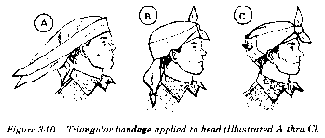 (Wilderness Survival, 2003)

Upper Arm injuries
    - Try to immobilize the arm when you wrap it.
a. To apply bandages attached to the field first aid dressing--
(1) Take one bandage across the chest and the other across the back and under the arm opposite the injured shoulder.
(2) Tie the ends with a nonslip knot (Figure 3-35).
- 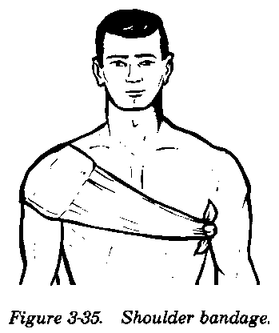
b. To apply a cravat bandage to the shoulder or armpit--
(1) Make an extended cravat bandage by using two triangular bandages (Figure 3-36 A); place the end of the first triangular bandage along the base of the second one (Figure 3-36 B).
(2) Fold the two bandages into a single extended bandage (Figure 3-36 C).
(3) Fold the extended bandage into a single cravat bandage (Figure 3-36 D). After folding, secure the thicker part (overlap) with two or more safety pins (Figure 3-36 E).
(4) Place the middle of the cravat bandage under the armpit so that the front end is longer than the back end and safety pins are on the outside (Figure 3-36 F).
(5) Cross the ends on top of the shoulder (Figure 3-36 G).
(6) Take one end across the back and under the arm on the opposite side and the other end across the chest. Tie the ends (Figure 3-36 H).
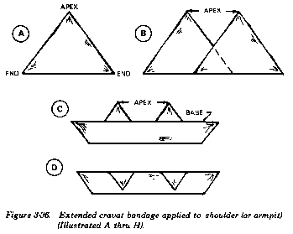
- 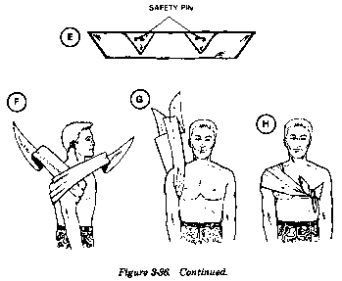
- Be sure to place sufficient wadding in the armpit. DO NOT tie the cravat bandage too tightly. Avoid compressing the major blood vessels in the armpit. (Wilderness Survival, 2003)

Broken Collarbone
(1) Insert the splinted arm in the center of the sling (Figure 4-5).
- 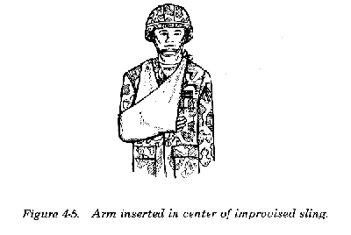
(2) Bring the ends of the sling up and tie them at the side (or hollow) of the neck on the uninjured side (Figure 4-6).
- 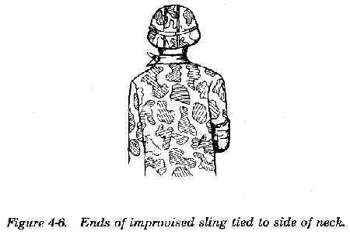
(3) Twist and tuck the corner of the sling at the elbow (Figure 4-7).

- 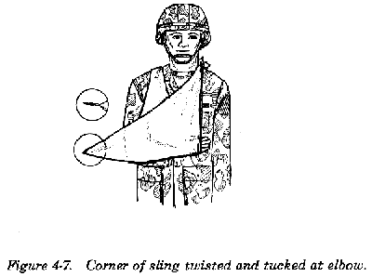

Handout taken from
Wilderness Survival. (2003). Retrieved 9 20, 2012, from A Guide to Wilderness and Camping: http://www.wildernessmanuals.com/manual_4/chpt_3/5.html

