Growth and Development
Adolescence: the transition from child to adult
Ages 11 to 20



By Libby Fannin, Heather Zeiter, and Demi Fox

Physical Growth Changes
Overall
- Physical changes occur as a result of hormonal changes (testosterone for boys and estrogen and progesterone for girls), which leads to physical growth and the development of secondary sex characteristics.
- Less obvious changes include physiologic alterations, neurogonadal maturity, and the ability to procreate.
- Primary sex characteristcs involve the reproductive organs whereas secondary sex characteristics are changes related to hormones and don’t play a direct role in reproduction. Secondary sex characteristics include voice changes and the development of facial and pubic hair development.
- Systemic changes include increased blood volume, blood pressure, vital capacity , and metabolic function which allows for better performance overall. The heart increases in size and strength but the pulse decreases. Sebaceous and apocrine glands increase in activity which results in increased sweat production and bacterial growth.
Boys
- Hair develops on pubic, axillary and facial areas predominately
- Change in the larynx leads to vocal changes
- Nocturnal emissions occur

Girls
- There is thought to be link from excess body fat to the early development of menarche, meaning that the more fat, the earlier a girl will begin menstruation.
- Breast buds appear initially, which is typically one of the first signs of puberty. The breasts later develop fully but time length varies from girl to girl.
- Menstruation typically begins two years after the first signs occur.



Developmental Milestones

- Psychosocial development
  - Erickson
    - Group Identity vs. alienation: develop a sense of personal identity with role diffusion
    - This is an adolescent trying to fit in with their peers though clothes, interests, and small things like make-up. Adolescents begin to reject the identity of their parent’s generation.
  - Individual Identity
    - This includes body awareness, relationships with peers and family, and how they interpret societal and cultural influences.
    - This is time-consuming and has periods of confusion, depression, and discouragement.
  - Sex-role Identity
    - Adolescents share expectations of romantic relationships and understanding mature-sex-role behaviors.
  - Emotionality
    - Mood swings are very common and with time, they will have more control over their emotions.
- Cognitive Development
  - Formal operations(Piaget’s last stage)
    - Abstract thinking develops allowing adolescents to look to the future, use scientific reasoning, and formal logic. They can understand other cultures and show concern of other people’s opinions.
- Moral Development
  - Kohlberg believes that adolescents begin to develop personal integrity, having n internalized set of moral principles. Adolescents question previous morals sometimes because parents don’t always practice what they preach.
- Spiritual Development
  - They lean towards more independence, may question their family’s beliefs, and can have deep spiritual concerns. There has been studies that showed high religiosity or spirituality in adolescents is related to these adolescents doing less high risk behaviors.
- Social Development
  - They want separation from their parents in order to find their own role in society. Interpersonal maturation for adolescents is related to the acceptance by peers, a few close friends, and secure love and support from their family.
  - Relations with parents become stressed as adolescents struggle for independence and fights restriction. Parental reactions play a major role in how the relationship with the parental figure becomes. Parental supervision is vital at this time in order to prevent sex and substance abuse, but the parents also need to be able to respect their child’s privacy and show interest in their life.
  - Relationships with peers become closer, more tightly knit as time goes on. They spend more time with peers than family. Plus, best friends are important to successful development of their identity and social interactions.
- Sexuality
  - Sex rates for teenagers have been steadily declining.
  - Cognitive skill development contributes to feelings of painful conjectures, self-conscious concern, and hypothetical thinking.
  - Sexual identity development includes experimentation with same-sex peers, masturbation, and sexual activity with opposite sex.
  - Adolescents believe that love and sex go hand in hand.
  - Determine sexual orientation through attraction, fantasy, actual sexual behavior, and self-labeling.
  - Sexual Milestones
- Self-concept
  - There is a loss of security with the various physical changes.
  - They compare themselves to each other and are critical of themselves, holding an idealized image for themselves.
  - They try to find their “true self”.

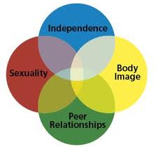
Language, Emotional, Cognitive
Emotions
- Mood swings are common
- May vary between considerable maturity and childlike behavior
- May be happy and full of life one minute and depressed and withdrawn the next
- Early adolescents react more immediate and with less control
- Older adolescents can control their emotions with a little more control
Cognitive
- Development of abstract thinking
- No longer just ‘real’ or ‘actual’, now understand ‘possible’
- Develop the ability to understand influence and consequences
- Begin to understand scientific reasoning and formal logic
- Attention span increases in length
Language
- Adolescents often develop their own set of ‘slang’ within their peer groups

Safety
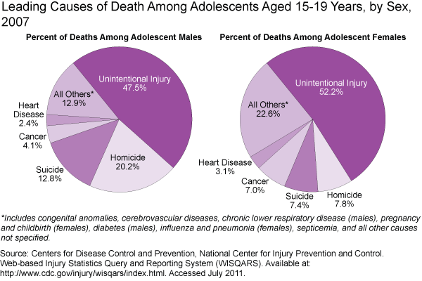
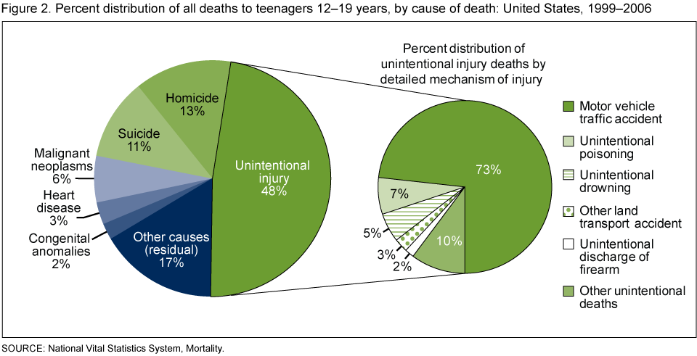

- Injury Prevention
  - MVA’s
    - Encourage safe driving, safety belts, limit drivers, limit technology, be a good role model
  - Firearms
    - “Firearms are used in more than half of all teen suicides”(teensuicide)
  - Sports related injuries
  - Drug & Alcohol abuse
    - Educate against
    - Know signs and symptoms of use
  - Suicide prevention
  - “warning signs of teen suicide:
    - Talks about death and/or suicide (maybe even with a joking manner).
    - Plans ways to kill him or herself.
    - Expresses worries that nobody cares about him or her.
    - Has attempted suicide in the past.
    - Dramatic changes in personality and behavior.
    - Withdraws from interacting with friends and family.
    - Shows signs of depression.
    - Shows signs of a substance abuse problem.
    - Begins to act recklessly and engage in risk-taking behaviors.
    - Begins to give away sentimental possessions.
    - Spends time online interacting with people who glamorize suicide and maybe even form suicide pacts.”(teensuicide)
    - Yellow ribbon program
      - “FEEDBACK OF TRAININGS
      - YOUTH: “When I compared the teen suicides 4 years
      - prior to the Yellow Ribbon launch with the 4 years
      - since the launch, there was a 62% decrease in the
      - teen suicide rate”. MI 2005 – Macomb County Medical
      - Examiner, Gary Burnett, Macomb County Mental Health
      - ADULT: “96 % of participants agreed that they have
      - been given the tools to train participants to respond
      - effectively to a young person in crisis and would
      - recommend the training to others”. A Commitment to
      - Life Project, Healthy Communities Alliance Inc.”(yellowribbon)
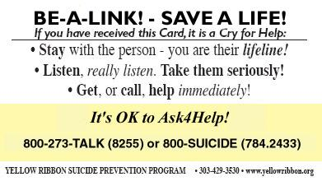
  - STDs & Pregnancy prevention through education
  - Education on Tanning
- Health maintenance
  - Immunizations
    - TdaP & HPV
  - Health screenings
    - Scoliosis, physicals, females Pap test
Moral & Spiritual
Moral
- Often question moral values and rules
- Search for their own ideals and morals
- At this age understand and question authoritative figures saying and demanding one thing but not doing themselves
Spiritual
- “greater levels of religiosity and spirituality are associated with fewer high risk behaviors”(Perry 1111)
- Nurses provide an open ear for teens to discuss spirituality
Nutritional Information
- More nutritional requirements are needed due to the rapid and extensive increase in height, weight, muscle mass and sexual maturity.
- Caloric and protein requirements are higher than almost any other time in life
- Many adolescents have sufficient protein intake
- The need for minerals calcium, iron and zinc increase during this time
  - Calcium for skeletal growth, iron for expansion of muscle mass and blood volume, and zinc for skeletal and bone tissue
- Girls with heavy menses may experience iron deficiency
- Calcium is important during this time to prevent osteoporosis
- Eventual bone mass is a balance between amount of bone laid down during adolescents and the amount later lost with aging
- Maximum bone mass is acquired during this time, therefore the calcium deposited during these years determine the risk of osteoporosis
Eating habits and behavior
- Eating habits are largely related to culture and family preference
- More eating is done away from home due to independence
- Not eating or eating a poorly nutritional breakfast is a huge problem
- Snacks are chosen based on accessibility rather on nutritional value
- Excess intake of calories, fat, sodium, sugar, cholesterol are common
- Inadequate intake of vitamins ( folic acid, vitamin B₆, vitamin A) and minerals ( iron, calcium, zinc)
- These bad eating patterns can effect later in life health such as obesity, heart disease, cancers, or osteoporosis
- Overeating and under eating are also major problems
- Obesity is a major problem among our youth, and eating habits start at a young age
Promoting development in ADL’s
- Today’s youth is said to be less fit than 20 years ago
- Adolescents spend more time and energy participating in sport activities than any other age group
- School-based health and physical education tires to provide both immediate effects and also encouragement of lifelong activity patterns
- With schools cutting physical activity less than half of students get 20 minutes of physical activity during school, which it needs to be more around 60 minutes
- The practice of sports helps with adolescents growth and development; providing growing muscles, interactions with peers, self-respect, self-appraisal, socially acceptable means of enjoyment, and concern for others
- Children need to be encouraged to participate in activities that contribute to lifelong physical fitness
Promoting healthy family function
- Parent –child relationship during adolescence changes from one of protection-dependency to one of mutual affection and equality
- Parents and child may go through turmoil during this time trying to learn the new roles now being achieved
- Children during this time struggle for independence while parents still want to hold tight and protect
- They are seen as maturing pre-adults, allowed new privileges and responsibilities, while still being denied by adults of certain things due to their unpredictability and insecurity
- The major issue at this age is curfew
- While trying to figure this difficult time out they tend to create tension within the home
- They try to resist parental control and conflicts arise from any situation or subject
- While adolescents spend more time away from home and with their peers, parents still play a impacting role
- Parents still need to set ground rules and supervise their child
- Parents and children need to have an open relationship, child knowing they can go their parent without fear
- Parents should fit in the role of an authoritative role in which authority is used to guide the adolescent while allowing developmentally appropriate of freedom and proving clear, consistent messages regarding expectation
- Parents must gain trust of their adolescent through respect of their privacy and show honest and sincere interest in what their child feels and believes

Citations:

http://www.cdc.gov/nchs/data/databriefs/db37_fig_2.png
http://www.teensuicide.us/
http://www.yellowribbon.org/
ATI. (2011). RN Nursing Care of Children (8 ed.). ATI.

