Growth and Development
Adolescent

Language, Emotional, Cognitive
Emotions
- Mood swings are common
- May vary between considerable maturity and childlike behavior
- May be happy and full of life one minute and depressed and withdrawn the next
- Early adolescents react more immediate and with less control
- Older adolescents can control their emotions with a little more control
Cognitive
- Development of abstract thinking
- No longer just ‘real’ or ‘actual’, now understand ‘possible’
- Develop the ability to understand influence and consequences
- Begin to understand scientific reasoning and formal logic
- Attention span increases in length

Language
- Adolescents often develop their own set of ‘slang’ within their peer groups

Safety
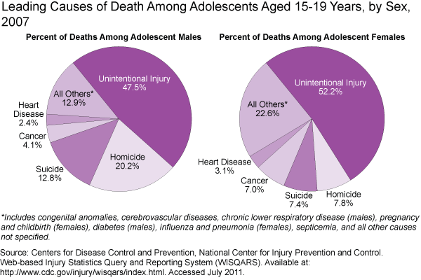
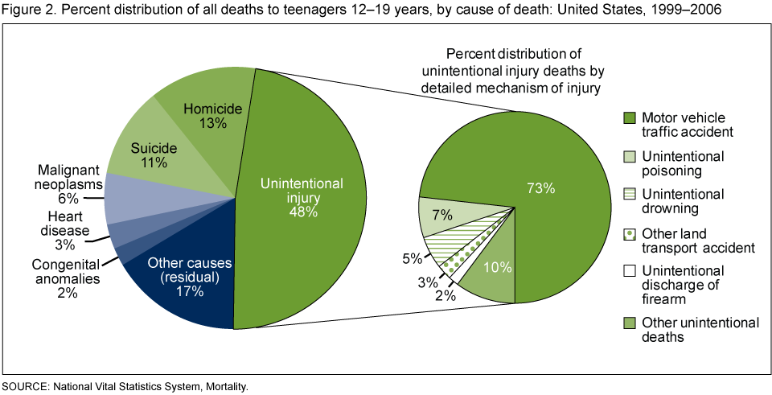
http://www.cdc.gov/nchs/data/databriefs/db37_fig_2.png
- Injury Prevention
  - MVA’s
    - Encourage safe driving, safety belts, limit drivers, limit technology, be a good role model
  - Firearms
    - “Firearms are used in more than half of all teen suicides”(teensuicide)
  - Sports related injuries
  - Drug & Alcohol abuse
    - Educate against
    - Know signs and symptoms of use
  - Suicide prevention
  - “warning signs of teen suicide:
    - Talks about death and/or suicide (maybe even with a joking manner).
    - Plans ways to kill him or herself.
    - Expresses worries that nobody cares about him or her.
    - Has attempted suicide in the past.
    - Dramatic changes in personality and behavior.
    - Withdraws from interacting with friends and family.
    - Shows signs of depression.
    - Shows signs of a substance abuse problem.
    - Begins to act recklessly and engage in risk-taking behaviors.
    - Begins to give away sentimental possessions.
    - Spends time online interacting with people who glamorize suicide and maybe even form suicide pacts.”(teensuicide)
    - Yellow ribbon program
      - “FEEDBACK OF TRAININGS
      - YOUTH: “When I compared the teen suicides 4 years
      - prior to the Yellow Ribbon launch with the 4 years
      - since the launch, there was a 62% decrease in the
      - teen suicide rate”. MI 2005 – Macomb County Medical
      - Examiner, Gary Burnett, Macomb County Mental Health
      - ADULT: “96 % of participants agreed that they have
      - been given the tools to train participants to respond
      - effectively to a young person in crisis and would
      - recommend the training to others”. A Commitment to
      - Life Project, Healthy Communities Alliance Inc.”(yellowribbon)
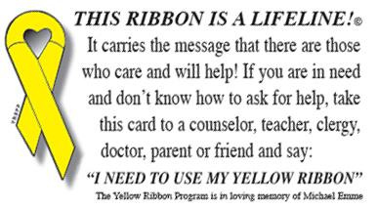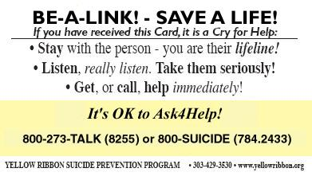
  - STDs & Pregnancy prevention through education
  - Education on Tanning
- Health maintenance
  - Immunizations
    - TdaP & HPV
  - Health screenings
    - Scoliosis, physicals, females Pap test
Moral & Spiritual
Moral
- Often question moral values and rules
- Search for their own ideals and morals
- At this age understand and question authoritative figures saying and demanding one thing but not doing themselves
Spiritual
- “greater levels of religiosity and spirituality are associated with fewer high risk behaviors”(Perry 1111)
- Nurses provide an open ear for teens to discuss spirituality

http://www.teensuicide.us/
http://www.yellowribbon.org/
ATI. (2011). RN Nursing Care of Children (8 ed.). ATI.

Question ideas
True or False, by early adolescence a child should start to show the ability to control their emotions.
A- False, by late adolescence they may start to show some control over emotional outbursts.
Which of the following would be the appropriate response by a nurse who overhears a 14 year old female patient stating she wishes she had just swallowed a bottle of pills?
A.) Roll her eyes and walk on, teenage girls are so dramatic
B.)Approach the patient and ask if she needs to talk, let her know that she overheard her and would like to listen if she needs someone to talk too.
C.)Let the teens parents know what she heard, they will handle the situation how they want too
D.) Place the girl on suicide precautions, do not leave her unattended, and order a psych evaluation stat.
A- B

