Growth and Development
Adolescent

Language, Emotional, Cognitive
Emotions
- Mood swings are common
- May vary between considerable maturity and childlike behavior
- May be happy and full of life one minute and depressed and withdrawn the next
- Early adolescents react more immediate and with less control
- Older adolescents can control their emotions with a little more control
Cognitive
- Development of abstract thinking
- No longer just ‘real’ or ‘actual’, now understand ‘possible’
- Develop the ability to understand influence and consequences
- Begin to understand scientific reasoning and formal logic
- Attention span increases in length

Language
- Adolescents often develop their own set of ‘slang’ within their peer groups

Safety
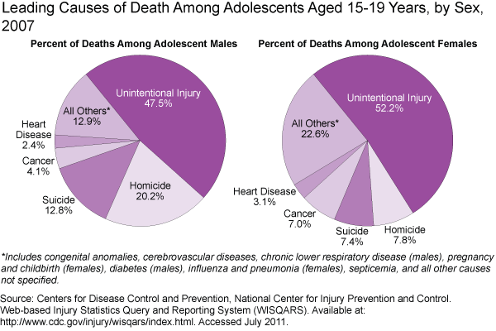
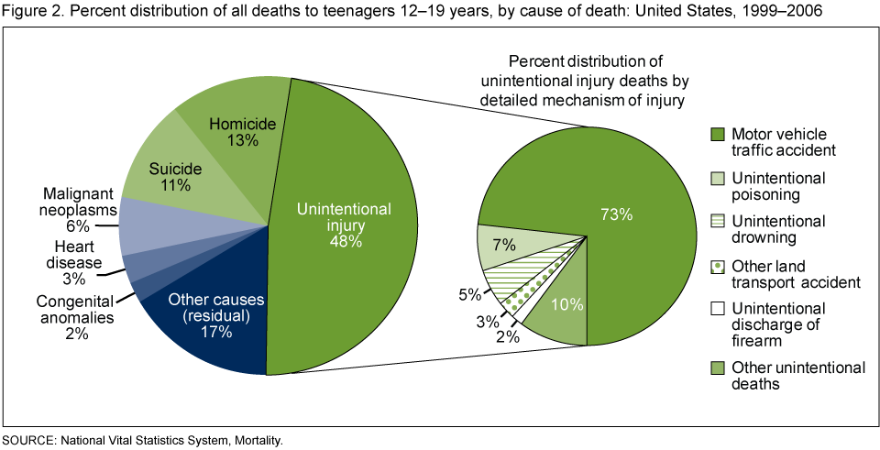
http://www.cdc.gov/nchs/data/databriefs/db37_fig_2.png
- Injury Prevention
  - MVA’s
    - Encourage safe driving, safety belts, limit drivers, limit technology, be a good role model
  - Firearms
    - “Firearms are used in more than half of all teen suicides”(teensuicide)
  - Sports related injuries
  - Drug & Alcohol abuse
    - Educate against
    - Know signs and symptoms of use
  - Suicide prevention
  - “warning signs of teen suicide:
    - Talks about death and/or suicide (maybe even with a joking manner).
    - Plans ways to kill him or herself.
    - Expresses worries that nobody cares about him or her.
    - Has attempted suicide in the past.
    - Dramatic changes in personality and behavior.
    - Withdraws from interacting with friends and family.
    - Shows signs of depression.
    - Shows signs of a substance abuse problem.
    - Begins to act recklessly and engage in risk-taking behaviors.
    - Begins to give away sentimental possessions.
    - Spends time online interacting with people who glamorize suicide and maybe even form suicide pacts.”(teensuicide)
    - Yellow ribbon program
      - “FEEDBACK OF TRAININGS
      - YOUTH: “When I compared the teen suicides 4 years
      - prior to the Yellow Ribbon launch with the 4 years
      - since the launch, there was a 62% decrease in the
      - teen suicide rate”. MI 2005 – Macomb County Medical
      - Examiner, Gary Burnett, Macomb County Mental Health
      - ADULT: “96 % of participants agreed that they have
      - been given the tools to train participants to respond
      - effectively to a young person in crisis and would
      - recommend the training to others”. A Commitment to
      - Life Project, Healthy Communities Alliance Inc.”(yellowribbon)
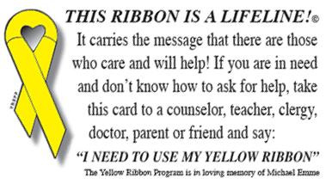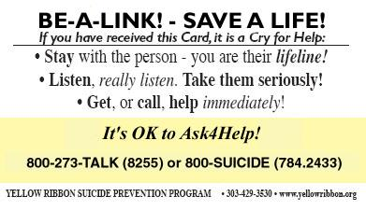
  - STDs & Pregnancy prevention through education
  - Education on Tanning
- Health maintenance
  - Immunizations
    - TdaP & HPV
  - Health screenings
    - Scoliosis, physicals, females Pap test
Moral & Spiritual
Moral
- Often question moral values and rules
- Search for their own ideals and morals
- At this age understand and question authoritative figures saying and demanding one thing but not doing themselves
Spiritual
- “greater levels of religiosity and spirituality are associated with fewer high risk behaviors”(Perry 1111)
- Nurses provide an open ear for teens to discuss spirituality

http://www.teensuicide.us/
http://www.yellowribbon.org/
ATI. (2011). RN Nursing Care of Children (8 ed.). ATI.

