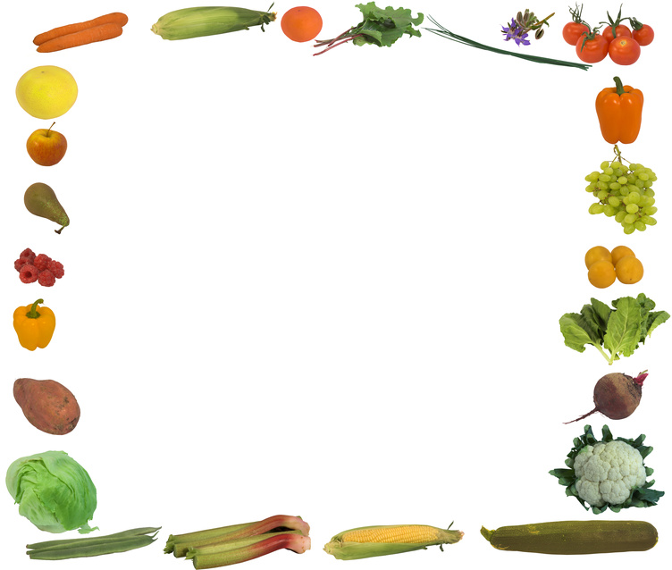
HOLIDAY CHALLENGE

Lose 10 pounds in 10 weeks

FACT: Nursing School has a way of
adding a few pounds to the scale.
FACT: It is possible to gain 15 pounds
over holiday break.

The Challenge
- It is 10 weeks until we return in January.
- Between now and then is A LOT of food!
- Join this challenge to protect yourself from becoming a Nursing School statistic
- Fill out a thermometer and share your
progress (Use a fun Code Name if you want. Ex. Healthy Nurse 2B)
- Encourage others to join in the fun!!

