Muscle Cramps
- Explain the symptoms of muscle cramps
  - Painful, involuntary tightening of muscles in arms, legs or stomach that will not relax – “Charlie horse”
  - Can last a few seconds, up to 15 minutes or longer
  - Usually occur after physical exertion, or due to heat exhaustion
- What action needs to be taken for first aid of muscle cramps
  - Move person to a cool place
  - Give person sips of cool water, gulping down water, or giving ice cold water may cause abdominal cramping, nausea, and vomiting
  - Apply firm pressure or gently massage muscle that is cramping
  - Stretch the contracted muscle if possible
- What actions can be used for prevention of muscle cramps
  - Stay hydrated – drink lots of water
    - If working in the outdoors in the heat
    - Hard or unusual exercise
  - Stretch before exercising or doing heavy work

Heat Stroke/Sunstroke
- What is the difference between heat stroke and heat exhaustion
  - Less common and much more severe than heat exhaustion
  - The body gets so overheated that its natural mechanisms for controlling body temperatures are completely shut off
  - Heat stroke can be life threatening
- Explain the symptoms of heatstroke
  - Body temperature may be 102°F to 105°F or higher
  - Red, hot, and dry skin
  - No sweating – sweating is a natural mechanism that is shut down during heat stroke
  - Extremely rapid pulse
  - Confusion, disorientation
  - Fainting, unconsciousness
  - Convulsions – seizures

- What action needs to be taken for first aid of heatstroke
  - Cool down the victim – take them to a shaded spot or a cool place
  - Place victim face up with head and shoulders raised
  - Cool the body down quickly
    - Take of victim’s clothes
    - Sponge bare skin with cold water and soak underclothing with cool water
    - Drape bare skin with wet cloths
    - Apply cold packs
    - Use a fan
    - Place victim in a cold water bath
    - Dry the skin once body temps reach 101°F
    - When victim is able to drink on their own safely – give them as much water as they want
    - Treat shock
    - Call for medical assistance ASAP
- What actions can be used for prevention of heatstroke
  - Stay in the shade during hot weather
  - Wear a hat and light-colored clothing when working out in the sun to stay cooler
  - Only work or play for 30 minutes at a time in the direct sunlight
  - Drink plenty of water
  - Increase your salt intake by a very small amount – this will help hold water in and keep your body hydrated
  - Plan strenuous work and activities for the morning and evening when it is typically cooler

Poisonous Plants
- Identify local poisonous plants and how to treat for exposure to them.
  - All poisonous plants create an oil (urushiol) that irritates the skin of most people
  - Oil can be spread to other parts of the body through skin on skin contact or clothing to skin contact
- Signs and symptoms of allergic reaction to a poisonous plant
  - Skin rash
  - Redness
  - Swelling
  - Itching
  - Burning
  - Fever
  - Headache
  - In severe cases blisters may appear – they may break open and crust over
  - Pictures were retrieved from: http://poisonivy.aesir.com/view/rashes.html

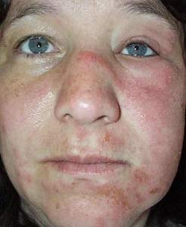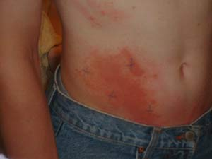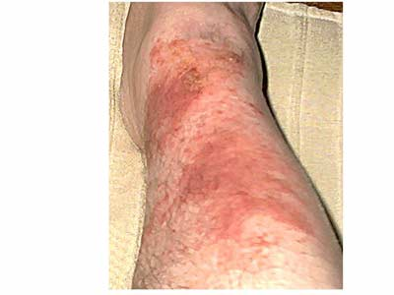
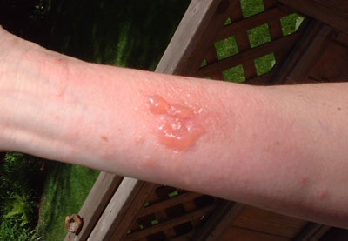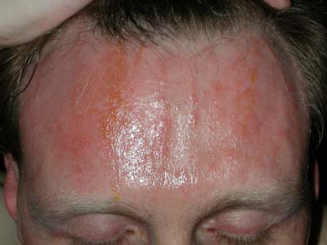

- How to treat reactions to poisonous plants
  - Remove and wash all contaminated clothing and exposed skin with soap and water
  - Wipe exposed area with rubbing alcohol
  - Apply calamine lotion or soothing skin lotion for mild rashes
  - Seek medical attention for severe rashes or any rashes on the face or genitals
  - Seek medical attention if the plant parts were chewed or swallowed
- How to prevent getting contaminated by poisonous plants
  - Learn what poisonous plants look like – they appear different depending on the season
  - All 3 of these poisonous plants have white, tan, or yellowish berries
  - Wear protective clothing when working outdoors around unfamiliar plants
  - When handling tools, clothes, camping gear or any item that might be contaminated be very careful
  - Be cautious petting animals that might have been around poisonous plants as their fur might be carrying the oils
  - Wash with soap and water if you suspect you have been contaminated

- Poison Ivy
  - All Poison Ivy Pictures retained from: http://www.poison-ivy.org/
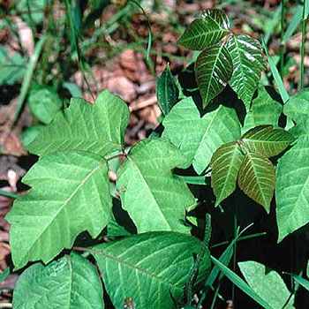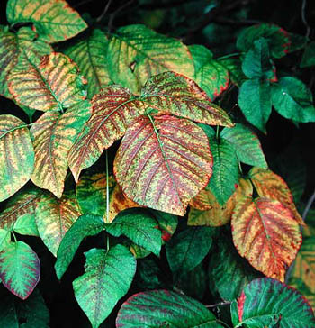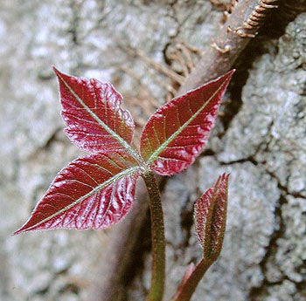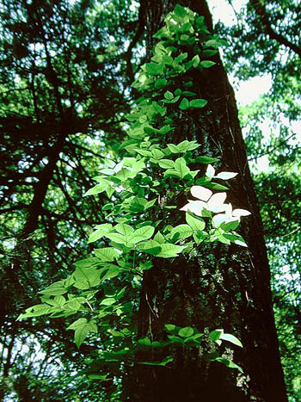

  - Found throughout all of mainland USA
  - “Usually has three broad, spoon-shaped leaves or leaflets, but it can have more. The phrase, “Leaves of three? Let it be.” May help you remember what poison ivy looks like.
  - Grows as a climbing vine or a low, spreading vine that sprawls through grass (more common in eastern states) or as a shrub (more common in northern states, Canada, and the Great Lakes region).
  - Often grows along rivers, lake fronts, and ocean beaches.
  - Has bright red leaves and white or cream berries in the autumn.”

(Information retained from: http://www.everydayhealth.com/health-center/habitat-and-description-of-poison-ivy-oak-and-sumac-info.aspx)

- Poison Oak
  - Pictures retained from: http://walking.about.com/od/medfirstaid/ig/Poison-Oak-Photos/index_g.htm

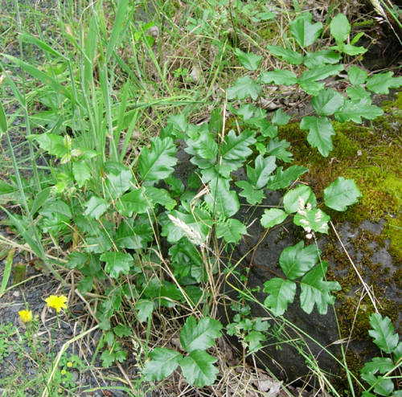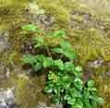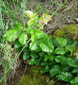

  - “Poison oak is most common in the western United States, although it is also found in eastern states. It rarely is found in idwestern states.
  - Has leaves that look like oak leaves, usually three leaflets but sometimes up to seven per leaf group.
  - Grows as a vine or a shrub.”

(Information retained from: http://www.everydayhealth.com/health-center/habitat-and-description-of-poison-ivy-oak-and-sumac-info.aspx)

- Poison Sumac
  - All pictures retained from http://landscaping.about.com/od/weedsdiseases/ig/Poison-Sumac-Pictures/

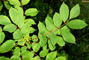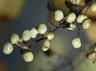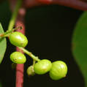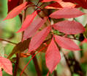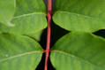

  - “Poison sumac is much less common than poison ivy or poison oak. It is found in wooded, swampy areas, such as Florida and parts of other southeastern states. It is also found in wet, wooded areas in the northern United States.
  - Has 7 to 13 leaflets per leaf stem. The leaves have smooth edges and pointed tips.
  - Grows as a shrub or small tree.”

(Information retained from: http://www.everydayhealth.com/health-center/habitat-and-description-of-poison-ivy-oak-and-sumac-info.aspx)

- Show what to do for “hurry” cases of stopped breathing
  - Check for breathing by placing your ear to the victim’s mouth and nose, or watch their chest rise and fall
  - Maintain an open airway
  - Start rescue breathing
  - Call for help immediately
- Show what to do for “hurry” cases serious bleeding
  - Use a clean cloth or sterile dressing as a pad, apply direct and firm pressure over the wound to stop the bleeding. Use gloves if possible, or washed hands
  - Raise the wound above the victim’s heart
  - Do not release your hand unless the bleeding has stopped
  - Put a fresh dressing over the old one if blood has soaked through
  - Press your palm to a pressure point in the groin or armpit area if need be
  - Once bleeding stops, secure a pad firmly to the area
  - Feel for a pulse below the wound
  - Use a tourniquet as a last resort
  - Treat for shock if need be
- Show what to do for “hurry” cases ingested poisoning of these plants
  - Seek medical attention immediately
  - Poison control number: (800) 222-1222
  - Maintain an open airway
  - Ingestion of these poisonous plants may cause nausea, vomiting, and possibly even death

Most of this information is taken from the BSA Handbook’s First Aid Section

Supply List:

Muscle Cramps
- Bottled water

Heatstroke
- Bottled water
- Towels
- Water supply
- Light colored clothing
- Hat
- Electrolyte packets (salt tablets)
- Cold packs
- Fan
- Tub or cooler filled with water

Poisonous Plants
- Soap and water
- Rubbing alcohol
- Calamine lotion
- Extra set of clean clothing

