What you need to know about getting an Epidural
What is an epidural?
A regional anesthesia that blocks sensation to the lower half of the body and also restricts muscle movement of the legs.

Who should receive an epidural?
Epidurals are typically given to women during the Active Stage of Labor, Delivery, and Cesarean Births. The patient should have an IV in place and receiving fluids, have a fetal monitor on at all times, be monitored for Blood Pressure throughout, and be on bed rest (even if there is a fire alarm!!)

Who administers epidurals?
At FRMC you will most likely have one of the 4 nurse anesthetists administering your epidural.

When will you be able to receive your epidural?
There is really no set time that you can request your epidural. Typically you will know when your contractions are getting too intense and you want relief from them. Usually, most mom’s will receive an epidural an hour or more after her water breaks.

Is there a reason I might not be eligible to get an epidural?
- There is a point during labor when epidurals may not be given because mom is too close to delivery and an epidural would not go into effect prior to the birth. (It typically takes about 20 minutes for the full effects of an epidural to become evident)
- Certain blood related problems may disqualify a patient for epidurals: For example - if your platelet levels are too low and your clotting ability is decreased you might be a risk for bleeding.
What are the pros and cons of receiving an epidural?
Pros:
- Pain is alleviated in the abdomen, perineum, and lower back
- Pain relief can be adjusted for patient comfort
- Minimal side effects to the baby compared to other methods of pain relief
Cons:
- Bed Rest – may take an few hours to “get your feet back” after delivery
- Ineffective pain relief (15% of epidurals do not give the kind of pain relief expected)
- Urge to push may be diminished
- Baby may be affected (mainly due to a decrease of the mom’s blood pressure)
  - More sleepy
  - Increased risk of jaundice
  - Difficulty of breast feeding the first few hours up to days after birth
- Spinal headaches (lie flat, drinking fluids, increasing caffeine, pain meds may all help)
- Hitting a nerve – brief sensation of tingling down one leg
- Shivering or itching
- Sensitivity in the back may last up to a year after the procedure

What to expect during the procedure
If you really want to see great step by step pictures of what happens during an epidural please check out this site: http://www.pattiramos.com/epiduralprocedure.html
- You will first be given an IV with fluids to increase your blood volume
- When the nurse anesthetist arrives they will raise the bed and you will dangle your legs off to one side
- Your labor and delivery nurse will stand in front of you the whole time helping you to stay in the correct position, and letting you know what to expect before it happens.
- You will be asked to curl your back while the nurse anesthetist feels for the right spot for the epidural’s placement
- Your lower back will be scrubbed down with iodine
- You will feel a prick on your back as the nurse anesthetist gives you a numbing medicine prior to giving you the actual epidural
- A special needle will be placed in the epidural space and the epidural catheter is inserted through the needle - this is all done by feel only so you will want to hold very still
- A test dose is given to be sure they are in the right space – they will ask you if your legs feel funny, ringing in the ears, dizziness, rapid heartbeat or if you have a metallic taste in your mouth.
- Once it is confirmed that they are in the right spot, the needle is removed and the catheter is taped in place (all the way up your back)
- Placed on your back – but with a pillow under one side so you are not laying directly on top of the catheter

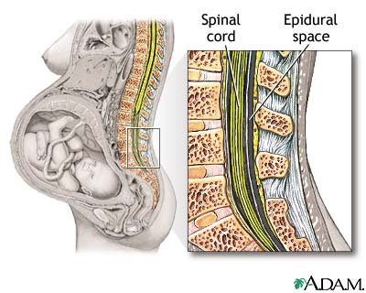
http://pregnancy.about.com/od/laborbirth/ss/pictureguidechildbirth_6.htm on September 9, 2012

