The first milk your body naturally creates for your baby is a rich, thick, yellowish milk called colostrum.

Colostrum is only available the first 72-96 hours after a baby is born and is created in the exact amount that your baby’s tiny belly can hold.

Your newborn’s belly is very small, only able to fit 1-2 teaspoons of liquid – it is only the size of a hazelnut.
By one week of age, your baby’s belly has increased to about the size of a walnut and can hold about 2 ounces of liquid.
Babies require 8-12 feedings a day. Because their bellies are so small, their stomachs empty quickly, therefore, he or she will be hungry more often.
Although your breasts may not feel heavy and full right away, you can be sure that your baby is receiving the right amount of food that it needs to fill up his or her tiny tummy!
If your baby appears content during and after a feeding, then you can rest assured your baby’s belly is full.
Your milk supply is based solely on supply and demand. Therefore, supplementing with formula decreases the demand for more milk, thus also decreasing your supply.

It might appear that your baby is hungrier, or left unsatisfied at times. This may be due to growth spurts – your milk supply will quickly catch up to baby’s demand. Supplementing with formula at this time will not allow your breast milk supply to stay current to your baby’s needs.
The first few weeks it is highly recommended to not use pacifiers and bottles because babies must learn to open their mouths very wide for breastfeeding.
ᴓ
Colostrum is packed full of nutrients and antibodies that your baby’s body requires in the exact amounts needed for optimal growth and health.
No formula can scientifically duplicate the complex make-up that comes naturally in colostrum and breast milk.
Breast milk is considered the most nutritious and easily digested food for your baby.
If you are questioning whether your baby is getting what he or she needs, feel the firmness of your breasts before and after nursing your baby, you may notice a slight difference – that is reassurance that your baby did take in milk.
Weighing your baby daily or at least 2-3 times a week can help reassure you that your baby is gaining weight because it has enough nutrients, but remember a slight weight loss may occur for some babies over the first few days of life.
If your baby is getting enough milk his or her urine should be clear to pale yellow in color.
If you ever have any questions or concerns please contact your Pediatrician or Lactation Consultant.

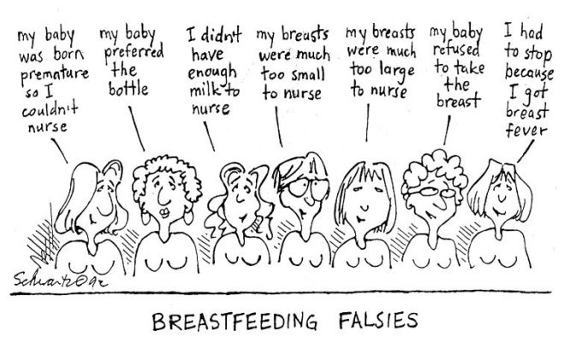
Retained from: www.breastfeeding.com
Resources:
Your Guide to Breastfeeding. Retrieved from: http://www.womenshealth.gov/publications/our-publications/breastfeeding-guide/BreastfeedingGuide-General-English.pdf

Perry, S. E., Hockenberry, M. J., Lowdermilk, D. L., & Wilson, D. (2010). Maternal child nursing care. (4th ed.). Maryland Heights, Missouri: Mosby.
Resources for Breastfeeding and Supportive Services
Why Colostrum is Considered Liquid Gold
National Breastfeeding Helpline
(800) 994-9662
Mon-Fri 9am – 6pm (EST)


WIC Program
(703) 305-2746
http://fns.usda.gov/wic/Breastfeeding/breastfeedingmainpage.htm

Breastfeeding Basics
http://www.womenshealth.gov/breastfeeding/

Breastfeeding on the Job
http://www.womenshealth.gov/breastfeeding/government-programs/business-case-for-breastfeeding

MyPyramid Plans
http://www.mypyramid.gov/mypyramidmoms/pyraidmoms_plan.aspx

La Leche League
www.llli.org

International Board Certified Lactation Consultant (IBCLC)
http://www.ilca.org
Fast Facts about the Benefits of Breastfeeding

Evidence Based Information
http://kellymom.com/

By: Tammy Duncil and Andrea Flewelling

