Education Plan
Education Opportunities | Barriers to Education Plan
1. CPR | Lack of Parental Visitation
2. O₂ | Lack of Parental Visitation
3. Tracheostomy | Lack of Parental Visitation
4. Breathing Problems | Lack of Parental Visitation
5. Ventilation | Lack of Parental Visitation
6. Suctioning | Lack of Parental Visitation
7. Aerosol | Lack of Parental Visitation
8. Gastrostomy | Lack of Parental Visitation

Nursing Diagnoses:
1. Impaired Ventilation related to respiratory muscle fatigue as evidenced by:
-dyspnea
-apprehension
-increased restlessness
-decreased cooperation
-decreased SpO₂
2. Interrupted Family Process related to illness as evidenced by:
-effectiveness in completing assigned tasks
-isolation from community resources
-lack of participation in problem solving or decision making
3. Risk for Aspiration related to tracheostomy.
List the Measurable Educational Objectives for your Client:
Weaning of Ventilation, Tracheostomy, and Gastrostomy; Maintenance of Homecare.

Teaching Content | Teaching Methods
1. CPR | Demonstration, Visual Aid, Return Demonstration
a. open the airway
b. give breaths
c. perform chest compression
d. administer medications
2. O₂ | Demonstration, Return Demonstration
a. monitoring levels
b. administration
c. signs of toxicity
3. Tracheostomy | Demonstration, Guide, Return Demonstration
a. suctioning
b. routine care
c. emergency care
4. Breathing Problems | Guide
a. infections
b. manifestations
c. emergency care
5. Ventilation | Demonstration, Guide, Return Demonstration
a. maintenance
b. routine care
c. emergency care
6. Suctioning | Demonstration, Visual Aid, Return Demonstration
a. kit
b. procedure
c. emergency care
7. Aerosol | Demonstration, Guide, Return Demonstration
a. administration
8. Gastrostomy | Demonstration, Guide, Return Demonstration
a. feeding
b. routine care
c. aspiration
d. emergency care

Evaluation:
1. Describe Effectiveness or Ineffectiveness of the Client’s Education Plan
The caregivers of the client did not visit, therefore teaching could not have been accomplished.
2. Were your Educational Objectives Met?
No. We were unable to educate due to the lack of parental visitation.
3. What Factor(s) will Impact this Client’s Follow Through with the Education you Provided?
Lack of parental visitation resulted in lack of education, therefore follow through is highly unlikely.
4. Would you Modify this Education Plan?
No. I would not modify this education plan. I believe that it is pertinent to the care of the patient.

CPR for Children (Ages 1-8)
CPR for children is similar to CPR for adults. The compression to ventilation ratio is 30:2. If you are alone with the child give 2 minutes of CPR before calling 911.
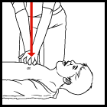 | 1) Use the heel of one or two hands for chest compression  2) Press the sternum approximately one-third the depth of the chest (about 2 inches) at the rate of least 100/minute
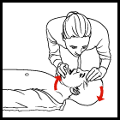 | 3) Tilt the head back and listen for breathing. If not breathing normally, pinch nose and cover the mouth with yours and blow until you see the chest rise. Give 2 breaths. Each breath should take 1 second.
CONTINUE WITH 30 PUMPS AND 2 BREATHS UNTIL HELP ARRIVES

Tracheostomy Care
Rubbing of the trach tube and secretions can irritate the skin around the stoma. Daily care of the trach site is needed to prevent infection and skin breakdown under the tracheostomy tube and ties. Care should be done at least once a day; more often if needed. Children with new trachs or children on ventilators may need trach care more often. Tracheostomy dressings are used if there is drainage from the tracheostomy site or irritation from the tube rubbing on the skin.
It may be helpful to set up a designated spot in your home for equipment and routine tracheostomy care.

Equipment
- Sterile cotton tipped applicators (Q-tips)
- Trach gauze and "unfilled" gauze
- Sterile water
- Hydrogen peroxide (1/2 strength with sterile water)
- Trach ties and scissors (if ties are to be changed)
- Two sterile cups or clean disposable paper cups
- Small blanket or towel roll

Procedure
- Wash your hands.
- Explain procedure in a way appropriate for the child's age and understanding.
- Lay your child in a comfortable position on his/her back with a small blanket or towel roll under his/her shoulders to extend the neck and allow easier visualization and trach care.
- Open Q-tips, trach gauze and regular gauze.
- Cut the trach ties to appropriate length (if trach ties are to be changed).
- Pour 1/2 strength hydrogen peroxide into one cup and sterile water into the other.
- Clean the skin around the trach tube with Q-tips soaked in 1/2 strength hydrogen peroxide. Using a rolling motion, work from the center outward using 4 swabs, one for each quarter around the stoma and under the flange of the tube. Do not allow any liquid to get into trach tube or stoma area under the tube. Note: Some doctors recommend cleaning with just soap and water in home care, using hydrogen peroxide only to remove encrusted secretions. This is because daily use of hydrogen peroxide might irritate the skin of some children.
- Rinse the area with Q-tip soaked in sterile water.
- Pat dry with gauze pad or dry Q-tips.
- Change the trach ties if needed (See Changing a Tracheostomy Tube).
- Check the skin under the trach ties.
- Tuck pre-cut trach gauze around and under the trach tube flush to skin. Do not cut the gauze or use gauze containing cotton because the child may inhale small particles. Use precut tracheostomy gauze or unfilled gauze opened full length and folded into a U shape or use two gauze pads, one placed under each wing of the tube. Be sure the trach dressing does not fold over and cover the trach tube opening. Change the dressing when moist, to prevent skin irritation. Tracheostomy dressings may not be needed for older tracheostomies when the skin is in good condition and the stoma is completely healed and free from rash or redness.
- For tracheostomy tubes with cuffs, check with your doctor for specific cuff orders. Check cuff pressure every 4 hours (usual pressure 15 - 20 mm Hg). In general, the cuff pressure should be as low as possible while still maintaining an adequate seal for ventilation.
- Monitor skin for signs of infection. If the stoma area becomes red, swollen, inflamed, warm to touch or has a foul odor, call your doctor.
- Check with the doctor before applying any salves or ointments near the trach. If an antibiotic or antifungal ointment is ordered by the doctor, apply the ointment lightly with a cotton swab in the direction away from the trach stoma.
- Wash your hands after trach care.

Care of the Inner Cannula
Some older children and teens have trach tubes with an inner cannula. Some inner cannulas are disposable (DIC: Disposable Inner Cannula). These should be changed daily, discarding the old cannula. Check with your equipment vendor regarding disposable cannulas.
For the reusable cannulas, the cannula should be cleaned 1 to 3 times a day and more often if needed. Do not leave the inner cannula out for more than 15 minutes.

Equipment
- 1/2 strength hydrogen peroxide
- Sterile water or normal saline
- Two clean or sterile containers (small bowl or cup)
- Inner cannula brush (tracheostomy brush or sterile pipe cleaner)
- Unfilled gauze pad
Cleaning kits are available for inner cannula trach care. Check with your supply vendor.

Procedure
- Wash your hands.
- Explain procedure in a way appropriate for the child's age and understanding.
- Pour 1/2 strength hydrogen peroxide into a bowl or cup and normal saline or sterile water into the other.
- Open the gauze pad
- Remove the inner cannula
- Place the inner cannula into 1/2 strength hydrogen peroxide. Soak it for a few seconds and use the brush to clean secretions on the inside and outside of cannula.
- Place the cannula into normal saline or sterile water solution, soak and rinse.
- Dry off excess water with clean or sterile gauze pad.
- Suction through the outer cannula if needed.
- Replace inner cannula. Be sure the cannula is secure or "locked" in place in the trach tube.
- Wash your hands.

Cuffed Tracheostomy Tubes
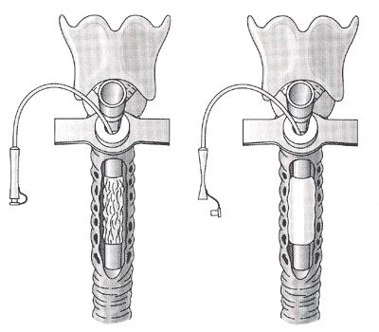
Foam-filled Bivona cuff tracheostomy tube
deflated (left), inflated (right)
A cuff is a soft balloon around the distal end of the tube that can be inflated to seal the trachea for children needing ventilator support or to help prevent secretions from entering the lungs.
Avoid over inflating the tracheostomy tube cuff. The pressure of the cuff against the wall of the trachea can cause damage if it is too high. Two techniques that can be used to help avoid excess pressure are the minimal occluding volume technique and the minimal leak technique.
Suction the trach tube if needed. After suctioning the tube, suction the mouth and above the trach cuff so that secretions do not go into lungs when cuff is deflated.

Cuff Deflation Techniques
- Minimal Occluding Volume Technique: Deflate the cuff, then slowly begin re-injecting air (or sterile water depending on the type of tube) with a luer lock syringe. Place a stethoscope to the side of the child's neck near the trach tube. Inject air into the pilot line until you can no longer hear air going past the cuff. This means the airway is sealed. For children that are totally ventilation dependent, provide breaths with manual resuscitator.
- Minimal Leak Technique: The same procedure as Minimal Occluding Volume, except that after the airway is sealed, slowly withdraw a small amount (approximately 1cc), so that a slight leak is heard at the end of inspiration.
Periodic measurements of the cuff volume should be noted and any changes reported to the doctor. A pressure manometer may be used to check cuff pressure on balloons filled with air. Generally, cuff pressure should be below 25 cm H2O.
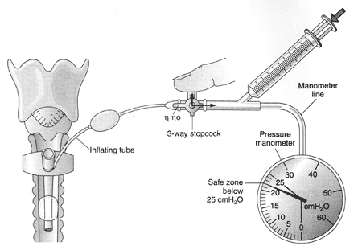
Trach tube with cuff, pilot inflating balloon and pressure manometer

Changing a Tracheostomy Tube
The tracheostomy tube is typically changed every 1-4 weeks to prevent mucus build-up and for cleanliness. This may very depending on the particular child. Check with the doctor for frequency of trach change. Always change the trach tube with two people present (unless this is not possible in an emergency). Change the trach tube before a feeding or at least 2 hours after a feeding.

Supplies
- Same size trach tube with obturator
- Size smaller trach tube with obturator
- Trach ties
- Small blanket or towel roll
- Blanket for mummy restraint (if needed)
- Sterile water soluble lubricant
- Blunt ended scissors
- Tweezers or hemostats
- Suction machine
- O2 blow-by (if ordered)
- Good light source
- The kitchen or dining room table covered with a pad or blanket may be a good place for a trach change.

Procedure
- Explain the procedure in a way appropriate for a child's age and understanding. Use a calm gentle approach. If you are anxious, the child may sense this.
- Wash hands.
- Cut trach ties to the appropriate length, cut the ends of the tape at an angle to make it easier to thread through the hole in the trach wing (flange) and to prevent fraying. Or wrap a piece of tape around the end of the tie similar to the end of a shoe lace to make it easier to thread.
- Inspect all tubes for cracks, tears, or decreased flexibility before use, especially if tubes are reused. For cuff tubes, inflate cuff to check function and check for leaks (deflate completely before inserting).
Bring trach tie through one end of new trach tube. Avoid touching the part of the tube that is inserted into the trachea. Try to keep it sterile.
- Insert obturator into new tube; be sure it slides in and out easily. The obturator helps to guide the tube, and the rounded tip adds protection to the stoma during insertion.
- Place a small amount of sterile water soluble lubricant (surgilube or KY Jelly) on the end of the new trach tube and place the tube in sterile tray or clean surface until ready to insert. Note: Never use Vaseline or petroleum as a lubricant. Some doctors do not recommend using lubricant, because of the danger of aspiration. If you do use a lubricant, use it sparingly and wipe off excess.
- Have a suction machine and O2 handy if needed.
- Place the child on his/her back with a small blanket or towel roll under his/her shoulders to help with hyperextension. It might be helpful to wrap the child in a blanket mummy-style, if he/she is not cooperative. The child may also sit up for the trach change.
- Administer oxygen if ordered.
- Cut the old trach ties while holding onto trach tube. Always hold the tube when ties are not secure; a cough can dislodge the tube.
- Gently remove the old trach tube (follow angle of the tube, an upward and outward arc).
- Insert the new tube in a smooth curving motion directing the tip of the tube toward the back of the neck in a downward and inward arc (like inserting a suction catheter).
- Do not force the tube!
- Remove the obturator immediately while holding the tube securely with the other hand. Remember that the child cannot breath with the obturator in place.
- Changing the trach tube will cause the child to cough; do not let go of the tube.
- Thread the trach tie through other end of tube and tie, allowing one finger between the neck and the ties. Tweezers or hemostats may be needed to thread ties through the hole of the wing of tracheostomy tube. Once the ties are properly adjusted, secure with a double or triple square knot and cut off the excess tape (Never tie in a bow).
- Inspect old tube for color, mucus plugs or odor, then discard. Most plastic pediatric trach tubes are disposable and are not washed and reused. Metal tracheostomy tubes are washed, then boiled to sterilize and reused.
- When changing trach tube, observe for skin irritation, breakdown, and signs of infection.
- Remember to praise the child. A trach change can be emotionally difficult for some children.
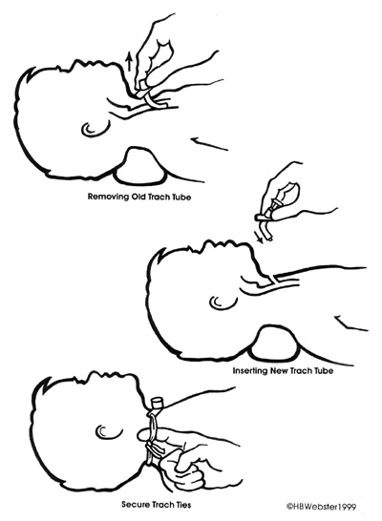
- Movie of Aaron having his trach tube changed; Download File
(2 MB mpg file. Please wait for file to completely download before playing)
- Quicktime Video of a trach tube change
(from ElectricAirway at Virtual Children's Hospital)
- Flicienne changing the canula

Tracheostomy Ties
Tracheostomy ties will need to be changed more often than the tube if they become soiled, wet, loose or cause pressure on the child's skin. Some specialists recommend changing ties daily, although this is usually not necessary in home care. However, infants with short fat necks, overweight children, and children on high humidification will probably need daily tie changes. Trach tie changes should also be done with two people. Twill tape comes with the tracheostomy tube or by the roll. If possible, secure new ties before removing old ties to decrease chances of the trach tube dislodging. There are several different techniques for securing the tracheostomy ties. The important things to remember are to use a knot, not a bow, and to be sure the ties are snug, but not too tight. You should be able to slip one finger under the ties. Change the position of the knot slightly with each change to avoid skin breakdown from the knot. If skin irritation does occur, place a gauze pad under the ties or use soft Velcro ties instead.
Check tension of trach ties several times a day, because ties may loosen.

Some Ways to Secure Trach Ties
- Use one long piece of twill tape and thread half the length through one side of trach tube. Then bring one end around the back of the neck and through the other side of the trach tube and tie the two ends in a triple knot in the back of the neck.
- Mallinckrodt (maker of Shiley Tracheostomy Tubes) recommends cutting two lengths of twill tape, each long enough to fold in half and still reach around the child's neck. Thread the folded end of one of the ties through one of the holes on the trach tube, going from skin side out. Pull the tie through until it forms a loop. Draw the ends through the loop until the tie is secured to the tube. Repeat on the other side of the trach tube. Bring the loose ends of both ties around to the back of the neck and tie them together using a square knot.
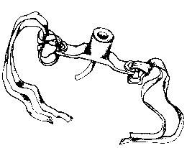
- Cut two pieces of twill tape long enough to fit around the neck and tie. Cut the tie at an angle to prevent fraying. Cut a 1/4 inch slit in each tape about 1 inch from the end. Insert the cut end of the tape through the neck plate hole from back to front. Pull the other end of the tape through the hole in the tape using tweezers or hemostats. Pull tightly while holding the tube. Repeat this on other the other side. Bring both ties together and tie in a triple square knot.
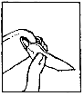
- Velcro straps, such as the Dale tracheostomy tube holder. Note: Velcro holders are comfortable and easy to adjust; however, keep in mind that toddlers and children with developmental disabilities may be able to release Velcro. If you clean and reuse Velcro ties, be sure the Velcro still holds securely after washing.
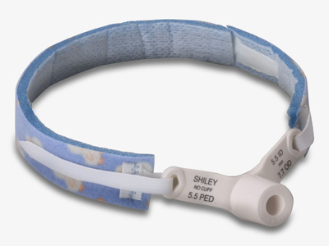
Dale Medical Products, Inc.
- Cotton shoe laces can be fun, as they come in many different colors and designs and are easy to thread.
- Umbilical cord tape or hemming tape from a sewing store can also make good trach ties.
- Metal trach holders are good because they do not trap moisture and they are reusable. However, they are also hard to find. Some parents have had these custom made by jewelers. Note: Keep wire cutters handy incase of an emergency when using metal trach holders.
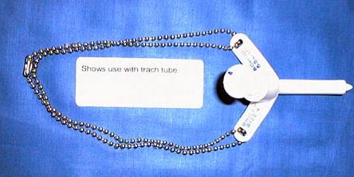
Metal Tracheostomy Tube Holder
More on Chain Tracheostomy Holders
Dog-tag chains (army ID tag chains) can also be adapted for a chain trach holder. Check your local Army Surplus store. For ties other than metal, keep a sample size tie handy for easy measuring and cutting of new ties.
- Gold Chain Tracheostomy Holder
- New Vent-Tie(R), combination trach tie and ventilator anti-disconnect device.
- Stronghold Anti-Disconnect
You may find it easier to place your child in a sitting position to adjust and tie the trach ties.

Risk Factor Associated with Difficult Tracheostomy Tube Changes
- When the stoma is scarred, calcified, distorted or obscured by granulation tissue
- When the trachea is deviated or rotated
- When the trachea is narrowed or smaller than normal
- When the patient is a child
- When the patient is obese
- If the tube must be placed quickly in an emergency
- If it is a new or recent tracheostomy
- If the person performing the change is not well-trained

Techniques for a Difficult Trach Change
- The obturator helps make insertion easy and trauma-free. Always keep an obturator on hand should the tube need an emergency change.
- Reposition the child if needed
- If the tube cannot be completely inserted, hold the tube in place, remove the obturator to let the child breathe, then continue to insert to tube.
- If still unable to insert tube, remove the tube, re-lubricate and try again.
- If this is unsuccessful, try to insert the one size smaller tube.
- Try spreading the skin around stoma and try to insert tube as the child is breathing in.
- If needed, insert a suction catheter through the smaller tube and guide the suction catheter into the trach stoma. Then slide the trach tube over the suction catheter and into the stoma. Remove the suction catheter. Click on thumbnail
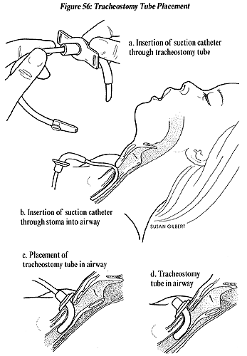
Illustration Source:
The Center for Pediatric Emergency Medicine (CPEM), Teaching Resource for Instructors in Prehospital Pediatrics. Illustrations by Susan Gilbert. http://www.cpem.org/html/giflist.html
- If all else fails, cut a section of suction catheter to place it into the stoma in order to keep the stoma open and maintain an airway. Be sure to cut the catheter long enough so that it cannot be aspirated! Hold on to the catheter and call emergency services.
- Give supplemental oxygen if needed and available
Do not force tube! If you absolutely cannot get any tube or catheter into the stoma, and the child is breathing fairly comfortably (through the stoma or through the mouth and nose), go immediately to the emergency room. Sometimes, the airway can be made worse by a trach tube inserted in the wrong place.

Suctioning a Tracheostomy
The upper airway warms, cleans and moistens the air we breath. The trach tube bypasses these mechanisms, so that the air via the tube is cooler, dryer and not as clean. In response to these changes, the body produces more mucus. The trach tube is suctioned to remove mucus from the tube and trachea to allow for easier breathing. Generally, the child should be suctioned every 4 to 6 hours and as needed. There may be large amounts of mucus with a new tracheostomy. This is a normal reaction to an irritant (the tube) in the airway. The heavy secretions should decrease in a few weeks. While a child is in the hospital, suctioning is done using sterile technique, however a clean technique is usually sufficient for most children at home. If your child has frequent respiratory infections, trach care and suctioning techniques may need to be addressed. Frequency of suctioning will vary from child to child and will increase with respiratory tract infections. Try to avoid suctioning too frequently. The more you suction, the more secretions can be produced.

Care Techniques
- Sterile Technique: sterile catheters and sterile gloves
- Modified Sterile Technique: sterile catheters and clean gloves
- Clean Technique: clean catheter and clean hands
The size of the suction catheter depends on the size of the tracheostomy tube. Size 6, 8 or 10 French are typical sizes for neonatal and pediatric trach tubes. The larger the number, the larger the diameter of the suction catheter. Use a catheter with an outer diameter that is about half the inner diameter of the artificial airway this will allow air to enter around it during suctioning. You can also compute the catheter size with this formula: Multiply the artificial airways diameter in millimeters by two. For example, 8 mm X 2 = 16, so a 16 French catheter. Also see Tracheostomy Sizing Chart for recommended catheter sizes for specific Bivona and Shiley pediatric tracheostomy tubes.
Older children may be taught to suction themselves.

Suction Depths
- Shallow Suctioning: Suction secretions at the opening of the trach tube that the child has coughed up.
- Pre-measured Suctioning: Suction the length of the trach tube. Suction depth varies depending on the size of the trach tube. The obturator can be used as a measuring guide.
- Deep Suctioning: Insert the catheter until resistance is felt. (Deep suctioning is usually not necessary. Be careful to avoid vigorous suctioning, as this may injure the lining of the airway).

Signs That a Child Needs Suctioning
- Rattling mucus sounds from the trach
- Fast breathing
- Bubbles of mucus in trach opening
- Dry raspy breathing or a whistling noise from trach
- Older children may vocalize or signal a need to be suctioned.
- Signs of respiratory distress under Tracheostomy Complications

Equipment
- Suction machine
- Suction connecting tubing
- Suction catheters
- Normal saline
- Sterile or clean cup
- 3cc saline ampules (“bullets”)
- Ambu bag
- Tissues
- Gloves (optional for home care, use powder-free gloves)
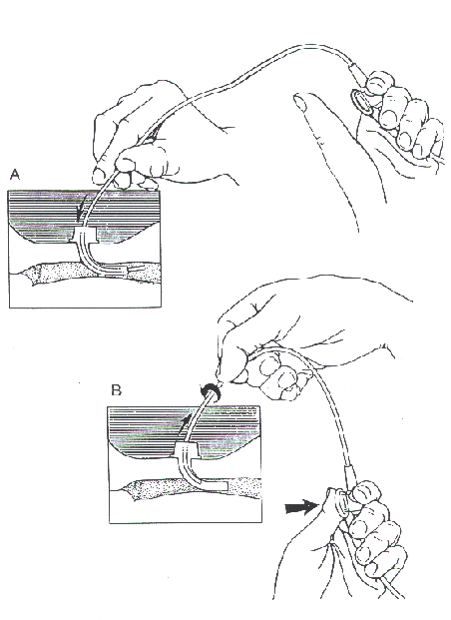
Illustration courtesy of the Department of Otolaryngology, Cincinnati Children's
Hospital Medical Center, Cincinnati, Ohio

Suctioning a Tracheostomy

Procedure
- Explain procedure in a way appropriate for child's age and understanding.
- Wash hands.
- Set up equipment and connect suction catheter to machine tubing.
- Pour normal saline into cup.
- Put on gloves (optional).
- Turn on suction machine (suction machine pressure for small children 50-100mm Hg, for older children/adults 100-120mm Hg)
- Place tip of catheter into saline cup to moisten and test to see that suction is working.
- Instill sterile normal saline with plastic squeeze ampule into the trach tube if needed for thick or dry secretions. Excessive use of saline is not recommended. Use saline only if the mucus is very thick, hard to cough up or difficult to suction. Saline may also be instilled via a syringe or eye dropper, which is less expensive than single dose units. Recommended amount per instillation is approximately 1cc.
- Gently insert catheter into the trach tube without applying suction. (Suction only length of trach tube - premeasured suctioning. Deeper insertion may be needed if the child has an ineffective cough.)
- Put thumb over opening in catheter to create suction and use a circular motion (twirl catheter between thumb and index finger) while withdrawing the catheter so that the mucus is removed well from all areas. Avoid suctioning longer than 10 seconds because of oxygen loss. Note: Some research has shown that by applying suction both going in and then out of the tube takes less time and therefore results there is less hypoxia. Also, there are now holes on all sides of the suction catheters, so twirling is not necessary.
- Draw saline from cup through catheter to clear catheter.
- For trach tubes with cuffs, it may be necessary to deflate the cuff periodically for suctioning to prevent pooling of secretions above trach cuff.
- Let child rest and breathe, then repeat suction if needed until clear (allow at least 30 seconds between suctioning).
- Oxygenate as ordered (extra oxygen may be given before and after suction to prevent hypoxia).
- Some children need extra breaths with an Ambu bag (approximately 3 - 5 breaths). Purposes of bagging: hyperoxygenation, hyperinflation, and hyperventilation of the lungs. However, this is usually not needed for stable children with no additional respiratory problems.
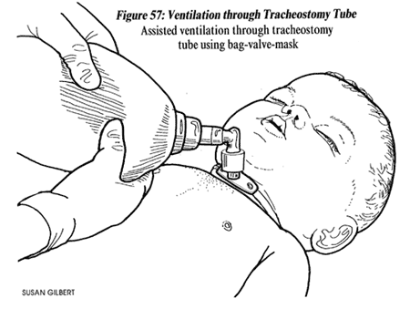
Illustration Source:
The Center for Pediatric Emergency Medicine (CPEM), Teaching Resource for Instructors in Prehospital Pediatrics. Illustrations by Susan Gilbert. http://www.cpem.org/html/giflist.html
- The child's mouth or nose may also be suctioned, if needed after suctioning the trach, then dispose of that catheter (do not put same catheter back into trach).
- Turn off the machine, dispose of the suction catheter, saline and gloves. In home care, catheters may sometimes be used more than once before disposal or cleaning if the child needs frequent suctioning. Keep the tip of the catheter clean, and store it in the original package. Some catheters have a protective sleeve to help keep it clean.
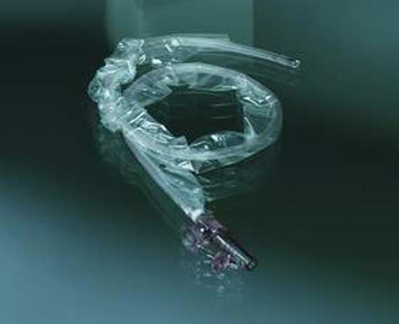
Bard Medical Division Tracheal Suction Catheter
- A bulb syringe may be used between suctioning if the child is able to cough up some secretions on his/her own.
- Be aware of color, odor, amount and consistency of the secretions and notify doctor of changes in secretions.
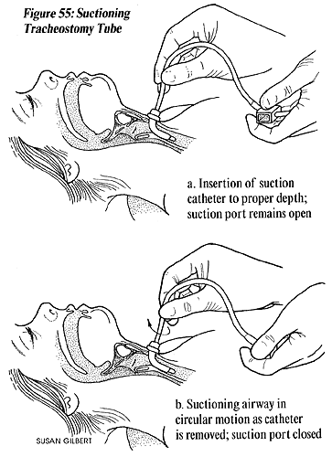
Illustration Source:
The Center for Pediatric Emergency Medicine (CPEM), Teaching Resource for Instructors in Prehospital Pediatrics. Illustrations by Susan Gilbert. http://www.cpem.org/html/giflist.html

Other Suctioning Devices
- A newer suction technique, which is used most often in hospitals for children on ventilator support is a closed multiuse catheter system, also called an "in-line" catheter. This closed system allows suctioning without disconnecting the ventilator. The catheter is protected inside a sleeve and is usually changed only once a day.
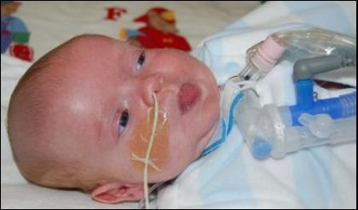
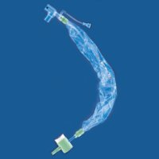
Ballard® in-line catheter
- In addition to a stationary suction machine, small, portable, battery-operated suction machines are available for travel. The batteries are rechargeable or the machine can be plugged into a car cigarette lighter.
- The DeLee suction trap is a small plastic suction device. The caregiver sucks on a tube to create a negative suction pressure. (The secretions are collected in a sputum trap and do not come in contact with the caregiver.)
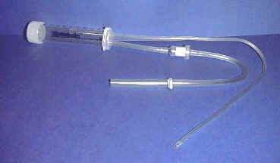

DeLee Suction Trap
- Luer lock syringe with a suction catheter attached. Disconnect the suction catheter from the thumb hole apparatus and attach the end of the catheter to the syringe. (Use size 8 or 10 french suction catheter)
- Bulb syringes can be useful for removing mucus at the opening of the tube, but does not replace routine suctioning of the length of the trach tube.
- Bulb syringe can be modified by cutting off tip of bulb syringe and inserting suction catheter hub into opening. To use, squeeze bulb, insert catheter into trach tube and release bulb (always remove catheter before squeezing bulb).
- The CoughAssist is an alternative to traditional suctioning that is especially helpful for those with an ineffective ability to cough. The CoughAssist assists patients in the removal of bronchial secretions from the respiratory tract. This is a new, vacuum-like, non-invasive technique. (See: Respironics, Inc.)
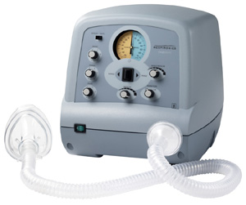
CoughAssist
- Hand-operated suction systems such as the RES-Q-VAC provides suction anywhere and anytime and is totally portable.
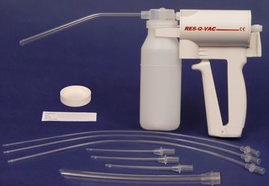
Hand-powered Suction Device
Encourage your child to cough; this also helps to clear the airway and lungs. Using chest P.T., postural drainage and percussion as needed to maximize airway clearance.

Tracheostomy Complications

Respiratory Distress and Tube Obstruction
Mucus plugs are the most common cause of respiratory distress for children with tracheostomies. Symptoms of a mucus plug include resistance when trying to suction or bag and/or signs of respiratory distress.

Symptoms of Respiratory Distress
- Difficulty breathing
- Increased respiratory rate
- Increased heart rate
- Grunting, noisy breathing
- Stridor (audio file) (video file)
- Whistling noise when breathing
- Cyanosis (pale, blue color around lips, nail beds, eyes)
- Restlessness
- Sweaty, clammy skin
- Retractions (pulling in of the skin between the ribs, and below the breast bone, above collar bones or in the hollow of the neck)
- Anxiety, frightened look
- Flared nostrils
- Change in pulse or blood pressure
- Infants may have trouble sucking
- Difficulty or refusing to eating
- Inability to wake the child
- Head bobbing due to use of strap muscles for breathing
- Reduced airflow through the tube
- More comfortable with head elevated or sitting up
- Low O2 saturations for children with a home pulse oximeter
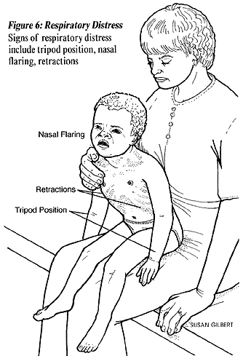
Illustration Source:
The Center for Pediatric Emergency Medicine (CPEM), Teaching Resource for Instructors in Prehospital Pediatrics. Illustrations by Susan Gilbert. http://www.cpem.org/html/giflist.html
Suction trach or change trach tube as needed for respiratory distress. The tube may have become blocked with dried secretions or blood. If symptoms do not clear with suction or trach change, call the doctor or 911, go directly to the emergency room, or call an ambulance.

Bleeding
Very small amounts of bleeding (pink or red streaked mucus) often occurs as a result of routine suctioning. This bleeding can be managed with close observation and by modifying the care that might have caused the problem.

Possible Causes of Minor Bleeding
- Irritation to the fragile tissue around the stoma
- Insufficient humidity to the airway
- Too frequent, deep or vigorous suctioning
- Suction pressure that is too high (Suction machine pressure for small children 50-100mm Hg, for older children/adults 100-120mm Hg)
- Infection
- Trauma, manipulation of trach
- Foreign object in the airway
- Excessive coughing
Call your doctor, emergency services, or go directly to your local emergency room for a significant amount of bright red bleeding from the tracheostomy.

Infection
Children with tracheostomies are at high risk for respiratory infections. The trach tube bypasses the natural defenses (nasal hair and mucus membranes) of the upper airway that filter out dust and bacteria. Also, monitor for local infections at the stoma site. Hand washing before any trach care is one of the best defenses against infection.

Symptoms of Infection
- Yellow or green secretions (may be pink/blood tinged)
- Thicker mucus
- Increased amount of mucus
- Redness, rash and/or inflamed at stoma site
- Bleeding at stoma site
- Foul odor
- Elevated temperature (fever)
- Congested lung sounds
- Increased respiratory effort or change in respiratory rate
- Listlessness
- Discomfort with trach care, tender at stoma site
Tracheitis
A dry tracheitis is an infection in the trachea that may develop if humidification of the airway is inadequate.
Call the doctor for symptoms of infection.

Other Complications
Tracheal Stenosis
Scar tissue at the site of the tracheostomy tube, often from excessive trach cuff pressure.
Tracheoesophageal Fistula
An abnormal connection between the trachea and the esophagus resulting from erosion of the back wall of the trachea.
Granuloma (common)
A growth of inflammatory tissue, which is caused by the irritation of the airway by the tracheostomy tube.
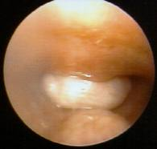
Granuloma inside trachea, just about trachoestomy tube. (white area)
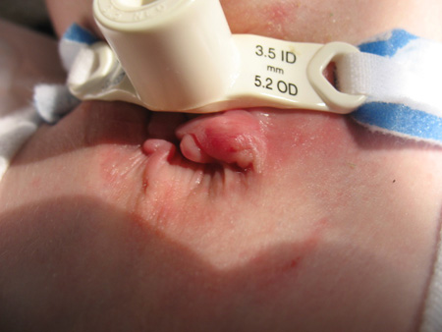
Granuloma at stoma (Photo courtesy of Kerry S. Baldwin)
Pressure Necrosis
Infants with short, fat necks or children on mechanical ventilation may develop infections or pressure sores of the skin and soft tissue around the trach site. Inspect skin daily.
Tracheoinnominate Fistula (rare)
An erosion of the tube into a large artery that runs in front of the trachea. Hemorrhage could lead to death if not stopped.

Accidental Decannulation (What to Do If the Trach Tube Comes Out Accidentally)
- Try to Stay calm
- Reinsert tube immediately even if conditions are not ideal.
- There should always be two spare trachs with the child at all times, the child’s size and one size smaller for emergency replacement. If the regular size does not fit, then the smaller size will keep the airway patent (open). Keep two trach tubes taped at the head of the child’s bed and in your travel bag. Always keep blunt-nosed scissors handy to cut trach ties.
- Opening the airway is always the first priority. If a spare trach tube is not handy, replace the one that came out. Later, when the situation is under control, you can replace it with a clean trach tube.
- If you cannot reinsert the tube, observe the child to see if he/she can breathe through the stoma itself. This may be possible if the stoma is well healed and fairly large. The child may also be able to breathe through the nose and mouth if there is no severe obstruction above the trach site. Go immediately to the emergency room.
- Comfort the child when situation is under control.
- See Changing Tracheostomy Tube, which includes, "Techniques for a Difficult Trach Change."
- Children with trachs are often on some type of monitoring device (apnea monitors or pulse oximeters) when not directly supervised (naps and bedtime), to alert caretakers in the event of a problem such as accidental decannulation or a mucus plug. Ask your physician about these devices and if they would be appropriate for your child.
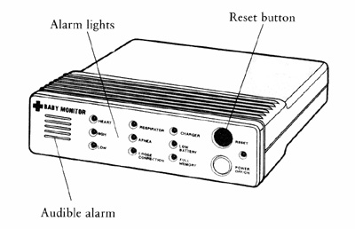
Cardiac Apnea Monitor
- A less sophisticated but useful alarm is to attach bells to the child's legs and/or arms. However, be sure that the bells cannot be removed or swallowed!
- It may be comforting to have the child sleep in the same room with you for closer monitoring, particularly infants and young children.

What to Do If Your Child Pulls on the Trach Tube
- Caring for a child with a tracheostomy may cause anxiety. Try not to let the child see that you are anxious.
- Try not to make a big deal about the trach, particularly if the child touches the trach tube. They will learn very quickly that by touching or pulling the trach tube, they receive attention, which tends to reinforce the behavior.
- Once children develop a pattern of pulling on the trach tube, it is more difficult to control, especially for young children and children with developmental disabilities. A Tracheostomy Collar may be helpful in preventing the child from pulling out the tracheostomy tube. A trach collar is like a belt with a hole in the center for the trach tube opening, then it fastens in the back of the neck. Check with your doctor or medical supply vendor.

CPR with a Tracheostomy
All parents and caregivers should be trained in cardiopulmonary resuscitation (CPR). In fact, infant and child CPR classes for parents are required before a baby can be discharged from many Neonatal Intensive Care Units (NICU). Although it is not the purpose site to teach CPR, I would like to point out some important differences when delivering CPR to an infant or child with a tracheostomy tube.

If the Child is Not Breathing
- Open the airway using the chin lift, but do not hyperextend the neck.
- Suction the trach tube.
- If the trach has an inner cannula, remove the inner cannula and suction slightly past (mm) the length of the trach tube.
- Change the trach tube if plugged or dislodged.
- Give two gentle puffs of air into the trach tube using an Ambu bag (breathing bag) with trach adapter or mouth to trach technique.
- If air leaks from nose and mouth, hold them closed.
- If the tube is obstructed or lost, it may be possible to give ventilation by sealing your mouth over the stoma and blowing or place the face mask of ambu bag over the stoma (gently, just enough to cause the child’s chest to expand).
- If the child's airway is not obstructed, you can use mouth to mouth resuscitation by closing the stoma with your finger.
- Give CPR as indicated.

Breathing Problems
Bronchitis
Bronchitis occurs when the bronchial tubes thicken, and become inflamed and or infected. This causes less air to flow into and out of your lungs. A thick greenish or yellowish mucous is produced. Coughing will be frequent and painful. A brief episode of bronchitis is brought on by a severe cold or viral infection.Chronic bronchitis is often referred to as "smoker's cough".
Chronic Cough
A cough that lasts a month or more is a chronic cough. A chronic cough can occur at any time in the day, it may only occur in the morning for one person, and in the afternoon for another person. It is also true whether it is a dry cough or a productive cough, one that brings up sputum. A productive cough that lasts for several weeks or comes back every year is usually a sign of chronic bronchitis.
Allergies are one of the most common causes of a chronic cough. In some cases, a decongestant drug may decrease allergic coughing. A chronic cough can also signal asthma, or even cancer. A cough that causes shortness of breath, extreme pain, or blooding of the throat should get medical attention right away. Taking cough drops or syrups for more than a week may only mask the illness while it gets worse.
*Long term use of cough syrups will only hide an illness as it keeps getting worse.
Chronic Obstructive Lung Disease
Chronic Obstructive Lung Disease, also called Chronic Obstructive Pulmonary Disease, COPD. Chronic bronchitis or emphysema, are the most common causes of COPD. Early symptoms of COPD include chronic bronchitis and emphysema. Chronic lung disease is the fifth leading cause of death in the United States. Smoking is the leading cause of COPD. If you want to know more about chronic obstructive lung disease, call your local chapter of The American Lung Association or (800) LUNG-USA.
Emphysema
Emphysema is a chronic disease that makes it hard to breathe because of physical changes in the air passages. When a person has emphysema the walls of the air sacs within the lungs, called alveoli, break down and over-inflate. The oxygen and carbon dioxide gas exchange that occurs in the lungs is slowed down. This person will experience chronic cough, shortness of breath, and ongoing lung infections. It is possible in extreme cases of emphysema that the person will have severe difficulty breathing, especially exhaling. Emphysema is known to lead to COPD
Pneumonia
Pneumonia is an infection of the lungs, caused by a build-up of fluid in the lung's tiny air sacs. This means that less oxygen is being delivered to the blood. Resulting in an enormous strain on the heart and lungs. Pneumonia usually strikes people who are ill or elderly . It is the sixth leading cause of death in the United States. The lung infection can be caused by several agents, including bacteria, virus, fungus, and parasites. Pneumonia symptoms include coughing, sputum, chest pain, shaking chills, and fever. A small cold or flu may be your first symptom.
Pneumothorax
Pneumothorax is a collapsed lung. This happens when air collects in the space between the lung and the chest wall. The more air on the outside of the lung, the greater the risk. If the pressure on the outside is greater than the pressure on the inside it can result in fatality.
Pneumothorax may be a result from a puncture due to surgery, biopsy or other medical procedures. A gunshot or knife wound are also causes. A lung can rupture during exercise or coughing, this is the most sudden form of pneumothorax. Collapsed lung is a common problem in premature infants. These infants may have rapid, grunting breathing and bluish color. Adult signs of collapsed lung are sudden, sharp chest pain, uneven chest wall movement, shortness in breath, and blue colored lips and fingernails. In severe cases the person may have a very weak yet rapid pulse, pale skin, bulging neck veins, and a hard time breathing. A minor rupture may cause no symptoms at all.
Pulmonary Embolism
Pulmonary embolism is a blockage in a lung artery by a blood clot. About 2% of cases are fatal do to the blood supply to a large part of the lung being cut off. Blood clots in the lungs often begin with clots in the legs. You are more likely to have clots after surgery, stroke, long term bed rest or inactivity.
Symptoms of clots in the lungs include a sudden shortness of breath, chest pain, coughing up blood, or a low fever. A person with a large clot can pass out, appear blue in color, and have bulging neck veins. Most clots resolve with 10 to 14 days. Oxygen therapy and blood thinners will help prevent further blood clots.
**Extreme cases may require emergency surgery.
Sleep Apnea - Infants
Sleep Apnea occurs when normal breathing stops during sleep. If it happens to infants it can be fatal. Premature babies have a higher risk. As the baby reaches their original due date, the risk goes down. Apnea often occurs in Sudden Infant Death Syndrome, or SIDS, which refers to unexplained death. Possible causes include:
- immature breathing control in the brain
- bleeding in the brain during delivery
- exposure to drugs or poisons
- a blocked airway, for example by a relaxed tongue
- a birth defect
- low blood sugar.
The hospital staff often notice sleep apnea soon after birth. Sometimes an extended hospital stay is required. Ways to prevent sleep apnea in high risk infants include:
- laying the baby flat on their back or on their sides
- keeping the neck slightly extended
- drugs similar to asthma drugs
- oxygen therapy
Snoring and Sleep Apnea - Adults
20% of adults have a sleep disorder known as "obstructive sleep apnea". The muscles at the back of the roof of the mouth relax and sag during sleep, this causes snoring. "Apnea" came from the Greek word "without air". Snoring is interrupted with pauses in breathing, then loud gasps, when the loud snoring resumes. Most sleep apnea sufferers are overweight, middle-aged men. Loud chronic snoring is the first sign of obstructive sleep apnea. This will also disrupt the sleep of the snorer's partner.
Sleep apnea will effect the daytime performance of the suffer
- daytime fatigue
- difficulty concentrating
- anxiety, irritability, or depression
- greater potential for falling asleep while driving
- cardiovascular problems, such as high blood pressure, heart attack, or stroke.

Airway Management & Mechanical Ventilation Basics

The goal of airway management is to ensure that the patient has a patent airway through which effective ventilation can take place. An obstructed airway causes the body to be deprived of oxygen and, if ventilation isn’t reestablished, causes brain death within minutes. When a patient is critically ill and requires an artificial airway and mechanical ventilation, it is the responsibility of the healthcare professionals caring for the patient to ensure that the airway is secure, and that it’s as close to the patient’s natural airway as possible. This means mechanically performing physiological functions such as humidifying inspired air and removing secretions.
Mechanical ventilation is used when a patient is unable to breathe adequately on his or her own. The ventilator can either completely take over respiratory function, or it can be used to support the patient’s own respiratory efforts.
Indications for Mechanical Ventilation
The patient experiencing respiratory failure or arrest is the first type of patient most of us think of when we hear “mechanical ventilation.” The code scenario described above is a classic clinical situation; if the patient survives the code, we know he will be transferred to the ICU on a ventilator. Similarily, any patient experiencing respiratory distress with impaired gas exchange or increased work of breathing is likely to be intubated and mechanically ventilated, hopefully before he or she reaches the point of respiratory arrest.
Mechanical ventilation can also be used in other situations. For example, relieving the work involved with breathing decreases myocardial and systemic oxygen consumption. This is particularly beneficial for patients who have both respiratory and cardiac failure. The increased work of breathing resulting from respiratory distress or fatigue puts extra stress on the heart, which can lead to a cardiac event. A diminished work of breathing also decreases intracranial pressure, thus mechanical ventilation is often used in patients with brain injuries.
In some cases, it’s advantageous for a patient to be heavily sedated or even pharmacologically paralyzed. Patients with brain injuries may be placed in a barbituate coma in order to decrease the metabolism and use of oxygen in the brain. This facilitates healing and reduces the risk of further ischemic brain injury. Likewise, patients who are admitted after ingesting drugs or alcohol, or who are experiencing drug or alcohol withdrawal, may be violent and a safety risk to themselves and others. They may be pharmacologically sedated and paralyzed during this time, especially if they are hospitalized for another physical problem or injury that could be exacerbated by their behavior, such as myocardial infarction, trauma, or after surgery.
Finally, mechanical ventilation may be used to provide stability of the chest wall after trauma or surgery if movement or coughing would disrupt broken bones or surgical incisions. In this case, the patient would likely be heavily sedated and pharmacologically paralyzed to inhibit any spontaneous movement.

Definition
Aerosol drug administration is the administration of a drug via air particles delivered by an appropriate device that is inhaled and absorbed into the patient's body via the lungs.

Purpose
Aerosol administration of drugs is indicated in circumstances where rapid absorption and localization effects of the drug are required to produce the appropriate response. Aerosol administration methods are most commonly used in asthmatic conditions or specific lung conditions that cause difficulty in breathing. Diseases including emphysema, asthma, chronic obstructive pulmonary disease (COPD), and other similar conditions warrant and necessitate the use administration of drugs by this route of administration.

Precautions
Aerosol administration in itself is generally a safe practice, as long as the health care provider or client is well educated in its use. It is contraindicated in conditions where complete obstruction of the airway is present, as the administration route is completely blocked. Such conditions, however, are usually resolved rapidly in emergency situations.

Description
Aerosol drug administration, also known as inhalation therapy, or in some cases, nebulized drug therapy, is the method by which drugs are dispersed into the lungs or bronchial airways in the form of tiny droplets—often bound to water, oxygen, or another gaseous substance. Drugs are generally delivered by two means. The first is via a device called a nebulizer. The nebulizer is a mechanical pump (of which there are many types) that produces a fine mist in which the drug is dispersed via an appropriate nebulizer-compatible face mask. This fine mist is inhaled deep into the lungs for maximum effect. The second method of delivery is via a hand-held, nebulized aerosol device. These devices, also known as "puffers," use the effects of a pressurized gas to create and disperse the drug into a fine mist or spray, which is then inhaled.
Both methods of aerosol inhalation are very effective when used correctly. In cases of extreme breathlessness or dyspnea (labored or difficult breathing), the mechanical pump nebulizers are generally more effective, as they disperse the drug over a longer time period; this, in turn, gives the recipient a longer time period, allowing the airways to open more effectively.
In terms of medical treatment costs and medication costs, aerosol drug administration is relatively inexpensive. Nebulized therapy via a mechanical pump is usually completed within five to ten minutes. Delivery of drug via hand-held devices is completed within a few seconds.

Procedure for effective mechanical pump nebulization
- The nebulizer solution and equipment specific to the type of pump being used should be prepared. If necessary, the instruction guides should be consulted. (Detailed instruction is beyond the scope of this guide due to the vast number and variety of pumps available.)
- An appropriate face mask is obtained.
- The recipient should be placed in a comfortable, upright position that is greater than 45 degrees. This will enable maximum breathing efficiency. A hospital bed with an adjustable backrest, or a chair with good back support, is adequate. The comfort of the recipient should be ensured and maintained throughout the procedure.
- The client should be reassured. Often, when a patient is suffering from breathing difficulty, he or she becomes anxious and frightened. The nurse should do his or her best to relax and reassure the patient as much as possible. When relaxed, the airway has the best chance of recovery, and inhalation of the nebulized drug is assured.
- When patient is comfortable and in a suitable position, the nebulizer pump can be turned on. The nurse must confirm that a steady mist is flowing from the mask or application device.
- When a steady flow of mist is achieved, the nurse should fit the mask or application device correctly to the patient's face or trachea (if applicable).
- While nebulization and delivery of drug is occurring, the patient should be monitored for signs of reaction to the drug and for improvements or deterioration in breathing patterns.
- Once the procedure is complete, the patient's oxygen saturation level should be measured, if equipment is available. This measurement should be recorded and reported along with any other documentation.
- The recipient should be asked if the medication has had a positive effect. If not, further advice or orders should be sought from the physician.
- The nurse should provide education about delivery of the drug by inhalation to the recipient. He or she should also answer questions the recipient may have.

Procedure for inhalation from hand-held devices
- Again, there are many devices available that operate in different manners. A detailed description of each, however, is beyond the scope of this guide.
- For effective delivery of drug from these type of devices, it is essential that the medication is prepared properly, using the instructions supplied with the device.
- Once the medication has been prepared, the recipient must hold his or her lips one to two inches (3-5 cm) from the open mouth. The patient needs to breathe in deeply (powdered-drug-type devices), or breathe in deeply while depressing the canister (for canister/barrel type devices); this will allow the drug to be inhaled deeply into the airways and lung tissue.
- Positive responses should be observed or measured by the nurse.
- All data, as appropriate, must be recorded by the nurse. If treatment is note effective, further advice or orders should be sought.

Preparation
Generally, there are no specific pretreatment procedures, except for the set-up of equipment used for the procedure. The recipient generally requires no personal preparation in common use of this procedure.

Aftercare
Recipients should be monitored for signs of positive response to the drug. It is important to rinse the mouth following inhalation therapy, as drug residue can remain in the mouth and cause oral problems and tooth decay in some instances.

Complications
Complications are almost always related to the type of drug being delivered. Complications may also arise due to drug overdose. It is important in a hospital or clinic emergency environment, particularly with asthma sufferers, that the health care provider assess how much, and what type of medication, has been administered prior to the patient's arrival in the emergency department, to avoid such complications.

Gastrostomy Tube (G-Tube) Home Care
Your child has had a tube placed in his / her stomach called a gastrostomy tube or g-tube. This tube provides an alternate way to offer food and / or medicines. It also can be used to vent your child's stomach for air or drainage.
When the tube is first placed in your child's stomach it may or may not be secured with a stitch through the skin and around the tube. This helps the tube stay in place until the gastrostomy tract is well healed. If your child has a stitch around the tube, healing takes place in about 21 days. A tract will form between the stomach and skin in about 3 months. Your doctor may talk to you about changing the tube at this time.

Supplies Needed
- Clean work area
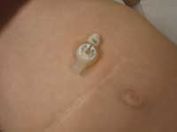
- Soap and water
- Clean gauze pads
- Scissors
- Tape
- Syringe for flushing
- Water for flushing

Cleaning and Dressing the Wound
- Wash your hands with soap and water.
- Remove old dressing. Look at the area where the tube enters the skin. Check for redness, swelling, any drainage or excess skin growing around the tube. A small amount of clear tan drainage can be normal.
- Wash skin around the tube with soap and warm water. Clean around g-tube to remove any drainage and / or crusting. Clean around suture gently. Dry skin thoroughly. The site should be kept clean and dry.
- Redress as you have been instructed by your doctor or nurse. Anchor the end of the tube by putting a piece of tape around the tube and pinning it to a folded piece of tape on his / her stomach or pin it to his / her diaper or T-shirt. Onsies or tubular dressings also help safely secure the tube.
- Do not use ointments around tube site unless directed by your child's doctor or nurse.

Flushing the Tube
It is important to flush your child's g-tube before and after any tube feedings, before and after any medications or at least every eight hours.
Usually 3-10 ml of water will clear the tube; however, your doctor or nurse will tell you the amount to give your child.

Giving Medications
- Liquid medications may be injected directly into the tube after the tube has been flushed.
- For pills first check with your doctor or pharmacist before crushing any medications. Crush the medicines into a powder and mix with enough water to make a liquid (1-10 mls).
- For capsules, first check with your doctor or pharmacist before opening the capsule. Open and dissolve powder with enough water to make a liquid (1-10 mls).
- Remember: do not mix medicines unless directed by your health care team.

Venting the Tube
- You may need to vent your child's tube to remove excess air or fluid in your child's stomach. It can be done 2 different ways. Your doctor or nurse will tell you if this is needed.
- Open the G-tube port and attach to a drainage device (such as a mucous trap or drainage bag). You may be asked to measure and record the amount of drainage.
- Your physician may instruct you to vent the g-tube using a catheter-tip syringe and aspirating the excess air or gastric fluid from stomach. This is used for bloating, distension or gagging. You may be asked to measure and record any drainage and frequency.

Protecting the Tube
- Do not allow your child to pull on the tube. One piece, snap T-shirt works best for infants and toddlers. Keep the tube secured beneath the child's clothing.

Problem Solving
Problems | Causes | Solutions
G-tube was pulled out. | Numerous | Cover with small clean dressing and tape. Then call doctor or nurse. The g-tube needs to be put in as soon as possible within 1- 4 hours so the tract will not close. Bring your old tube to either the doctor's office or emergency room.
Redness and irritation around the stomach, soreness and foul odor. | May be caused by leakage or infection. | Continue routine care and contact your child's doctor. A skin barrier cream may be ordered at this time.
Leaking | Malfunctioning tube Increase air | Keep dressing clean and dry. Try more frequent venting. Call your child's doctor or nurse. The tube may need to be replaced.
Skin or excess tissue appears to be growing where tube enters skin. | Some children are more prone to this than others. | Call your child's doctor or nurse to discuss treatment.
G-tube is clogged. | Thick formulas or medication. | Try to slowly push warm water into the tube with a 10 ml syringe. Repeat steps every 10-15 minutes. Never put any object into the tube to unclog it. If you are unable to unclog the tube call your child's doctor or nurse.

Tips
- It is important that you know what type and size tube your child has. Be sure to check with your doctor or nurse to get this information.
- Discuss ways to develop oral motor skills for your child with your doctor.
- Always call your doctor or nurse if you have questions or problems.

Contact Us
For additional information on this or any Health Topic, please call the Family Resource Center, 513-636-7606, or your pediatrician.

