Firelands Regional Medical Center School of Nursing

Medical Surgical Nursing Advance Concepts

Diabetic Patient Education Interview and Assessment

Student Name:

GENERAL INFORMATION
38 | Age | male | Sex | single | Marital Status

Occupation: restaurant owner

Previous Diabetic Education:
 | Last Grade of School Completed: some college

PATIENT HISTORY
When diagnosed with diabetes? November 2011 | Type of diabetes: Type II

Previous hospitalizations for diabetes? |  | Yes | x | No | Dates/reasons:
 | High blood pressure
 | Heart problems (MI, CHF, angina, rhythm, pacemaker)
 | High cholesterol/lipids
In past | Alcohol |  | drinks/week
no | Smoke, (history > 100 cigs in lifetime) |  | cigs/day
 | Peripheral vascular (occlusive)
 | Kidney problems
October 2011. Drank a few beers occasionally. | Quit alcohol
 | Quit smoking date

FAMILY HISTORY
Family members with diabetes:
 | M
X | F
 | Sibling(s)
X | GP(s) grandmother
 | Children
Family history of premature CHD (MI or sudden death before age 55 in parent or sibling)? |  |  | Yes |  | No

Comments: relates one of their grandmothers had Diabetes, but not sure which one.

DISEASE PROCESS

Patient’s definition of diabetes: “I got the sugar” “I know that my sugar in my blood is too high at times”

Patient’s explanation of how controlled:

Current management:
x | Self
 | Family
 | Other
 | Diet
x | Exercise
x | Oral agent Glucophage 500 BID
 | Insulin

Current monitoring:
x | Self
x | Family: fiancée
x | Doctor
 | Other
 | Urine Method |  | Frequency |  | Usual results
x | Blood Method: | 1 touch | Frequency | 4x/week | Usual result: high (300+)
 | Keeps a record of urine/blood monitoring results?

MEDICATIONS
Oral agent : Glucophage |  | Dose: 500 mg |  |  | Times: 2x/day
Insulin |  | Dose |  |  | Times
Who draws up insulin? |  |  | Who administers insulin?
Sites used | Equipment used |  |  | Disposal

Other medications (prescription and OTC):
None

RESULTS
Glycosylated hemoglobin done?
X | Yes: 10.3 H
 | No
 | Unknown
Results:
Blood glucose done?
X | Yes: 288H
 | No
 | Unknown
Results:
Lipid profile done?
X | Yes: cholesterol HDL ratio 5.4H
 | No
 | Unknown
Results:
 |  | Cholesterol |  | Triglyceride | 30L | HDL |  | LDL
Urine albumin/protein done?
X | Yes: negative
 | No
 | Unknown
Results:
Blood Pressure:
X | Yes
 | No
 | Unknown
Usual Results: 122/74

Comments:

MEAL PLANNING
Follows special diet? |  | Yes | x | No | Describe:

Familiar with carb counting? |  | Yes | x | No | Calorie/Carb Level:

Follows diet described?
 | Always
 | Usually
 | Sometimes
X | Rarely
 | Never

Dietary restrictions/intolerance’s: none
Cultural/religious concerns: none | Appetite: good
Eating schedule/times: no breakfast, eats lunch, dinner and late night. Sometimes snacks in middle of night.
Who does shopping? fiancée | Who prepares meals? self and fiancée
Eats out (where, frequency): 3-4x’s/week
Problem areas/hardest part of following meal plan: | Staying away from fast food due to busy schedule

Height: 5’10” | Weight: 305# | Calculated BMI: 43.8 | Patient’s Weight goal: 260#

Sudden changes in weight? |  | Yes | x | No
Seen Dietitian before? |  | Yes | x | No

Comments: referred to Erie County Health Dept. dietician for more education and meal planning

EXERCISE/ACTIVITY

Type and amount of daily activity:
 | Sedentary
 | “Around the house”
 | Sports
 | Walking
x | Other: started exercising at the YMCA with a friend. Plays basketball, mild jogging, light cardio

Routine exercise program (walking, swimming, biking, etc.) | Type: Golfing | Frequency:1-2x/week

Limitations: shortness of breath with extensive cardio or running

Comments: has set goals to increase certain exercise level

ACUTE COMPLICATIONS
Has experienced symptoms of high blood sugar | x | Yes |  | No | When: “all of the time”
Symptoms identified:
 | Tiredness
x | Thirst
 | Blurred vision
 | Frequent urination
 | Nausea/vomiting
 | Other: nocturia, polyuria, increased hunger after napping
Action taken:
x | Monitored blood sugar
x | Adjusted self-care regime, i.e. food, medicine, diet
x | Called doctor
 | None
 | Other:

Comments: started checking blood sugar via 1 touch, however does not test on a regular basis, or take medication as ordered

Has experienced symptoms of low blood sugar |  | Yes | x | No | When:
Symptoms identified:
Weakness
Sweating
Dizziness
Shakes
Other:
Identifies causes of low blood sugar:
 | Too much medicine
 | Too much activity
 | Skipping/delaying meals
x | Doesn’t know
 | Action taken:

Wears/carries diabetic identification or card? |  | Yes | x | No

Comments:

CHRONIC COMPLICATIONS

Able to identify health problems or complications that occur related to diabetes?
x | Circulatory
x | Vision
 | Heart
 | Kidney infection
 | Amputation
 | Doesn’t know any

Comments:
Slight brown discoloration to bilat shin areas. Relates has a hard time seeing especially when driving at night.

EYE CARE
History of eye problems:
 | Cataracts
 | Glaucoma
 | Retinopathy
x | Visual impairment
 | Blindness
 | None

Regular eye checkups? |  |  | Yes |  | x |  | No
Frequency:
Date of last exam:
Were eyes dilated? |  |  |  | Yes |  | x |  | No

Comments: Relates used an eye exam machine at a medical center. Findings were: need to follow up with an eye doctor. Pt. did not make an appointment due to no health insurance.

PERIODONTAL CARE

History of teeth or gum problems:
 | Red, swollen, or bleeding gums
 | Difficulty chewing
 | Loose teeth
x | Dentures
 | Open sores
 | Bad breath
 | Mouth pain
 | None

Regular dental checkups? |  | Yes | x | No
Frequency:
Date of last exam: April 2010

Comments: had a couple of teeth pulled and wears a partial

DAILY LIVING CONCERNS
Feelings about having diabetes: relates needs to get it under control and be healthier, especially since he has a child now
Changes in lifestyle related to diabetes: started watching carbs/sugar intake by checking nutritional information on food packages and switching to diet soda.
Financial concerns: none
Travels/Hobbies: none

x | Knows others with diabetes
 | Attends support groups
x | Subscribes to any diabetes publications (PROVIDED)
x | Internet Resources (PROVIDED)

Comments: newly subscribed to American Diabetes Association Magazine

FOOT CARE
Any changes in skin, feet, legs?
No new changes, however, bilat shin have had a brownish discoloration for a long time
History of:
 | Foot ulcers
 | Toe/foot deformities
 | Amputation
x | Peripheral pain, numbness, or decreased sensation

Follows routine for foot care |  | x | Yes |  | No
Describe:
x | Daily shower/bath
x | Trims nails straight across
x | Applies lotion Lachydrin
x | Never goes barefoot
x | Inspects for cuts, blisters, sores
 | Wears special shoes
Sees podiatrist regularly |  |  | Yes | x | No
Frequency:
Date of last exam:

Comments: uses pumice stone while showering, applies Lachydrin lotion to bilat feet daily, wears cotton socks at all times and changes them frequently

COMPREHENSIVE FOOT ASSESSMENT:
Type your documentation of the complete detailed foot assessment in the left hand section below. Documentation of the + and – results for the filament testing on the foot diagram to the right will need to be done manually with pen afterwards.
Bilat pedal pulses strong and equal. All 10 toes present. Cap refill brisk and less than 3 seconds. Left hallux nail thickened. Bilat soles of feet and heels very dry, with copious amount of dead skin present. No cracks noted in between toes. Pt. denies pain.  Findings for filament testing are as followed:  LEFT foot: RIGHT foot:  - + 1. +  - + 2. +  - + 3. +  - - 4. +  - - 5. -  - + 6. +  - + 7. +  - + 8. +  - - 9. -  - + 10. + | 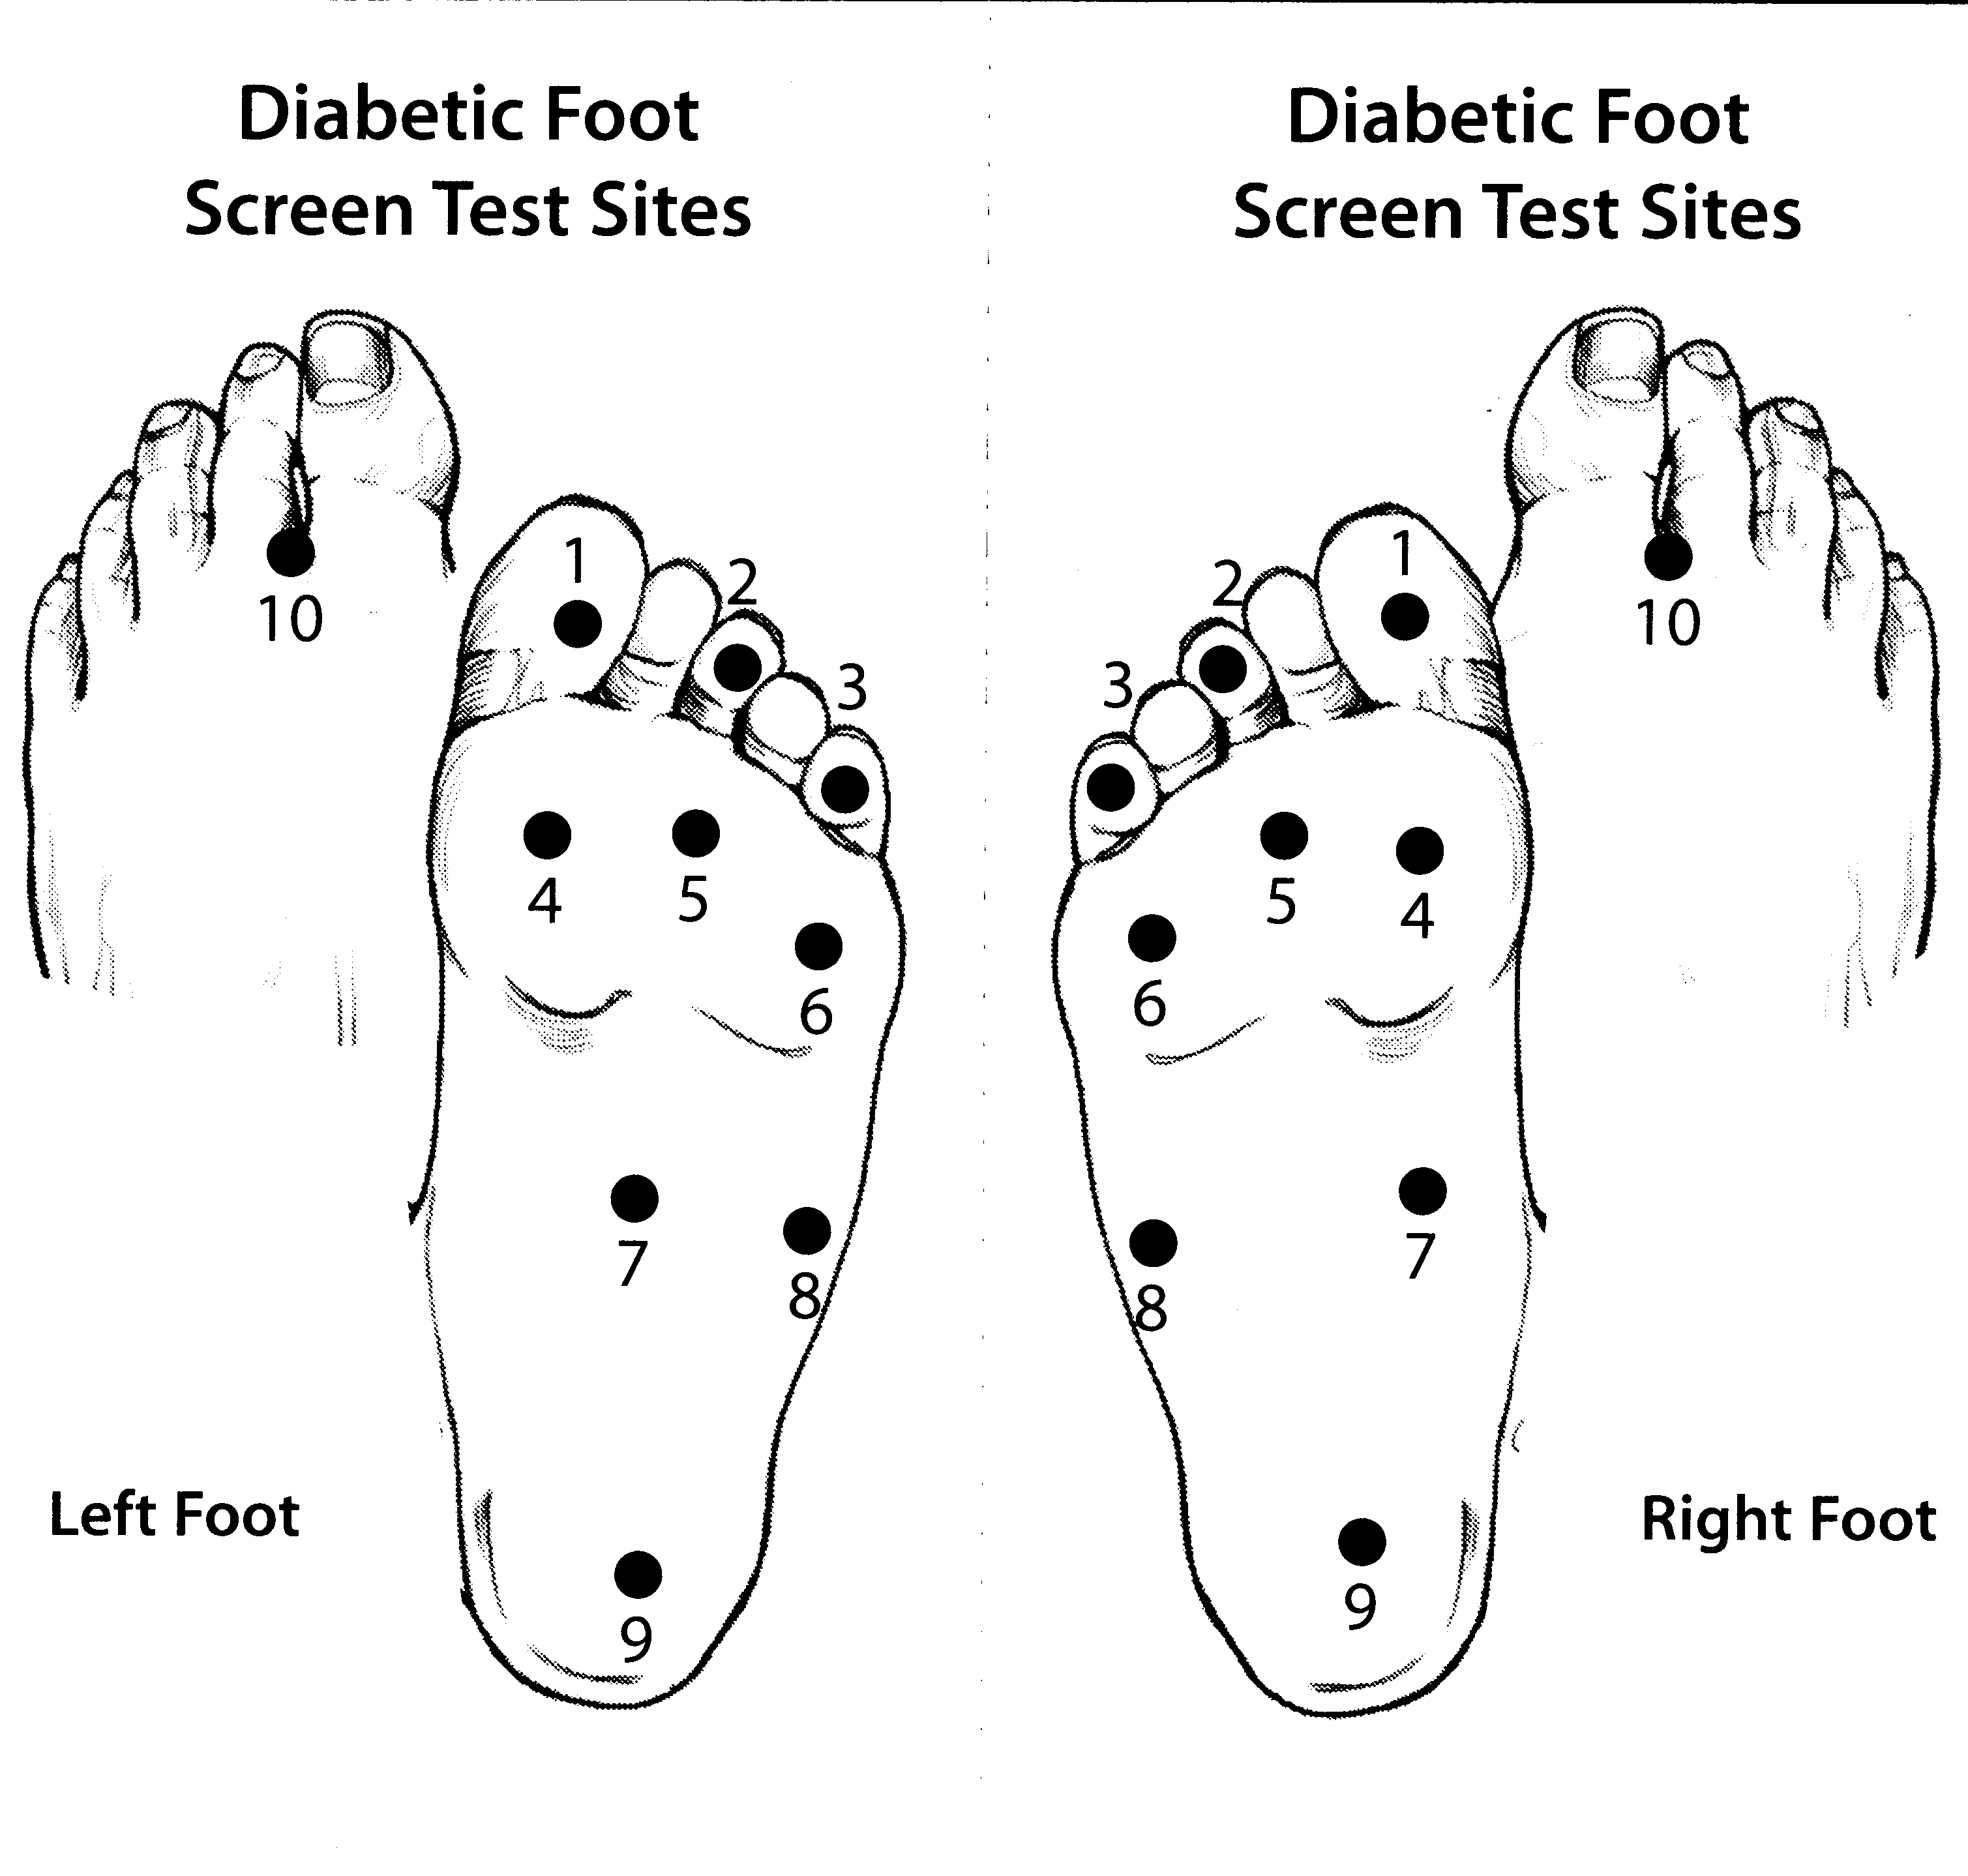

BARRIERS TO LEARNING/SPECIAL CIRCUMSTANCES:
 | Memory deficit
 | Is “homebound”
x | Erratic Work Schedule
 | Hand dexterity limited
 | Poor vision
 | Limited income
 | Cannot/poorly reads
 | Little/no support
 | Limited comprehension
x | Other: does not have health insurance. This is the reason he does not go to the doctors regularly

Comments:

(SILS) HEALTH LITERACY SCREENER Question: (Lewis, page 56) How often do you need to have someone help you when you read instructions, pamphlets, or other written material from your doctor or pharmacy?
Client’s response:
“Never. I can figure it out on my own.”

LEARNING STYLE: Learns best by: | x | Reading |  | Listening | x | Doing Things
Comments:

SUMMARY of ASSESSMENT and INTERVIEW:
Pt. has a general understanding of what Diabetes is. Pt. relates that Diabetes is the way that blood sugar is used and produced in the body and that it can be controlled by exercise, diet and medication if needed. However, is somewhat noncompliant when it comes to checking blood sugar, taking medications when scheduled and eating a well balanced diet. Pt. has started and exercise program and has support. Pt. verbalized the need to be more compliant due to his health and family. Pt. verbalized understanding of how Diabetes affects many things in the body like circulation, eye sight and sensation. Pt. relates that he has a better overview of Diabetes with this interview and teaching offered.

In review of the client’s interview and assessment determine what are all the possible learning needs that your client is in need of and place by priority below. List each learning need as a patient learning objective. Learning objectives begin with a verb (calculate, list, describe, demonstrate, etc.) and are measurable to evaluate such as, demonstrates correct injection of insulin.
LEARNING NEEDS (Listed and Prioritized)

1. | Pt will be able to identify 5 signs and symptoms of hypo AND hyperglycemia and DM disease process
2. | Pt. will take medication as directed twice a day
3. | Pt. will follow a well balanced diet by picking out of the food groups 3-4 small meals a day
4. | Pt. will monitor blood sugar at least twice a day and as needed
5. | Pt. will monitor bilat feet daily for ulcers, cracks and sores
6. | Pt. will notify doctor of any changes in health (hypo, hyperglycemia, chest pain, changes in feet, etc)
7.
8.
9.
10.

LEARNER CHARACTERISTICS: (Lewis, page 56) Which generational learner characteristic does your client belong?
Visual reader

TEACHING STRATEGIES: Based on the information you have received, what are your recommended teaching strategies you have selected for your client’s diabetes education?
I gave the pt. Diabetes reading, colorful visual, handout materials, subscribed to a Diabetes magazine for new monthly information, a mirror to check feet, reliable website for research, phone numbers to the Erie County Health Dept. to reach dietician for diet questions and reading materials on dieting. This will enable the pt. to read about Diabetes at their own leisure, have resources if there are questions

TEACHING PLAN
From your learning needs list, develop an education plan on what you and your client agree upon for teaching. Develop an outline of the teaching content you plan to present to the client. For teaching actions, include the methods of teaching used, i.e lecture, discussion, demonstration. Include the name of visual aids used such as pamphlets, posters, videos, etc.

TEACHING CONTENT | TEACHING ACTIONS
- Diabetes and its disease process  - Diabetes and new content for controlling Diabetes  - How to monitor feet for ulcers and other abnormalities  - Resources for questions regarding diet/meal planning and Diabetes | - Provided colorful pamphlets on Diabetes and the disease process.  - Subscribed to American Diabetes magazine  - Mirror provided to assess feet daily for ulcers, sores, etc.  - Provided websites and Erie Co. health Dept. phone number of dietician for questions asked regarding Diabetes and diet

EVALUATION
Describe how you evaluated the effectiveness of the client’s educational plan. Were your educational objectives met? Give rational.
Since the pt. is a visual and hands on type of learner, I provided colorful handouts to stimulate the pt. to read about Diabetes. I also provided website addresses for the pt. to research Diabetes since they enjoy using the computer. A mirror was also provided for the pt. to assess their own feet and recognize signs and symptoms of an ulcer or other abnormalities. Objectives were met because pt. was able to recall 5 signs and symptoms of hypo/hyperglycemia, how Diabetes affects various parts of the body (eyesight, sensation & circulation), the importance of taking medication as ordered on schedule, checking blood sugar the same time every time twice a day and as needed and to follow up with doctor routinely and as needed.

What factors may impact your client’s follow through with education (positive and negative)? Explain.
Pt. owns a restaurant and has a very erratic schedule. Pt. is often on the road for business and relates does not have the ability to make healthy choices at times.

NURSING DIAGNOSIS
List the top nursing diagnosis and rationale for selection:
#1 | Knowledge Deficit related to disease process (Type II Diabetes)
Rationale | AEB: relates that it is just my sugar in my blood that is too high, blood glucose levels too high, blood sugar level not checked on scheduled times and are very high, medication prescribed and not taken as ordered, poor circulation noted to bilat lower extremities.

U:\SON\Diane\Med-Surg Adv Concepts\2012 Diabetes Project Assessment Form.doc

