Diabetes Mellitus in Sweden
Dan Phillips & Leslie Luna
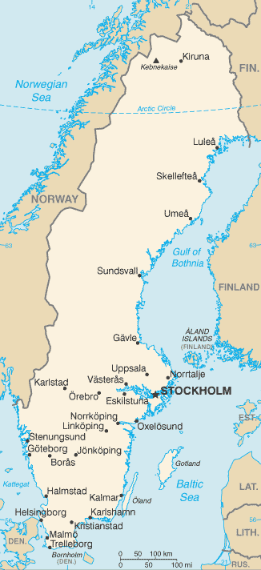
Demographics of Sweden
- Third largest country in Europe.
- Population- 9,103,788 as of 2012 census.
- World leader in managing household waste. 99% of all waste produce is recycled or utilized to generate some form of energy.
- Their unemployment rate is 7.5%
Overall Health
- 15% of population smokes. United States is 19%.
- Obesity amongst adults in Sweden is 12% as of 2009, compared to the United States which is 35.7% as of 2010.
- A healthcare guarantee was implemented in 2005 that ensured an individual would be treated with in seven days for a common healthcare problem and would see a specialist within 90 days if specific treatment or surgery was deemed necessary.
Diabetes in Sweden

- The Karolinska Institute out of Sweden has discovered a new protein that can inhibit the accumulation of fat in areas around the heart and other muscles. Which is a reverse of the effects of Type 2 diabetes and with the removal of that fat natural insulin in the body can work better because the muscles respond to it more effectively. It has not been approved for human use yet although it is showing to be very effective for animal testing.

Reference
https://www.cia.gov/library/publications/the-world-factbook/
http://www.indexmundi.com/sweden/demographics_profile.html
http://www.cdc.gov/mmwr/preview/mmwrhtml/mm6144a2.htm
Ogden CL, Carroll MD, Kit BK, Flegal KM. Prevalence of obesity in the United States, 2009–2010. NCHS data brief, no 82. Hyattsville, MD: National Center for HealthStatistics. 2012. http://www.cdc.gov/nchs/data/databriefs/db82.pdf

‘Targeting VEGF-B as a novel treatment for insulin resistance and type 2 diabetes’, Carolina E. Hagberg, Annika Mehlem, Annelie Falkevall, Lars Muhl, Barbara C Fam, Henrik Ortsäter, Pierre Scotney, Daniel Nyqvist, Erik Samen, Li Lu, Sharon Stone-Elander, Joseph Proietto, Sofianos Andrikopoulos, Åke Sjöholm, Andrew Nash, Ulf Eriksson, Nature, AOP 26 September 2012, doi: 10.1038/nature11464. http://www.alphagalileo.org/PrintVeiw.aspx?ItemId=123495&CultureCode=en

