Diabetes Mellitus in Sweden
Dan Phillips & Leslie Luna
Demographics of Sweden
- Third largest country in Europe.
- Population- 9,103,788 as of 2012 census.
- Birth rate is 10.24/1000 and death rate is 10.21/1000 so they are just replacing themselves.
- 3.583 physicians/1000 citizens.
- World leader in managing household waste. 99% of all waste produce is recycled or utilized to generate some form of energy.
- Their unemployment rate is 7.5%
Overall Health
- 15% of population smokes. United States is 19%.
- Obesity amongst adults in Sweden is 12% as of 2009, compared to the United States which is 35.7% as of 2010.
- A healthcare guarantee was implemented in 2005 that ensured an individual would be treated with in seven days for a common healthcare problem and would see a specialist within 90 days if specific treatment or surgery was deemed necessary.
Diabetes in Sweden
- There is roughly 350,000 Sweden’s with Diabetes. Which is 5.2% of their population compared to the United States which is 10.3%
- There are 40/100,000 children and 200/100,000 adults effected annually by diabetes.
- Most individuals affected by diabetes in Sweden are from the working class and have lower education.
- Healthcare is paid for primarily by the Government, no dollar amount could be obtained as to how much money is spent on DM. Over all 9.9% of there GDP is spent on healthcare.
- The Karolinska Institute out of Sweden has discovered a new protein that can inhibit the accumulation of fat in areas around the heart and other muscles. Which is a reverse of the effects of Type 2 diabetes and with the removal of that fat, natural insulin in the body can work better because the muscles respond to it more effectively. It has not been approved for human use yet although it is showing to be very effective for animal testing.
How healthy is Sweden?
- Sweden’s Government promotes healthy lifestyles and healthy balance between family and work.
- Over half of the citizens in Sweden participate in physical sports. Governmental subsidies are provided to promote sports in their country.
- When a family has a newborn the father is required to take one month off from work and the mother can have up to 13 months.
- The many Government promoted health plans and the natural proactive lifestyles of Sweden’s makes it a great place to live.
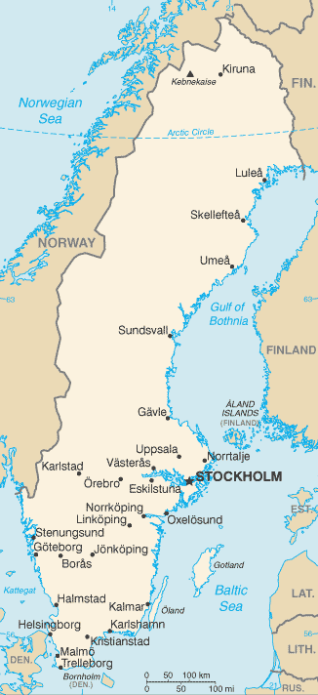

Reference
Ogden CL, Carroll MD, Kit BK, Flegal KM. Prevalence of obesity in the United States, 2009–2010. NCHS data brief, no 82. Hyattsville, MD: National Center for HealthStatistics. 2012. http://www.cdc.gov/nchs/data/databriefs/db82.pdf

‘Targeting VEGF-B as a novel treatment for insulin resistance and type 2 diabetes’, Carolina E. Hagberg, Annika Mehlem, Annelie Falkevall, Lars Muhl, Barbara C Fam, Henrik Ortsäter, Pierre Scotney, Daniel Nyqvist, Erik Samen, Li Lu, Sharon Stone-Elander, Joseph Proietto, Sofianos Andrikopoulos, Åke Sjöholm, Andrew Nash, Ulf Eriksson, Nature, AOP 26 September 2012, doi: 10.1038/nature11464. http://www.alphagalileo.org/PrintVeiw.aspx?ItemId=123495&CultureCode=en

TT/The Local/og. http://www.thelocal.se/41908/20120709/

https://www.cia.gov/library/publications/the-world-factbook/

http://www.indexmundi.com/sweden/demographics_profile.html

