Clinical Discussion for Jill and Devon

Please describe your client for this week. Devon and I took care of a fourteen month old boy whom was born 29 weeks premature. He has basically been hospitalized since birth. There has been a few trips home but he continues to return due to respiratory infections. He has a trach. and is on ventilation with small windows without it now being introduced. He has a g-tube and is currently on a feeding plan that is providing oral and tube feeds with formula. Pureed foods are being introduced as well. There is an undiagnosed neurological issue that causes him to shake his head as if he was saying no. He was a very easy child. He just goes with the flow and was quick with a smile and somewhat of a flirt.
What was your client's diagnosis? He suffers from chronic respiratory distress and is at C. C. Children’s Rehabilitation Hospital for pulmonary rehab. He also receives therapies for development, feeding issues, and family education including preparation for discharge.
What was something new or interesting you experienced this week when caring for your client? There were many experiences that were new. We hung tube feedings, flushed the g-tube, cleaned and redressed his trach area, weighed and bathed him, participated in recreational therapy, listened to the physicians during pulmonary specialist rounds, and watched his physical therapy session. Dealing with the vent was a little stressful. Even weighing and dressing him was more of a challenge because of the vent. We watched his g-tube being vented but did not have the opportunity to do it. The physical therapist was especially interesting and knowledgeable about his motor development needs and how to help him achieve some milestones.
Please choose an Evidence-based Article that relates to your client's diagnosis and answer the following questions.
Name of the article.
Summary of the article including sample and method.
Nursing interventions for the article.
How does this article relate to the client your have cared for this week?
How can you use this article to change your nursing practice?

Trach care with pictures
http://www.stjude.org/stjude/v/index.jsp?vgnextoid=473a3d5ae6b0d110VgnVCM1000001e0215acRCRD
Mic-key care guide with pics
http://www.kchealthcare.com/docs/R8201B%20MIC-KEY%20Care%20guide%20English.pdf

http://www.tracheostomy.com/care/complications/index.htm

Tracheostomy Complications

Respiratory Distress and Tube Obstruction
Mucus plugs are the most common cause of respiratory distress for children with tracheostomies. Symptoms of a mucus plug include resistance when trying to suction or bag and/or signs of respiratory distress.

Symptoms of Respiratory Distress
- Difficulty breathing
- Increased respiratory rate
- Increased heart rate
- Grunting, noisy breathing
- Stridor (audio file) (video file)
- Whistling noise when breathing
- Cyanosis (pale, blue color around lips, nail beds, eyes)
- Restlessness
- Sweaty, clammy skin
- Retractions (pulling in of the skin between the ribs, and below the breast bone, above collar bones or in the hollow of the neck)
- Anxiety, frightened look
- Flared nostrils
- Change in pulse or blood pressure
- Infants may have trouble sucking
- Difficulty or refusing to eating
- Inability to wake the child
- Head bobbing due to use of strap muscles for breathing
- Reduced airflow through the tube
- More comfortable with head elevated or sitting up
- Low O2 saturations for children with a home pulse oximeter
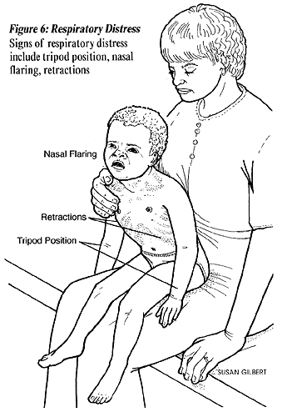
Illustration Source:
The Center for Pediatric Emergency Medicine (CPEM), Teaching Resource for Instructors in Prehospital Pediatrics. Illustrations by Susan Gilbert. http://www.cpem.org/html/giflist.html
Suction trach or change trach tube as needed for respiratory distress. The tube may have become blocked with dried secretions or blood. If symptoms do not clear with suction or trach change, call the doctor or 911, go directly to the emergency room, or call an ambulance.

Bleeding
Very small amounts of bleeding (pink or red streaked mucus) often occurs as a result of routine suctioning. This bleeding can be managed with close observation and by modifying the care that might have caused the problem.

Possible Causes of Minor Bleeding
- Irritation to the fragile tissue around the stoma
- Insufficient humidity to the airway
- Too frequent, deep or vigorous suctioning
- Suction pressure that is too high (Suction machine pressure for small children 50-100mm Hg, for older children/adults 100-120mm Hg)
- Infection
- Trauma, manipulation of trach
- Foreign object in the airway
- Excessive coughing
Call your doctor, emergency services, or go directly to your local emergency room for a significant amount of bright red bleeding from the tracheostomy.

Infection
Children with tracheostomies are at high risk for respiratory infections. The trach tube bypasses the natural defenses (nasal hair and mucus membranes) of the upper airway that filter out dust and bacteria. Also, monitor for local infections at the stoma site. Hand washing before any trach care is one of the best defenses against infection.

Symptoms of Infection
- Yellow or green secretions (may be pink/blood tinged)
- Thicker mucus
- Increased amount of mucus
- Redness, rash and/or inflamed at stoma site
- Bleeding at stoma site
- Foul odor
- Elevated temperature (fever)
- Congested lung sounds
- Increased respiratory effort or change in respiratory rate
- Listlessness
- Discomfort with trach care, tender at stoma site
Tracheitis
A dry tracheitis is an infection in the trachea that may develop if humidification of the airway is inadequate.
Call the doctor for symptoms of infection.

Other Complications
Tracheal Stenosis
Scar tissue at the site of the tracheostomy tube, often from excessive trach cuff pressure.
Tracheoesophageal Fistula
An abnormal connection between the trachea and the esophagus resulting from erosion of the back wall of the trachea.
Granuloma (common)
A growth of inflammatory tissue, which is caused by the irritation of the airway by the tracheostomy tube.
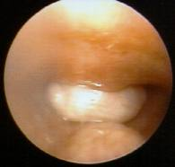
Granuloma inside trachea, just about trachoestomy tube. (white area)
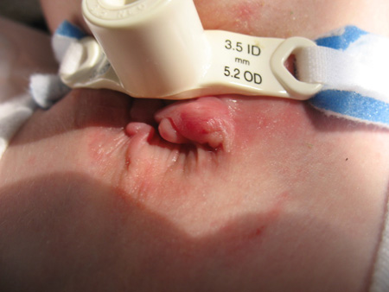
Granuloma at stoma (Photo courtesy of Kerry S. Baldwin)
Pressure Necrosis
Infants with short, fat necks or children on mechanical ventilation may develop infections or pressure sores of the skin and soft tissue around the trach site. Inspect skin daily.
Tracheoinnominate Fistula (rare)
An erosion of the tube into a large artery that runs in front of the trachea. Hemorrhage could lead to death if not stopped.

Accidental Decannulation (What to Do If the Trach Tube Comes Out Accidentally)
- Try to Stay calm
- Reinsert tube immediately even if conditions are not ideal.
- There should always be two spare trachs with the child at all times, the child’s size and one size smaller for emergency replacement. If the regular size does not fit, then the smaller size will keep the airway patent (open). Keep two trach tubes taped at the head of the child’s bed and in your travel bag. Always keep blunt-nosed scissors handy to cut trach ties.
- Opening the airway is always the first priority. If a spare trach tube is not handy, replace the one that came out. Later, when the situation is under control, you can replace it with a clean trach tube.
- If you cannot reinsert the tube, observe the child to see if he/she can breathe through the stoma itself. This may be possible if the stoma is well healed and fairly large. The child may also be able to breathe through the nose and mouth if there is no severe obstruction above the trach site. Go immediately to the emergency room.
- Comfort the child when situation is under control.
- See Changing Tracheostomy Tube, which includes, "Techniques for a Difficult Trach Change."
- Children with trachs are often on some type of monitoring device (apnea monitors or pulse oximeters) when not directly supervised (naps and bedtime), to alert caretakers in the event of a problem such as accidental decannulation or a mucus plug. Ask your physician about these devices and if they would be appropriate for your child.
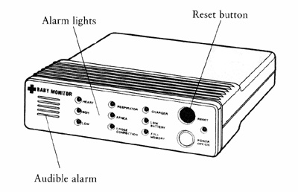
Cardiac Apnea Monitor
- A less sophisticated but useful alarm is to attach bells to the child's legs and/or arms. However, be sure that the bells cannot be removed or swallowed!
- It may be comforting to have the child sleep in the same room with you for closer monitoring, particularly infants and young children.

What to Do If Your Child Pulls on the Trach Tube
- Caring for a child with a tracheostomy may cause anxiety. Try not to let the child see that you are anxious.
- Try not to make a big deal about the trach, particularly if the child touches the trach tube. They will learn very quickly that by touching or pulling the trach tube, they receive attention, which tends to reinforce the behavior.
- Once children develop a pattern of pulling on the trach tube, it is more difficult to control, especially for young children and children with developmental disabilities. A Tracheostomy Collar may be helpful in preventing the child from pulling out the tracheostomy tube. A trach collar is like a belt with a hole in the center for the trach tube opening, then it fastens in the back of the neck. Check with your doctor or medical supply vendor.

CPR with a Tracheostomy
All parents and caregivers should be trained in cardiopulmonary resuscitation (CPR). In fact, infant and child CPR classes for parents are required before a baby can be discharged from many Neonatal Intensive Care Units (NICU). Although it is not the purpose site to teach CPR, I would like to point out some important differences when delivering CPR to an infant or child with a tracheostomy tube.

If the Child is Not Breathing
- Open the airway using the chin lift, but do not hyperextend the neck.
- Suction the trach tube.
- If the trach has an inner cannula, remove the inner cannula and suction slightly past (mm) the length of the trach tube.
- Change the trach tube if plugged or dislodged.
- Give two gentle puffs of air into the trach tube using an Ambu bag (breathing bag) with trach adapter or mouth to trach technique.
- If air leaks from nose and mouth, hold them closed.
- If the tube is obstructed or lost, it may be possible to give ventilation by sealing your mouth over the stoma and blowing or place the face mask of ambu bag over the stoma (gently, just enough to cause the child’s chest to expand).
- If the child's airway is not obstructed, you can use mouth to mouth resuscitation by closing the stoma with your finger.
- Give CPR as indicated.
More about CPR with a tracheostomy from The Children's Mercy Hospitals and Clinics

This page updated 05/14/07
Home | Disclaimer | Español | Site Map | Contact Us
Site written and maintained by Cynthia Bissell, RN
Questions, comments, suggestions always welcome.
Copyright 1996- 2011 tracheostomy.com

