Molding
The shaping of the fetal head by overlapping of the cranial bones to facilitate movement through the birth canal

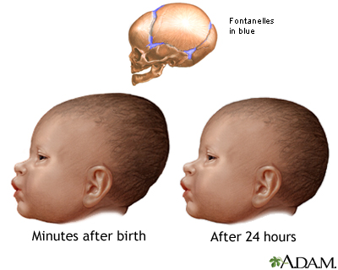

Vernix Caseosa
A product of the sebaceous glands, or sweat glands, it is a cheese-like whitish substance

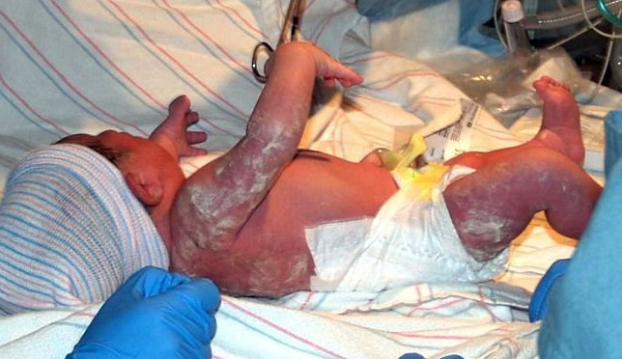

Milia on the Nose
Distended, small, white sweat glands, noticeable on the newborn face

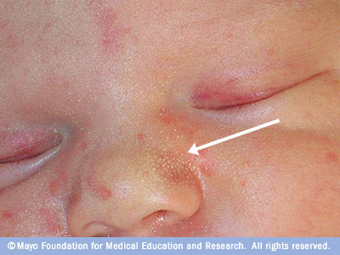

Lanugo
Very fine hairs

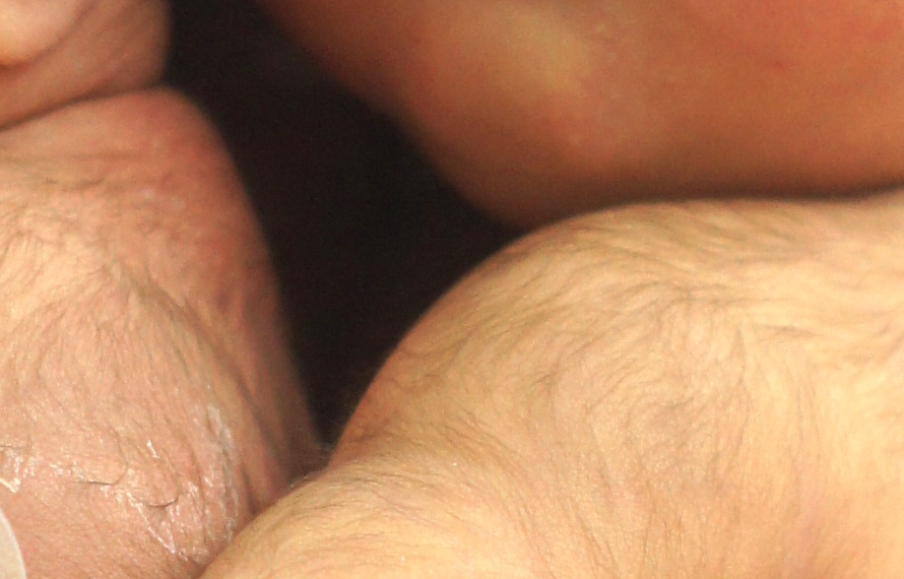

Stork Bites
Pink and easily blanched spots that appear on the upper eyelids, nose, upper lip, back of the head, and nape of the neck

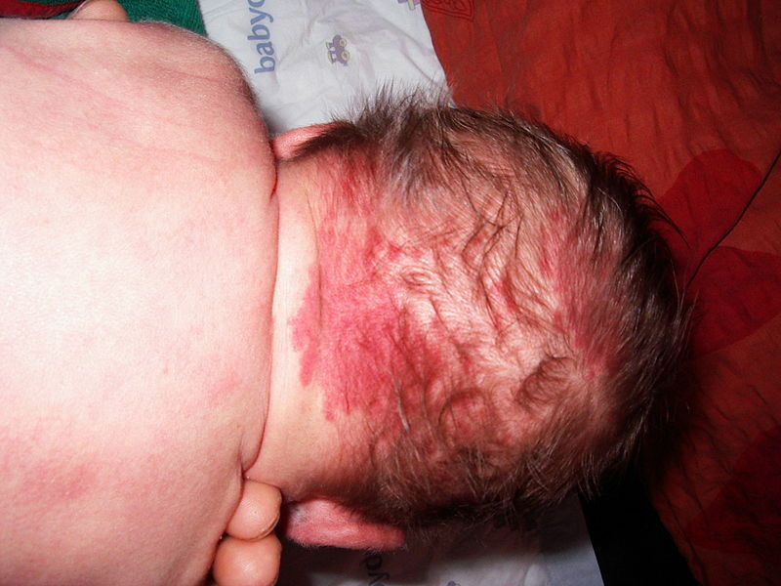

Mongolian Spots
Bluish black area of pigmentation that fade gradually; they may appear over any part of the exterior surface of the body, but are most commonly noted on the back and buttocks

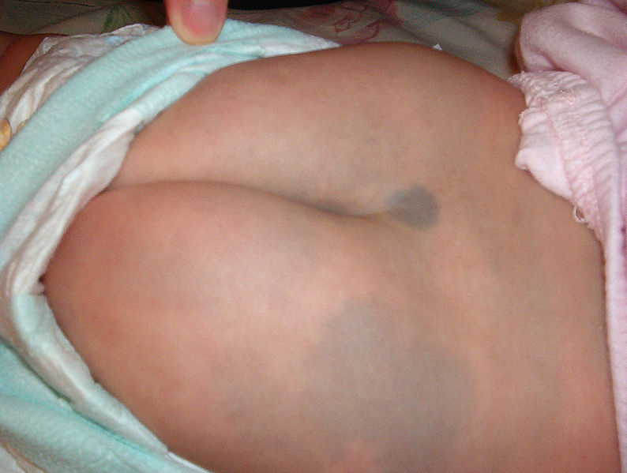

Jaundice
The manifestation of the pigment bilirubin in the tissues of the body, jaundice within the first 24 hours of life or persistence of jaundice beyond 7 to 10 days requires further investigation

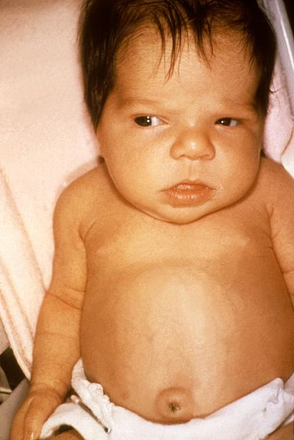

Newborn Rash (Erythema Toxicum)
Found in term neonate during the 1st 3 weeks of age. Newborn rash has no clinical significance and requires no treatment

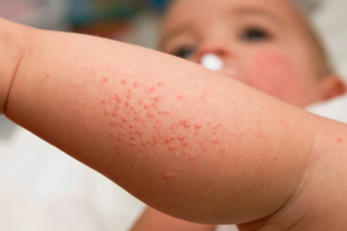

Swollen baby’s genitals
Newborns are born with extra fluid in their bodies, which they excrete over the first few days of life. A newborn infant is expected to lose at least 10 percent of their birth weight in the first few days and this weight loss is mostly water. This fluid tends to collect in specific areas, particularly the face (causing puffy eyes) and genitalia (causing swollen labia in girls or a swollen scrotum in boys). The genitals may also be swollen due to the extra dose of maternal hormones that babies get just before birth

