http://extension.missouri.edu/p/GH6235


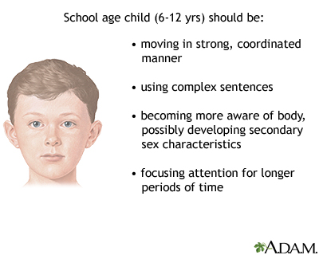 http://www.nlm.nih.gov/medlineplus/ency/images/ency/fullsize/9870.jpg

http://americasangel.org/wp-content/uploads/2010/06/growthStages.jpg
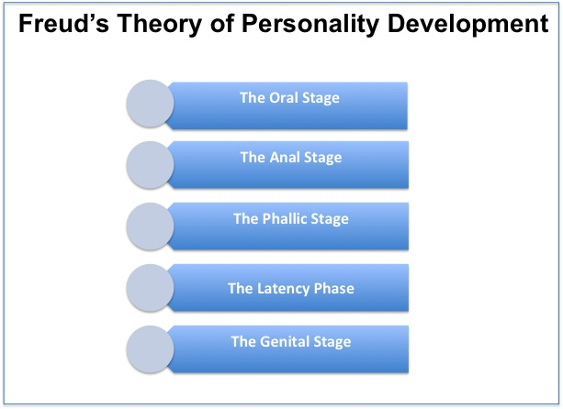
http://cdn.mdhil.com/wp-content/uploads/2012/07/freuds-theory-of-personality-development.jpg
http://projects.coe.uga.edu/epltt/images/b/b8/Piaget_1.jpg
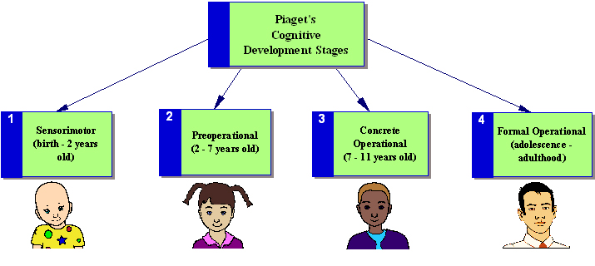

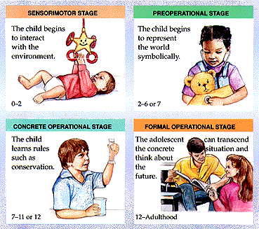
http://etec512group3.wikispaces.com/file/view/piaget_stages.gif/263081104/piaget_stages.gif
http://t0.gstatic.com/images?q=tbn:ANd9GcQuB-fuFQvY8mVZN7eoT6F-YUCt41jLLpwt9wHNf4-ymTZcjEjr4YxXSSU



http://www.ehow.co.uk/DM-Resize/photos.demandstudios.com/getty/article/171/182/86520069_XS.jpg?w=300&h=300&keep_ratio=1
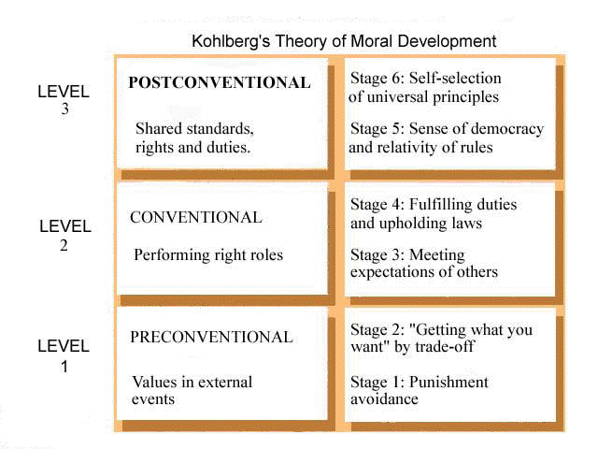http://1.bp.blogspot.com/-LPMZruUzrjM/T-IDrOn0tsI/AAAAAAAADGE/vJmoHthNP0c/s1600/KOHLSTAG.GIF

http://dunwoodyga.gov/Libraries/Police_Documents/ChildSafetySeat_saves_lives.sflb.ashx

http://www.goodhousekeeping.com/cm/goodhousekeeping/images/3z/child-bike-helmet-s2.jpg

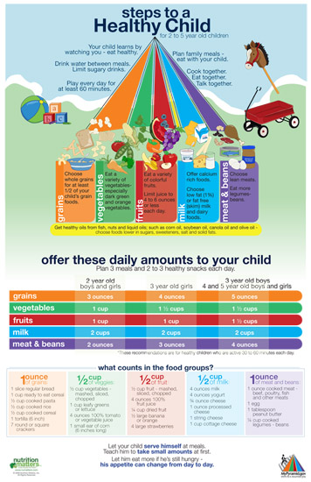http://stores.intuitwebsites.com/NutritionMattersInc/catalog/PreschoolChildNutritionPoster.jpg
http://t0.gstatic.com/images?q=tbn:ANd9GcTwp5mQ8Fqi0tu8RRG3l0ftwGxF_-9-EyUDcql-FpHAEh_J566TW8hCO79K
http://t1.gstatic.com/images?q=tbn:ANd9GcTpixWRzse-nezCZfGT6XZds4Qwa4QSIqBt2bumvSEEgnn18J5f1-HQsw

http://gamerfitnation.com/wp-content/uploads/2011/08/Child-Nutrition-nutrition-children.jpeg
http://t3.gstatic.com/images?q=tbn:ANd9GcRPAHlAwPoz__NB0Jo5-oaQKRlxKQO-9cQyoc5MYoXRkShxZb7ksmFolg
http://t1.gstatic.com/images?q=tbn:ANd9GcSJSM1jBF89wIQnUJsbhWsC68skrFtbXdp_vsUd4aRoExCaXcOhyM5Y6aXV

http://www.theantidrug.com/advice/images/hdr-parentingAdvice.jpg
http://t2.gstatic.com/images?q=tbn:ANd9GcTM26K4vTZ-R5s5Fi0pmOwAxKmzIeuOPolrgBKNnxN17bvHFC0zdApa4Q
http://cdn.blogs.sheknows.com/realmomsguide.sheknows.com/2011/02/parenting-style.jpg
http://t0.gstatic.com/images?q=tbn:ANd9GcQ9FR8XzJ2FYnJS-0Q7PO63NS_lOxZl6aiwfB-V696lsoNQEcHrRWNOKec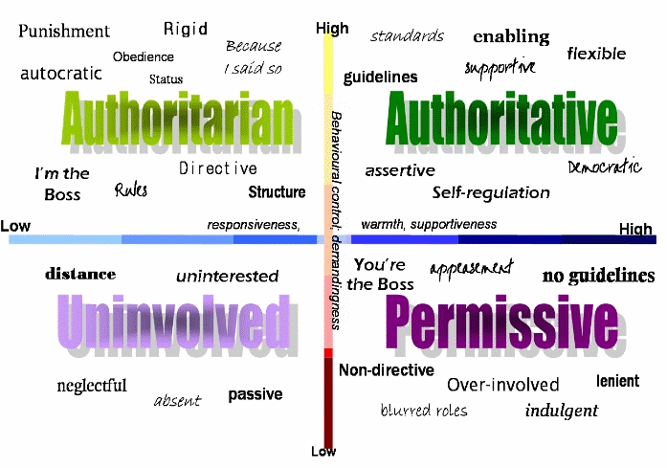

http://shechive.files.wordpress.com/2010/02/parenting-what-not-to-do-13.jpg?w=500&h=558
http://terrificparenting.com/wp-content/uploads/2012/04/happy-family-on-the-floor.jpg
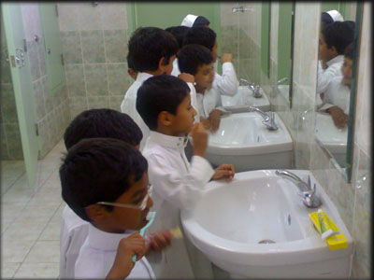http://t3.gstatic.com/images?q=tbn:ANd9GcQm2w08bRTSZl9r95jEj5kfwJY8wrTYQGYzBTUqG7-IgWxWUcHT2CfFAg
http://dentistinbeaumont.com/images/beaumont-dentist-dental-caries-prevention.jpg
http://openparachute.files.wordpress.com/2011/04/morality.jpg?w=500
http://www.bookskidslove.com/ICanRead.jpg

