Triage

A process for sorting injured people into groups based on their need for or likely benefit from immediate medical treatment. Triage is used in hospital emergency rooms, on battlefields, and at disaster sites when limited medical resources must be allocated.
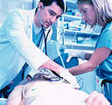
Bruises
A bruise forms when a blow breaks blood vessels near your skin's surface, allowing a small amount of blood to leak into the tissues under your skin. The trapped blood appears as a black-and-blue mark.
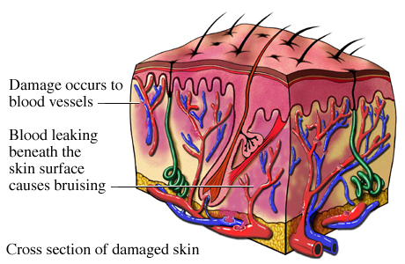
If your skin isn't broken, you don't need a bandage, but you enhance bruise healing with these simple techniques:
- Elevate the injured area.
- Apply ice or a cold pack several times a day for a day or two after the injury.
- Rest the bruised area, if possible.
- Consider acetaminophen (Tylenol, others) for pain relief, or ibuprofen (Advil, Motrin, others) for pain relief and to reduce swelling.
SEEK MEDICAL ASSISTANCE IF:
You have unusually large or painful bruises — particularly if your bruises seem to develop for no known reasons.
You begin to bruise easily.
Determining the Age of a Bruise by Its Color
Color of Bruise | Age of Bruise
Red (swollen, tender) | 0-2 days
Blue, purple | 2-5 days
Green | 5-7 days
Yellow | 7-10 days
Brown | 10-14 days
No further evidence of bruising | 2-4 weeks

You're experiencing abnormal bleeding elsewhere, such as from your nose or gums, or you notice blood in your eyes, stool or urine.
You have no history of bruising, but suddenly experience bruises.
These signs and symptoms may indicate a more serious problem, such as a blood-clotting problem or blood-related disease. Bruises accompanied by persistent pain or headache also may indicate a more serious underlying illness and require medical attention.
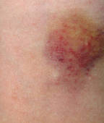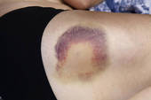
Strains and Sprains
Your ligaments are tough, elastic-like bands that connect bone to bone and hold your joints in place. A sprain is an injury to a ligament caused by tearing of the fibers of the ligament. The ligament can have a partial tear, or it can be completely torn apart.
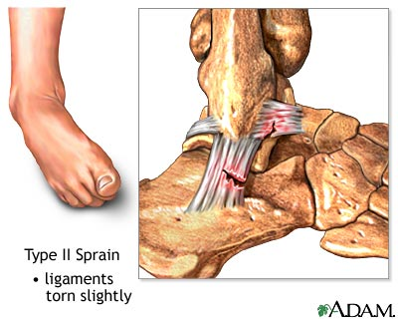
Of all sprains, ankle and knee sprains occur most often. Sprained ligaments swell rapidly and are painful. Generally, the greater the pain and swelling, the more severe the injury is. For most minor sprains, you probably can treat the injury yourself.
Follow the instructions for R.I.C.E.
- Rest the injured limb. Your doctor may recommend not putting any weight on the injured area for 48 hours. But don't avoid all activity. Even with an ankle sprain, you can usually still exercise other muscles to minimize deconditioning. For example, you can use an exercise bicycle with arm exercise handles, working both your arms and the uninjured leg while resting the injured ankle on another part of the bike. That way you still get three-limb exercise to keep up your cardiovascular conditioning.
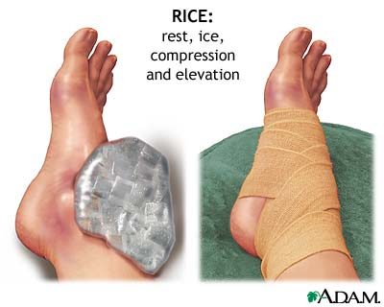
- Ice the area. Use a cold pack, a slush bath or a compression sleeve filled with cold water to help limit swelling after an injury. Try to ice the area as soon as possible after the injury and continue to ice it for 15 to 20 minutes, four to eight times a day, for the first 48 hours or until swelling improves. If you use ice, be careful not to use it too long, as this could cause tissue damage.
- Compress the area with an elastic wrap or bandage. Compressive wraps or sleeves made from elastic or neoprene are best.
- Elevate the injured limb above your heart whenever possible to help prevent or limit swelling.
After two days, gently begin using the injured area. You should feel a gradual, progressive improvement. Over-the-counter pain relievers, such as ibuprofen (Advil, Motrin, others) and acetaminophen (Tylenol, others), may be helpful to manage pain during the healing process.
See your doctor if your sprain isn't improving after two or three days.
Minor (thermal/heat) burns or scalds (superficial, or 1st degree)
To distinguish a minor burn from a serious burn, the first step is to determine the extent of damage to body tissues. The three burn classifications of first-degree burn, second-degree burn and third-degree burn will help you determine emergency care.
1st-degree burn
The least serious burns are those in which only the outer layer of skin is burned, but not all the way through.
- The skin is usually red
- Often there is swelling
- Pain sometimes is present
Treat a first-degree burn as a minor burn unless it involves substantial portions of the hands, feet, face, groin or buttocks, or a major joint, which requires emergency medical attention.
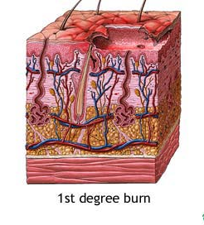

Serious burns (partial-thickness, or 2nd degree)
2nd-degree burn
When the first layer of skin has been burned through and the second layer of skin (dermis) also is burned, the injury is called a second-degree burn.
- Blisters develop
- Skin takes on an intensely reddened, splotchy appearance
- There is severe pain and swelling.
If the second-degree burn is no larger than 3 inches (7.6 centimeters) in diameter, treat it as a minor burn. If the burned area is larger or if the burn is on the hands, feet, face, groin or buttocks, or over a major joint, treat it as a major burn and get medical help immediately.
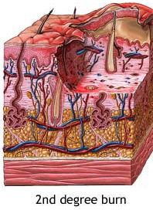
- Cool the burn. Hold the burned area under cool (not cold) running water for 10 or 15 minutes or until the pain subsides. If this is impractical, immerse the burn in cool water or cool it with cold compresses. Cooling the burn reduces swelling by conducting heat away from the skin. Don't put ice on the burn.
- Cover the burn with a sterile gauze bandage. Don't use fluffy cotton, or other material that may get lint in the wound. Wrap the gauze loosely to avoid putting pressure on burned skin. Bandaging keeps air off the burn, reduces pain and protects blistered skin.
- Take an over-the-counter pain reliever. These include aspirin, ibuprofen (Advil, Motrin, others), naproxen (Aleve) or acetaminophen (Tylenol, others). Use caution when giving aspirin to children or teenagers. Though aspirin is approved for use in children older than age 2, children and teenagers recovering from chickenpox or flu-like symptoms should never take aspirin. Talk to your doctor if you have concerns.
Caution
- Don't use ice. Putting ice directly on a burn can cause a person's body to become too cold and cause further damage to the wound.
- Don't apply egg whites, butter or ointments to the burn. This could cause infection.
- Don't break blisters. Broken blisters are more vulnerable to infection.
Minor burns usually heal without further treatment. They may heal with pigment changes, meaning the healed area may be a different color from the surrounding skin. Watch for signs of infection, such as increased pain, redness, fever, swelling or oozing. If infection develops, seek medical help. Avoid re-injuring or tanning if the burns are less than a year old — doing so may cause more extensive pigmentation changes. Use sunscreen on the area for at least a year.
For major burns
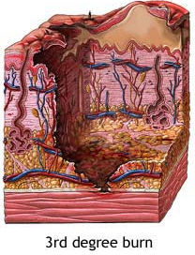
Call 911 or emergency medical help. Until an emergency unit arrives, follow these steps:
- Don't remove burned clothing. However, do make sure the victim is no longer in contact with smoldering materials or exposed to smoke or heat.
- Don't immerse large severe burns in cold water. Doing so could cause a drop in body temperature (hypothermia) and deterioration of blood pressure and circulation (shock).
- Check for signs of circulation (breathing, coughing or movement). If there is no breathing or other sign of circulation, begin CPR.
- Elevate the burned body part or parts. Raise above heart level, when possible.
- Cover the area of the burn. Use a cool, moist, sterile bandage; clean, moist cloth; or moist cloth towels.
Get a tetanus shot. Burns are susceptible to tetanus. Doctors recommend you get a tetanus shot every 10 years. If your last shot was more than five years ago, your doctor may recommend a tetanus shot booster.
Prevention:
Be careful when using candles, space heaters, and curling irons
Keep children away from radiators
Be alert around hot drinks
Check the temperature of bath water before putting a child in the tub
Check smoke alarms at least once a month
Keep a fire extinguisher in the kitchen
Do not allow children to play in kitchen when something is cooking
Supplies:
Ice pack
Ace wrap, Band-Aids
Sterile gauze
Pain reliever (Aspirin, Ibuprofen, Aleve, Tylenol)
