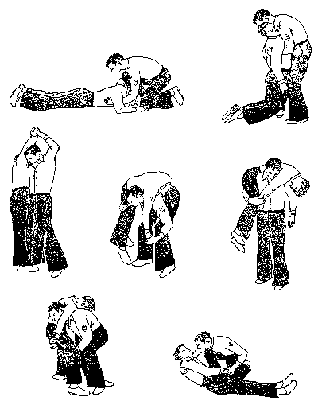http://t3.gstatic.com/images?q=tbn:ANd9GcSxcHNa7PJipoXkqWIqNZUPtg1cht2RwUbFXpNroSHhuhQmdZdk
http://t2.gstatic.com/images?q=tbn:ANd9GcSd9Gv26t3ZXqEkXMrOBVryEv1ji8b21iQ_ZEbyuWzBdzk1Wb_kRg
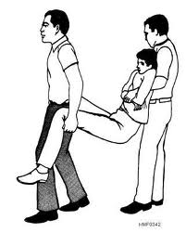
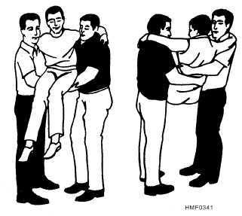
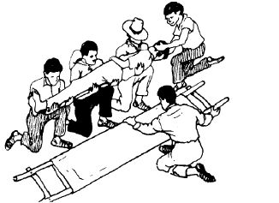http://autonopedia.org/healing/First_Aid/First_Aid_files/First_Aid-58.jpg

HUMAN CRUTCH:
When victim is Conscious & with a light wound to an inferior limb.
1) Place yourself on the wounded side. Put your arm around the victim's waist & grab his clothes on the intact side.
2) Place the victim's arm around your neck & from your free hand hold his hand tightly.
3) Tell the victim to lean on you as he would on a crutch.
4) Start together on the same foot, begin with the wounded side.

SEAT USING 2 or 3 or 4 HANDS:
Can only be used if there are 2 rescuers, if the distance to do is small & the victim is conscious.

2 HANDS SEAT: WAY TO DO SO:
1) The 2 rescuers bent a knee on each side of the victim, then each one passes an arm around the back & grab his clothes on each side.
2) Then passing each on their free arm under the victim's thighs they grab one another by a "hook hold" or "wrist hold"* If the victim can do it, she passes his arms around their neck.
3) Giving a signal the 2 rescuers get up together.

3 HANDS SEAT: USED WHEN 1 WOUNDED LEG MUST BE UPHELD.
1) The rescuers bend 1 knee on each victim's side.
2) If it's the left leg wounded, the rescuer on the left side, keeps his left hand free. The second rescuer places his left wrist & each one grabs the free wrist of the other.
3) The victim places his arms around the rescuers' neck then lift himself a bit, so that the 3 hand seat can slide under him.
4) The left rescuer holding the wounded leg with his free hand, both lift together with a signal.

4 HANDS SEAT: USED FOR A HEAVY PERSON WHO CAN USE HIS ARMS.
1) The 2 rescuers bend a knee on each victim side & each one grabs his own left wrist.
2) Each rescuer then grabs the other one free wrist.
3) Victim place arms around rescuer's neck & lift himself up a bit to permit this seat to slide under him.
4) Using a signal the rescuers lift together.

TRANSPORT ON THE STRETCHER:
1) You need at least 5 persons, one who commands & 2 to do the traction of the feet & head.
2) The chief chooses 2 or 3 persons who place the same knee on the ground, & on the unhurted side of the victim.
3) The chief kneels on the opposite side & tells his assistants to slide their hands under the body's victim neck, chest, hips & ankles.
4) The chief ties himself by a hand-grip with the centre assistant, this MUST be told ahead.
5) At the chief signal, the assistants rise the victim & put him over their knees, while staying with their knee bent.
6) The chief let's go with his hands then place the stretcher under the victim.
7) Then the chief ties his hands once again with his centre assistant & gives the signal to lower the victim on the stretcher. Once the victim is well tied up then release the traction, not before.

STRETCHER:
Best method if you have one near by, to carry the victim when seriously wounded & conscious or not.

PREPARATION:
When you use a "normal" stretcher, verify if the cross-bar is straight & in their right position.
Try it yourself to see if it can support your weight. You MUST cover the canvas with a carpet or blankets or overcoat. The victim MUST be well protected over as well as under him. (Heat loss) etc.

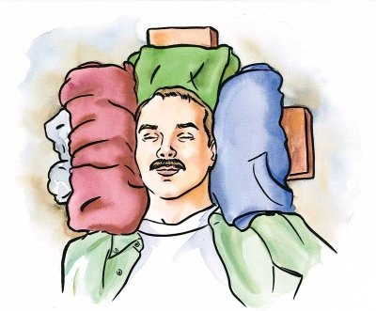http://www.blscprtraining.com/back.jpg
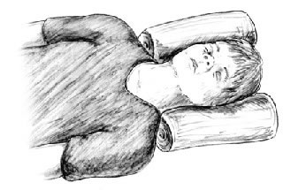http://www.childrenscolorado.org/imgs/Housecalls/fa_neckinjury.jpg
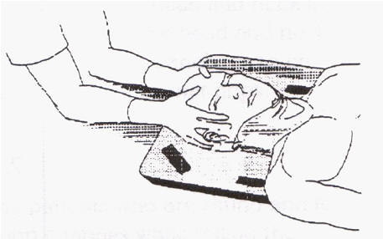http://www.iemt.org/SFA_Slides/headgrip.jpg
Signs and Symptoms of Head & Neck Injury!!!!
- Change in level of consciousness
- Difficulty in breathing
- Impaired vision
- Inability to move body part
- Headache
- Vomiting
- Loss of balance
- Tingling sensation or numbness to limbs

