Break/Sprain/Wound Bandages

Sprained Ankle
All injuries to a joint must be assumed that a bone fracture may also be included.
- Victim should take off any weight to the injured joint and not use the joint.
- Do not try to move or straightened and injured limb.
- Cover any open wounds with a sterile dressing.
- Apply ice packs, or a cold compress, in 20 minute intervals (20 minutes on, 20 minutes off). Make sure a barrier such as a thin towel is placed between the bare skin and the ice pack.
- Seek medical treatment if the pain is persistent or severe.

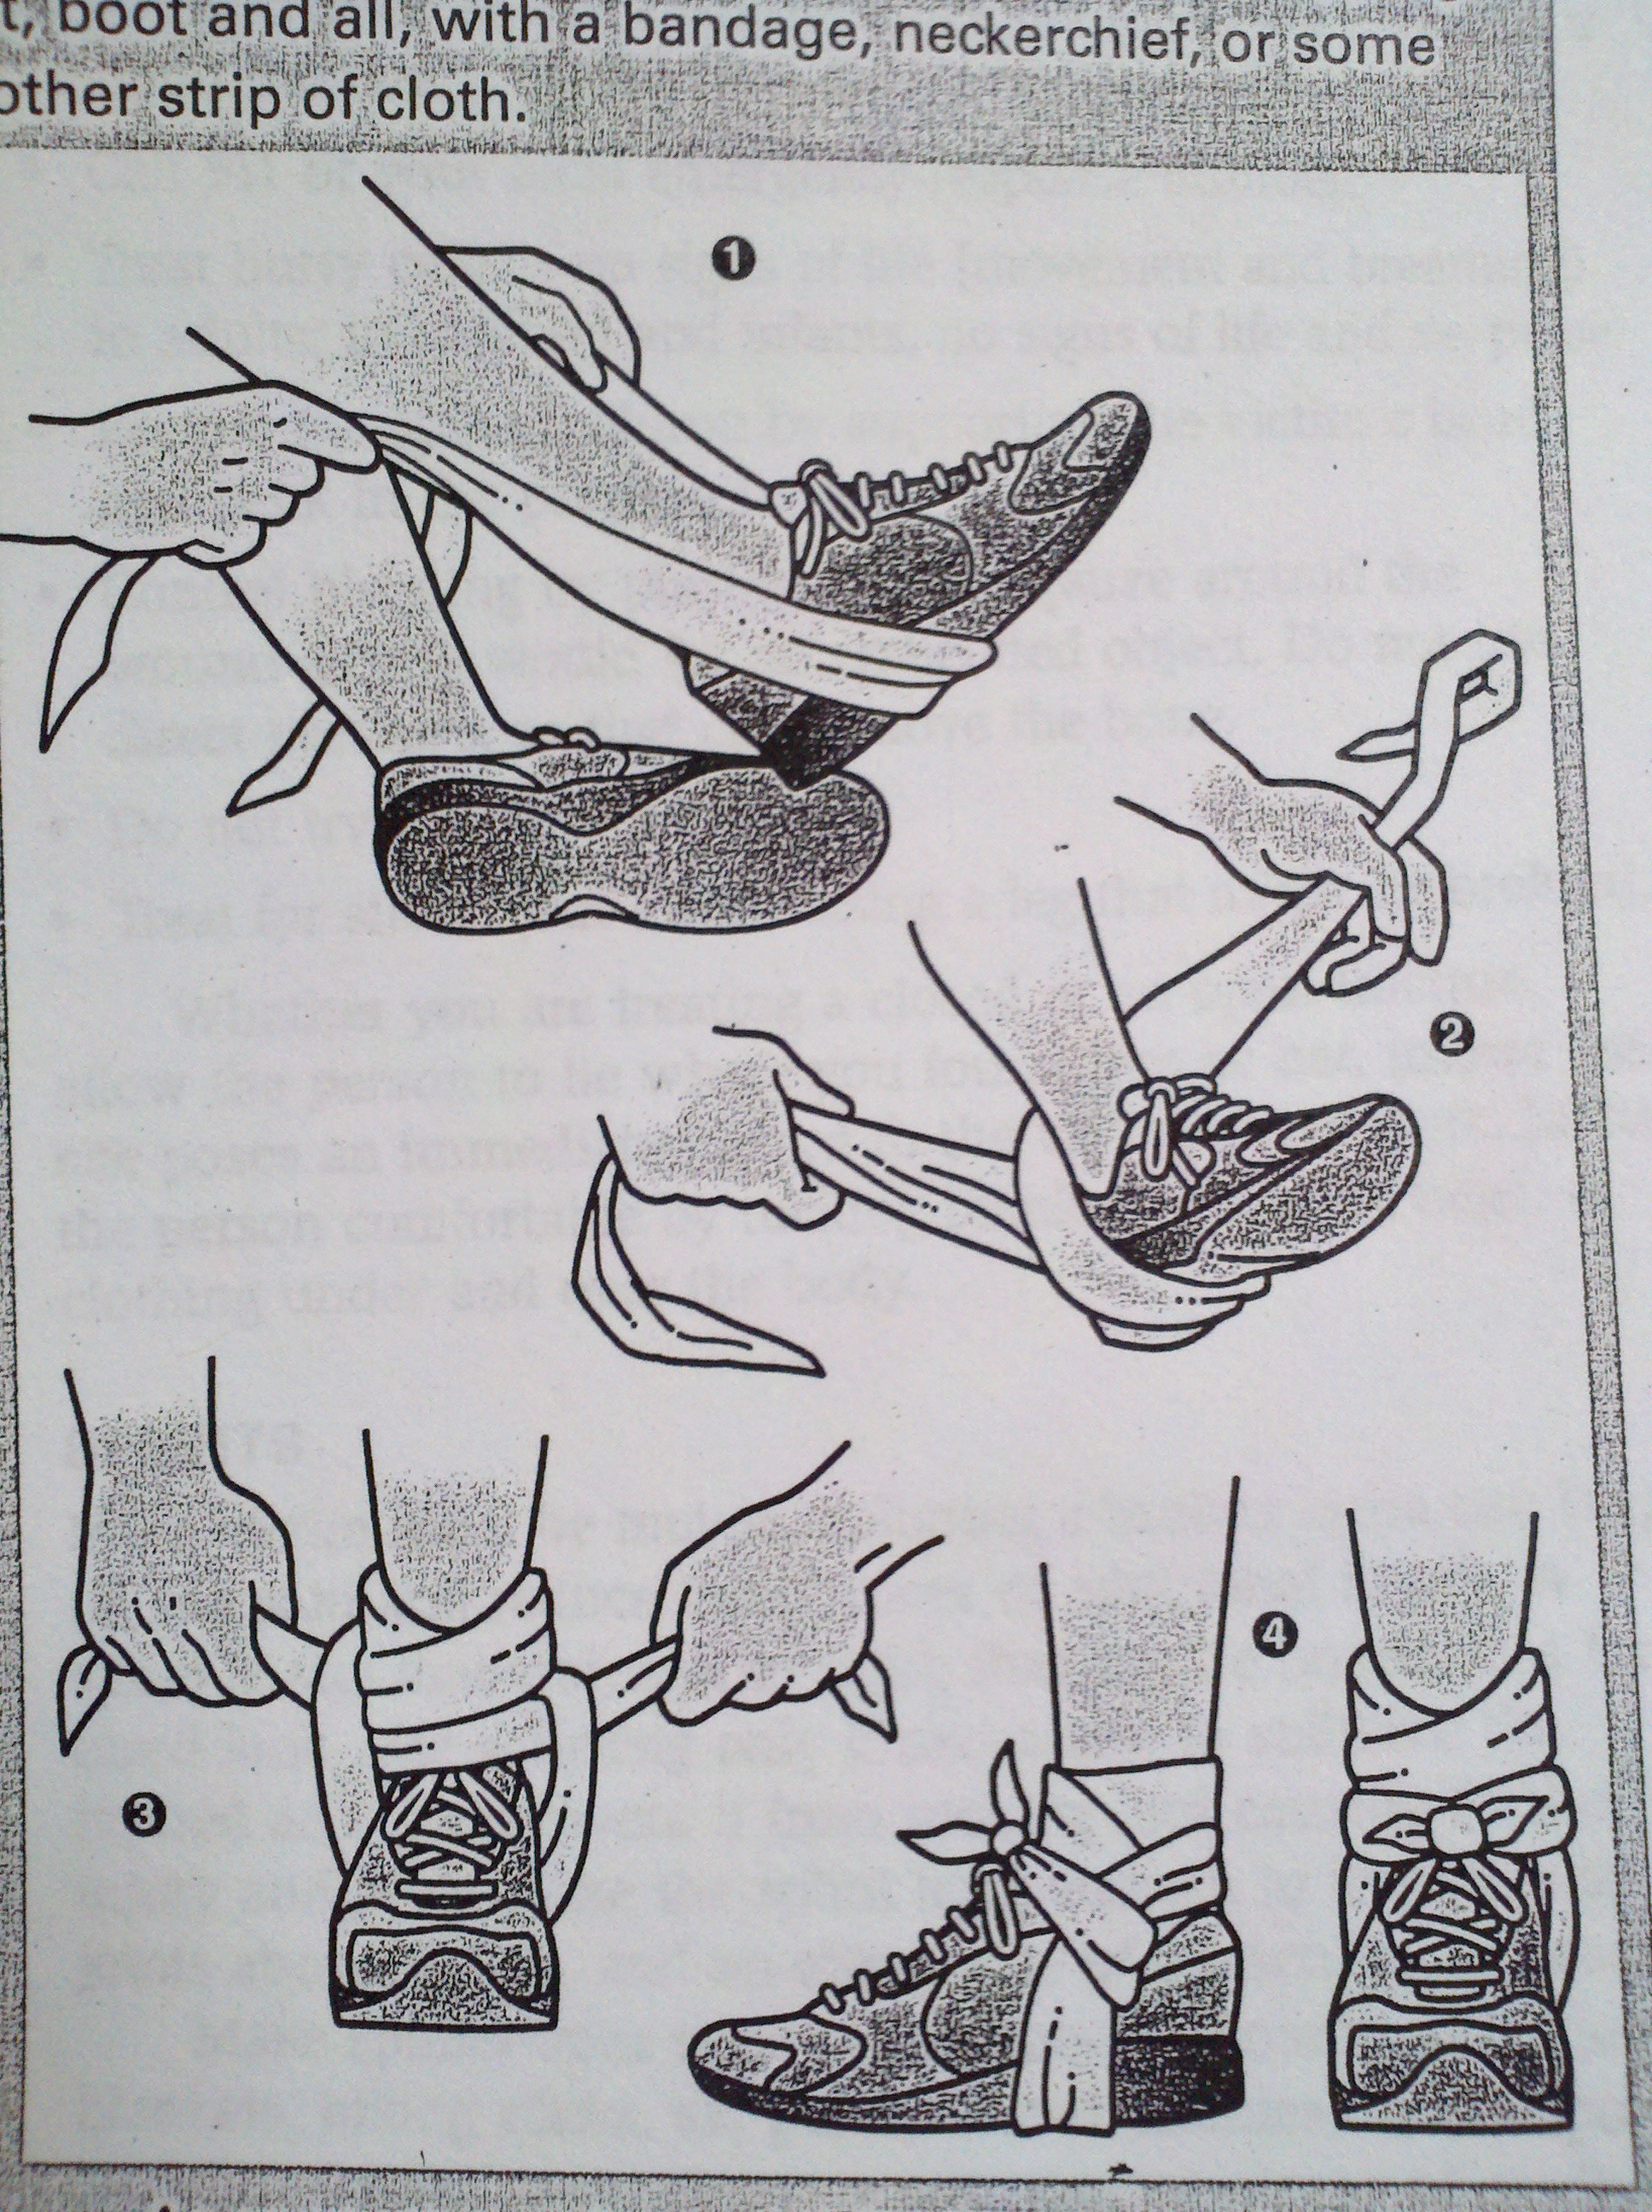

Sprained Ankle While Hiking
The following steps should be taken if someone suffers an ankle sprain during a hike and the group must continue walking:
- Do not remove hiking boot. The boot helps give support, and if removed the joint may swell and make it impossible to put the boot back on.
- Reinforce the ankle by wrapping it, boot included, with a bandage (some long strip of cloth).
(Reinforcement demonstration.)

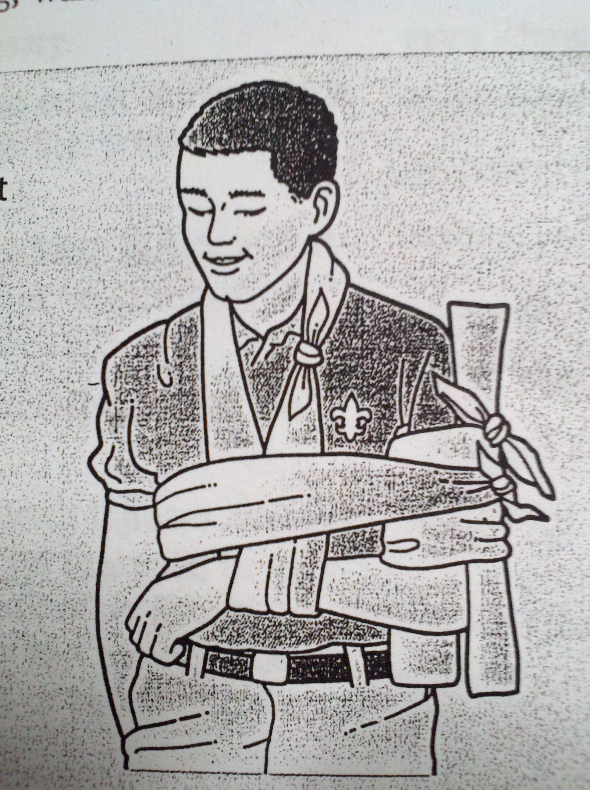

Upper Arm Fracture
- Tie a splint to the outer-side of the upper-arm. (Try to avoid placing knot directly at point of fracture.)
- Place the arm in a sling with the hand raised about 3 inches above level, slightly less than 90 degrees.
- Use a cravat bandage to hold the upper arm against the side of the chest. (The body will act as a splint to immobilize the elbow and shoulder.)

Cravat Bandage
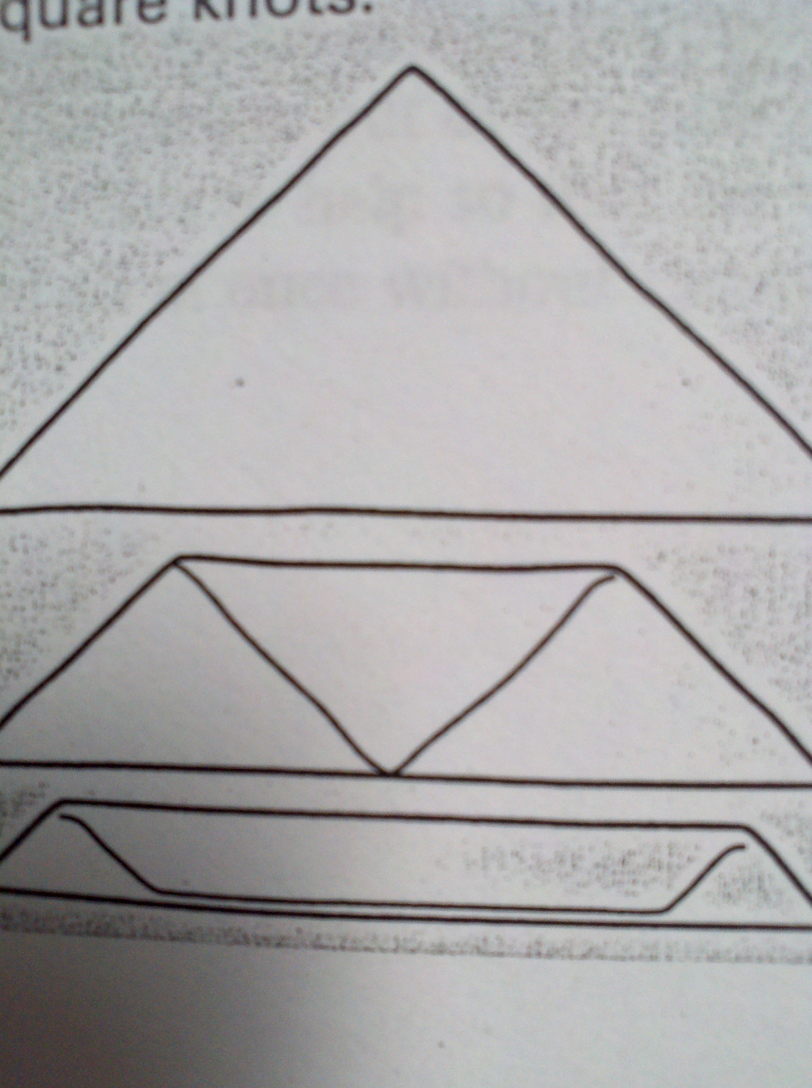
- Use a Scout neckerchief or triangular bandage.
- Fold the point down to the long edge.
- Continue folding long-ways until you have made a long, narrow, cloth strip.
- All bandages should be tied in place with square knots.
(Demonstration on how to create a Cravat bandage.)

Sling Bandage
Used to support an injured hand, arm, collarbone, or shoulder.
- Support the injured limb above and below the injured area.
- Check the injured area for circulation (feeling, warmth, and color), check the fingertips as well.
- Position a large triangular bandage across the chest with the injured arm on top of the bandage. (The victim may need a clean gauze bandage to protect the neck where the sling will be knotted, if available.)
- Bring the upper free end of the sling behind the neck and the lower free corner upward toward the neck behind the back and tie the ends together with a square knot, forming the sling.
- To keep the area more stable, use the cravat bandage as described above to immobilize the injured arm.
- Recheck the injured area for feeling, warmth, and color once bandage is on to make sure it is not too tight, and circulation is being achieved to the fingertips.
(Demonstration on how to make a sling bandage.)

