STANDARD PRECAUTIONS
Standard Precautions mean that we treat every victim as if they are infected with a disease that can be passed to us through their blood.
Standard Precautions also mean that we use personal protective equipment to prevent direct contact with a patient's blood or body fluids.
The consistent practice of Standard Precautions is the best method that we can use to protect ourselves from acquiring a bloodborne disease.
Treat all blood as if it were contaminated.
If possible, do not use bare hands to stop bleeding; always use a protective barrier; always was exposed skin areas with warm water and soap immediately after caring for the victim.
- Should be included in all first-aid kits
  - Disposable gloves
    - Use when controlling bleeding or dressing wounds
  - Plastic goggles or other eye protection
    - To prevent victim’s blood from getting into your eyes in event of serious arterial bleeding.

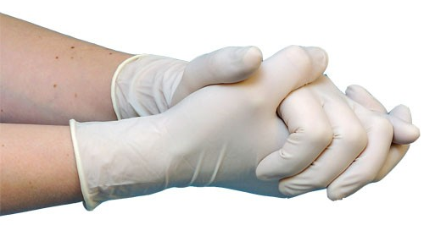
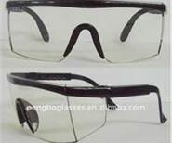
http://www.unc.edu/~rlensley/bbp.htm#STANDARD

