Goals for Breaks/Sprains/Wounds
- Demonstrate bandages for sprained ankle and injuries on the head, upper arm, and the collarbone ( needed equipment is a triangular bandage)

Triangular bandage on foot for sprained ankle

- To apply a triangular bandage to the foot--
- a. Place the foot in the middle of the triangular bandage with the heel well forward of the base (Figure 3-42 A). Ensure that the toes are separated with absorbent material to prevent chafing and irritation of the skin.
- b. Place the apex over the top of the foot and tuck any excess material into the pleats on each side of the foot (Figure 3-42 B).
- c. Cross the ends on top of the foot, take them around the ankle, and tie them at the front of the ankle (Figure 3-42 C, D, and E).
- 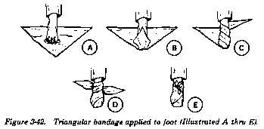 (Wilderness Survival, 2003)

Applying a Bandage to the Head

- Apply a Triangular Bandage to the Head. To apply a triangular bandage to the head--
- (1) Turn the base (longest side) of the bandage up and center its base on center of the forehead, letting the point (apex) fall on the back of the neck (Figure 3-10 A).
- (2) Take the ends behind the head and cross the ends over the apex.
- (3) Take them over the forehead and tie them (Figure 3-10 B).
- (4) Tuck the apex behind the crossed part of the bandage and/or secure it with a safety pin, if available (Figure 3-10 C).
- 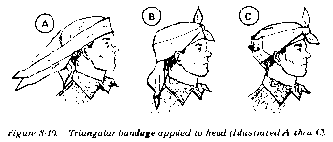 (Wilderness Survival, 2003)

Upper Arm injuries
    - Try to immobilize the arm when you wrap it.
- a. To apply bandages attached to the field first aid dressing--
- (1) Take one bandage across the chest and the other across the back and under the arm opposite the injured shoulder.
- (2) Tie the ends with a nonslip knot (Figure 3-35).
- 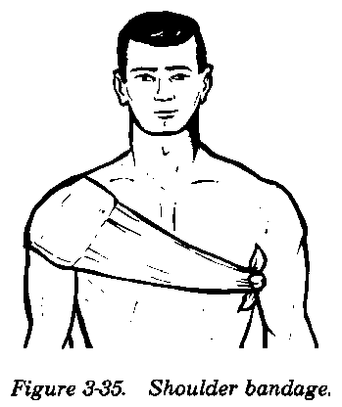
- b. To apply a cravat bandage to the shoulder or armpit--
- (1) Make an extended cravat bandage by using two triangular bandages (Figure 3-36 A); place the end of the first triangular bandage along the base of the second one (Figure 3-36 B).
- (2) Fold the two bandages into a single extended bandage (Figure 3-36 C).
- (3) Fold the extended bandage into a single cravat bandage (Figure 3-36 D). After folding, secure the thicker part (overlap) with two or more safety pins (Figure 3-36 E).
- (4) Place the middle of the cravat bandage under the armpit so that the front end is longer than the back end and safety pins are on the outside (Figure 3-36 F).
- (5) Cross the ends on top of the shoulder (Figure 3-36 G).
- (6) Take one end across the back and under the arm on the opposite side and the other end across the chest. Tie the ends (Figure 3-36 H).
- 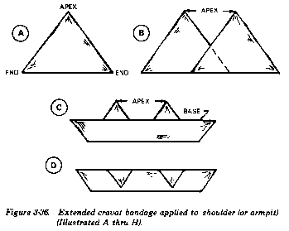
- 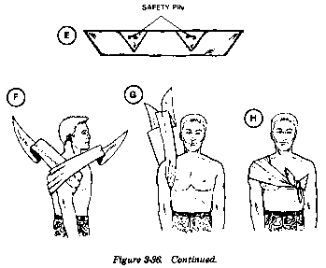
- Be sure to place sufficient wadding in the armpit. DO NOT tie the cravat bandage too tightly. Avoid compressing the major blood vessels in the armpit. (Wilderness Survival, 2003)

  - Broken Collarbone
(1) Insert the splinted arm in the center of the sling (Figure 4-5).
- 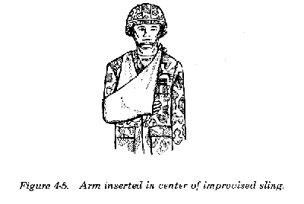
(2) Bring the ends of the sling up and tie them at the side (or hollow) of the neck on the uninjured side (Figure 4-6).
- 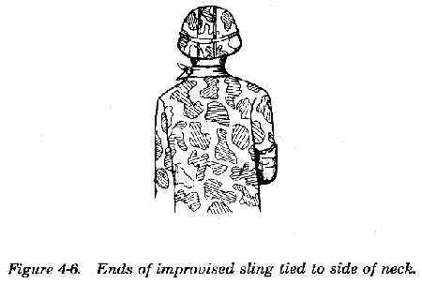
(3) Twist and tuck the corner of the sling at the elbow (Figure 4-7).
- 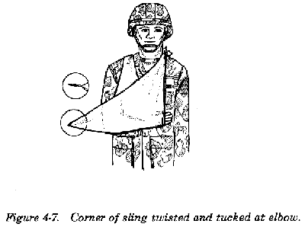

- Explain how you would obtain emergency medical help at home, camping, and on the open water
  - At home
    - call 911 scream for help, begin CPR or other needed interventions
  - Camping
    - call 911 if available, scream, make a big fire and send smoke signals
  - On the open water
    - use a flare, use the radio to send out an SOS
- Explain the term triage ( Maybe dedicate part of the board to a visual representation of the story)
  - Let’s imagine you, John, and Tammy were on a camping trip. While you are out walking, John and Tammy fall down a hill. John got a small cut on his leg. Tammy is unconscious. What do you do?
  - Triage says you treat the most threatening injury first. You help people who could be in a life threatening situation before those with a minor injury.
  - In the above situation, you would assess Tammy and help her before you would wrap up John’s cut
- Explain standard precautions for bloodborne pathogens
Standard Precautions mean that we treat every victim as if they are infected with a disease that can be passed to us through their blood.
Standard Precautions also mean that we use personal protective equipment to prevent direct contact with a patient's blood or body fluids.
The consistent practice of Standard Precautions is the best method that we can use to protect ourselves from acquiring a bloodborne disease.
Treat all blood as if it were contaminated.
If possible, do not use bare hands to stop bleeding; always use a protective barrier; always was exposed skin areas with warm water and soap immediately after caring for the victim.
- Should be included in all first-aid kits
  - Disposable gloves
    - Use when controlling bleeding or dressing wounds
  - Plastic goggles or other eye protection
    - To prevent victim’s blood from getting into your eyes in event of serious arterial bleeding.

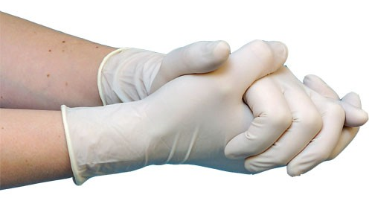
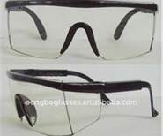
(Eisley)

- Show the steps for someone suffering from a severe cut on the elf and on the wrist. Describe the risks and benefits of a tourniquet as well as how to use them.
How to Treat Severe Bleeding

- Apply direct pressure over the wound with a clean cloth or sterile dressing.
- Raise the injury above the level of the heart while pressing on the wound.
- Apply pressure firmly without releasing until the bleeding stops.
- If the bleeding does not stop, add additional dressings and put pressure to the pressure point on the victim’s groin or armpit.
- Replace soaked dressing with fresh ones.
- Secure the pad firmly when bleeding stops with wide bands of cloth tied snugly. Do not tie the cloths so snugly they cut off circulation.
- Feel for a pulse further out on the limb. Loosen the bandage if there is no pulse.
- Only use a tourniquet as a last resort if the bleeding cannot be stopped.

Tourniquets

- Only use a tourniquet when a limb is severed or so badly mangled that you cannot stop heavy bleeding any other way, and there is a danger of the person bleeding to death.
- Only use a tourniquet as a last resort, when a pressure dressing has failed to stop the bleeding or an arm or leg has been cut off.

Dangers of a tourniquet – As tourniquet cuts off blood supply, it can cause a limb to basically die from lack of blood. However, if someone gets a substantial wound, cutting off the blood supply can keep them from bleeding to death.
- Describe the signs of a broken bone. Show first aid procedures for handling fractures including open fractures of the forearm, wrist, upper leg, and lower leg using improvised materials.
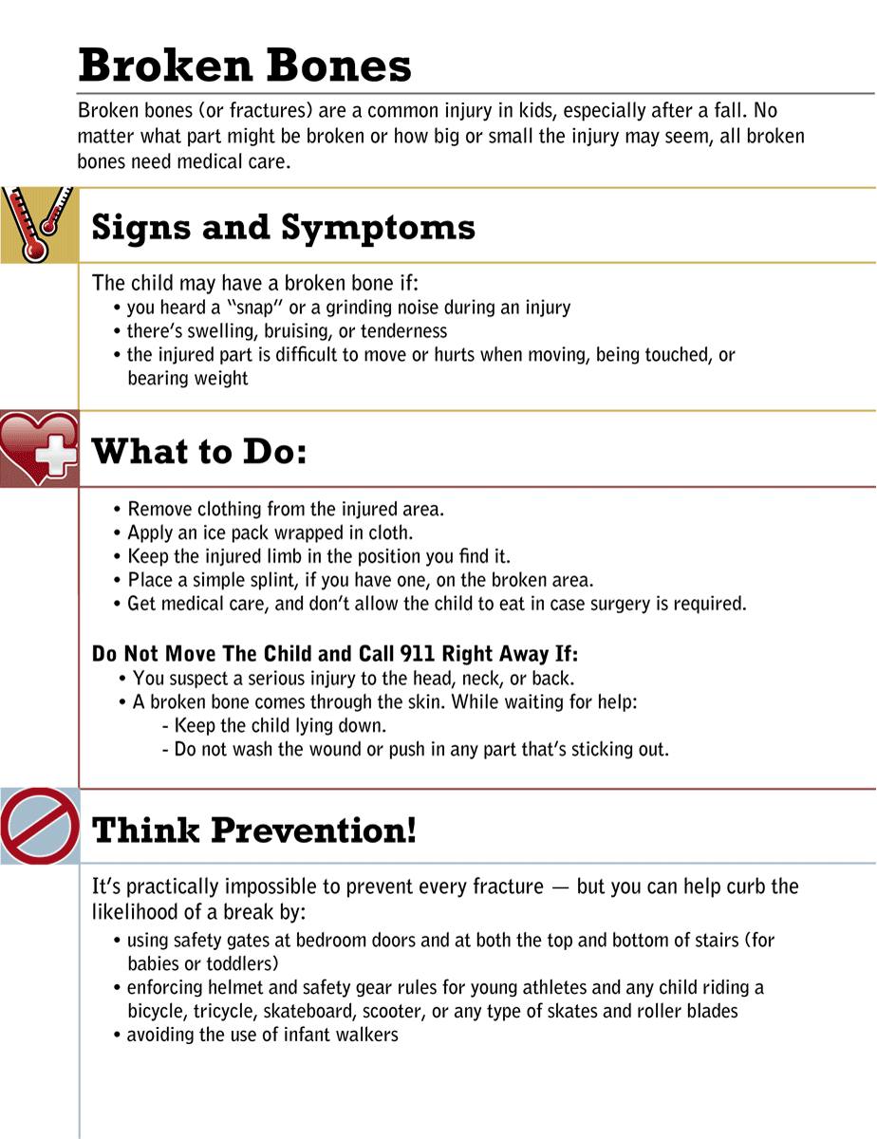

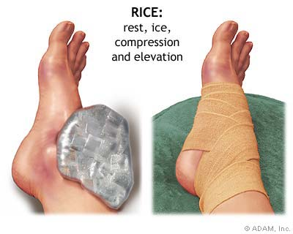
If you suspect a back or neck (spinal) injury, do not move the affected person. Permanent paralysis and other serious complications can result. Assume a person has a spinal injury if:
There's evidence of a head injury with an ongoing change in the person's level of consciousness
The person complains of severe pain in his or her neck or back
The person won't move his or her neck
An injury has exerted substantial force on the back or head
The person complains of weakness, numbness or paralysis or lacks control of his or her limbs, bladder or bowels
The neck or back is twisted or positioned oddly

If you suspect someone has a spinal injury:
Call 911 or emergency medical help.
Keep the person still. Place heavy towels on both sides of the neck or hold the head and neck to prevent movement.
Provide as much first aid as possible without moving the person's head or neck. If the person shows no signs of circulation (breathing, coughing or movement), begin CPR, but do not tilt the head back to open the airway. Use your fingers to gently grasp the jaw and lift it forward. If the person has no pulse, begin chest compressions.
If the person is wearing a helmet, don't remove it.
If you absolutely must roll the person because he or she is vomiting, choking on blood or in danger of further injury, you need at least one other person. With one of you at the head and another along the side of the injured person, work together to keep the person's head, neck and back aligned while rolling the person onto one side.

Bibliography
Eisley, R. (n.d.). Bloodbourne Pathogens. Retrieved 9 20, 2012, from UNC Hospitals: http://www.unc.edu/~rlensley/bbp.htm#STANDARD
PWilderness Survival. (2003). Retrieved 9 20, 2012, from A Guide to Wilderness and Camping: http://www.wildernessmanuals.com/manual_4/chpt_3/5.html

