Signs and Symptoms
It’s not always easy to tell when a bone is broken, especially if your child is too young to describe what he’s feeling. Ordinarily with a fracture, you will see swelling and your child will clearly be in pain and unable—or unwilling—to move the injured limb. However, just because your child can move the bone doesn’t necessarily rule out a fracture. Anytime you suspect a fracture, notify your pediatrician immediately.

use an improvised sling or rolled-up newspaper or magazine as a splint to protect the injury from unnecessary movement.
If part of the injury is open and bleeding, or if bone is protruding through the skin, place firm pressure on the wound; then cover it with clean (preferably sterile) gauze. Do not try to put the bone back underneath the skin. After this injury has been treated, be alert to any fever, which may indicate that the wound has become infected.

Stings, Bites, and Allergies
Stinging Insects
Remove the stinger as soon as possible with a scraping motion using a firm item (such as the edge of a credit card). Put a cold compress on the bite to relieve the pain. If trouble breathing; fainting; swelling of lips, face, or throat; or hives over the entire body occurs, call 911 or an emergency number right away. For hives in a small area, nausea, or vomiting, call the pediatrician. For spider bites, call the pediatrician or Poison Help (1-800-222-1222). Have the pediatrician check any bites that become red, warm, swollen, or painful.
Animal or Human Bites
Wash wound well with soap and water. Call the pediatrician. The child may need a tetanus or rabies shot or antibiotics.
Ticks
Use tweezers or your fingers to grasp as close as possible to the head of the tick and briskly pull the tick away from where it is attached. Call the pediatrician if the child develops symptoms such as a rash or fever.
Snake Bites
Take the child to an emergency department if you are unsure of the type of snake or if you are concerned that the snake may be poisonous. Keep the child at rest. Do not apply ice. Loosely splint the injured area and keep it at rest, positioned at or slightly below the level of the heart. Identify the snake, if you can do so safely. If you are not able to identify the snake but are able to kill it safely, take it with you to the emergency department for identification.
Allergy
Swelling, problems breathing, and paleness may be signs of severe allergy. Call 911 or an emergency number right away. Some people may have emergency medicine for these times. If possible, ask about emergency medicine they may have and help them administer it if necessary.
Fractures and Sprains
If an injured area is painful, swollen, or deformed, or if motion causes pain, wrap it in a towel or soft cloth and make a splint with cardboard or other firm material to hold the arm or leg in place. Do not try to straighten. Apply ice or a cool compress wrapped in thin cloth for not more than 20 minutes. Call the pediatrician or seek emergency care.
If there is a break in the skin near the fracture or if you can see the bone, cover the
area with a clean bandage, make a splint as described above, and seek emergency care. If the foot or hand below the injured part is cold or discolored (blue or pale), seek emergency care right away.
Skin Wounds
Make sure the child is up to date for tetanus vaccination. Any open wound may need a tetanus booster even when the child is currently immunized. If the child has an open wound, ask the pediatrician if the child needs a tetanus booster.
Bruises
Apply cool compresses. Call the pediatrician if the child has a crush injury, large bruises, continued pain, or swelling. The pediatrician may recommend acetaminophen for pain.
Cuts
Rinse small cuts with water until clean. Use direct pressure with a clean cloth to stop bleeding and hold in place for 1 to 2 minutes. If the cut is not deep, apply an antibiotic ointment, then cover the cut with a clean bandage. Call the pediatrician or seek emergency care for large or deep cuts, or if the wound is wide open. For major bleeding, call for help (911 or an emergency number). Continue direct pressure with a clean cloth until help arrives.
Scrapes
Rinse with clean, running tap water for at least 5 minutes to remove dirt and germs. Do not use detergents, alcohol, or peroxide. Apply an antibiotic ointment and a bandage that will not stick to the wound.
Splinters
Remove small splinters with tweezers, then wash until clean. If you cannot remove the splinter completely, call the pediatrician.
Puncture Wounds
Do not remove large objects (such as a knife or stick) from a wound. Call for help (911 or an emergency number). Such objects must be removed by a doctor. Call the pediatrician for all puncture wounds. The child may need a tetanus booster.
Bleeding
Apply pressure with gauze over the bleeding area for 1 to 2 minutes. If still bleeding, add more gauze and apply pressure for another 5 minutes. You can also wrap an elastic bandage firmly over gauze and apply pressure. If bleeding continues, call for help (911 or an emergency number).
True or False: Children have unique bones.
TRUE! Pediatric orthopedics is its own specialty because children have bones that are different from adult bones. As you might expect, treatment of broken bones in children is also different from the way we treat broken bones in adults. The reason for the difference in treatment is due to several factors described below.
True or False: Children don't heal as quickly as adults.
FALSE! Children's bones have an amazing capacity for healing. The younger the child the more true this fact becomes. In infants, a fracture of the mid shaft of the femur (thigh bone) will heal easily in a large cast called a hip spica. In adults, the rate of non-union (failure to heal) of femur fractures is quite high even after surgery such as placing a rod inside the femur. This ability to heal allows surgeons to treat children differently, and more often non-operatively.
True or False: Broken bones can cause permanent growth problems.
TRUE! Children's bones contain growth plates where new bones cells are quickly dividing. The presence of growth plates is an important consideration as a fracture in or around the growth plate can have significant long-term effects. Because of this, children are watched closely by their doctor as they heal
True or False: Children often bend their bones rather than break them.
TRUE! Their bones are more pliable, and tend to bend more without breaking. This attribute explains the reason for finding both greenstick and torus fractures almost exclusively in the pediatric population. Greenstick fractures occur when the bone breaks on one side, like bending a fresh tree branch, but it stays in continuity on the bent side. A torus fracture occurs when the bone buckles on one side, but it is not separated.
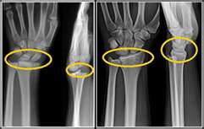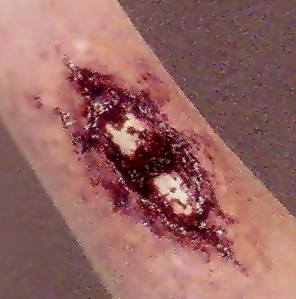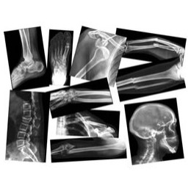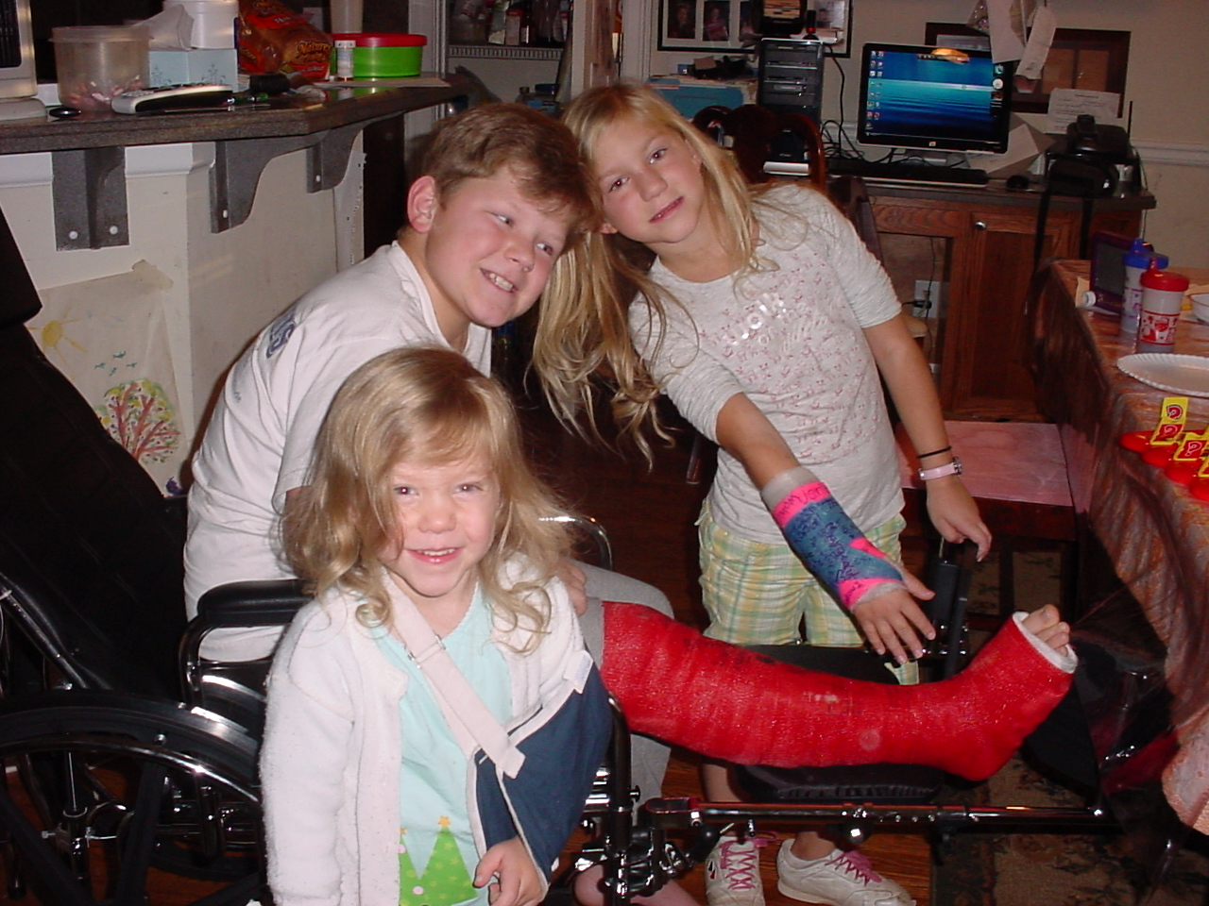
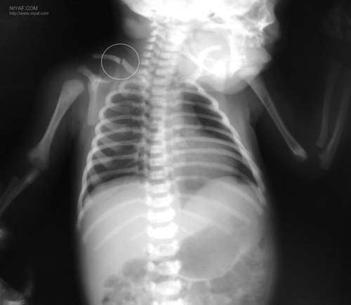
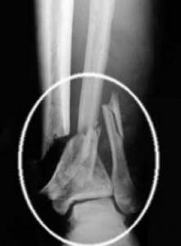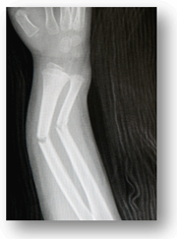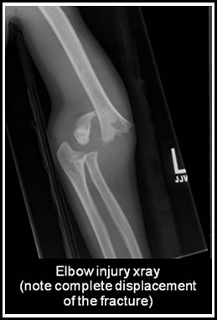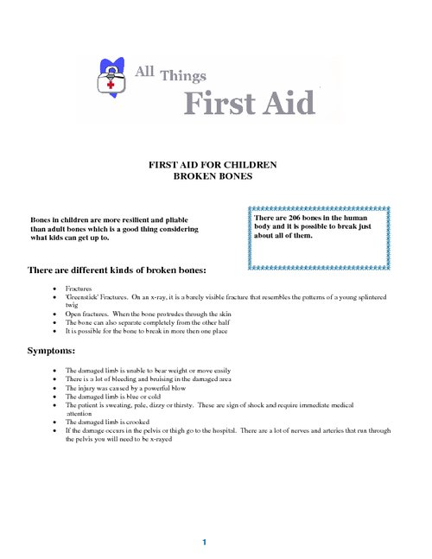

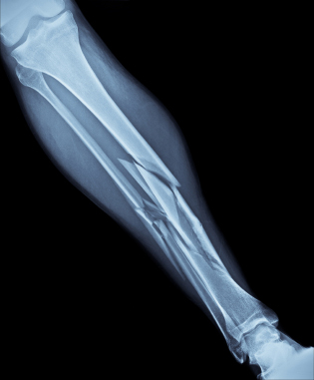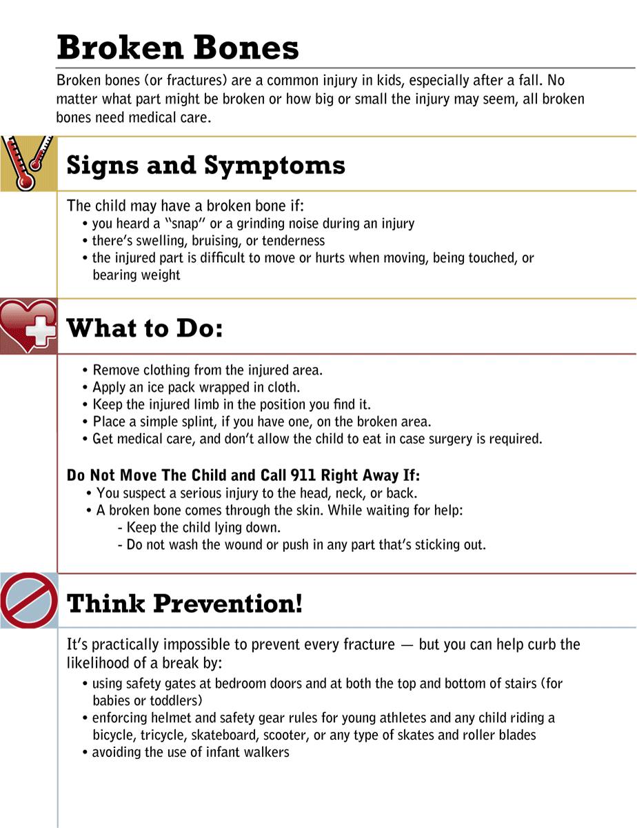

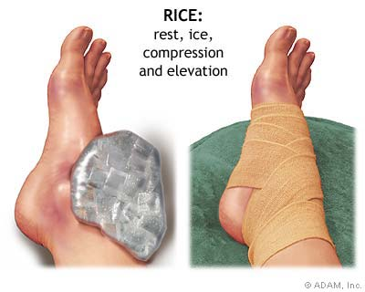
If you suspect a back or neck (spinal) injury, do not move the affected person. Permanent paralysis and other serious complications can result. Assume a person has a spinal injury if:
There's evidence of a head injury with an ongoing change in the person's level of consciousness
The person complains of severe pain in his or her neck or back
The person won't move his or her neck
An injury has exerted substantial force on the back or head
The person complains of weakness, numbness or paralysis or lacks control of his or her limbs, bladder or bowels
The neck or back is twisted or positioned oddly

If you suspect someone has a spinal injury:
Call 911 or emergency medical help.
Keep the person still. Place heavy towels on both sides of the neck or hold the head and neck to prevent movement.
Provide as much first aid as possible without moving the person's head or neck. If the person shows no signs of circulation (breathing, coughing or movement), begin CPR, but do not tilt the head back to open the airway. Use your fingers to gently grasp the jaw and lift it forward. If the person has no pulse, begin chest compressions.
If the person is wearing a helmet, don't remove it.
If you absolutely must roll the person because he or she is vomiting, choking on blood or in danger of further injury, you need at least one other person. With one of you at the head and another along the side of the injured person, work together to keep the person's head, neck and back aligned while rolling the person onto one side.

Lori Logan
Breaks/Sprains/Wounds
We will be making a tri-fold poster board with pictures and information on fractures, signs and symptoms, and treatments including open wound (compound fractures).
Signs and Symptoms:
- Hear a “pop” or “cracking” sound
- Swelling or bruising
- Inability or unwillingness to move the limb
- Pain
Definitions of:
Triage
Standard precautions
Distal and Proximal ( easy way to remember- distal =d for distance AWAY from you)
Demonstration of types of bandages, how to apply, which bandage for what anatomical region should be used and demonstrate proper placement of tourniquet and how to self splint an arm
Explain steps for severe cut on leg or wrist and instruction on how and where to place tourniquet
- Demonstrate first aid procedure on handling a broken bone, with and without integrity of skin disruption.
- Anatomical splinting (wrapping injured leg with uninjured leg similar to “buddy” wrap
- DO NOT move from position it is in
- Support the limb closest to both joints when moving to apply stabilization
- Apply securing splint, brace or wrap as appropriate (using supplies in first aid kit, improvising with tent poles, a tree limb etc.
- Always wrap distally to proximally and check for numbness, tingling, color & temp of extremity
- If broken skin, apply sterile bandage over the area
- If bone is visible protruding out of skin, DO NOT TOUCH THE BONE OR TRY TO PUSH IT BACK INTO THE SKIN. APPLY STERILE BANDAGE TO COVER THE AREA
- Do not allow victim to eat or drink anything
- Notify leader/call 911

Improvised materials that may be assessable and useable:
- Belts, shoe strings=tourniquet
- Magazines=place under arm in a U shape for immobilization
- Scarf, towel, blanket and sleeping bag=sling, rolled can be used to support head/neck for spinal stabilization
- Opposite leg – called anatomical splinting
- Tent poles, small branch or stick for immobilization

