Childbirth Education Preparation
Anatomy, Physiology, and Terms
The Basics of Pregnancy
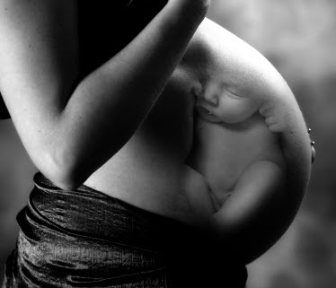
By: Lara Wilken, Demi Fox, Elizabeth Fannin,
& Kurtis Hupp

The Fetal Position:
Anterior: The baby is head down with the back portion of the head toward the mom’s front.
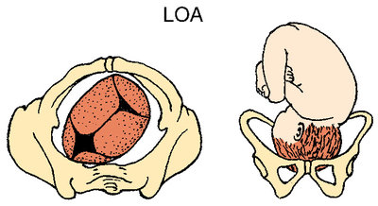
Posterior: The baby is head down with the back portion of the head toward the mom’s back.
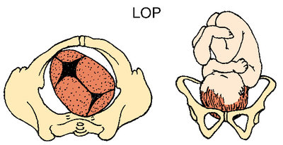

Labor:
Labor is the contracting and relaxing of the uterus that causes the shortening of the vaginal portion of the cervix, thinning of its walls along and widening of its opening leading to the baby’s delivery.

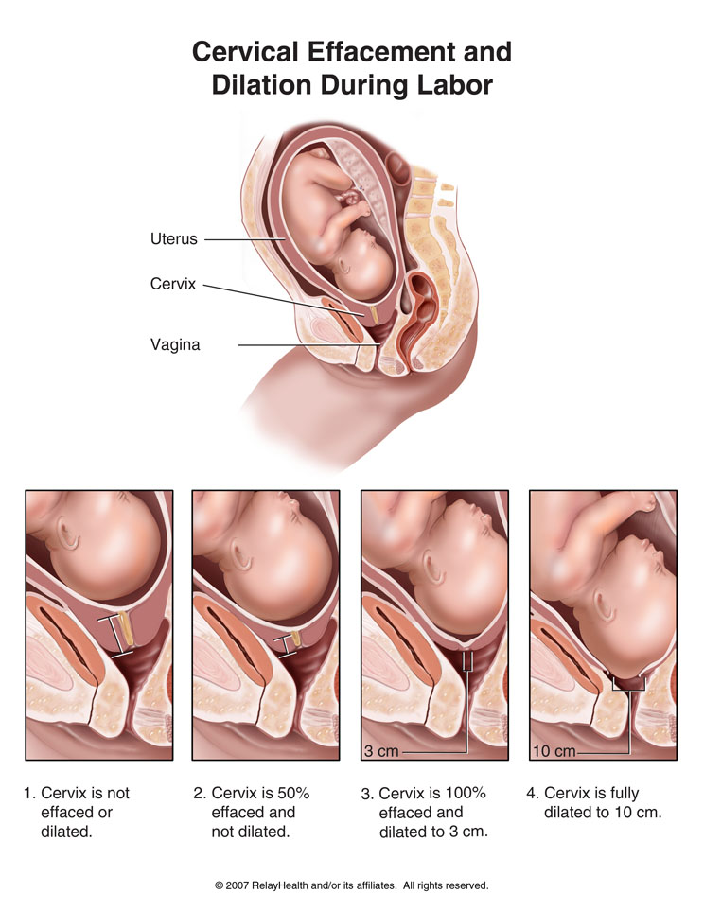

Contractions:
In the last trimester of pregnancy the uterus contracts, you may have felt a tightening of your uterus. These are Braxton Hicks contractions that are uncomfortable, but not painful. The purpose of these contractions is to soften the cervix to better prepare for the changes that will occur during labor.
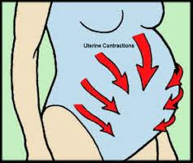
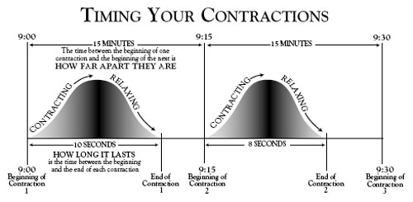

Signs of Labor:
There are multiple signs of labor…
- Loss of the mucous plug
- Rupture of the membrane
- Increased backache, lower abdominal cramps, and/or contractions
- Slight Bloody Show
- Spurt of Energy
- Diarrhea or nausea
When you think labor is happening continue with normal activities as long as possible while monitoring what is happening. Time your contractions, limit your intake to easily digested foods and liquids, rest if it is late, contact your doctor, and or local hospital.
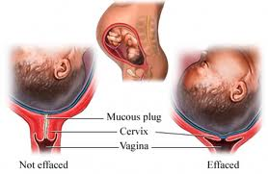
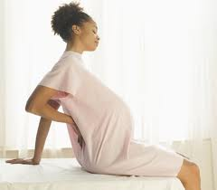

References:

http://t2.gstatic.com/images?q=tbn:ANd9GcSA4oczU-xOvVit-wsU1bTVDa8UgQ4hZZif3dxT5i-wGr-foLC6quLTQHW6
http://0.tqn.com/d/pregnancy/1/5/8/e/3/Fotosearch_COG12045.jpg
http://0.tqn.com/d/pregnancy/1/5/4/e/3/lopFotosearch_COG12046.jpg
http://t0.gstatic.com/images?q=tbn:ANd9GcSZhtDjYVNwmtSgXUznG2xncA1fwuYud-Y93KYbhM3XDQohTYoZ
http://www.empowher.com/files/ebsco/images/si55551477_96472_1.jpeg
http://healthpages.org/wp-content/uploads/2010/06/timing-contractions.jpg
http://t2.gstatic.com/images?q=tbn:ANd9GcSGWSNa3YXCopJkZcUC1_sMjd8cYmiT5nobaOFdkeTD4Ybq9ku _
http://t1.gstatic.com/images?q=tbn:ANd9GcRt7rxO0ZXzIxYqN89ImrTdnaEd7RAuq5e3fwsJyDz88t7KhyGI

