The Fetal Position:
Anterior: The baby is head down with the back portion of the head toward the mom’s front.
http://0.tqn.com/d/pregnancy/1/5/8/e/3/Fotosearch_COG12045.jpg
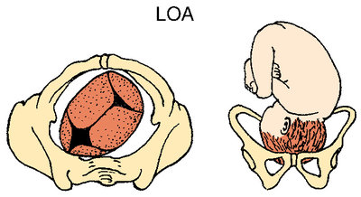
Posterior: The baby is head down with the back portion of the head toward the mom’s back.
http://0.tqn.com/d/pregnancy/1/5/4/e/3/lopFotosearch_COG12046.jpg
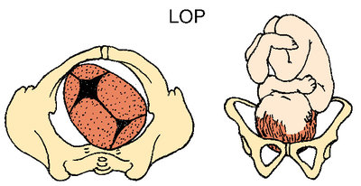

Labor:
Labor is the contracting and relaxing of the uterus that causes the shortening of the vaginal portion of the cervix, thinning of its walls along and widening of its opening leading to the baby’s delivery.
http://t1.gstatic.com/images?q=tbn:ANd9GcRt7rxO0ZXzIxYqN89ImrTdnaEd7RAuq5e3fwsJyDz88t7KhyGI
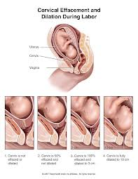
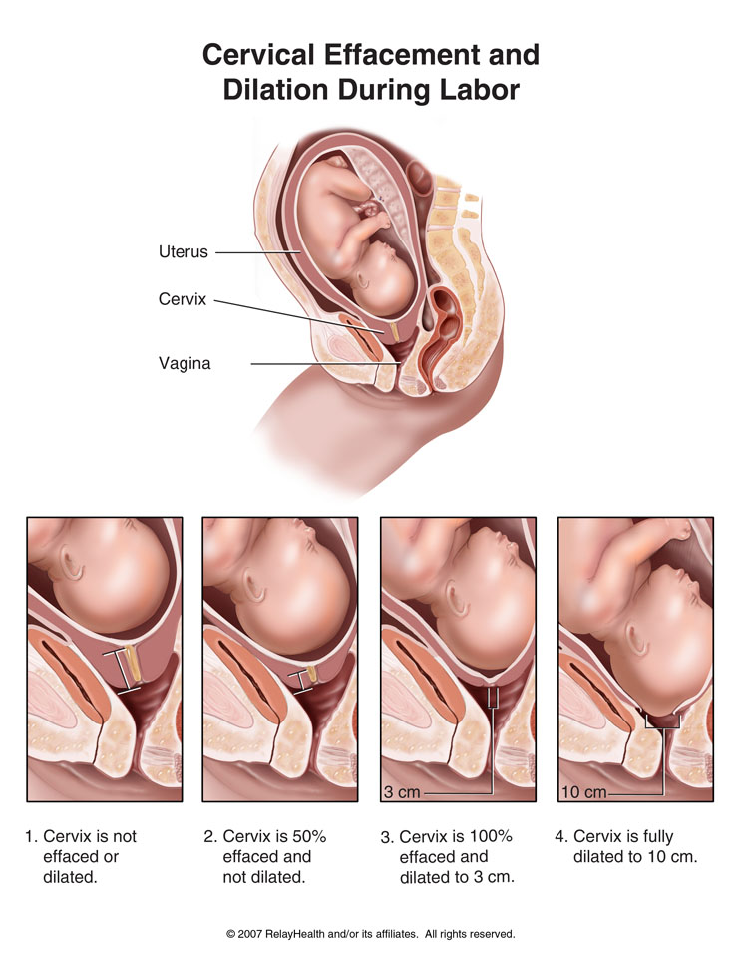

Contractions:
In the last trimester of pregnancy the uterus contracts, you may have felt a tightening of your uterus. These are Braxton Hicks contractions that are uncomfortable, but not painful. The purpose of these contractions is to soften the cervix to better prepare for the changes that will occur during labor.
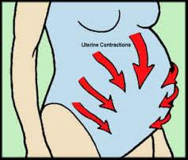
http://t2.gstatic.com/images?q=tbn:ANd9GcSGWSNa3YXCopJkZcUC1_sMjd8cYmiT5nobaOFdkeTD4Ybq9ku_

Signs of Labor:
There are multiple signs of labor…
- Loss of the mucous plug
- Rupture of the membrane
- Increased backache, lower abdominal cramps, and/or contractions
- Slight Bloody Show
- Spurt of Energy
- Diarrhea or nausea
When you think labor is happening continue with normal activities as long as possible while monitoring what is happening. Time your contractions, limit your intake to easily digested foods and liquids, rest if it is late, contact your doctor, and or local hospital.
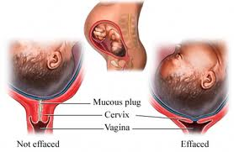
http://www.empowher.com/files/ebsco/images/si55551477_96472_1.jpeg
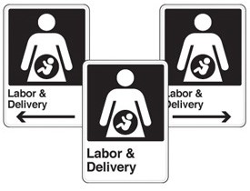http://static.emedco.com/media/catalog/product/cache/1/image/9df78eab33525d08d6e5fb8d27136e95/Health-Care-Facility-Wayfinding-Signs---Labor-%26-Delivery-MM565-ba.jpg



http://t2.gstatic.com/images?q=tbn:ANd9GcQpn6u7eG1s58K5nKuvbRXaKAKwPygixS0w862NCjg4kgvCWXz3

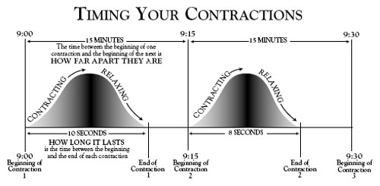
http://healthpages.org/wp-content/uploads/2010/06/timing-contractions.jpg


http://t0.gstatic.com/images?q=tbn:ANd9GcSZhtDjYVNwmtSgXUznG2xncA1fwuYud-Y93KYbhM3XDQohTYoZ

http://t0.gstatic.com/images?q=tbn:ANd9GcSZhtDjYVNwmtSgXUznG2xncA1fwuYud-Y93KYbhM3XDQohTYoZ


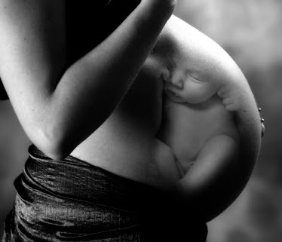
http://t2.gstatic.com/images?q=tbn:ANd9GcSA4oczU-xOvVit-wsU1bTVDa8UgQ4hZZif3dxT5i-wGr-foLC6quLTQHW6

