Normal Sinus Rhythm
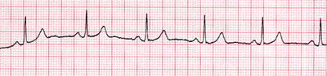

Sinus Bradycardia (HR <60 bpm)
Symptoms: pale, cool skin; hypotension; weakness; angina; dizziness or syncope; confusion or disorientation; SOB
Treatment: If BP normal, no treatment indicated
- Symptomatic: Follow ACLS Bradycardia Algorithm

Sinus Tachycardia (HR 101-200 bpm)
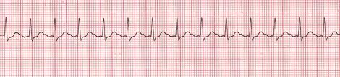
Symptomatic: chest pain, signs of shock, SOA, altered mental status, weakness, fatigue, and syncope
Treatment: Monitor VS, check BP, treat the underlying condition
- Dehydration, hypoxia, fever, and sepsis are treated outside ACLS algorithm
  - Administration of Oxygen and Normal Saline
- then Follow ACLS Tachycardia Algorithm

Premature Ventricular Contractions
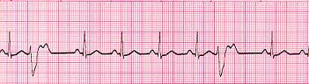
Treatment: Monitor VS, check BP
- Occasional PVC, non-symptomatic requires no treatment
- PVC in acute MI/chest pain, frequent multifocal or unifocal PVC’s (>6 per minute), or back-to-back PVC’s require management with medication

Atrial Flutter
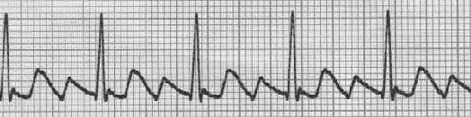
Symptoms: palpitations, chest pain, SOB, lightheadedness/dizziness, nausea, nervousness, feelings of impending doom, symptoms of HF like activity intolerance and swelling of the legs with prolonged flutter
Treatment: hemodynamic instability and serious s/s
- Follow ACLS Tachycardia Algorithm

Atrial Fibrillation
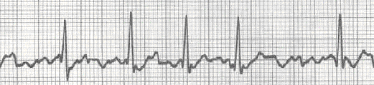
Symptoms: palpitations or chest discomfort, SOB, respiratory distress, hypotension, light-headedness, possible LOC, peripheral edema, jugular vein distention, pulmonary edema
Treatment: treated in presence of hemodynamic instability and serious s/s
- Follow ACLS Tachycardia Algorithm

Supraventricular Tachycardia (160-250 bpm)
Symptoms: Stable- SOB, palpitation feeling, dizziness, rapid breathing, numbness of body parts
Unstable- Ongoing chest pain, LOC
Treatment: Monitor VS, check BP
- Follow ACLS Tachycardia Algorithm (based on stable vs. unstable)

Ventricular Tachycardia (Monomorphic VT, Sustained >30 seconds)
Treatment: Monitor VS, check BP
- Stable: expert consultation always advised
- Unstable: Follow ACLS Tachycardia Algorithm

Torsades de Pointes (Polymorphic VT >150 bpm)
Causes: can result from a prolonged QT interval
Treatment (of stable polymorphic VT): Follow ACLS Tachycardia algorithm
Treatment (of unstable VT): treat with unsynchronized shocks (defibrillation)

Ventricular Fibrillation (pulseless rhythm)
Treatment: Check pulse; if no pulse present, defibrillate immediately
- Follow left branch of the ACLS Pulseless Arrest Algorithm
  - CPR is preformed until defibrillator attached to patient
  - Rapid defibrillation emphasized
  - Use manual defibrillator over AED to reduce interruptions in compressions

Asystole (No pulse, <5 bpm, occasional agonal beats)
Treatment: Check VS, Identify presence of H’s and T’s as underlying cause, ensure equipment failure not to blame for rhythm
- Follow the right branch of ACLS Pulseless Arrest Algorithm

1° AV Heart Block (P-R interval >0.20 seconds)
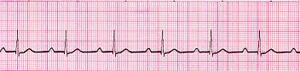
Treatment: Monitor VS, check BP
- If stable, no treatment indicated
- Monitor patient’s condition for deterioration of rhythm
Symptomatic: Follow ACLS Bradycardia Algorithm

2° AV Heart Block, Mobitz Type I (Wenckebach) (Progressive lengthening of P-R interval)
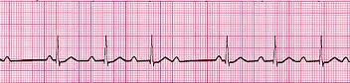Treatment: Monitor VS and BP
- If rate <60 bpm or VS unstable, Follow ACLS Bradycardia Algorithm

2° AV Heart Block, Mobitz Type II (Some P-waves stand alone; P-R interval constant and normal)
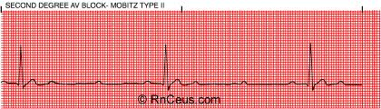
Rate: 30-100 bpm depending on conduction ratio (1:1, 2:1, 3:1, 4:1); all intervals except R-R normal
Treatment: Monitor VS, check BP
- If VS stable, no treatment indicated
- If bradycardia persists or is symptomatic, Follow ACLS Bradycardia Algorithm
- Monitor patient for further deterioration

3° AV Heart Block: Complete Heart Block (no relationship between P-waves and QRS complexes)
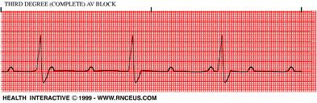
Description: atrial rate of 60-100 bpm; ventricular rate 20-40 bpm; BP may be low and CO may be compromised
Treatment: Monitor VS, check BP (only the ventricular rate produces a pulse)
- If s/s of shock: Follow ACLS Bradycardia Algorithm
- Do NOT give lidocaine
- Consider a pacemaker
- Carefully monitor patient until successfully monitored or paced

Pulseless Electrical Activity (PEA)
No Pulse
- CHECK FOR A PULSE; organized rhythm with no pulse is PEA
- Begin CPR and airway management at rate of 30:2
  - Positive outcome depends on good quality CPR and identification and correction of the cause of PEA
- Follow ACLS PEA Algorithm

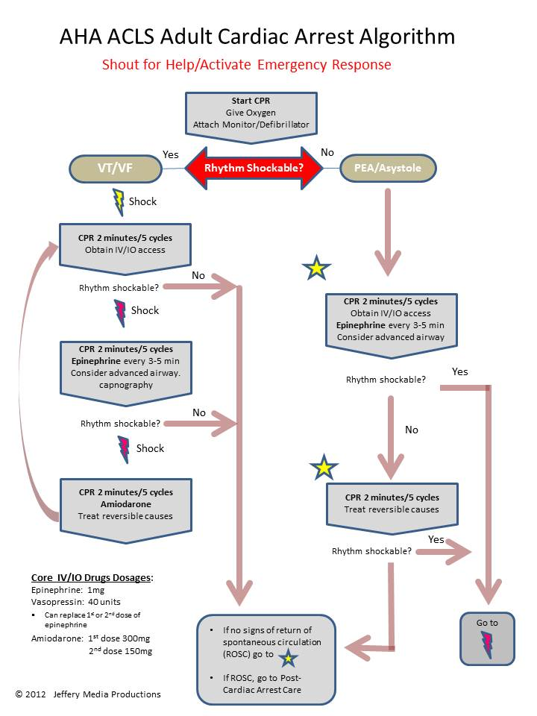
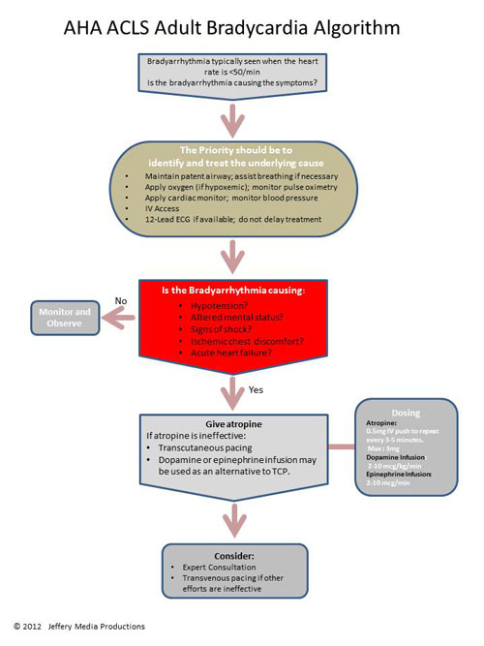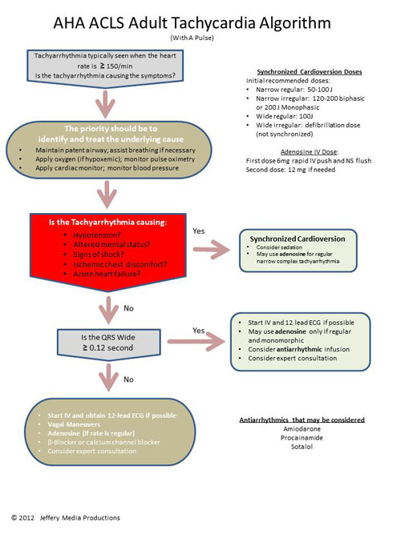

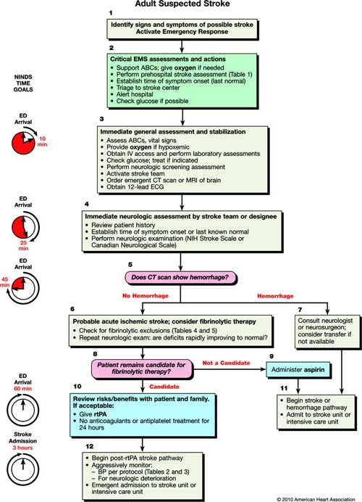

ACLS Algorithms and Their Primary Drugs

Ventricular Tachycardia & Ventricular Fibrillation
- epinephrine (Adrenaline) 1:10,000
  - 1mg IV/IO followed by 20 ml flush; repeat throughout code every 3-5 minutes. There is no maximum dose.
- vasopressin (Pressyn)
  - 40 units can replace the first or second dose of Epinephrine
- amiodarone (Cordarone)
  - 300mg IV/IO push. Second dose (if needed) 150 mg IV/IO push

Asystole & Pulseless Electrical Activity
- epinephrine (Adrenaline) 1:10,000
  - 1mg IV/IO followed by 20 ml flush; repeat throughout code every 3-5 minutes. There is no maximum dose.

Bradycardia
- Antiarrhythmics
  - atropine (Atro-Pen)
    - 0.5mg IV push to repeat every 3-5 minutes. Max: 3mg
- Vasopressors
  - epinephrine (Adrenaline)
    - 1mg epinephrine in 500ml NS and run as an IV Infusion on an infusion pump at a rate of 2-10mcg/min.
  - dopamine (Intropin)
    - second line drug for Bradycardia, 2-10mcg/kg/min as an IV Infusion on an infusion pump only. Titrate to patient response.
    - NEVER GIVE IV PUSH

Tachycardia

Other Antidysrhythmia Drugs

adenosine (Adenocard) (for regular, narrow-complex tachyarrhythmia)

1st dose- 6 mg rapid IV push; follow with NS flush

2nd dose- 12 mg if required

digoxin (Lanoxin)

magnesium

Sodium Channel Blocker (Antiarrhythmics)

procainamide (Pronestyl)

20-50 mg/min until arrhythmia suppressed, hypotension ensues, QRS duration increases >50%, or maximum dose 17 mg/kg given

Maintenance infusion: 1-4 mg/min

Calcium Channel Blocker

diltiazem (Cardizem)

verapamil (Calan)

Beta-blockers (Antiarrhythmic)

sotalol (Betaspace)

100 mg (1.5 mg/kg) over 5 minutes

Avoid if prolonged QT

amiodarone (Cordarone)

First dose: 150 mg over 10 minutes; repeat as needed if VT recurs.

Follow by maintenance infusion of 1 mg/min for first 6 hours.

Acute Coronary Syndromes
- Morphine: Initial dose is 2 to 4 mg IV over 1 to 5 minutes, administer slowly and only titrate to effect
  - May administer to patients with suspected ischemic pain unresponsive to oxygen and nitrates
  - Before administering morphine, be sure that the patient’s systolic blood pressure is >90 mm Hg and that they are not hypovolemic
  - Remember to reassess VS between doses
- Oxygen (For O₂ <94%)
- Nitroglycerin: 1 spray sublingually every 3-5 minutes up to a total of 3 sprays
  - Indications — Standard therapy for all patients with new pain/discomfort suggestive of ACS
  - Give within minutes of arrival
  - Nitroglycerin decreases pain in ischemia and is a vasodilator.
  - Before administering nitroglycerin, be sure that the patient’s systolic blood pressure is >90 mm Hg and they should not have bradycardia or tachycardia.
  - Do not give nitroglycerin if the patient has had an erectile dysfunction drug within the past week.
- Aspirin: 160 to 325 mg given as soon as possible, non-coated baby or adult aspirin may be used
  - Indications — Standard therapy for all patients with new pain/discomfort suggestive of ACS
  - Give within minutes of arrival
  - Aspirin irreversibly binds to platelets and partially inhibits platelet function.
  - Before administering aspirin, make sure patient does not have an aspirin allergy, or recent or active GI bleeding.
- Fibrinolytic therapy
- Heparin
- Beta-Blockers

Acute Stroke
- Oxygen, if hypoxemic
- Glucose (D50); treat if indicated
- No hemmorhage: Check for fibrinolytic exclusions
  - Not a candidate: administer aspirin
  - Candidate for fibrinolytic therapy
    - Give rtPA
- Labetalol
- Nitroprusside
- Nicardipine

