P.M.—Abs, Back, Traps
• 

Jackknife Sit-Up
3 sets to failure, 2-minute rest
• 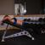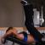

Decline Reverse Crunch
3 sets to failure, 2-minute rest
• 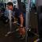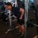

Smith Machine Bent Over Row
4 sets, 10 reps, 2-minute rest
• 

Pullups (Close-grip)
4 sets to failure, 2-minute rest
• 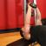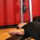

Straight-Arm Dumbbell Pullover
3 sets, 12 reps, 2-minute rest
• 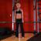

Barbell Shrug*
4 sets, 12 reps, 2-minute rest
• 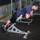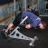

Hyperextensions (Weighted)**
3 sets to failure, 2-minute rest

