Activity #1: “Evidence Based Practice” Activity (p. 228)
- What information would you discuss with M.J. r/t HIV transmission, viral load, and the risks of unprotected sexual activity?
Transmission:
Discuss Preexposure prophylaxis (PrEP) is a comprehensive HIV prevention strategy to reduce the risk of sexually acquired HIV infection in adults at high risk. PrEP should be used in conjunction with other proven prevention intervention such as condoms, risk reduction counseling, and regular HIV testing.
Tenofovir in combination with emtricitabine, also known as Truvada, is used to reduce the risk of HIV infection in uninfected individuals who are at significant risk of acquiring HIV, Tenofovir/emtricitabine is also currently used in combination with other antiretroviral agents for the treatment of HIV infected people.
Viral Load:
Lab tests that measure viral loads provide an assessment of disease progression. The lower the viral load, the less active the disease. Low or “unpredictable” numbers does not mean that the virus has been eliminated from the body or that the individual can no longer transmit HIV to others. Rather, it refers to the fact that the amount of circulating HIV in the blood is below the level of detection of the test. So even though levels are low, it doesn’t mean the there still isn’t a change to infect your partner.
Risks:
Assess the patient’s risky behaviors on a regular basis. Obtain subjective and objective data from the patient (i.e. look at Table 14-14). Early recognition and treatment can slow the progression of HIV infection and prevent new infections. A complete hx and thorough systems review can help identify and address problems in a timely manner.
HIV infection is preventable. Avoiding or modifying risky behaviors is the most effective prevention tool. Nursing interventions to prevent disease transmission are based on an assessment of the individuals risk behaviors. Provide culturally sensitive, language appropriate, and age-specific teaching and behavior change counseling.
Prevention techniques can be divided into safe sexual activities (those that eliminate risk) and risk-reducing sexual activity (those that decrease, but do not eliminate, risk).
The goal is to develop safer, healthier, and less risky behaviors. The more consistently and correctly prevention methods are used, the more effective they are in preventing HIV infection.
Safe sexual activities eliminate the risk of exposure to HIV in semen and vaginal sections. Abstaining from all sexual activity is an effective to way to accomplish the goal, but there are safe options for those who cannot or do not wish to abstain. Limiting sexual behavior to activities in which the mouth, penis, vagina, or rectum does not come into contact with a parent’s mouth, penis, vagina, or rectum eliminates contact with blood, semen, or vaginal secretions. Safe activities include masturbation, mutual masturbation (“hand job”), and other activities that meet the “no contact” requirements. Insertive sex between partners who are not infection with HIV and not at risk of becoming infected with HIV is also considered safe.
Risk-reducing sexual activities decrease the risk of contact with HIV through the use of barriers. Barriers should be used when engaging in insertive sexual activity (oral, vaginal, or anal) with a partner who has HIV or whose HIV status is not known. The most commonly used barrier is the male condom. Male condoms can be sued for protection during anal, vaginal, and oral intercourse.
Educate the patient and importance of adhering to drug regimens, adopting a healthy lifestyle that includes avoiding exposure to other sexually transmitted infection and bloodborne diseases, protect other from HIV, maintain or develop healthy and supportive relationships, maintain activities and productivity, explore spiritual issues, come to terms with issues r/t disease, disability, and death, and cope with symptoms caused by HIV and its treatments.
What measure besides condom use would you discuss with M.J. to reduce the risk of HIV transmission?
Medications that were mentioned above. Abstinence, masturbation, and/or mutual masturbation, etc.

Activity #2: Create an educational flyer or brochure that could be used for patient education regarding HIV prevention methods.
HIV FLYER
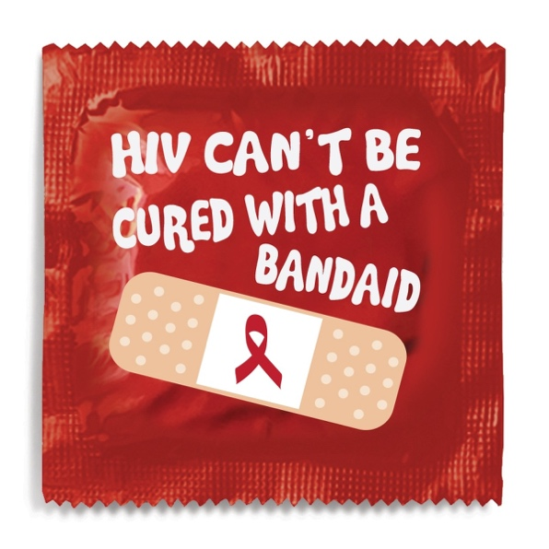

CONDOMS = SAFE SEX PRACTICES


MONOGAMOUS RELATIONSHIP = SAFE SEX PRACTICES
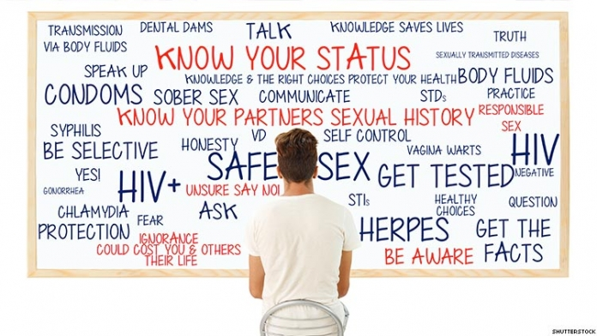
HONESTY

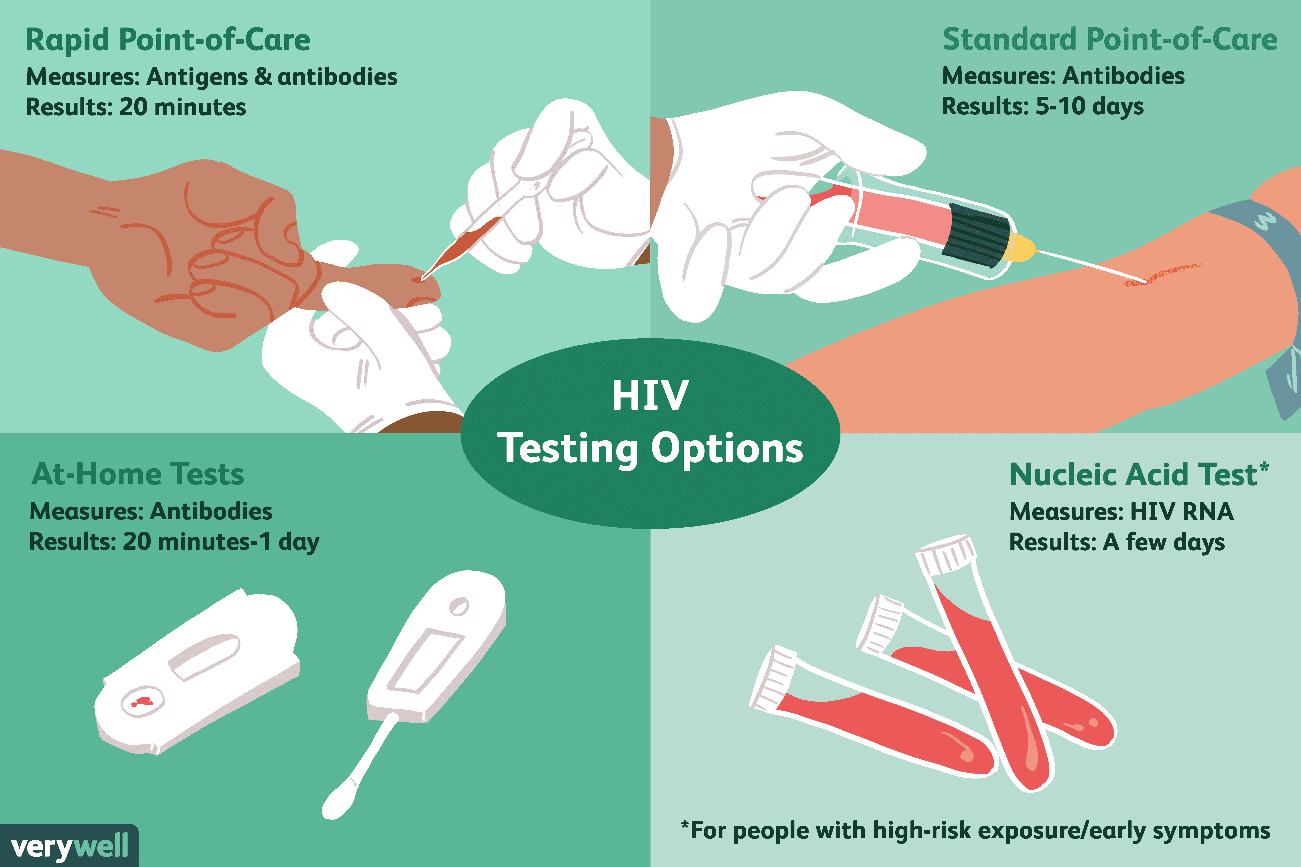

HIV TESTING

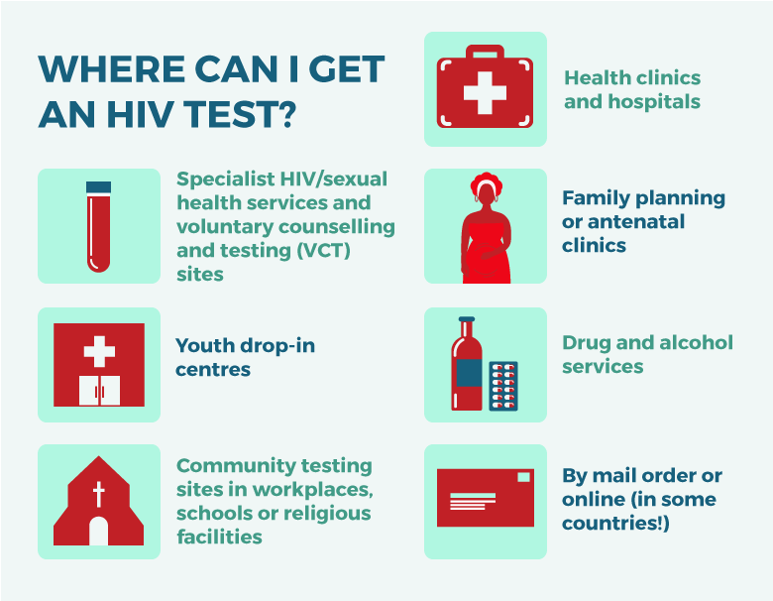
WHERE TO GET TESTED
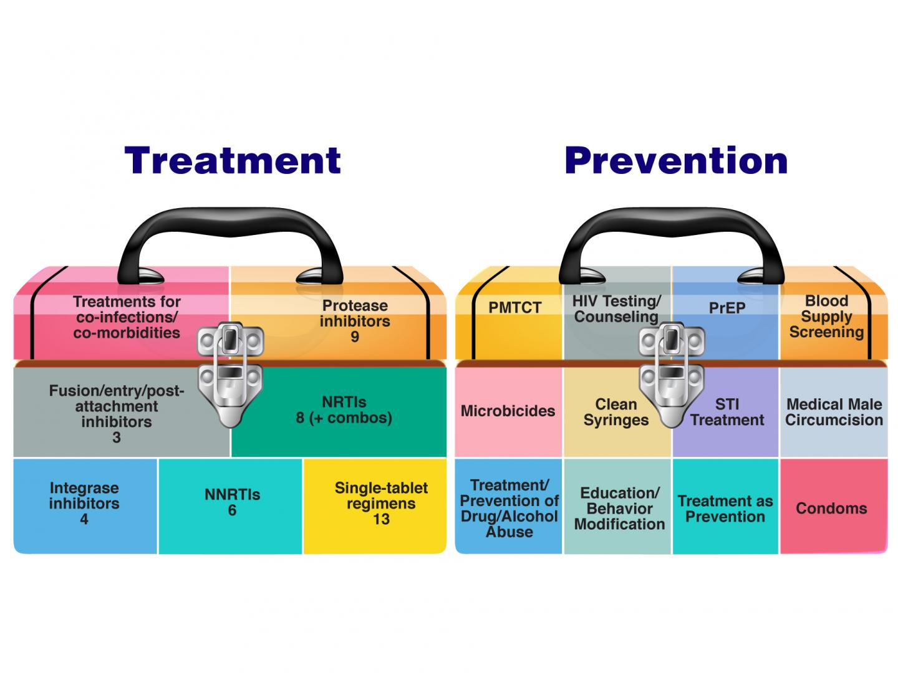
TREATMENT/PREVENTION
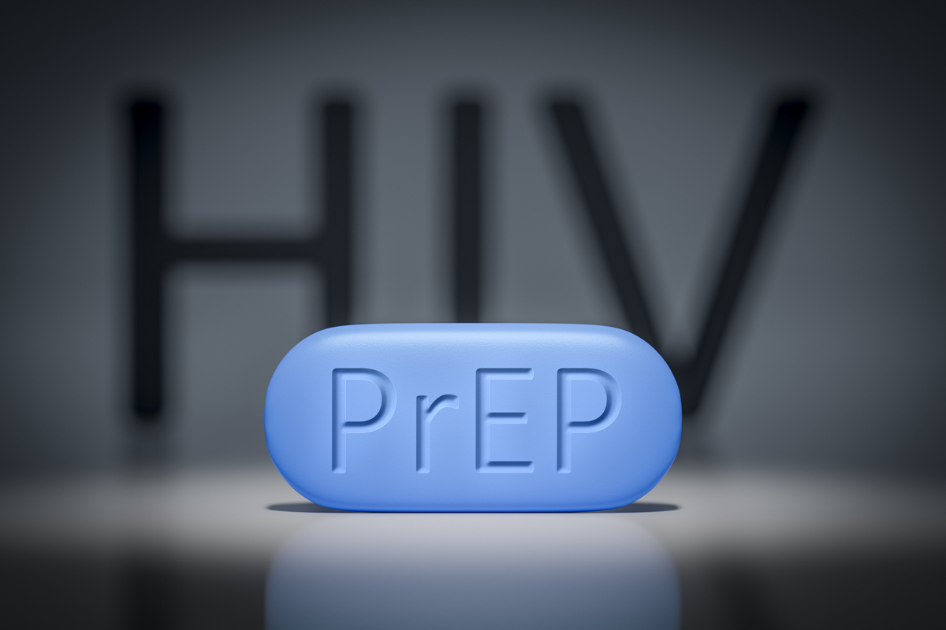

PrEVENTION in a pill
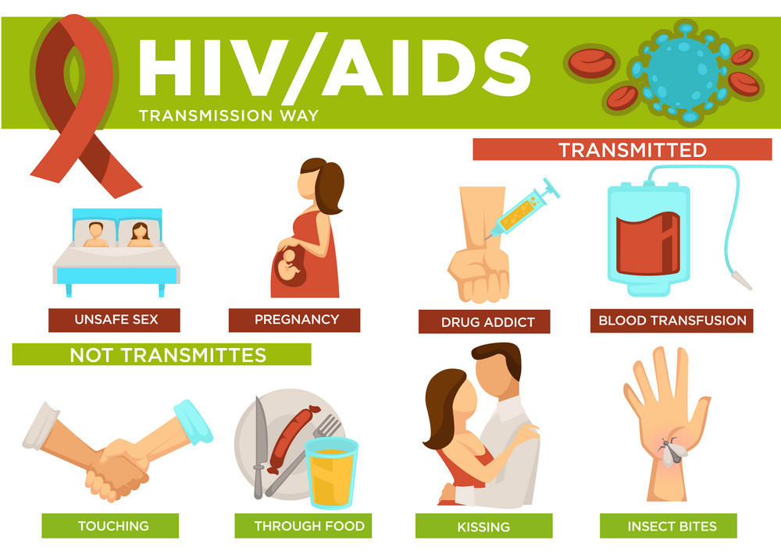
Taking a once-daily pill can reduce the risk of contracting HIV by more than 90%

EDUCAITON ON TRANSMISSION

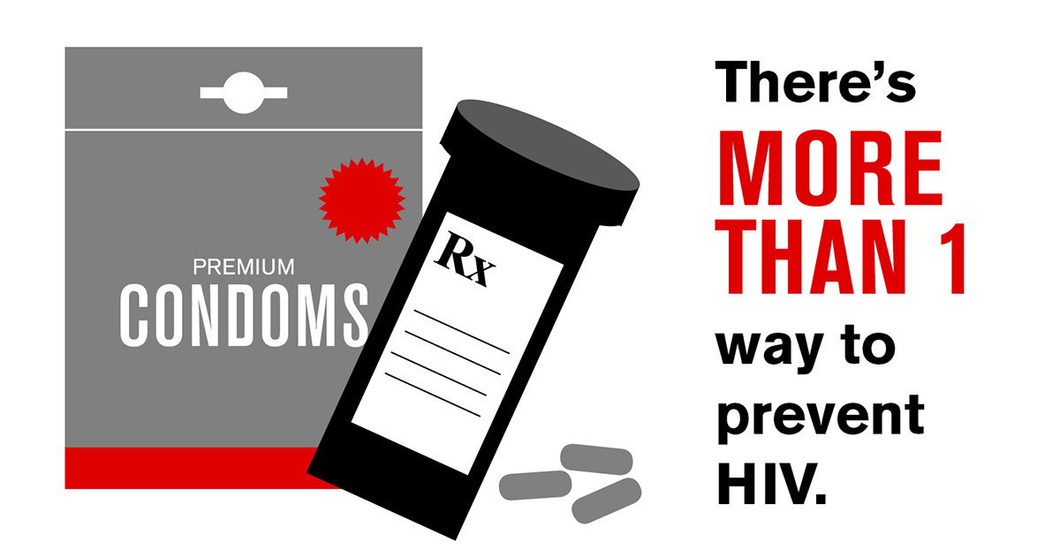
REMEMBER…

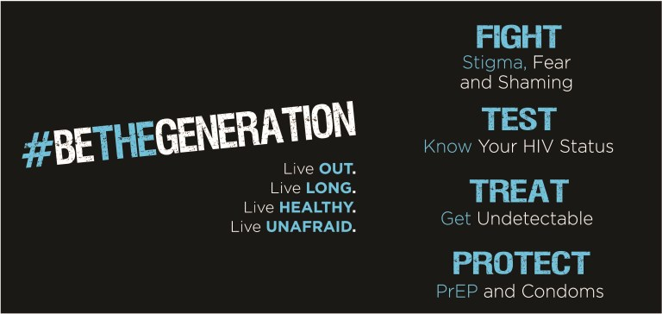
AND

