10 minute health care presentation

Picture from

CIA. "CIA - The World Factbook." Welcome to the CIA Web Site — Central Intelligence Agency. CIA, 09 Jan. 2012. Web. 09 Jan. 2012. <https://www.cia.gov/library/publications/the-world-factbook/geos/no.html>.
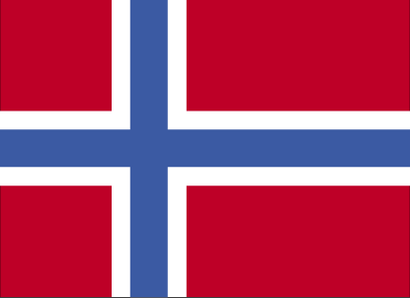

CIA. "CIA - The World Factbook." Welcome to the CIA Web Site — Central Intelligence Agency. CIA, 09 Jan. 2012. Web. 09 Jan. 2012. <https://www.cia.gov/library/publications/the-world-factbook/geos/no.html>.
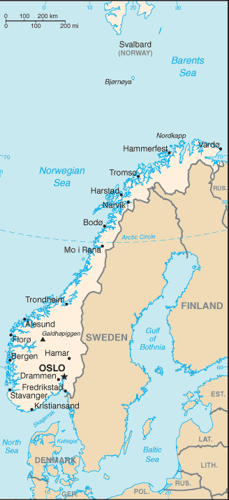 CIA. "CIA - The World Factbook." Welcome to the CIA Web Site — Central Intelligence Agency. CIA, 09 Jan. 2012. Web. 09 Jan. 2012. <https://www.cia.gov/library/publications/the-world-factbook/geos/no.html>.

Hand out from CIA. "CIA - The World Factbook." Welcome to the CIA Web Site — Central Intelligence Agency. CIA, 09 Jan. 2012. Web. 09 Jan. 2012. <https://www.cia.gov/library/publications/the-world-factbook/geos/no.html>.
Nationality:
noun: Norwegian(s)
adjective: Norwegian
Ethnic groups:
Norwegian 94.4% (includes Sami, about 60,000), other European 3.6%, other 2% (2007 estimate)
Languages:
Bokmal Norwegian (official), Nynorsk Norwegian (official), small Sami- and Finnish-speaking minorities
note: Sami is official in six municipalities
Religions:
Church of Norway 85.7%, Pentecostal 1%, Roman Catholic 1%, other Christian 2.4%, Muslim 1.8%, other 8.1% (2004)
Population:
4,691,849 (July 2011 est.)
country comparison to the world: 119
Age structure:
0-14 years: 18% (male 431,111/female 412,864)
15-64 years: 66% (male 1,568,729/female 1,529,799)
65 years and over: 16% (male 326,711/female 422,635) (2011 est.)
Median age:
total: 40 years
male: 39.1 years
female: 40.8 years (2011 est.)
Population growth rate:
0.329% (2011 est.)
country comparison to the world: 167
Birth rate:
10.84 births/1,000 population (2011 est.)
country comparison to the world: 176
Death rate:
9.24 deaths/1,000 population (July 2011 est.)
country comparison to the world: 66
Net migration rate:
1.7 migrant(s)/1,000 population (2011 est.)
country comparison to the world: 43
Urbanization:
urban population: 79% of total population (2010)
rate of urbanization: 1.2% annual rate of change (2010-15 est.)
Major cities - population:
OSLO (capital) 875,000 (2009)
Sex ratio:
at birth: 1.054 male(s)/female
under 15 years: 1.04 male(s)/female
15-64 years: 1.03 male(s)/female
65 years and over: 0.76 male(s)/female
total population: 0.98 male(s)/female (2011 est.)
Maternal mortality rate:
7 deaths/100,000 live births (2008)
country comparison to the world: 159
Infant mortality rate:
total: 3.52 deaths/1,000 live births
country comparison to the world: 209
male: 3.85 deaths/1,000 live births
female: 3.17 deaths/1,000 live births (2011 est.)
Life expectancy at birth:
total population: 80.2 years
country comparison to the world: 25
male: 77.53 years
female: 83.02 years (2011 est.)
Total fertility rate:
1.77 children born/woman (2011 est.)
country comparison to the world: 158
Health expenditures:
9.7% of GDP (2009)
country comparison to the world: 35
Physicians density:
4.076 physicians/1,000 population (2008)
country comparison to the world: 10
Hospital bed density:
3.52 beds/1,000 population (2008)
country comparison to the world: 59
Drinking water source:
improved:
urban: 100% of population
rural: 100% of population
total: 100% of population (2008)
Sanitation facility access:
improved:
urban: 100% of population
rural: 100% of population
total: 100% of population (2008)
HIV/AIDS - adult prevalence rate:
0.1% (2009 est.)
country comparison to the world: 145
HIV/AIDS - people living with HIV/AIDS:
4,000 (2009 est.)
country comparison to the world: 121
HIV/AIDS - deaths:
fewer than 100 (2009 est.)
country comparison to the world: 126
Obesity - adult prevalence rate:
10% (2009)
country comparison to the world: 55
Education expenditures:
6.8% of GDP (2007)
country comparison to the world: 18
Literacy:
definition: age 15 and over can read and write
total population: 100%
male: 100%
female: 100%
School life expectancy (primary to tertiary education):
total: 17 years
male: 17 years
female: 18 years (2008)
Unemployment, youth ages 15-24:
total: 9.2%
country comparison to the world: 107
male: 10.3%
female: 8% (2009)

