Hand hygiene and other preventive measures
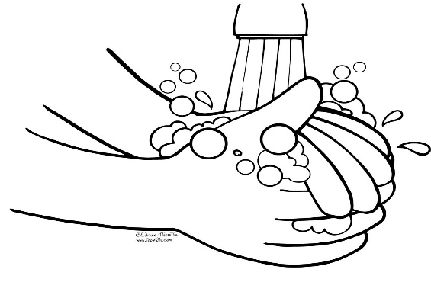
This Photo by Unknown Author is licensed under CC BY-NC-ND
- Household members and support staff should clean hands often, including immediately after removing gloves by washing hands with soap and water for 20 seconds.
- If soap and water are not available and hands are not visibly dirty, an alcohol-based hand sanitizer that contains at least 60% alcohol may be used. However, if hands are visibly dirty, always wash hands with soap and water.
- Household members and support staff should follow normal preventive actions including recommended hand hygiene and avoiding touching eyes, nose, or mouth with unwashed hands.
  - Additional key times to clean hands include:
    - After blowing one’s nose, coughing, or sneezing
    - After using the restroom
    - Before eating or preparing food
    - After contact with animals or pets
    - Before and after providing routine care for another person who needs assistance.
    - Encourage individuals to wash their hands immediately when they get home from anywhere (day program, parents house, trip to park). Support staff do the same.

Clean and Disinfect
Clean and disinfect high-touch surfaces before the end of your shift in household common areas including
- tables
- kitchen counter
- handles –refrigerator handles, cupboard handles
- hard-backed chairs
- doorknobs
- light switches
- remotes
- desks,
- toilets
- sinks
- laptop or tablet
In shared bedrooms
- top of dresser
- top of headboard and
- light switches on both lamps and for room
- door knobs
In shared bathrooms
- toilet
- sink
- ensure soap and paper towels are used instead of a towel
- door knobs

Bedding- bring your own bedding (sheets, blankets) and pillows. You should take them home with you after your shift is completed.

How to clean and disinfect:

Surfaces
- Wear disposable gloves when cleaning and disinfecting surfaces. Gloves should be discarded after each cleaning. If reusable gloves are used, those gloves should be dedicated for cleaning and disinfection of surfaces for COVID-19 and should not be used for other purposes. Clean hands immediately after gloves are removed.
- If surfaces are dirty, they should be cleaned using a detergent or soap and water prior to disinfection.
- For disinfection, diluted household bleach solutions, alcohol solutions with at least 70% alcohol, and most common EPA-registered household disinfectants should be effective.
- Diluted household bleach solutions can be used if appropriate for the surface. Follow manufacturer’s instructions for application and proper ventilation. Never mix household bleach with ammonia or any other cleanser.

- Unexpired household bleach will be effective against coronaviruses when properly diluted.

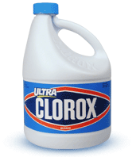
Prepare a bleach solution by mixing:
    - 5 tablespoons (1/3rd cup) bleach per gallon of water or
- 4 teaspoons bleach per quart of water

Clothing, towels, linens and other items that go in the laundry
- Wear disposable gloves when handling dirty laundry and then discard after each use. Clean hands immediately after gloves are removed.
- If no gloves are used when handling dirty laundry, be sure to wash hands afterwards.
- If possible, do not shake dirty laundry. This will minimize the possibility of dispersing virus ( if it is present) through the air.
- Launder items as appropriate in accordance with the manufacturer’s instructions. If possible, launder items using the warmest appropriate water setting for the items and dry items completely. Dirty laundry from an ill person can be washed with other people’s items.
- Clean and disinfect clothes hampers according to guidance above for surfaces. If possible, consider placing a bag liner that is either disposable (can be thrown away) or can be laundered.
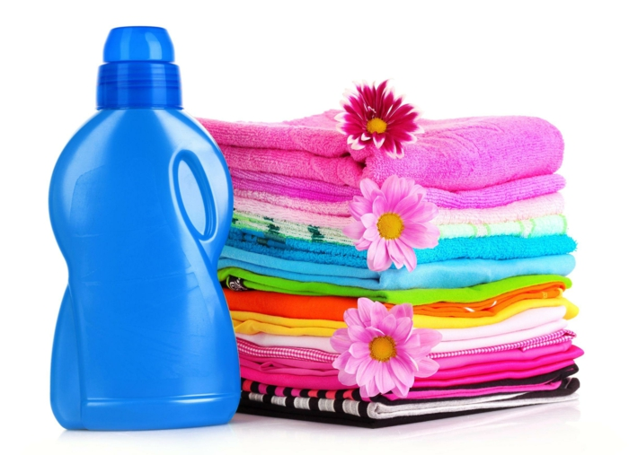

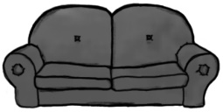Soft surfaces
For soft surfaces such as carpeted floor, rugs, and drapes.
- Clean the surface using soap and water or with cleaners appropriate for use on these surfaces.
- Launder items (if possible) according to the manufacturer’s instructions. Use the warmest appropriate water setting and dry items completely.
OR
- Disinfect with an EPA-registered household disinfectant.
- Vacuum as usual.

Electronics
For electronics, such as tablets, touch screens, keyboards, and remote controls.
- Consider putting a wipeable cover on electronics.
- Follow manufacturer’s instruction for cleaning and disinfecting.
  - If no guidance, use alcohol-based wipes or sprays containing at least 70% alcohol. Dry surface thoroughly.

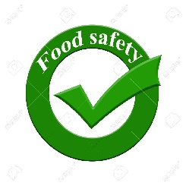Food
- Stay separated: The person who is sick should eat (or be fed) in their room if possible.
- Wash dishes and utensils using disposable gloves and hot water: Handle any used dishes, cups/glasses, or silverware with gloves. Wash them with soap and hot water or in a dishwasher.
- Clean hands after taking off gloves or handling used items.

Trash
- Dedicated, lined trash can: If possible, dedicate a lined trash can for the person who is sick. Use disposable gloves when removing garbage bags, and handling and disposing of trash. Wash hands afterwards.

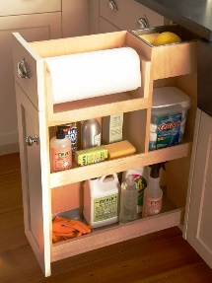Storage of Cleaning Supplies

Check Labels for Storage Recommendations
It’s important to remember that cleaning products are chemicals, and chemicals require some special handling. Therefore, it’s crucial to read the storage and warning labels on your housekeeping products.
Some household cleaners can cause dangerous reactions when mixed, meaning they shouldn’t be stored with one another. Others can have hazardous reactions to extreme temperature fluctuations, which makes keeping them in cold garages or next to the hot water heater an absolute no-no.
When it comes to dealing with chemicals, it’s always better to be safe rather than sorry, so don’t skip reading those labels.
Ensure we are keeping the cleaning supplies in a safe location to ensure the people we support do cause danger to themselves or others.

Created by M.Ames 3-15-2020
Updated by Amber Eisfeld 5-11-20
Source CDC website with additions

