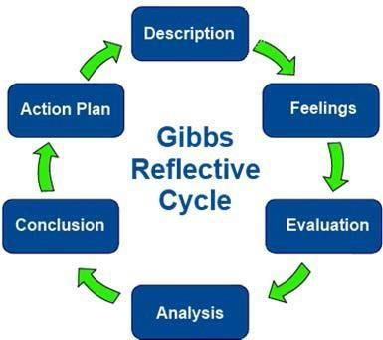
Covenant School of Nursing Reflective Practice

Step 1 Description  The layout of the room was one circle with chairs and one more row inside the circle around the long table that the main AA host were seating at. There were about 26 people attending the AA meeting including the 5 host at the main table. The group started the opening scene with a prayer that a member volunteered to read out loud. After the prayer they started at one side and started to state their names and say state they are an alcoholic and share a victory or struggle they have faced that week or what was helping them stay strong during their rehab on staying sober. Some shared and some didn’t but still said their name out loud and stated they are an alcoholic. After each person announced their name, everyone together said hi and repeated their name. after their story sharing, again everyone at the end stated together thanking them for sharing their story. The smell of cigarettes did linger in the room. I observed anxiety in many that were sitting and at the edge a bit. | Step 4 Analysis  I can see how staying sober can take time to process through and how group therapy brings in more connection for the group to express and take in what may help in strength or struggles to help them grow in their journey. I notice how some where a little on edge from being sober and couldn’t sit still. I notice that this journey is highly recommended to have someone to turn too from listening to their story’s and struggle when they didn’t have anyone by their side.
Step 2 Feelings  As I was waiting to go into the building, I was feeling quite nervous and anxious not knowing what to expect or how I will be received by just showing up to be there to observe. I wasn’t sure who was the host at first or where to sit or what to say or even mention I was there as a student. My anxiety was high, because walking in and trying to find a spot to sit was uncomfortable to me. Thankfully I had a peer join me that helped keep some of my fears down a level. I just felt that being there I felt unease from the looks I was receiving and how everyone seems so jittery to me. I didn’t get the chance to speak to the host, so I was feeling more anxiety waiting to be the next person to speak out and state my name and not know what to say after. Everyone’s story was so personal, and I didn’t want anyone to feel that I invaded their privacy to just be there to observe. When the time came for me to interduce myself, I just stated my name and right away that I was there to learn. A few did make a angry face and some laughed making a joke out of us being there to “learn”. I was not sure how to read that or how to respond to it. I did observe that many that shared their story, needed something or someone to latch too. In order to keep fighting, they needed to find strength in a higher belief to keep them tied to what they were fighting against in the demons they stated they had in their minds. They needed that one person or higher belief to make it through. They were afraid to be alone or feel alone. Some shared that feeling alone would bring fear on relapsing again or losing their goal once again. | Step 5 Conclusion  I feel that my anxiety would have been a bit better if I was able to meet with the host and explain I am one of the students that called to attended and that I don’t wish to talk out loud in the group. I should have put a scent in my nose and wear a mask to help reduce the smell that caused me to have a massive migraine. What I observed help me be in their shoes to understand and see it in a different perspective on what each one is facing and their struggles and victories. It is already a powerful step to be present in the meeting and it has helped other attend more than one they feel the urge to have drink when their life is falling apart at that time and able to talk to someone.
Step 3 Evaluation  I was able to hear in get inside more on seeing how the struggle is hard when trying to stop something that has brought them comfort but ruining their health and living situation to losing everything. I noticed that each time one shared their story it was helping another to bond and not feel alone. This group was vocal on support each other and sharing their feelings.  I did feel uncomfortable being there, and it could be from not being able to share anything to relate or help another. I was like a fly on the wall just listening. | Step 6 Action Plan  This experience has helped me understand more at a deeper level on how to view a client that comes into the hospital on CIWA precaution. I feel more empathy on learning more on what it takes to get help and how something can easily break someone down to relapse. Everyone has a story that can be weighing them down so heavily that has led them to be admitted with withdrawing from any substance. It is not easy but starting anywhere takes a lot of mental strength. The importance to seek therapy and have anyone to reach out to help makes a big impact on their recovery.

