PMH Simulation Reflection
Please reflect on your experiences in simulation this week and reply to each item below. You may add anything else you wish. Submissions should be a minimum of 300 words total.
- Describe your feelings about your participation in the simulations this week.
  - I was really excited and nervous for SIM this week but I’m glad how it turned out. It was really fun to see how my other group members got really into character with their scenarios and they made it a really fun experience.
- How did it go compared to what you expected it to be like?
  - PMH simulation was different than SIM then what we have experienced before in my opinion. I like it way better than the other SIMS we’ve done. I feel like I learned more about being an empathetic nurse and how to connect with patients on a more emotional level rather than a clinical level.
- What went well?
  - I think my favorite part was how we all worked really well together when we were primary and secondary nursing role. I think we did a really good job being the first group of SIM and not having any lectures for it.
- What could have gone better?
  - I think I could have acted better in my scenario
- Reflect on the scenario in which you were in the role of the patient or family member. How did that experience affect you?
  - I was the patient in the scenario for anxiety. I felt that this would be a good scenario for me since I’m not as good of an actor as the other people in my group and it would be easier for me to portray. This wasn’t hard for me to really act for because I do have generalized anxiety disorder and I know what it is to feel like the wall are caving in and you cant breathe at all. It made me kind of sad because I know first-hand what it is to feel like this 100% of the time and others don’t. It makes me feel not normal or jealous of the people who don’t experience anxiety at this level.
- Did this week change the way you think about mental health? If so, how?
  - This SIM week I learned a lot about other psychiatric illnesses that I did not know about and was able to get a deeper understanding of what the patient experiences.
- How will you use the knowledge gained from this experience in your practice as a registered nurse?
  - This will help me how to respond to awkward situations when you have a patient is asking you for drugs or for an alcoholic drink or hallucinating.

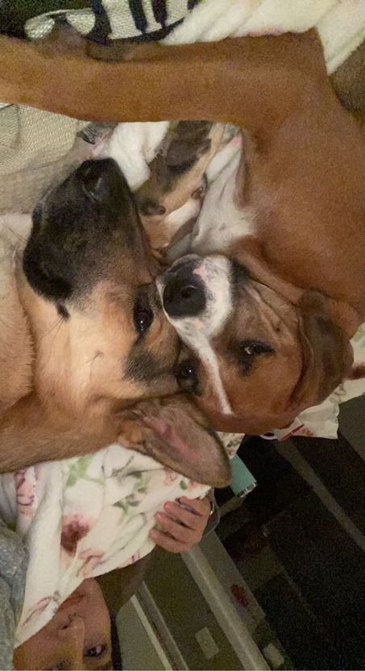
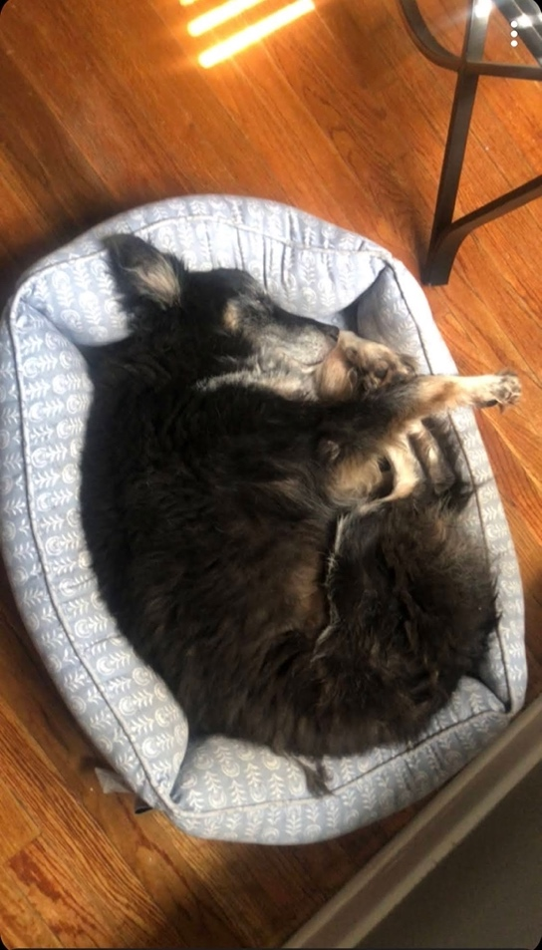
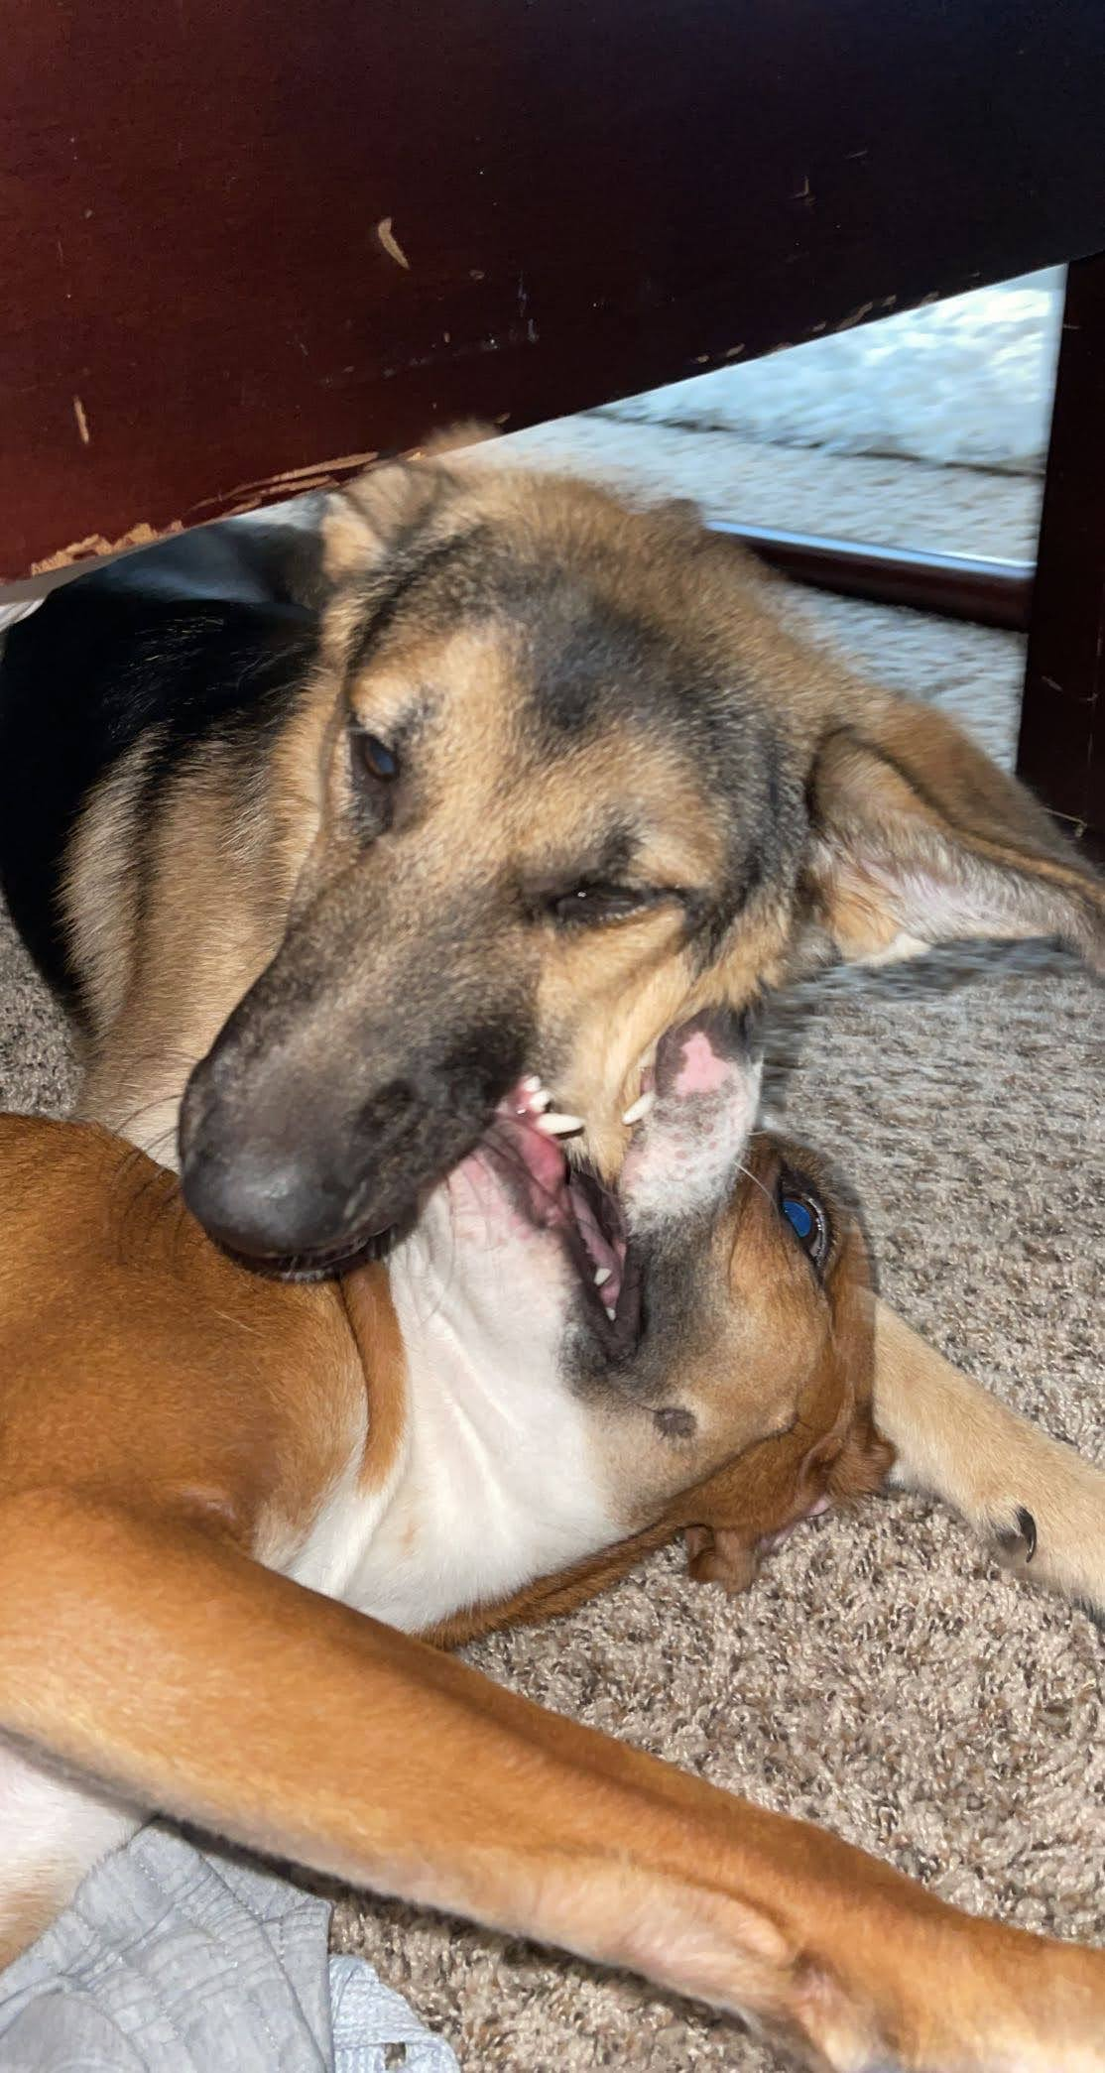
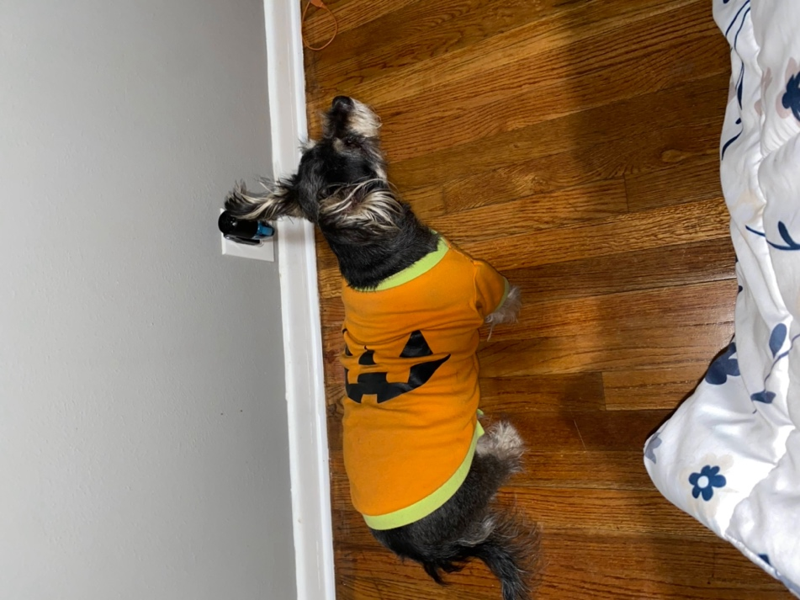
prissy is pumpkin dog
kenai is the german sheperd
nia is border collie dog laying in a bed too small for her
luna is boxer mix who loves her brother kenai.

