WHO AM I GAME- Hearing edition
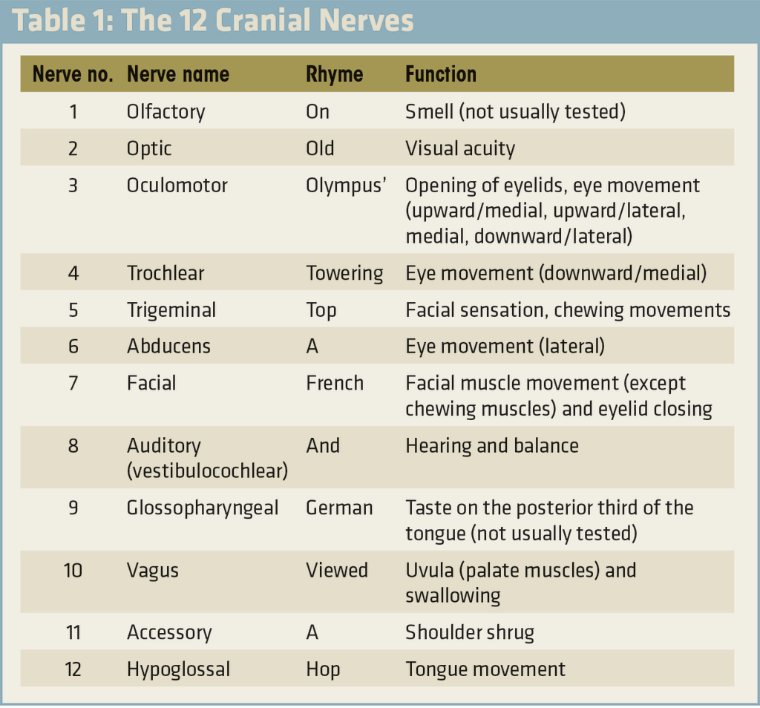
Cranial nerve that….
- 1 Olfactory – smell
- 2 Optic -Visual acuity
- 3Oculomotor- Opening of eyelids, eye movement upward/ medial, upward/lateral, medial, downward/ lateral)
- 4Trochlear – Eye movement (downward/ Medial)
- 5 Trigeminal- Facial sensation, chewing movement
- 6 Abducens- Eye movement (lateral)
- 7 Facial- Facial muscle movement (except chewing muscles) and eyelid closing
- 8 Auditory (Vestibulocochlear) - Hearing and balance
- 9 Glossopharyngeal- Taste on the posterior third of the tongue
- 10 Vagus- uvula (Palate muscles) and swallowing
- 11 Accessory- Shoulder shrug
- 12 Hypoglossal- Tongue movement
- I can lead to Ineffective communication (Hearing deficit)
- I can lead to decrease interaction, withdrawal, suspicion, loss of self-esteem and insecurity (Hearing deficit)
- I affect the outer and middle ear (Conductive)
- I affect the inner ear and affect nerve pathways (sensorineural)
- I affect the inner, middle, and outer ear (mixed)
- I am an assessment tool used to look at the ear (otoscope)
- I am an assessment test used that compares air conduction with bone conduction (Rinne’s test)
- I am normal when air conduction is louder than bone conduction (Rinne’s positive)
- I am abnormal when bone conduction is louder than air conduction (Rinne’s negative)
- I am an assessment test when conducted I will strike a 512htz tuning fork and place on my forehead (Weber’s)
- I am normal when tuning fork is on my forehead and can equally be heard in both ears (Weber’s test)
- I am abnormal when a tuning fork is on my forehead and the sound is different in my two ears. (Weber’s test)
- I am the medical term of ringing of the ears (Tinnitus)
- I am the medical term for the room is spinning (Vertigo)
- I am a symptom that occurs when there is fluid in the ear compressing the 8th cranial nerve (Vertigo)
- I am the reason the patient is a high fall risk (Vertigo)
- I can cause a patient grief and depression and may also lead to suicidal ideation (Tinnitus)
- I am caused by Otosclerosis (Conductive hearing loss)
- I am caused by otitis media with effusion (conductive hearing loss)
- I am caused by Poor Eustachian tube function (Conductive hearing loss)
- I am caused by impacted cerumen (earwax) (Conductive hearing loss)
- I am caused by tumors in the ear (Conductive hearing loss)
- I am caused by objects in the ear (such as a Lego) (Conductive hearing loss)
- I hear better in noisy environment (conductive hearing loss) (bone better than air conduction)
- My treatment plan is to either treat the cause or wear a hearing aid. (Conductive hearing loss)
- I am the most common type of permanent hearing loss (Sensorineural hearing loss)
- I cannot be fixed by surgery or medicine (Sensorineural)
- I am caused by illness or genetics (Sensorineural)
- I am caused by loud noises like concerts, gun firing, construction, factory work etc. (Sensorineural)
- I am caused by ototoxicity (Sensorineural)
- I am Vancomycin I cause what kind of damage (sensorineural /ototoxicity)
- I am Gentamycin I cause what kind of damage (Sensorineural / ototoxicity)
- I am Cisplatin I cause what kind of damage (Sensorineural / ototoxicity)
- I am Aspirin I cause what kind of damage (Sensorineural / ototoxicity)
- I am Furosemide I cause what kind of damage (sensorineural / ototoxicity)
- I am Quinine I cause what kind of damage (sensorineural / ototoxicity)
- I am caused by presbycusis (aging) (Sensorineural)
- I am caused by dilation of the endolymphatic system by overproduction or decrease reabsorption of endolymphatic fluid. (Meniere’s syndrome)
- My signs and symptoms include: Vertigo, Tinnitus, and Fluctuating hearing loss (Meniere’s syndrome)
- My interventions include: prevent injury during Vertigo attacks, provide bed rest in a quiet environment, provide assistance with walking, instruct the patient to move their head slowly to prevent worsening of the Vertigo, initiate sodium and fluid restrictions as prescribed, instruct the patient to stop smoking, instructed patient to avoid watching television because the flickering of lights may exacerbate symptoms, allow the patient to rest; And control Vertigo nausea in vomiting, mild diuretics may be prescribed to decrease endolymphatic volume, inform the patient about vestibular rehabilitation as prescribed. (Meniere’s syndrome)
- My surgical intervention includes a resection of the vestibular nerve or a total removal (Meniere’s syndrome)
- My post-operative interventions- packing and dressings on the ear. Speak to the patient on the side of the unaffected ear. Perform neurological assessments. Maintain safety. Assess when ambulating. Encourage the patient to use a bedside commode rather than ambulating to the bathroom. Administer anti- vertigo and anti-emetic medications as prescribed. (Meniere’s syndrome)
- For me you should assess for early detection to prevent permanent damage (Nursing care/education)
- For me you should educate patients and have them teach back to ensure understanding (Nursing care/ education)
- I must be taught about adequate nutrition and hydration to ensure that I can maintain oil and sebaceous glands to maintain hearing. (Nursing care/ education)
- I must be taught about medication regimens (nursing care/education)
- I must be taught about surgery if necessary (nursing care/ education)
- You should never shout at me (hearing deficit)
- You should speak low and slow (hearing deficit/ education)
- You can write out what you are trying to say (Hearing deficit/ education/ intervention)
- I would like some help with the cost of my hearing aids (Nursing care/ education/ intervention)

