Rhythm Strips Analysis for Practice Answers

Practice #1:
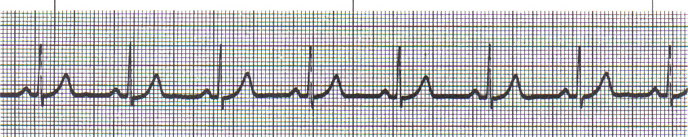

- What is the Rate? 70 bpm
(R-R)
- Is there a “P” wave with every “QRS” complex? Yes, upright “P” with every “Q”
- What is the width of the “QRS”? 0.08s or 2 small squares
- What is the length of the “PR” interval? 0.16s or 4 small boxes
- What is the rhythm? Normal Sinus Rhythm (even if NSR always assess patient)

- Any complications with this rhythm? None

- What interventions are anticipated? Assessing patient for pulses, cap refill, BP, skin temperature, & color because it could be PEA=Pulseless Electrical Activity. If assessment all WNL the rhythm is OK

Normal HR: 60-100 bpm

Rhythm Strips Analysis for Part I of Intro to EKG
Practice #2
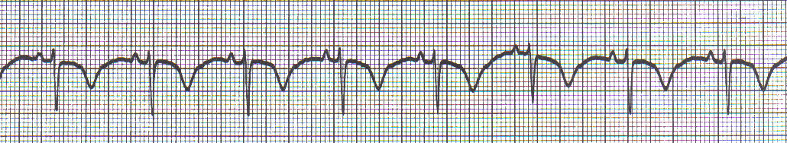
Isoelectric Line

- What is the Rate? 71 bpm
(R-R)
- Is there a “P” wave with every “QRS” complex? Yes, upright “P” with every “QRS”
- What is the width of the “QRS”? 0.08s normal
- What is the length of the “PR” interval? 0.12s normal
- What is the rhythm? Sinus Rhythm with inverted “T” wave. You cannot call it normal sinus rhythm because it is not normal if something else is going on but it does meet the criteria of sinus rhythm.

- Any complications with this rhythm? Ischemia for now and could advance to injury or infarction (“ST” changes)

- What interventions are anticipated? A focused cardiac assessment, drawn labs, give them some oxygen, get a 12-Lead EKG, notify the physician.

Rhythm Strips Analysis for Part I of Intro to EKG
Practice #3
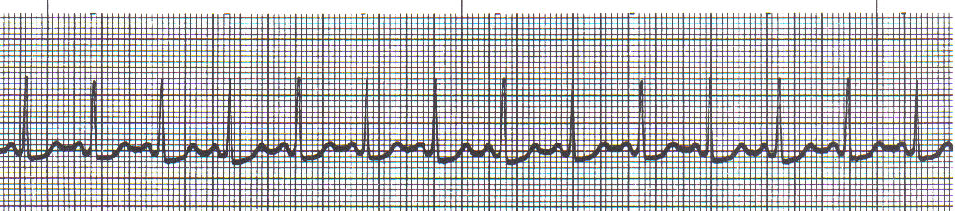
Isoelectric line

- What is the Rate? 130 bpm
(R-R)
- Is there a “P” wave with every “QRS” complex? Yes, upright “P” with every “QRS”
- What is the width of the “QRS”? 0.08s normal
- What is the length of the “PR” interval? 0.12s normal
- What is the rhythm? Sinus Tachycardia with slightly depressed ‘ST’

- Any complications with this rhythm? Loss of filling times

- What interventions are anticipated? Treat the cause, which include fever, pain, fear, anxiety, hypovolemia

Rhythm Strips Analysis for Part I of Intro to EKG
Practice #4
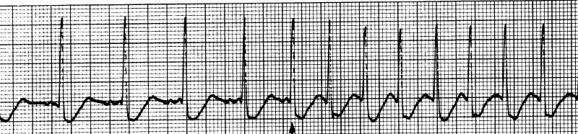
Isoelectric line

- What is the Rate? Previous HR 100bpm; then suddenly to HR 187 bpm
(R-R)
- Is there a “P” wave with every “QRS” complex? Previous no discernable ”P” the electrical activity is coming from above the ventricles in the atrium not the SA node
- What is the width of the “QRS”? 0.08s normal
- What is the length of the “PR” interval? No “PR” interval
- What is the rhythm? Paroxysmal Atrial fibrillation with Rapid Ventricular Response (RVR)

- Any complications with this rhythm? Decreased cardiac output, low perfusion

- What interventions are anticipated? If patient is hemodynamically stable the physician may choose to treat with an antiarrhythmic drug, such as amiodarone, diltiazem, etc…but if patient is hemodynamically unstable patient needs synchronized cardioversion.

Rhythm Strips Analysis for Part I of Intro to EKG
“T” wave
Practice #5
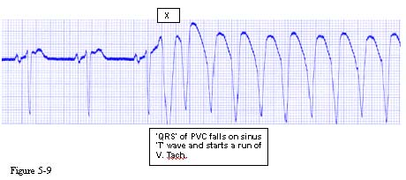

- What is the Rate? Previous HR 75 bpm, then “R” on “T” phenomenon causing V-tach
(R-R)
- Is there a “P” wave with every “QRS” complex? Previously Yes
- What is the width of the “QRS”? Previous 0.08s normal; then 0.32s abnormal
- What is the length of the “PR” interval? Previous 0.20s normal
- What is the rhythm? “R” on “T” phenomenon Vtach

- Any complications with this rhythm? Loss of cardiac output, loss of perfusion , low SBP

- What interventions are anticipated? If patient is hemodynamically unstable initiate BLS/ACLS protocol. If patient stable because it just occurred have the patient cough, bare down (vagal maneuver)

Rhythm Strips Analysis for Part I of Intro to EKG
Practice #6
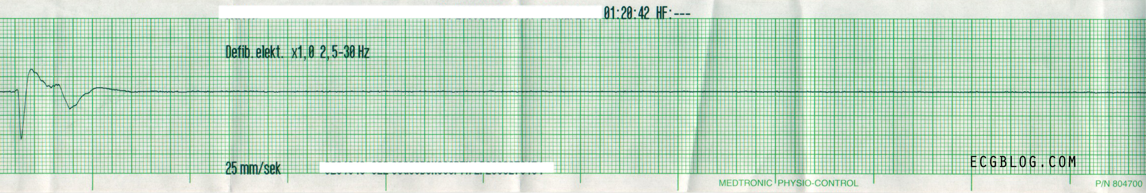
- What is the Rate? Assess patient first, check if leads attached, if patient is talking to you it is not asystole. (R-R)
- Is there a “P” wave with every “QRS” complex? NO
- What is the width of the “QRS”? Previously 1 – 0.16s abnormal then asystole
- What is the length of the “PR” interval? NO
- What is the rhythm? Asystole

- Any complications with this rhythm? Death

- What interventions are anticipated? Initial BLS/ACLS protocol – CPR (chest compressions), DO NOT DEFIBRILLATE!

Rhythm Strips Analysis for Part I of Intro to EKG
Practice #7
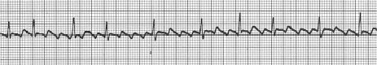
- What is the Rate? About 90 bpm
(R-R)
- Is there a “P” wave with every “QRS” complex? No normal “P” waves, sawtooth like, f-waves
- What is the width of the “QRS”? 0.08s normal
- What is the length of the “PR” interval? None, Flutters 3:1, 4:1 variation
- What is the rhythm? Atrial Flutter

- Any complications with this rhythm? Decreased cardiac output, thrombus, emboli, CVA, PE

- What interventions are anticipated? If patient has been in this rhythm < 48 hours or hemodynamically unstable – synchronized cardioversion. If > 48 hours and stable – anticoagulation therapy due to clot development risk for stroke and pulmonary embolus (PE)

Rhythm Strips Analysis for Part I of Intro to EKG
Practice #8
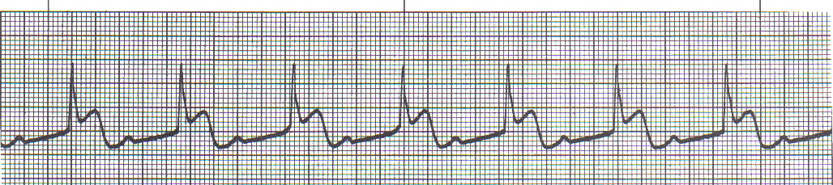
Isoelectric line

- What is the Rate? 60 bpm
(Look at the atrial rate: P-P or ventricular rate: R-R)
- Is there a “P” wave with every “QRS” complex? Yes, upright “P” with every “QRS”
- What is the width of the “QRS”? 0.16s abnormal
- What is the length of the “PR” interval? 0.48s abnormal
- What is the rhythm? Sinus rhythm with 1st degree AV block & “ST” elevation – myocardial infarction

- Any complications with this rhythm? Most 1st degree AV blocks are benign, but this patient has “ST” elevation > MI, this can result in death, intervene fast, notify physician.

- What interventions are anticipated? Initiate MONA protocol, this patient needs to go to the cath lab, resolving the MI will probably resolve the 1st degree AV block.

You can do this!

