R.B. Turnbull, Jr. MD School of WOC Nursing Education
Mini Case Studies: Ostomy

Student Name & Date:
Reviewed by:
Score: /40
For the following Ostomy patient case scenarios:
- Apply Ostomy characteristics provided to identify an ostomy pouching plan for the patients below.
  - Be specific: It is important to note a pouching system is a skin barrier wafer and a pouch. A complete answer should include both unless otherwise indicated. Include the manufacturer and full, product name. Product numbers should not be used. Make sure to include accessory products as needed.
  - When providing Rationale: Describe abdominal characteristics, stoma characteristics, and one other reason why you would choose the specific system.
- The first half of the first case study has been completed for you below as an example:

Scenario 1
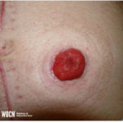
55-year-old with a history of colon cancer. Colostomy was created 2 months ago and presents today in the ostomy clinic for assessment and management. Pt is very active and would like to consider a more flexible pouching system. Pt is changing his pouching system every other day because he is fearful of leakage.
Assessment: Stoma is pink, budded, and protrudes above skin level. No erythema on parastomal skin. No reports of leakage.
Identify a one and two-piece pouching system option along with rationale for choice.

Image courtesy of Wound, Ostomy, and Continence Nurses SocietyTM image library.
One Piece System: Hollister Premier one-piece drainable pouch flat Flexwear barrier with clamp closure, change every 5-7 days and PRN.
Rationale: This system is flexible and matches the contours of this patient’s abdomen. It is appropriate for budded stomas with an even peristomal plane and is manufactured for wear for multiple days.
Two Piece option:
Rationale:
/2 points

Scenario 2
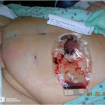
42-year-old with stoma placement on soft, obese abdomen.
Assessment: Stoma pink, budded, and protruding. Edema and necrosis circumferential at stomal edge. Serosanguineous drainage in pouch. Skin barrier wafer removal notes being cut too small, restricting and causing trauma to the stoma.
Identify a one and two-piece pouching system option along with rationale for choice.

Image courtesy of Wound, Ostomy, and Continence Nurses SocietyTM image library.
One Piece option: Coloplast SenSura Mio MAXI drainable pouch with soft outlet 18665 3/8-2 3/4
Rationale: “jelly belly”
Two Piece option: Holister 15204 2-3/4 flat skin barrier with integrated floating flange
Rationale: firm, shallow to deep convex skin barrier wafer help with this situation
/4 points

Scenario 3
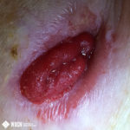
85-year-old presents with flush ileostomy and peristomal irritant dermatitis. Oval stoma with os low at 6 o’clock location. Protuberant hernia above further pushes the stoma into a lateral fold.
Pt wears bifocal glasses when applying the pouching system. Due to extreme hip contours, it is difficult to have a hernia belt stay in place.

Image courtesy of Wound, Ostomy, and Continence Nurses SocietyTM image library.
Pouching recommendations: stoma cutter, choose flat, flexible, or convex flexible skin barrier wafer

Rationale: response to convexity

/2 points

Scenario 4
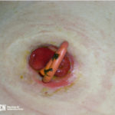
56-year-old obese individual with ruptured diverticulitis. A red rubber catheter in place as a bridge for the loop ostomy. Stoma is slightly budded and red. Peristomal skin with erythema and partial thickness wound 4-7 o’clock Etiology may be due to trauma from red rubber catheter movement.

Image courtesy of Wound, Ostomy, and Continence Nurses SocietyTM image library.
Pouching recommendations: 4 inch pouch coloplast concave

Rationale: how soon should bridge be removed?
Within a week or two depending on surgeon’s recommendations and per case
/2 points

Scenario 5
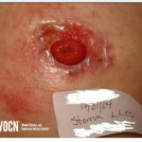
42-year-old arrives in emergency room with complaints of difficulty pouching and peristomal skin irritation. Current pouching system sometimes has less than 4 hours of wear time. Skin is very painful. Assessment finding of ulcerated skin around stoma. Stoma is at skin level on a firm abdomen. Patient acknowledges frequent sweating resulting in the need to change appliance. “It just doesn’t seem to stick”.

Image courtesy of Wound, Ostomy, and Continence Nurses SocietyTM image library.
Pouching Recommendations: full hydrocolloid no tape collar with extender
Rationale: the tape will cause further irritation
/2 points

Scenario 6
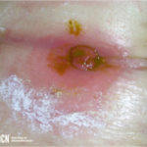
66-year-old obese individual with stoma in an abdominal fold. Appliance leakage causing contact dermatitis. Wear time has been less than 8 hours. Irritation is painful.

Image courtesy of Wound, Ostomy, and Continence Nurses SocietyTM image library.
Pouching Recommendations: non-adherent pouch
Rationale: to avoid further contact dermatitis from different skin wafers
/2 points

Scenario 7
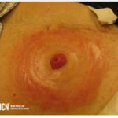
76-year-old presents to the ostomy clinic with peristomal redness to periphery. Irritation limited to appliance tape collar region. Satellite lesions present. Stoma is budded and round. States has had ostomy for 6 months and has not had any problem until recently after Home Health changed the products.

Image courtesy of Wound, Ostomy, and Continence Nurses SocietyTM image library.
Pouching Recommendations: all hydrocolloid with no tape collar, choose flat, flexible skin barrier wafer
Rationale: to avoid further irritation
/2 points

Scenario 8

Individual presents to the clinic with stoma measuring 3.5 inches. Stoma protrudes above skin level. Uneven peristomal contours with skin folds at 3 and 9 o’clock. Moisture-related skin damage on peristomal skin related to leakage.

Image courtesy of Wound, Ostomy, and Continence Nurses SocietyTM image library.
Pouching Recommendations: Hollister New image soft convex ceraplus skin barrier
Rationale: Designed to maintain adhesive properties and helps protect the skin’s natural moisture barrier and help maintain good peristomal skin health from day one. The flexible design help provide gentle pressure around the stoma to help obtain the right fit and conform to uneven skin surfaces.
/2 points

Scenario 9
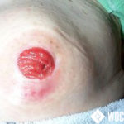
Patient presents to ostomy clinic due to peristomal hernia causing peristomal skin breakdown. Abdomen is firm. Appliance wear time has decreased since parastomal hernia development. Stoma is flush with skin. Os between 5 and 6 o’clock area. Complains of odor. “The odor is really bad when I empty the pouch”.

Image courtesy of Wound, Ostomy, and Continence Nurses SocietyTM image library.
Pouching Recommendations: SenSura MIO Convex Flip MAXI drainable pouch with full circle filter, can give iodor illuminator, start treating erythema with skin barrier
Rationale: Designed for curves, bulges and hernias and it filters odor/gas, decreases odor, to decrease further skin breakdown
/2 points

Scenario 10
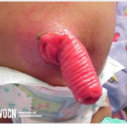
A pediatric Individual presents to the emergency room with stoma prolapse. Caregiver expresses inability to apply pouching system related to stomal protrusion. Stoma is red and healthy. No peristomal irritation.
Identify one pouching system with rationale for choice along with one consideration with appliance application specific to a prolapsed stoma.
Image courtesy of Wound, Ostomy, and Continence Nurses SocietyTM image library.
Pouching Recommendations: Would consider applying SenSura Mio Kids 1 piece MIDI drainable pouch but there’s missing info
Rationale: It is a child’s pouch and easy to apply for caregiver
Further Consideration: length of prolapse is required to know length of pouch. Age missing, needed for peds pouch size.
/3 points

Scenario 11
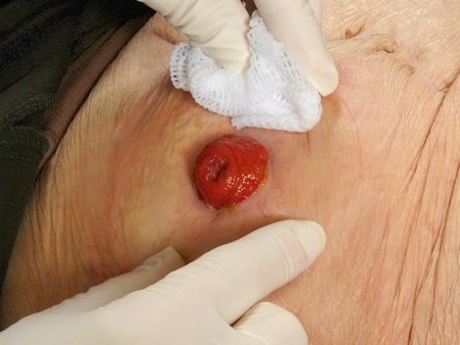
A 28-year-old with an ileostomy presents to the clinic for a follow-up evaluation. During the visit, the patient expressed the pouch is too long with the end of the pouch falling into the groin area. Assessment notes stoma red, viable, and protrudes above skin level. Abdominal space is small with short distance from stoma to groin. Current appliance is a one-piece cut to fit skin barrier. Pouch length 12”. Name at least two alternative pouching management system options and rationale for each.

Image courtesy of Judy Mosier, MSN, RN, CWOCN
Pouching option #1: Closed pouch with flat barrier
Rationale: shorter in length (9 inches in length), Hollister #82302/82402
Pouching option #2: SenSura Mio Flat MIDI drainable pouch
Rationale: shorter in length, Coloplast #10461 cut-to-fit
/4 points

Scenario 12
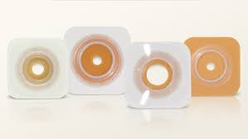
You are in your office and take a call from a patient. The patient voices having to change the skin barrier wafer more frequently, itching under the skin barrier, and desire to change manufacturers. The patient agrees to be seen in the clinic.
In preparation for this visit, you go to your resources to help you.
1. Identify one manufacturer (Hollister, Convatec, Coloplast, NuHope, etc)
2. Identify three skin barrier wafers from that manufacturer that differ in composition/ingredients.
3. Identify the type of ostomy or situation in which the wafer is appropriate.
For example: (can not be used)
Manufacturer: B. Braun
1. Skin barrier wafer: Flexima 3S

Composition & Purpose: Made of new generation plastics making it more soft and flexible. Appropriate for
any type of ostomy and active individuals
2. Skin barrier wafer: Flexima… etc
Manufacturer: Coloplast
Skin barrier Wafer 1: SenSura Mio Convex
Composition & Purpose: Flexlines ensure the convex shell bends around the stoma, not in the middle. Ability to bend and stretch, reduce leakage by providing a reliable seal between the skin and the baseplate, appropriate for inward areas around stoma.
Skin barrier Wafer 2: SenSura Mio Convex Flip
Composition & Purpose: Designed for outward body profile. The curve, star shape baseplate hugs the body and provide good fit with less creasing. Provides extra flexibility to allow baseplate to stay in place during body movement.
Skin barrier Wafer 3: Assura AC
Composition & Purpose: A two-piece appliance for pediatrics. Provides a secure adhesive coupling system. Different styles (ex: teddy bear design) and sizes to accommodate different child stages (newborns-5 years of age). Simple and soft. Hygienic and easy to clean with EasiClose outlet.
/6 points

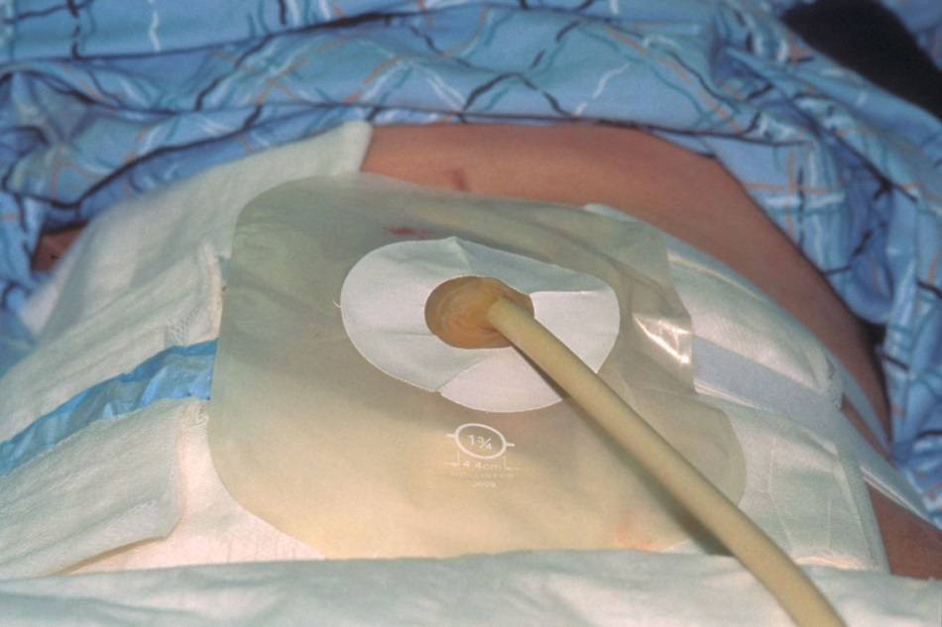
Image courtesy of Judy Mosier, MSN, RN, CWOCN
You are consulted to see a patient with a new colostomy. Upon entering the room, you note there is an indwelling catheter in the stoma. Nursing reports pouch leakage as the hole in the pouch for the tube is cut to fit the stoma resulting in a “big hole” in the front of the pouch. The surgeon’s request is to continue to pouch the stoma while pulling the tube through the pouch.
Describe how you will secure the tube while separately pouching the stoma and the tube…

…using a commercial access port: Nu-Hope Latex Catheter Holder
…in the absence of a commercial access port: Baby Nipple

/2 points

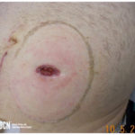
86-year-old obese individual presents to the ostomy clinic with a retracted stoma. States has a soft-formed stool once a day. Pouch changed daily as stool goes under the skin barrier wafer, and at times, no stool goes into the pouch.
It is determined a convex pouching system should be used. A convex skin barrier wafer is not available.
Identify two strategies to create convexity in the absence of a convex skin barrier wafer.
Image courtesy of Wound, Ostomy, and Continence Nurses SocietyTM image library.
Alternative convexity option #1: Ostomy ring
Alternative convexity option #2: Strip paste

/2 points

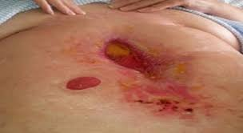
The WOC nurse is consulted to manage a wound with a stoma in proximity. The surgeon has consented to pouching the stoma in the same pouch as the wound. It is determined to be the best approach.
Identify one product that can be used to achieve this.

Image courtesy of Judy Mosier, MSN, RN, CWOCN
Pouching option: Eakin ConvaTec wound pouch
/1 point

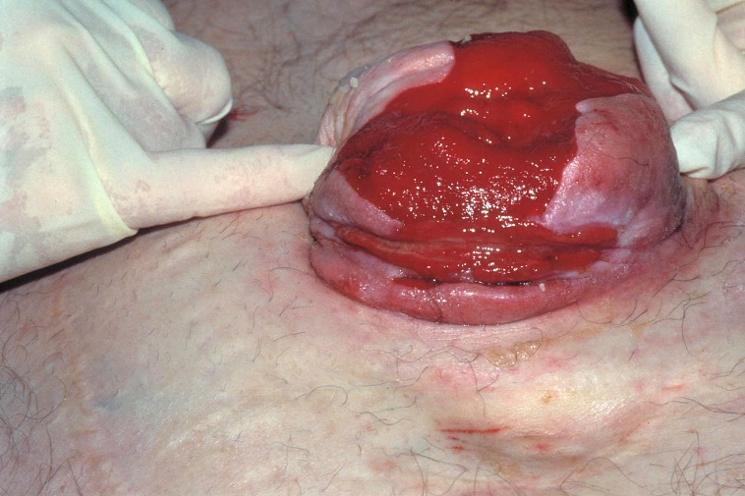
A 70-year-old patient presents to the ED with pouching difficulty. They report using a fistula pouch previously, however, this has become too costly of an option. Their stoma measures 4 1/3” in diameter and they are at a loss for pouching options. The patient will need pouching long term. Identify one product that is manufactured to accommodate a stoma of 4” or greater in size.
Image courtesy of Dr. James Wu
Pouching option: Draining pouch 18194 2-3/ 4 inch by Hollister or 18006 4 inch pouch
/2 point

