
Activity 7.1.1 Focus on Mitosis

Purpose
Mitosis is the division of the cell nucleus in which the chromosome in a parent cell divides into two identical sets. Mitosis is one part of the cell cycle, which includes interphase, mitosis, and cytokinesis. Interphase is a period of cell growth and development. Cytokinesis is the division of the cytoplasm of a parent cell and its contents into two daughter cells. Mitosis involves four phases: prophase, metaphase, anaphase, and telophase. Distinct activities within the cell nucleus help identify each phase.

During prophase, the chromatin coil and form chromosomes. The nucleolus and nuclear membrane break down and disappear, and spindle fibers may be observed. In the second phase of mitosis, metaphase, spindle fibers move the chromosomes to the center of the cell and hold them in place. Chromosomes will be observed lined up along the center of the cell. Anaphase occurs when the centromere of each pair of chromatids divides and chromatids move toward opposite ends of the cell. During the final phase of mitosis, telophase, two identical sets of chromatids are at opposite sides of the cell. The spindle fibers disappear, the chromatids unwind, and a nuclear membrane begins to form.
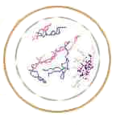 | 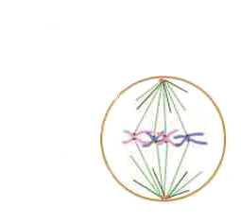 | 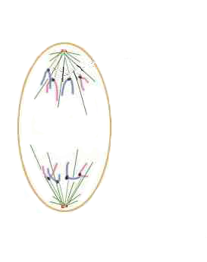 | 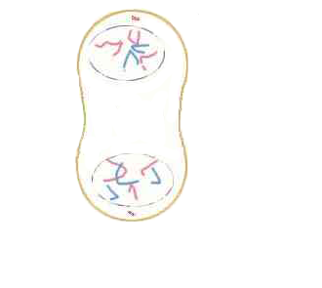
Prophase | Metaphase | Anaphase | Telophase
Mitotic cell division occurs in both plant and animal cells. In animals, cell division is occurring throughout the entire animal and it is hard to find evidence of all phases of mitosis in a small sample. In plants, most growth takes place in the meristematic tissues. These regions multiply rapidly and the cells are defined well enough to examine mitosis at various stages. Because the process between plants and animals is essentially the same, preparing slides of plant tissue to view the phases of mitosis is more feasible.

Materials
Per class:  - Root tips | Per student:  - Compound microscope  - Slide  - Cover slip  - Tissue macerating blade  - Tissue transfer brush  - Tissue treating tray  - Paper towels  - Stopwatch  - Pencil  - Agriscience Notebook
Per group of four students:
- Bottle of Solution A
- Bottle of Solution B
- Bottle of aceto-orecein stain
- Fish mitosis prepared slide

Procedure
Due to mitosis occurring inside the cell, detection of mitosis must be done under a microscope. You will prepare a slide of plant meristem tissue and examine the process of mitosis under magnification. You will also examine a prepared slide of animal mitosis and make some observations.

Part One – Examining Plant Mitosis
You will be preparing an onion root tip slide to examine the phases of mitosis in a plant. You will share common items within your group of four, but you will complete each step independently.

- In the tissue treating tray, fill the cavity marked “A” approximately ½ full with Solution A.
- Fill the cavity marked “B” approximately ½ full with Solution B.
- Obtain a root tip specimen and transfer it to cavity “A” with your transfer brush. Allow it to remain in the solution for 4-5 minutes until the root tip begins to get mushy.
- Carefully transfer the root tip to cavity “B” with the transfer brush. Allow it to remain in Solution B for 4-6 minutes.
- While you are waiting for Step 4, place your slide on a paper towel and add a large drop of aceto-orecein stain to the center of the slide.
- After the appropriate amount of time has passed, transfer the root tip to the drop of stain on the microscope slide.
- Use the tissue macerating blade to mince the root tip into tiny pieces. Be sure the root tip stays within the stain.
- Allow the root tip to absorb the stain for 15 minutes. Do NOT let the stain dry. If necessary, add additional stain.
- While you are waiting, set up the microscope.
- Fold a paper towel in half and place it on a flat surface.
- Place the microscope slide on in the center of the paper towel.
- Place the coverslip over the root tip tissue.
- Fold the paper towel up over the slide and coverslip.
- Apply downward pressure to the top of the coverslip using your middle finger. Do NOT twist or turn your finger as you press on the coverslip. The acetic acid in the stain causes the cytoplasm to swell. The pressure on the coverslip with spread apart chromosomes to enable you to make observations.
- Observe the slide you prepared under the microscope.
- Examine the slide under low power.
- Locate the root cap and move the slide so that the root cap is pointing toward you.
- Just above the root cap is the meristem. The larger cells in the center will have dark stained threadlike structures.
- When you have found good cells to study, increase the microscope to high power.
- Locate a cell in each phase of mitosis as well as interphase.
- In Table 1 on Activity 7.1.1 Student Worksheet, record observations for each stage of plant mitosis and interphase.

Part Two – Comparing Animal and Plant Mitosis
- Obtain a prepared slide of fish mitosis from your teacher.
- Attempt to locate each phase of mitosis on the animal cell.
- Complete Table 1 comparing your observations.

Conclusion
- How do plant and animal mitosis stages differ?

- Explain your difficulties with preparing and observing slides for the plant tissue.

- Explain your difficulties finding the phases of mitosis in the prepared animal slide.

Activity 7.1.1 Student Worksheet

Table 1. Mitosis Comparisons
Stage of Mitosis | Draw Observations From the Microscope
Stage of Mitosis | Plant | Animal

