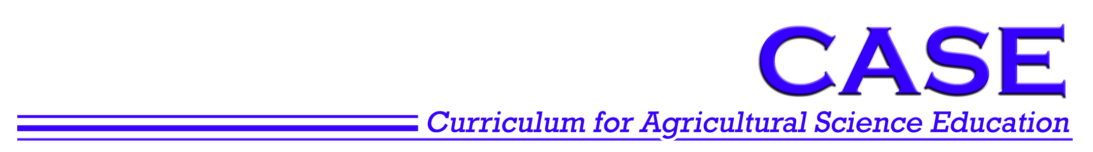
Activity 7.1.3 Experiment 4 Vestigial Wing, Ebony Body

Background
In this experiment, you will examine the inheritance of two genes found on different chromosomes in fruit flies. The genes in this experiment are the vestigial wing and ebony body genes. Bold wild genes are dominant over the mutant genes.

The examination of two genes is referred to as a dihybrid cross. The genotype of a fruit fly that is homozygous for both wild traits will be represented as VVEE, while the genotype of a fly that is homozygous for both mutant traits is represented as vvee.

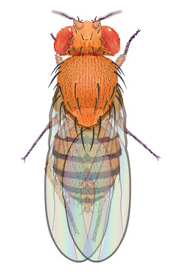 | 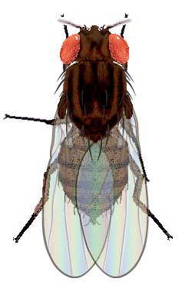 | 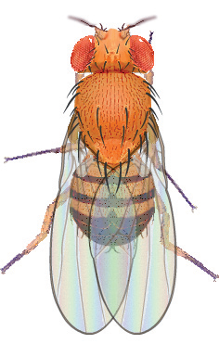 | 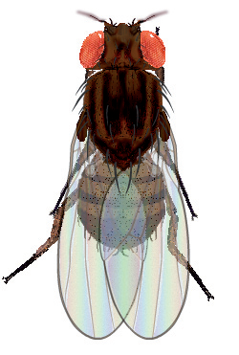
Wild Female | Ebony Body Female | Wild Male | Ebony Body Male
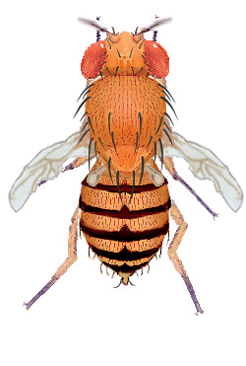 | 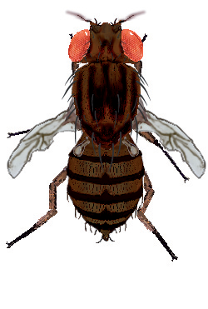 | 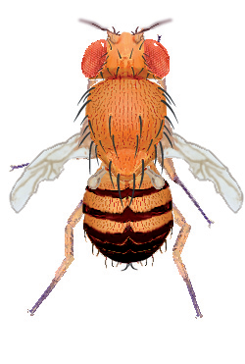 | 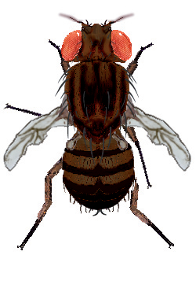
Vestigial Wing Female | Vestigial Wing and Ebony Body Female | Vestigial Wing Male | Vestigial Wing and Ebony Body Male

Procedure
- Open the Drosophila Genetics Lab on your computer as instructed by your teacher.
- Click on the Reset button and then Select button.
- Select Saved Parents and then Exp04_f.mfp or Exp04_m.mfp (f stands for female, while m stands for male).
- Drag each of the parents over to the Observation Platform and record their phenotype and genotype in question 1 of the Predictions.
- Compete questions 2 and 3 of the Predictions to determine the probability of wild flies and mutant flies in this mating.
- Click the Breed button. Examine and record the phenotype of 100 offspring in Table 1.
- Complete question 1 of the Results Analysis.
- Drag one male and one female into the Hold Jar.
- Empty the Parent/Offspring area.
- Drag the held flies into the Parent jar and select Breed. This is your Hybrid, or F1, cross.
- Examine each parent from the hybrid cross and record their phenotype and genotype in question 4 of Predictions.
- Compete questions 5 – 7 of the Predictions to determine the probability of wild wing flies and wild wing flies in this mating.
- Examine and record the phenotype of 200 offspring in Table 2. Complete questions 2 and 3 of the Results Analysis.

Predictions
- Determine the information below for each of the original parents, one of which is a homozygous wild individual and the other a homozygous mutant individual.
Parent | Phenotype | Genotype
Female
Male

- Complete the Punnett Square for the parent cross.
Genes from the female | Genes from the male
Genes from the female | ______ | ______ | _______ | ______
______
______
______
______

- What would you expect the ratio of wild flies to mutant flies to be in the Punnett Square you just completed?
 | wild | : |  | mutant

- Determine the information below for each of the hybrid parents, who are both heterozygous, in your F1 cross.
Parent | Phenotype | Genotype
Female
Male

- Complete the Punnett Square for the hybrid cross.
Genes from the female | Genes from the male
Genes from the female | ______ | ______ | _______ | ______
______
______
______
______

- What would you expect the ratio of wild : vestigial : ebony : vestigial and ebony flies to be in the Punnett Square you just completed?
 | wild | : |  | vestigial | : |  | ebony | : |  | vestigial & ebony

Results Analysis
Table 1. Parent Cross Results
Parent Description
Female Genotype |  |  |  |  |  |  |  | Male Genotype
Female Phenotype |  |  |  |  |  |  |  | Male Phenotype
Wild Flies |  |  | Vestigial Wing Flies |  |  |  |  |  | Ebony Bodied Flies |  |  |  | Vestigial Wing & Ebony Bodied
Female | Male |  | Female |  |  | Male |  |  | Female | Male |  |  | Female |  | Male
Total = |  |  | Total = |  |  |  |  |  | Total = |  |  |  | Total =
Ratio of Wild : Mutant |  |  |  |  |  |  | :

- How does the ratio of flies observed in the hybrid cross experiment compare to the ratio predicted in your Punnett Square?

Table 2. Hybrid Cross Results
Parent Description
Female Genotype |  |  |  |  |  |  |  |  | Male Genotype
Female Phenotype |  |  |  |  |  |  |  |  | Male Phenotype
Wild Flies |  |  |  |  | Vestigial Wing Flies |  |  |  |  | Ebony Bodied Flies |  |  |  |  | Vestigial Wing & Ebony Bodied
Female |  | Male |  |  | Female |  | Male |  |  | Female |  | Male |  |  | Female |  |  | Male
Total = |  |  |  |  | Total = |  |  |  |  | Total = |  |  |  |  | Total =
Ratio of Wild : Vestigial : Ebony : Vestigial & Ebony
 |  |  |  | : |  |  |  | : |  |  |  |  |  | :

- How does the ratio of flies observed in the hybrid cross experiment compare to the ratio predicted in your Punnett Square?

- Why might there be differences in the observed and predicted phenotypic ratios?

