
Activity 7.1.3 Experiment 3 Ebony Body

Background
In this experiment, you will examine the inheritance of two genes found on different chromosomes in fruit flies. The genes in this experiment are the wild orange and ebony body genes. Wild genes are dominant over the mutant genes.

A heterozygous fly possesses an allele for the wild body color and an allele for ebony body color. As the wild color of orange is dominant, the phenotype of a heterozygous fly will be an orange body color. The symbol used for the wild allele is E and the mutant allele is e.

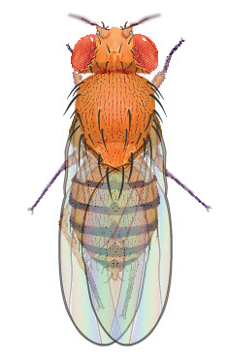 | 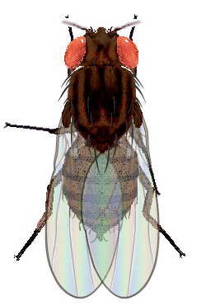 | 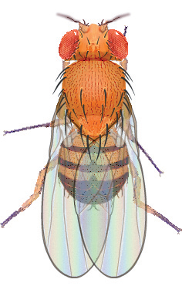 | 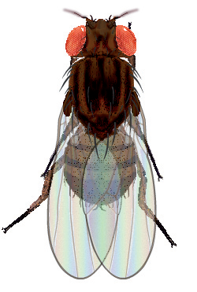
Wild Female | Ebony Body Female | Wild Male | Ebony Body Male

Procedures
- Open the Drosophila Genetics Lab on your computer as instructed by your teacher.
- Click on the Reset button and then Select button.
- Select Saved Parents and then Exp03_f.mfp or Exp03_m.mfp (f stands for female, while m stands for male).
- Drag each of the parents over to the Observation Platform and record their phenotype and genotype in question 1 of the Predictions.
- Compete questions 2 and 3 of the Predictions to determine the probability of wild orange flies and ebony body flies in this mating.
- Click the Breed button. Examine and record the phenotype of 100 offspring in Table 1.
- Drag one male and one female into the Hold Jar.
- Empty the Parent/Offspring area.
- Drag the held flies into the Parent jar and select Breed. This is your Hybrid, or F1, cross.
- Examine each parent from the hybrid cross and record their phenotype and genotype in question 4 of Predictions.
- Compete questions 5 – 7 of the Predictions to determine the probability of wild orange flies and ebony body flies in this mating.
- Examine and record the phenotype of 200 offspring in Table 2.

Predictions
- Determine the information below for each of the original parents, one of which is a homozygous wild orange individual and the other a homozygous ebony body individual.
Parent | Phenotype | Genotype
Female
Male

- Complete the Punnett Square for the parent cross.
Genes from the female | Genes from the male
Genes from the female | ______ | ______
______
______

- What would you expect the ratio of wild orange flies to ebony body flies to be in the Punnett Square you just completed?
 | wild | : |  | ebony

- Determine the information below for each of the hybrid parents, who are both heterozygous, in your F1 cross.
Parent | Phenotype | Genotype
Female
Male

- Complete the Punnett Square for the hybrid cross.
Genes from the female | Genes from the male
Genes from the female | ______ | ______
______
______

- What would you expect the ratio of wild orange flies to ebony body flies to be in the Punnett Square you just completed?
 | wild | : |  | ebony

- What are the expected ratios of genotypes in this cross? (EE : Ee : ee)
 | : |  | :

Results Analysis

Table 1. Parent Cross Results
Parent Description
Female Genotype |  |  | Male Genotype
Female Phenotype |  |  | Male Phenotype
Wild Bodied Flies |  |  | Ebony Bodied Flies
Female | Male |  | Female |  | Male
Total = | Total = |  | Total = |  | Total =
Total Wild Bodied Flies = |  |  | Total Ebony Bodied Flies =
Ratio of Wild body : Ebony Body |  |  |  | :

- How does the ratio of wild : ebony flies observed in the parent cross experiment compare to the ratio predicted in your Punnett Square?

Table 2. Hybrid Cross Results
Hybrid Description
Female Genotype |  | Male Genotype
Female Phenotype |  | Male Phenotype
Wild Bodied Flies |  | Ebony Bodied Flies
Female | Male | Female | Male
Total = | Total = | Total = | Total =
Total Wild Bodied Flies = |  | Total Ebony Bodied Flies =
Ratio of Wild Bodied : Ebony Bodied |  |  | :

- How does the ratio of wild : ebony bodied flies observed in the hybrid cross experiment compare to the ratio predicted in your Punnett Square?

- Why might there be differences in the observed and predicted phenotypic ratios?

