
Activity 6.1.1 Name That Part

Purpose
You have studied several systems within the body of the animal including the respiratory, circulatory, and digestive systems. Each system performs an essential activity in the body. While reproductive ability does not affect the daily life of the animal, reproduction is critical to a species sustainability and animal agriculture production.

Reproduction is often the limiting factor in profitability of a livestock enterprise. In order to determine the cause of reproductive success or failure, you must be familiar with the basic anatomy and physiology of the reproductive system. The parts of the male and female reproductive systems have distinct functions. Do you know the similarities and differences between the male and female reproductive systems?

Materials
Per student:
- Agriscience Library
- Modern Livestock and Poultry Production textbook
- 10 colored pencils
- Pencil
- Agriscience Notebook

Procedure
In this activity, you will identify the anatomy and physiology of the female and male reproductive tracts. You will find the location of each organ of the male and female reproductive systems and label the organs on a diagram. Next, you will learn the function of each part by reading pages 200-204 of Chapter 10 Animal Reproduction in your classroom text, Modern Livestock and Poultry Production.

Part One – Labeling Reproductive Systems
- Review the diagrams in Activity 6.1.1 Student Worksheet to familiarize yourself with the reproductive anatomy of a bull and a cow.
- Label the organs in the list that you know. Use a pencil to allow for corrections.
Female Reproductive Parts | Male Reproductive Parts
Ovary | Sheath
Infundibulum | Penis
Bladder | Cowper’s gland
Cervix | Epididymis
Fallopian tube (oviduct) | Prostate gland
Rectum | Retractor muscle
Uterine body (uterus) | Scrotum
Uterine horn | Seminal vesicles
Vagina | Sigmoid flexure
Vulva | Testicles
 | Vas deferens

- Using your textbook and the Agriscience Library correct and complete the labeling of the male and female reproductive tracts on Activity 6.1.1 Student Worksheet.

Part Two – Describing Reproductive Function
Read pages 208-212 from your textbook and describe the function of each organ of the male and female reproductive tract on Activity 6.1.1 Student Worksheet.

Part Three – Connecting With Color
- Select a colored pencil to represent each organ on the male diagram. Color the organ, then find and underline the function of the same organ in your notes with the same color.
- Use the colored pencils to match the female organs with the corresponding function on the female diagram. Underline the function of the organ in your notes and color the organ in the same color.

Conclusion
- What is a reproductive system?

- What are the major reproductive organs of the male?

- What are the major reproductive organs of the female?

Activity 6.1.1 Student Worksheet

Table 1. Female Reproductive Organs
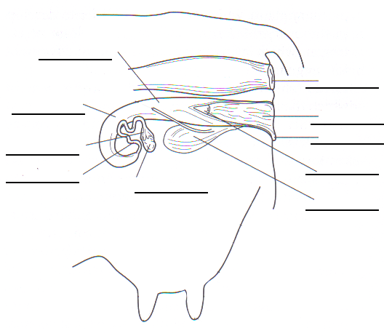 | Organ | Function
 | Ovary
 | Infundibulum
 | Fallopian tube (oviduct)
 | Uterine horn
 | Uterine body
 | Cervix
 | Vagina
 | Vulva

Table 2. Male Reproductive Organs
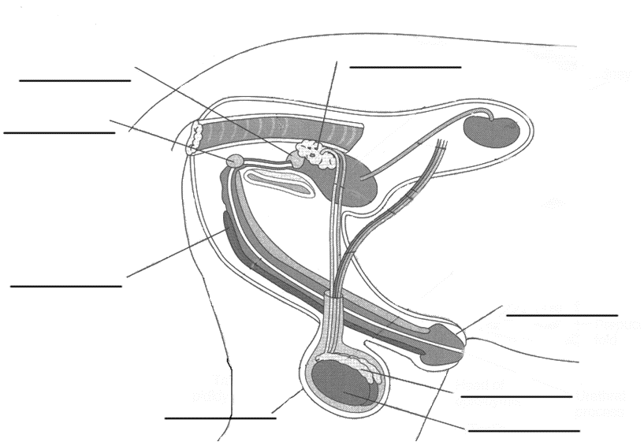 | Organ | Function
 | Scrotum
 | Testicles
 | Epididymis
 | Vas deferens
 | Seminal vesicles
 | Prostate gland
 | Cowper’s gland
 | Penis
 | Sigmoid flexure
 | Retractor muscle
 | Sheath

